Fosdem 2024

Table des matières

Saturday 1

FOSDEM 2024 - The State of OpenJDK 1

FOSDEM 2024 - A decade of JDK Updates in OpenJDK 1

FOSDEM 2024 - Exploring Quarkus Native: Choices and Implementation 1

FOSDEM 2024 - The CarpentriesOffline: Teaching Foundational Data Science and Coding Skills with Little or no Internet Access 1

FOSDEM 2024 - The French Open Science Monitor: steering the science based on open bibliographic databases 1

FOSDEM 2024 - Infra Finder: Increasing visibility of open technologies for open science 1

FOSDEM 2024 - Virtual Thread’s Next Steps 1

FOSDEM 2024 - Updating open data standards 1

FOSDEM 2024 - A microkernel-based orchestrator for distributed Internet services? 1

FOSDEM 2024 - A Modular Approach to Effortless and Dependency-Aware Unikernel Building 1

FOSDEM 2024 - Run Node.js in a unikernel reliably 1

FOSDEM 2024 - Carbon measurement and energy attribution for processes and hardware devices in the Linux kernel 1

FOSDEM 2024 - Web-accessibility for open-source privacy & security tools 1

FOSDEM 2024 - Science without secrets – how Galaxy democratizes data analysis 1

FOSDEM 2024 - Workflow managers in high-energy physics: enhancing analyses with Snakemake 1

FOSDEM 2024 - Open Neuroscience: practical suggestions for conducting open neuroscience research 1

FOSDEM 2024 - Apache Maven 4.0.0 - Current State 1

Sunday 1

FOSDEM 2024 - Open Source in 2024: boundaries, burnout, business 1

FOSDEM 2024 - Know Your Ingredients: Security Starts With the SBOM 1

FOSDEM 2024 - Breaking Barriers: Content Management Systems and Accessibility 1

FOSDEM 2024 - SBOMs that you can trust - the good, the bad, and the ugly 1

FOSDEM 2024 - Desktop Linux, as easy as a smartphone! Just in a Snap! 1

FOSDEM 2024 - Web Accessibility and ATAG 1

FOSDEM 2024 - Open Source for Sustainable and Long lasting Phones 1

FOSDEM 2024 - A journey documenting the Sanco 8003 computer 1

FOSDEM 2024 - Controlling a 6 degree Robot Arm using a 48K ZX Spectrum 1

FOSDEM 2024 - FOSDEM 2024 Highlights 1

# Saturday

## [FOSDEM 2024 - The State of OpenJDK](https://archive.fosdem.org/2024/schedule/event/fosdem-2024-3254-the-state-of-openjdk/)

Ub5132 10h30 openjdk state of

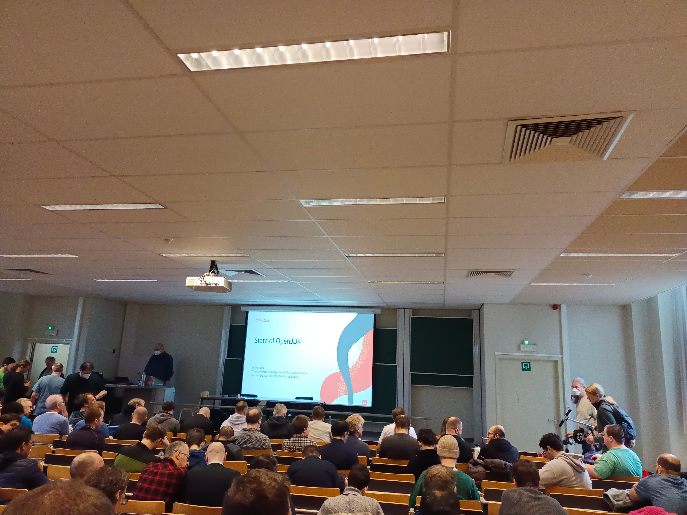

* Jdk14 2019 !
* Jdk17 lts 2021
* Jdk21 2023
* Release frequency change : tail and tip
  + More frequent as soon as ready, secured only when all corrected/secured/stable
  + Easier to get the new features
  + Look for/found the Right size of a release
  + Better rhythm for both developers looking for th tip of the tech and industry looking for the stable ones
* (Voir slides sur les features jdk21/17/11 lts)
* GitHub migration

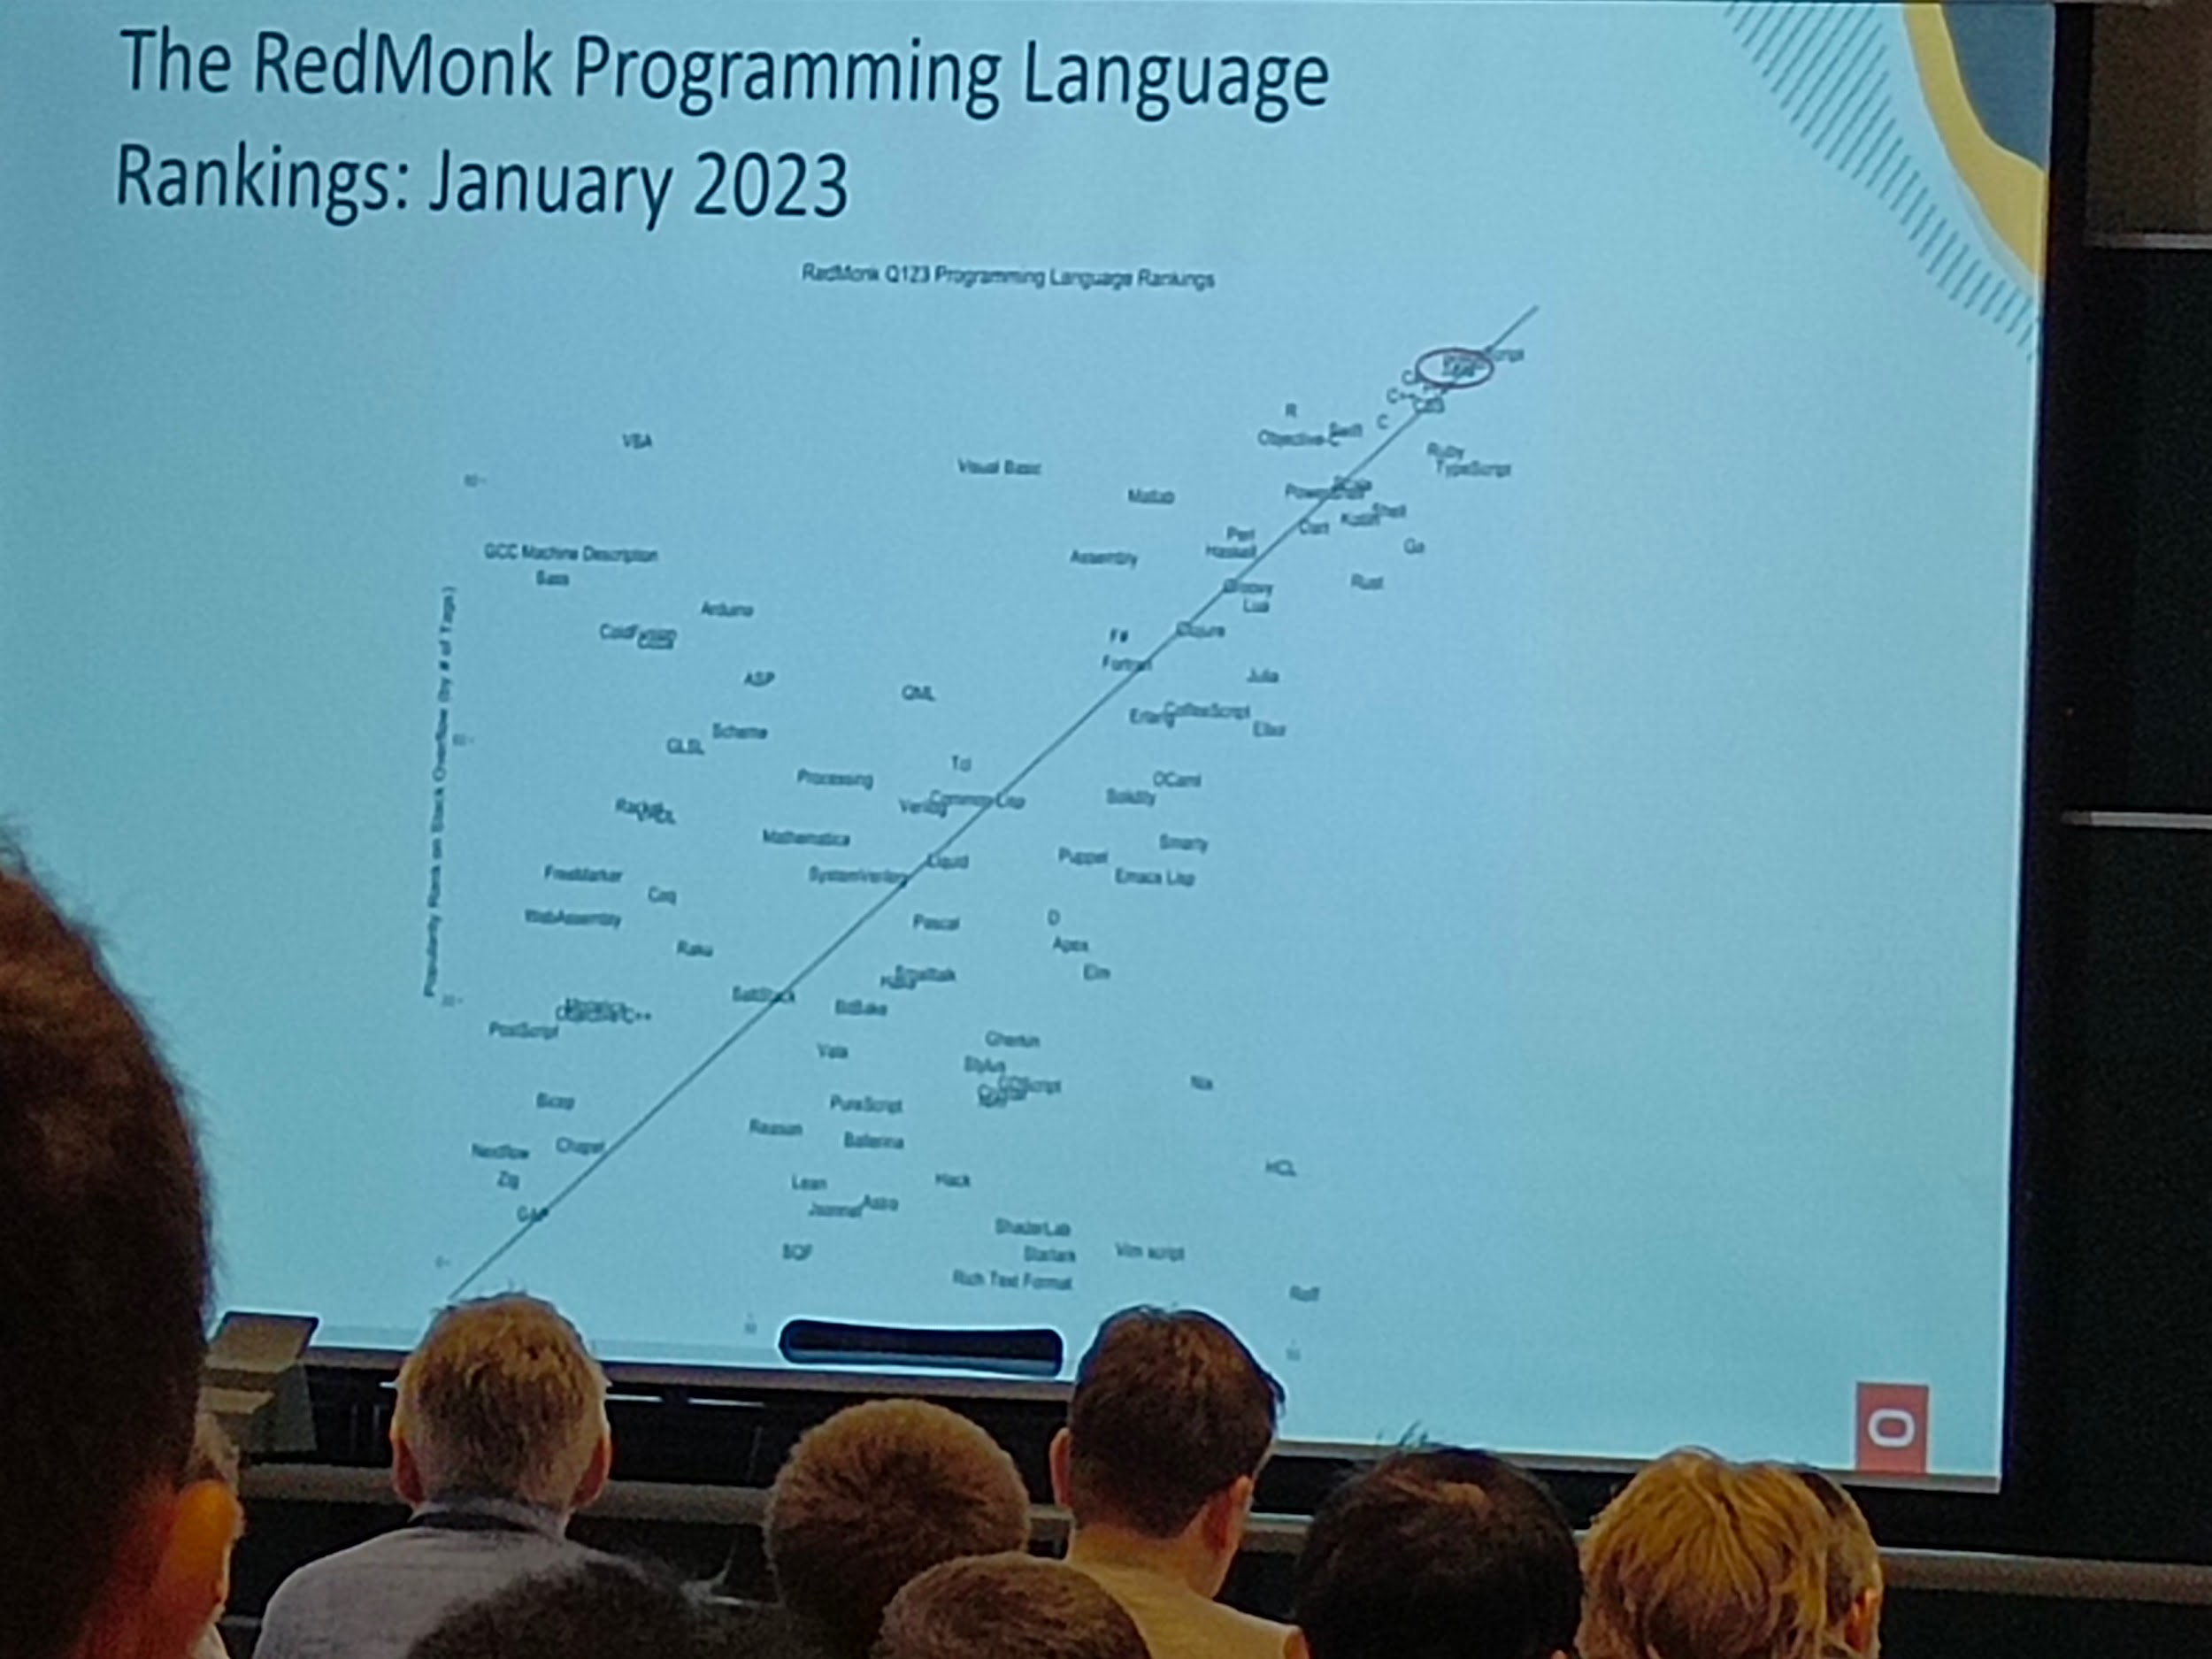

* Contributors

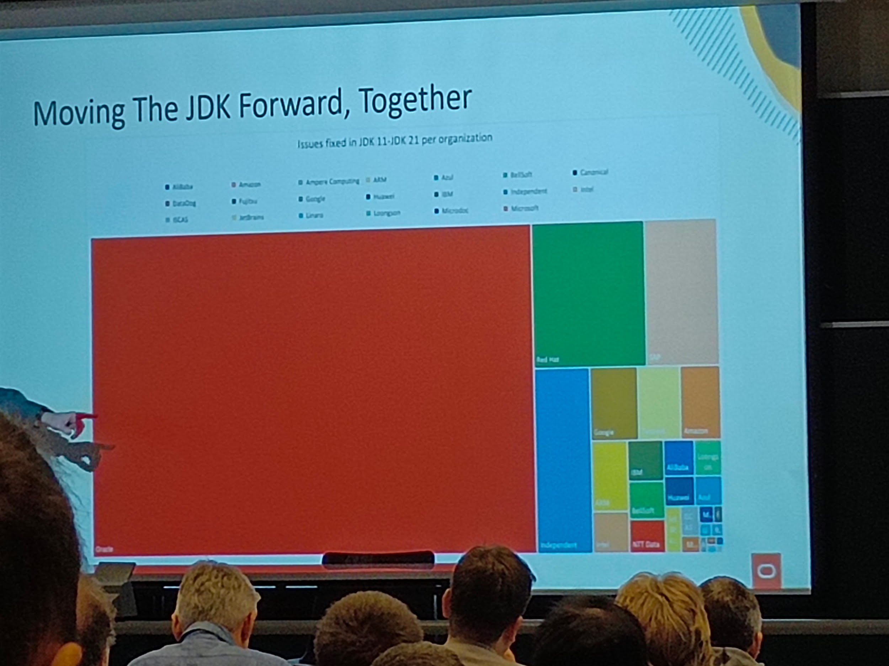

* (Bleu : independents)
* Competitors

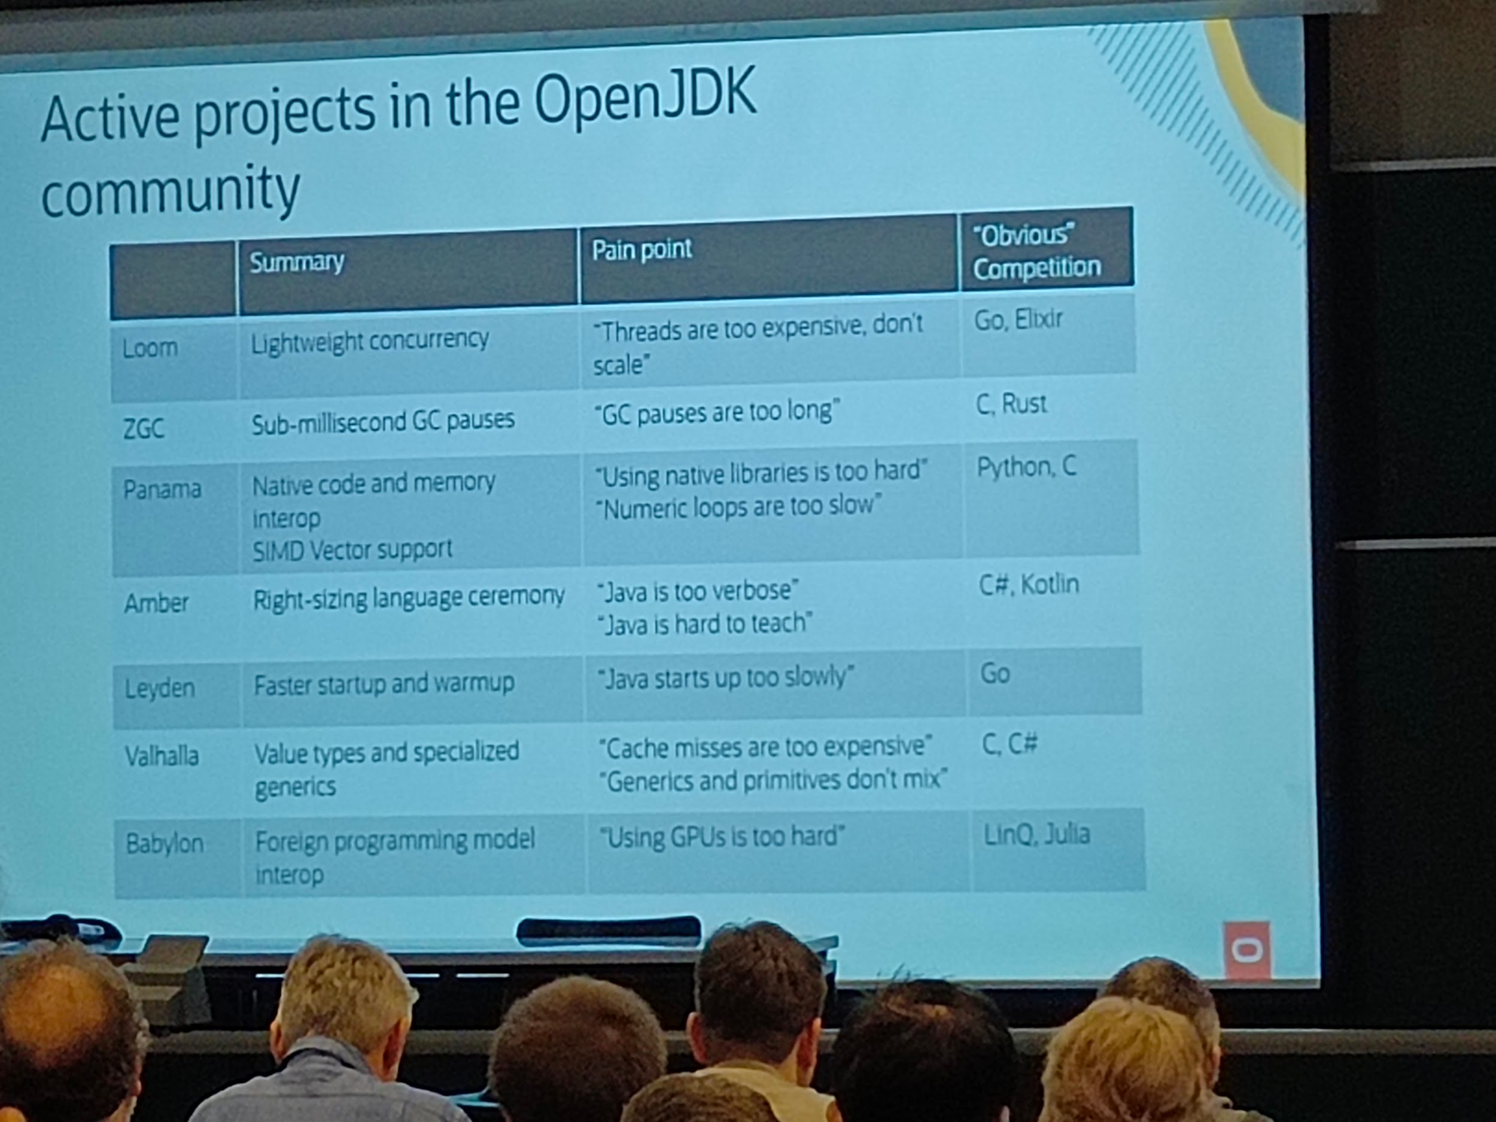

-------

## [FOSDEM 2024 - A decade of JDK Updates in OpenJDK](https://archive.fosdem.org/2024/schedule/event/fosdem-2024-2427-a-decade-of-jdk-updates-in-openjdk/)

Ub5132 11h05 openjdk in a decade

* OpenJdk6: ouverture de jdk à openjdk, openjdk6 made from jdk6/jdk7
* OpenJdk7: openjdk7 what purpose?
* Long term maintained version
* Jdk8 quite heavy with many features

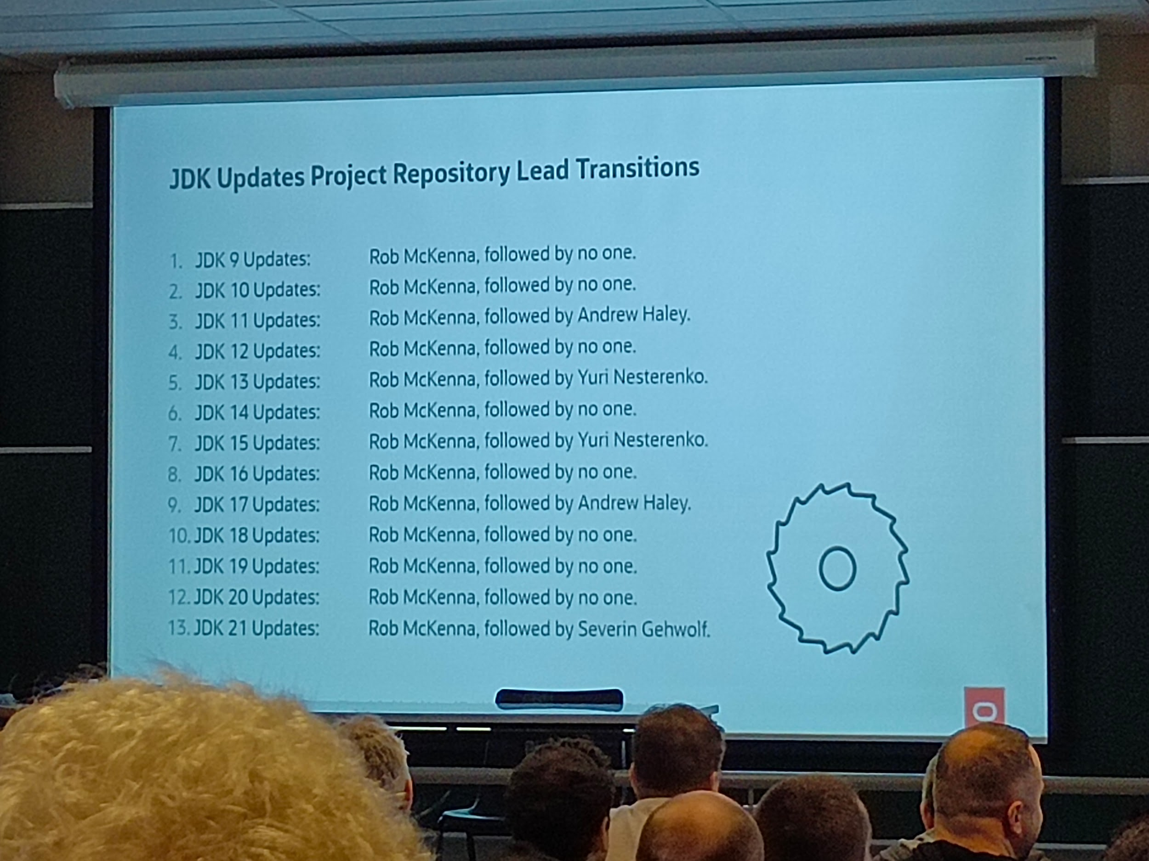

----

## [FOSDEM 2024 - Exploring Quarkus Native: Choices and Implementation](https://archive.fosdem.org/2024/schedule/event/fosdem-2024-1876-exploring-quarkus-native-choices-and-implementation/)

Ub5132 11h30 quarkus

* Java framework
* Kubernet native

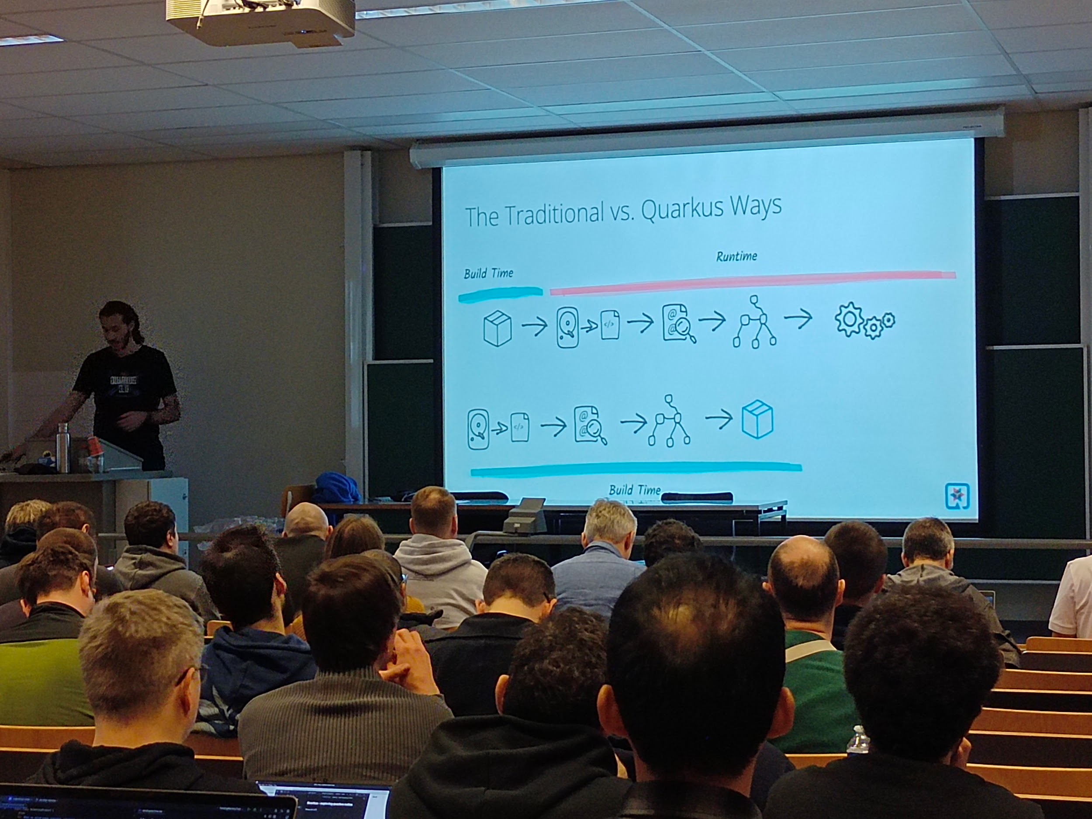

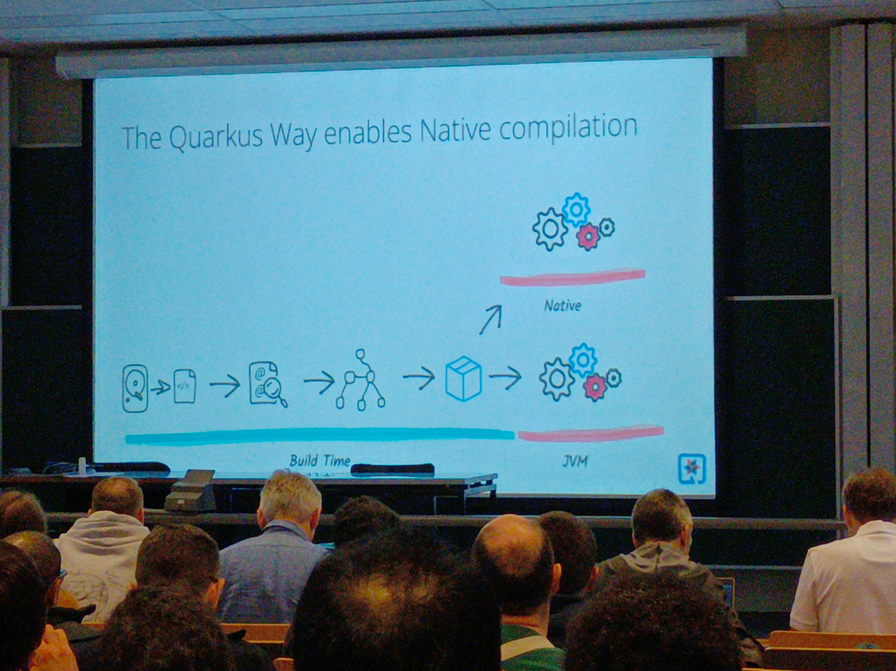

* Native?
* Faster, small standalone binary, smaller memory footprint
* Slower Dev cycle, lower peak perf, secure patch require recompil, not portable, lack of tooling support
* How?
  + GraalVm,

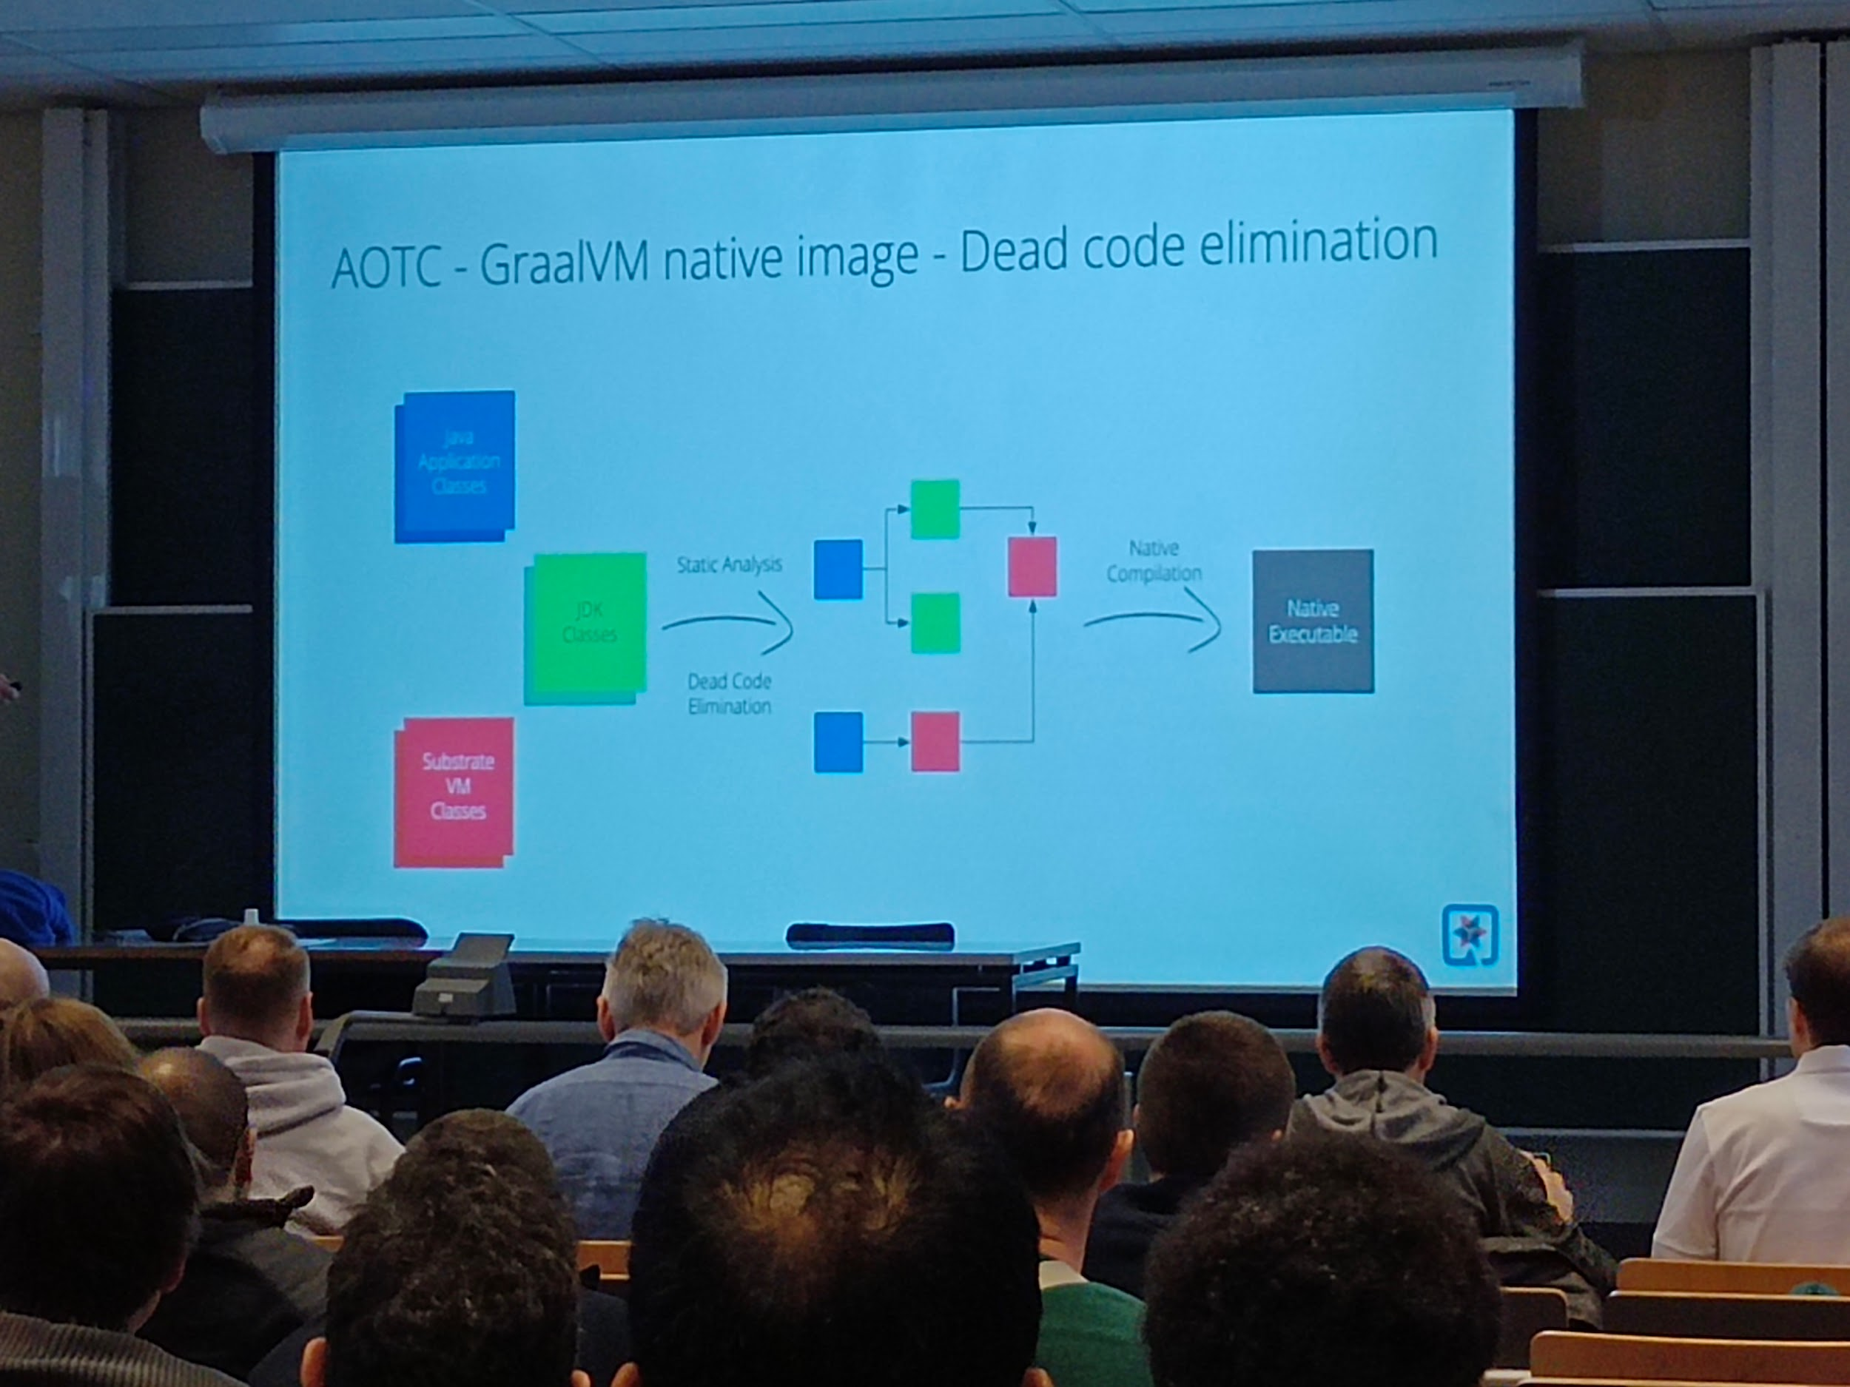

* + Limitation of GraalVm native
    - Some unsupport and caveats
* How quarkus can help?
  + Quarkus has good support on GraalVm already,
* Why quarkus? (Voir slides…)
* Dead code elimination
* How?

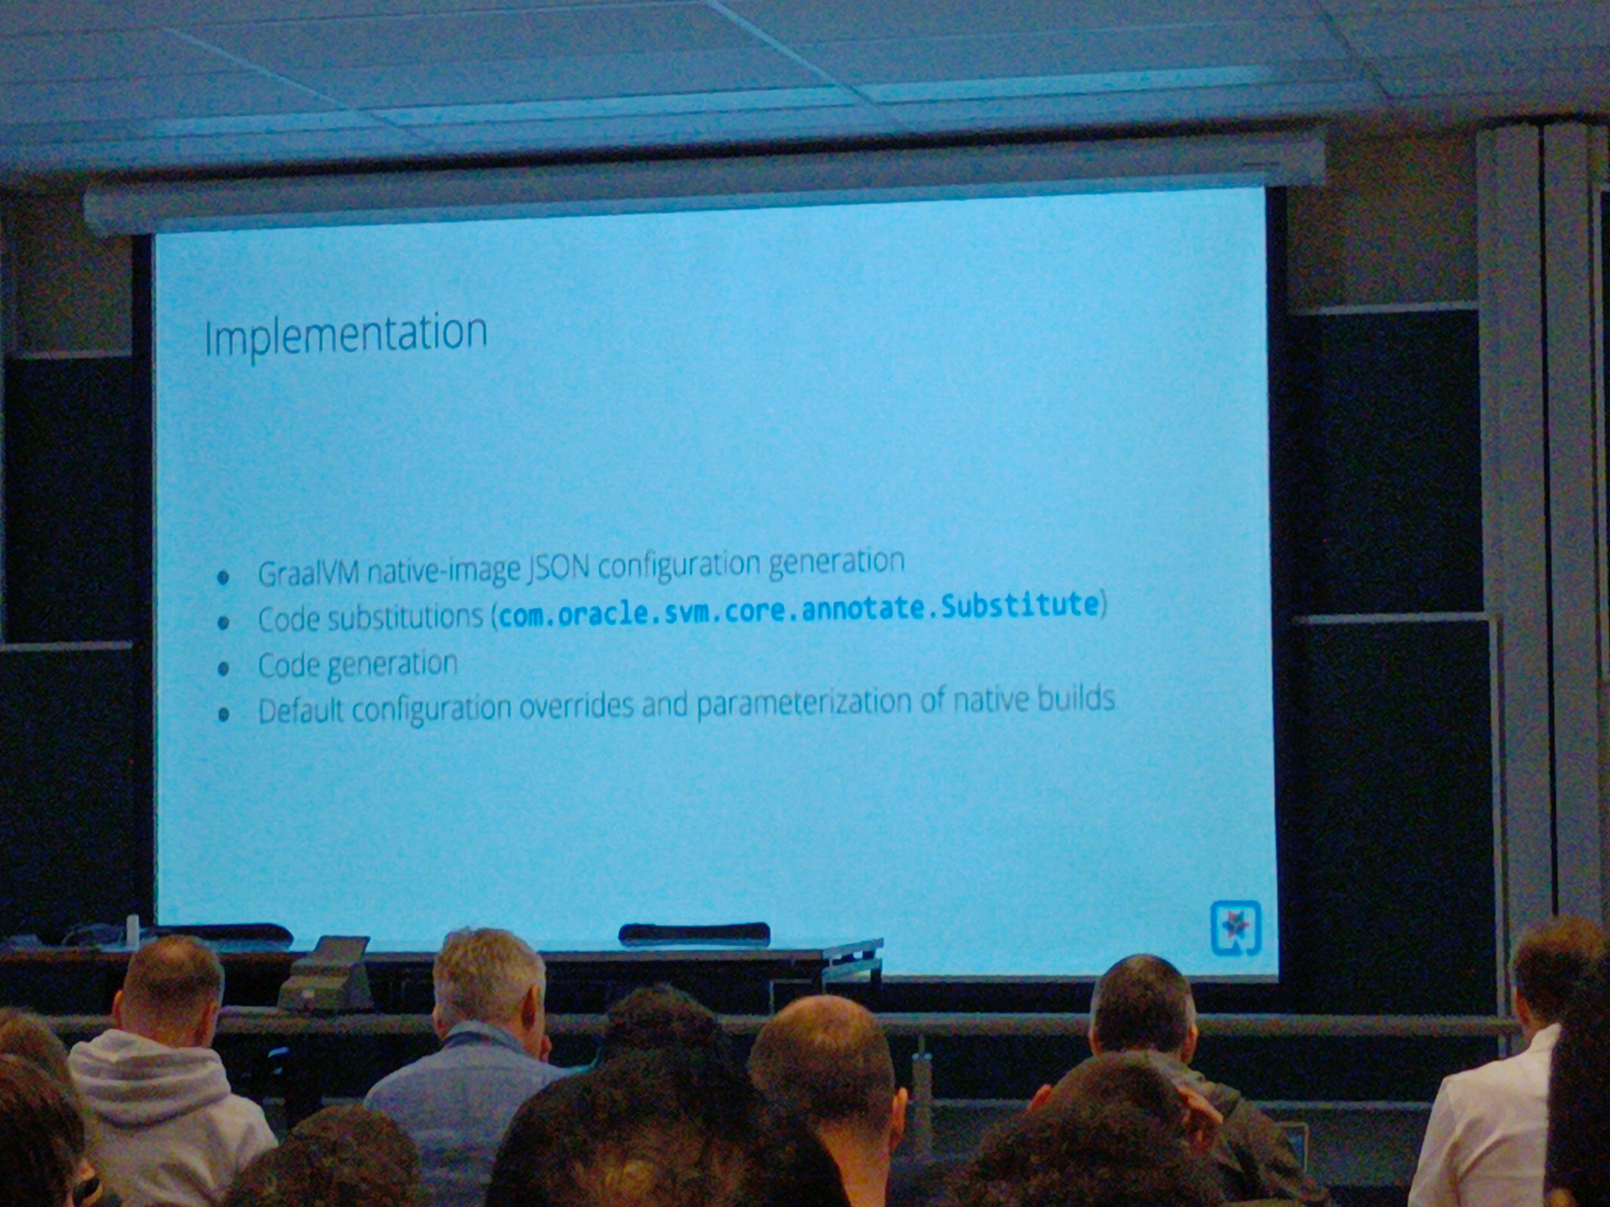

Dead code elimination, how?

By substitution and recompil

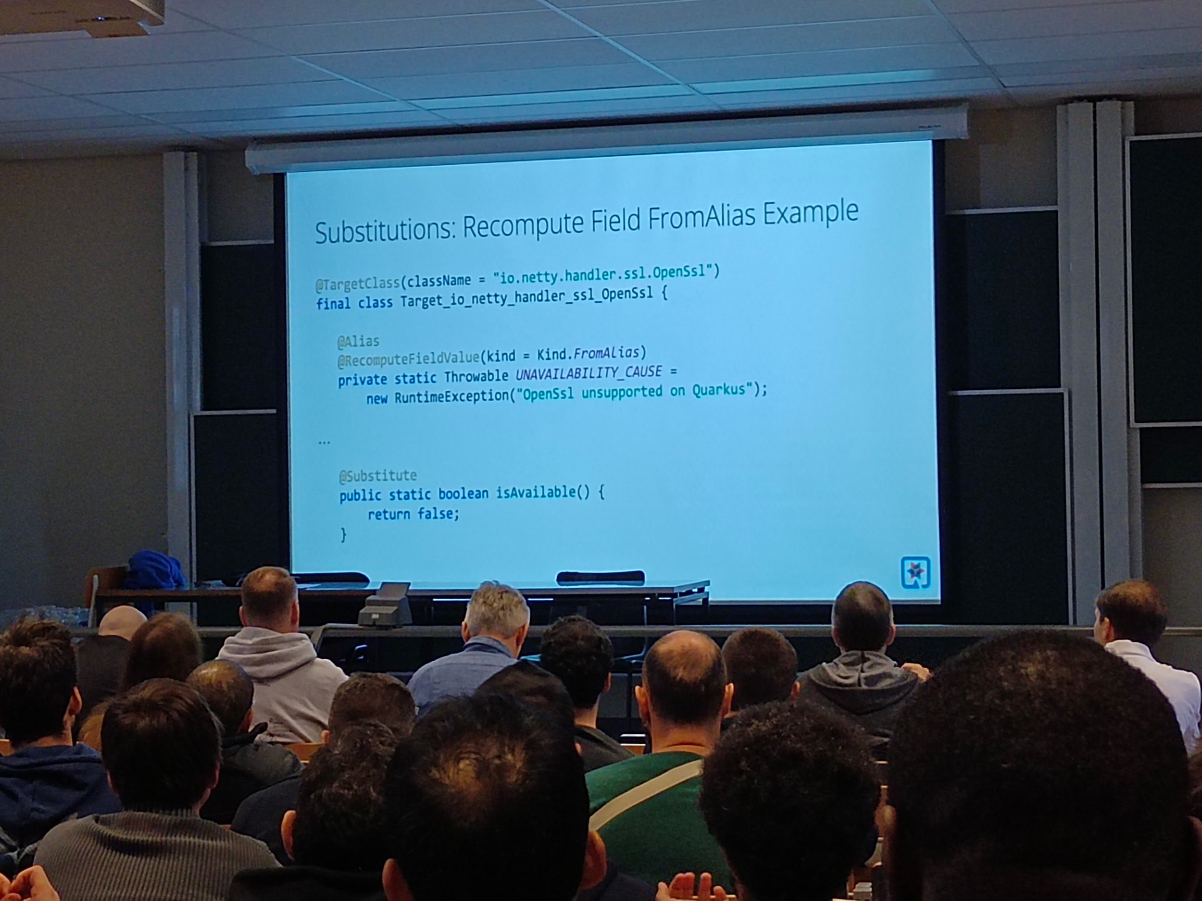

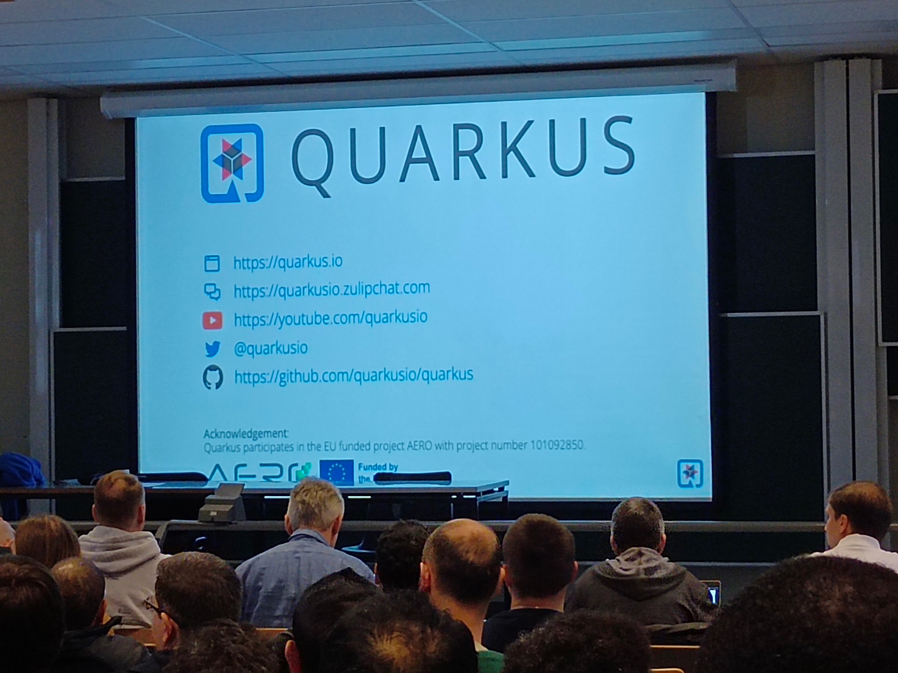

* How know if lib supported? should be listed, exists some tricks to make it happen if not supported by default

## [FOSDEM 2024 - The CarpentriesOffline: Teaching Foundational Data Science and Coding Skills with Little or no Internet Access](https://archive.fosdem.org/2024/schedule/event/fosdem-2024-3205-the-carpentriesoffline-teaching-foundational-data-science-and-coding-skills-with-little-or-no-internet-access/)

Ub4132 carpentriesoffline

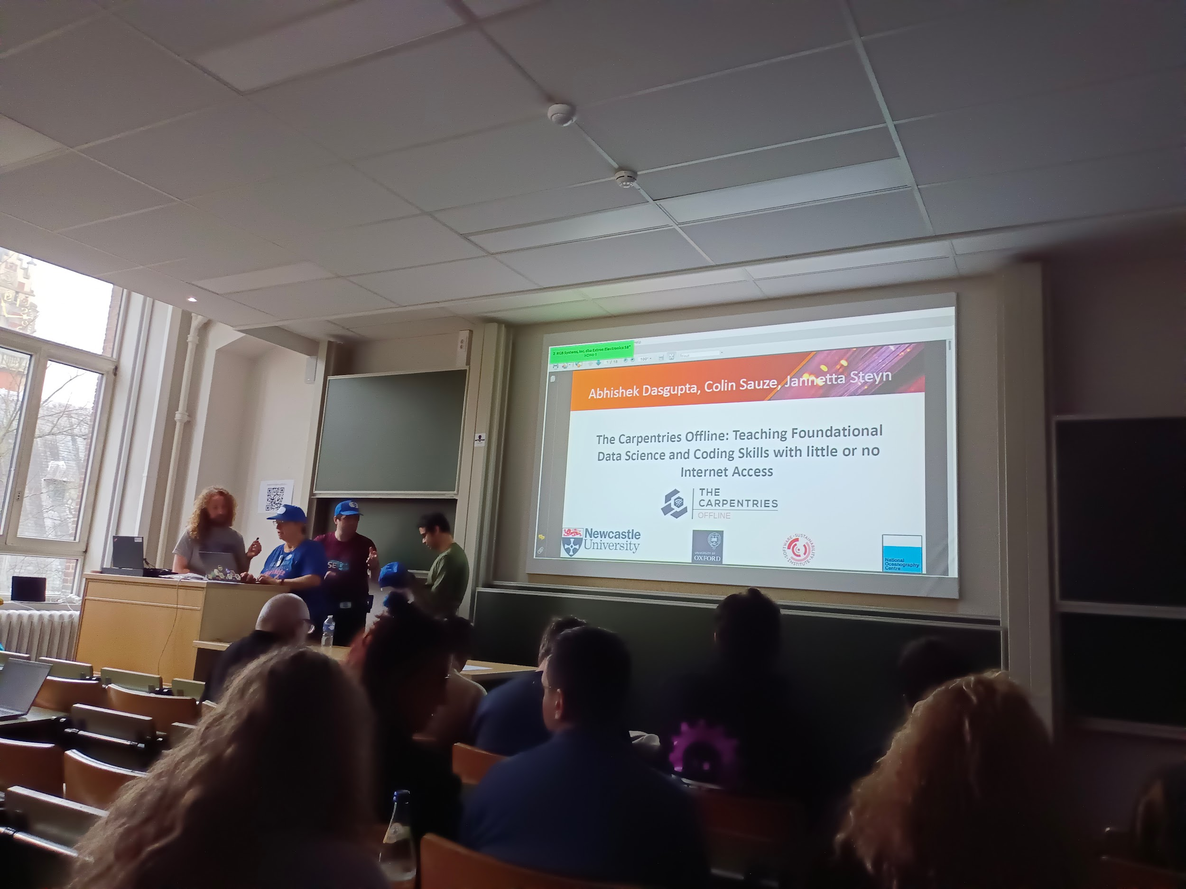

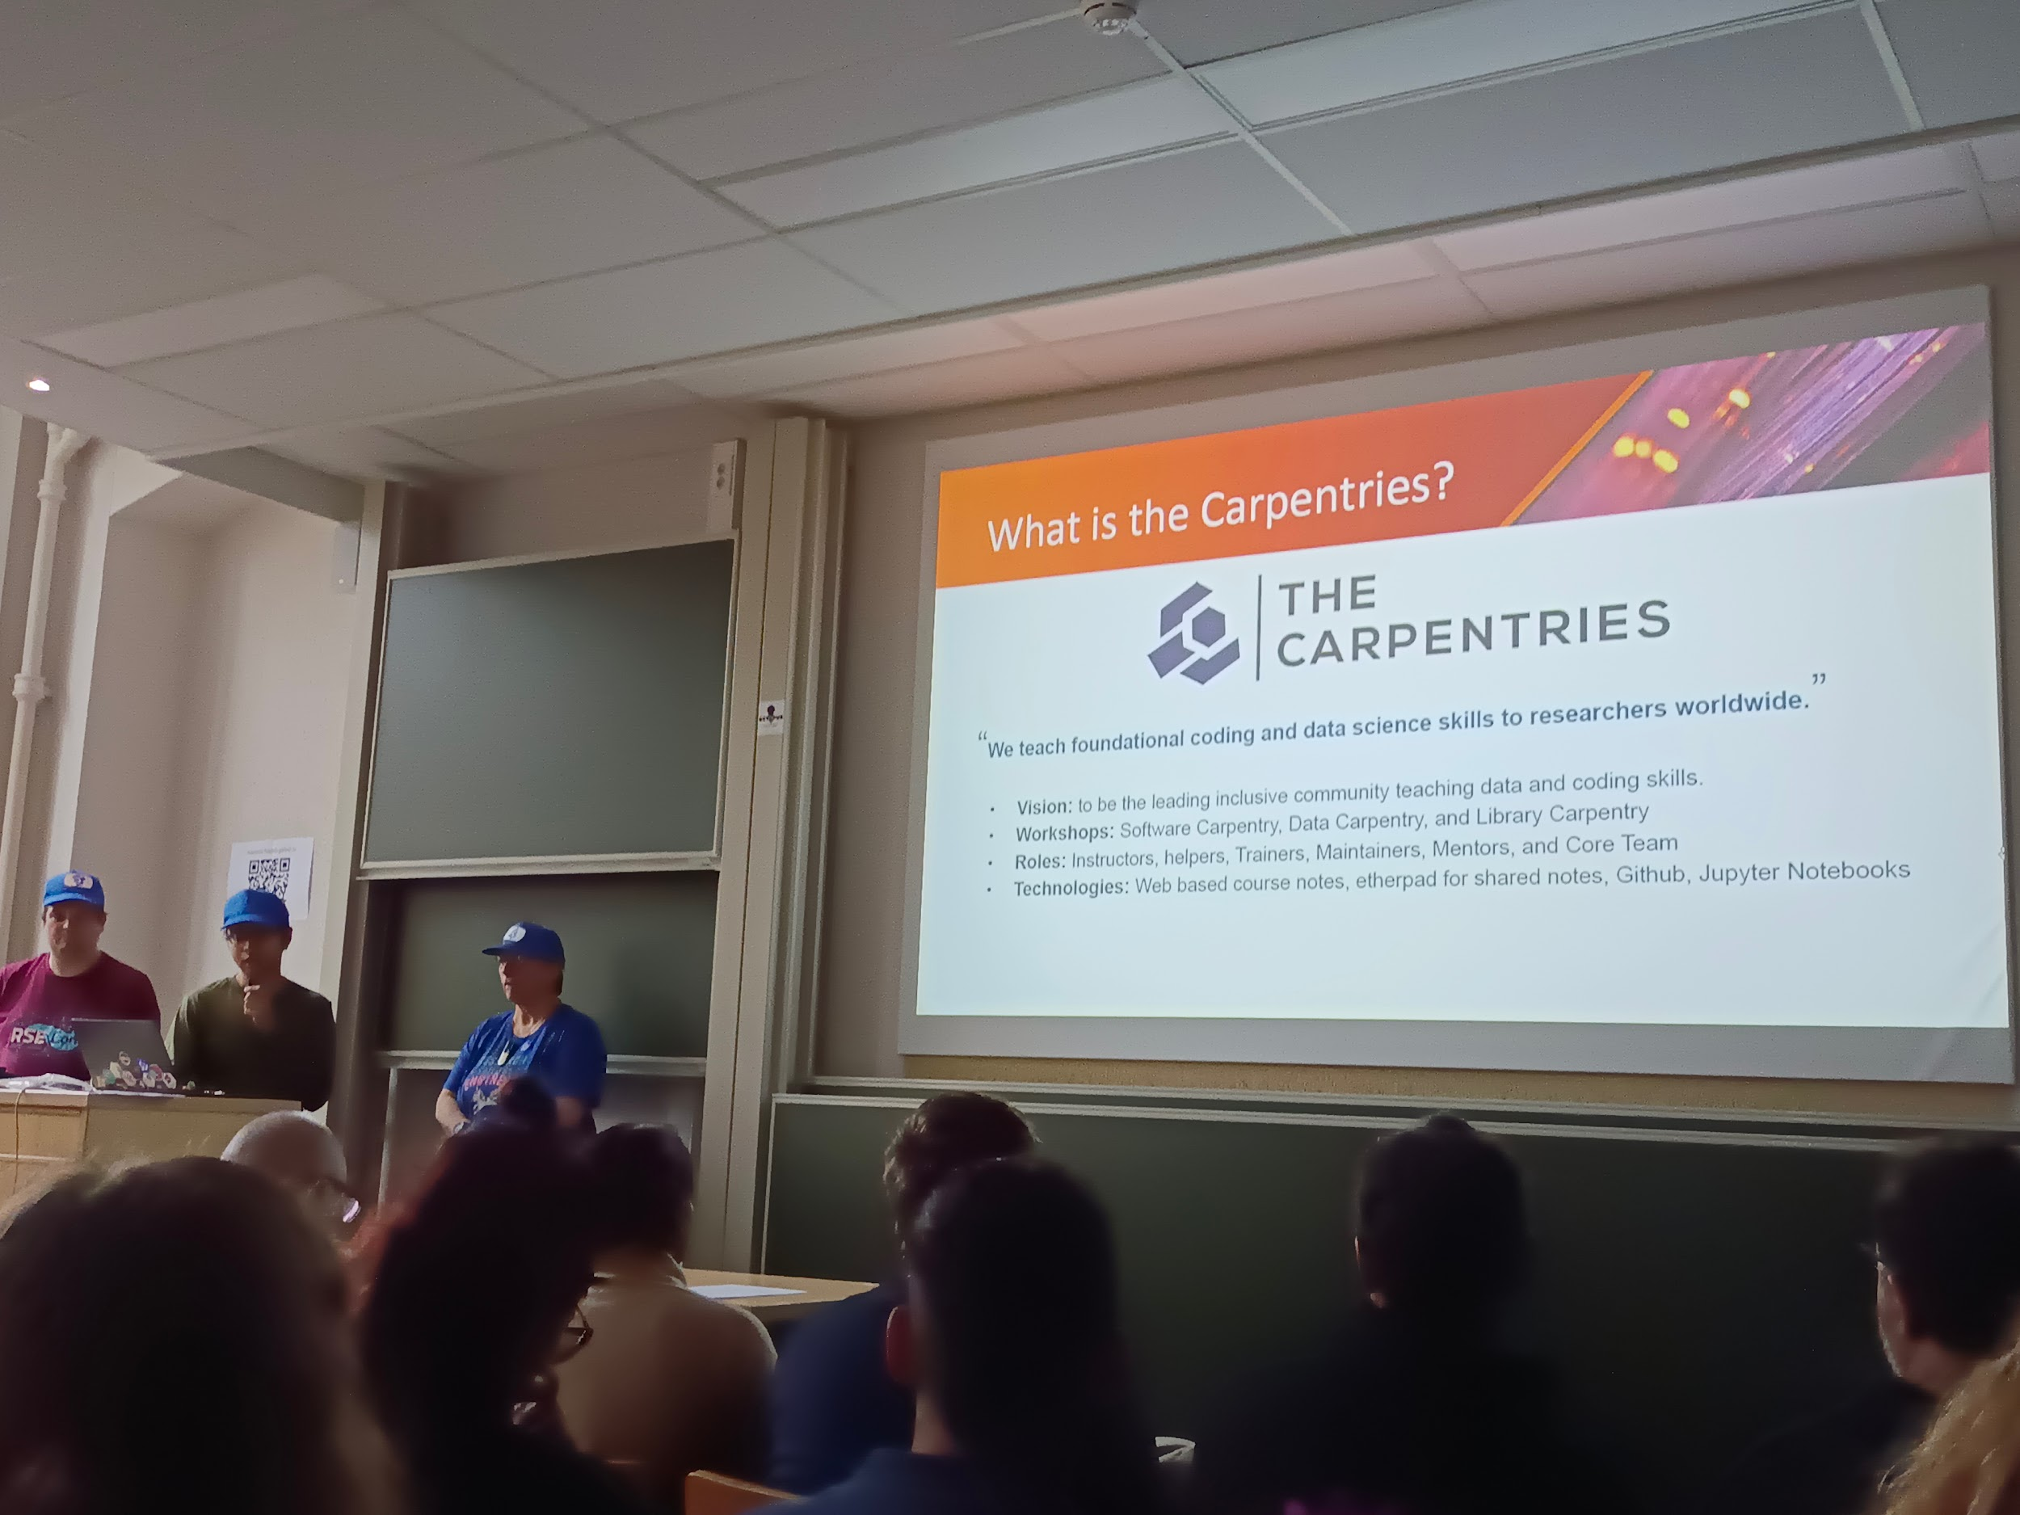

* Etherpad, GitHub, jupyter notebooks
* Raspberry Pi as access point and web server
* > Offlinedatasci (by uni of Florida)
* Python, R, partial mirror pypi, cran,
* RaspOs, Gitea, etherpad, … (voir slides) to reproduce an online like situation

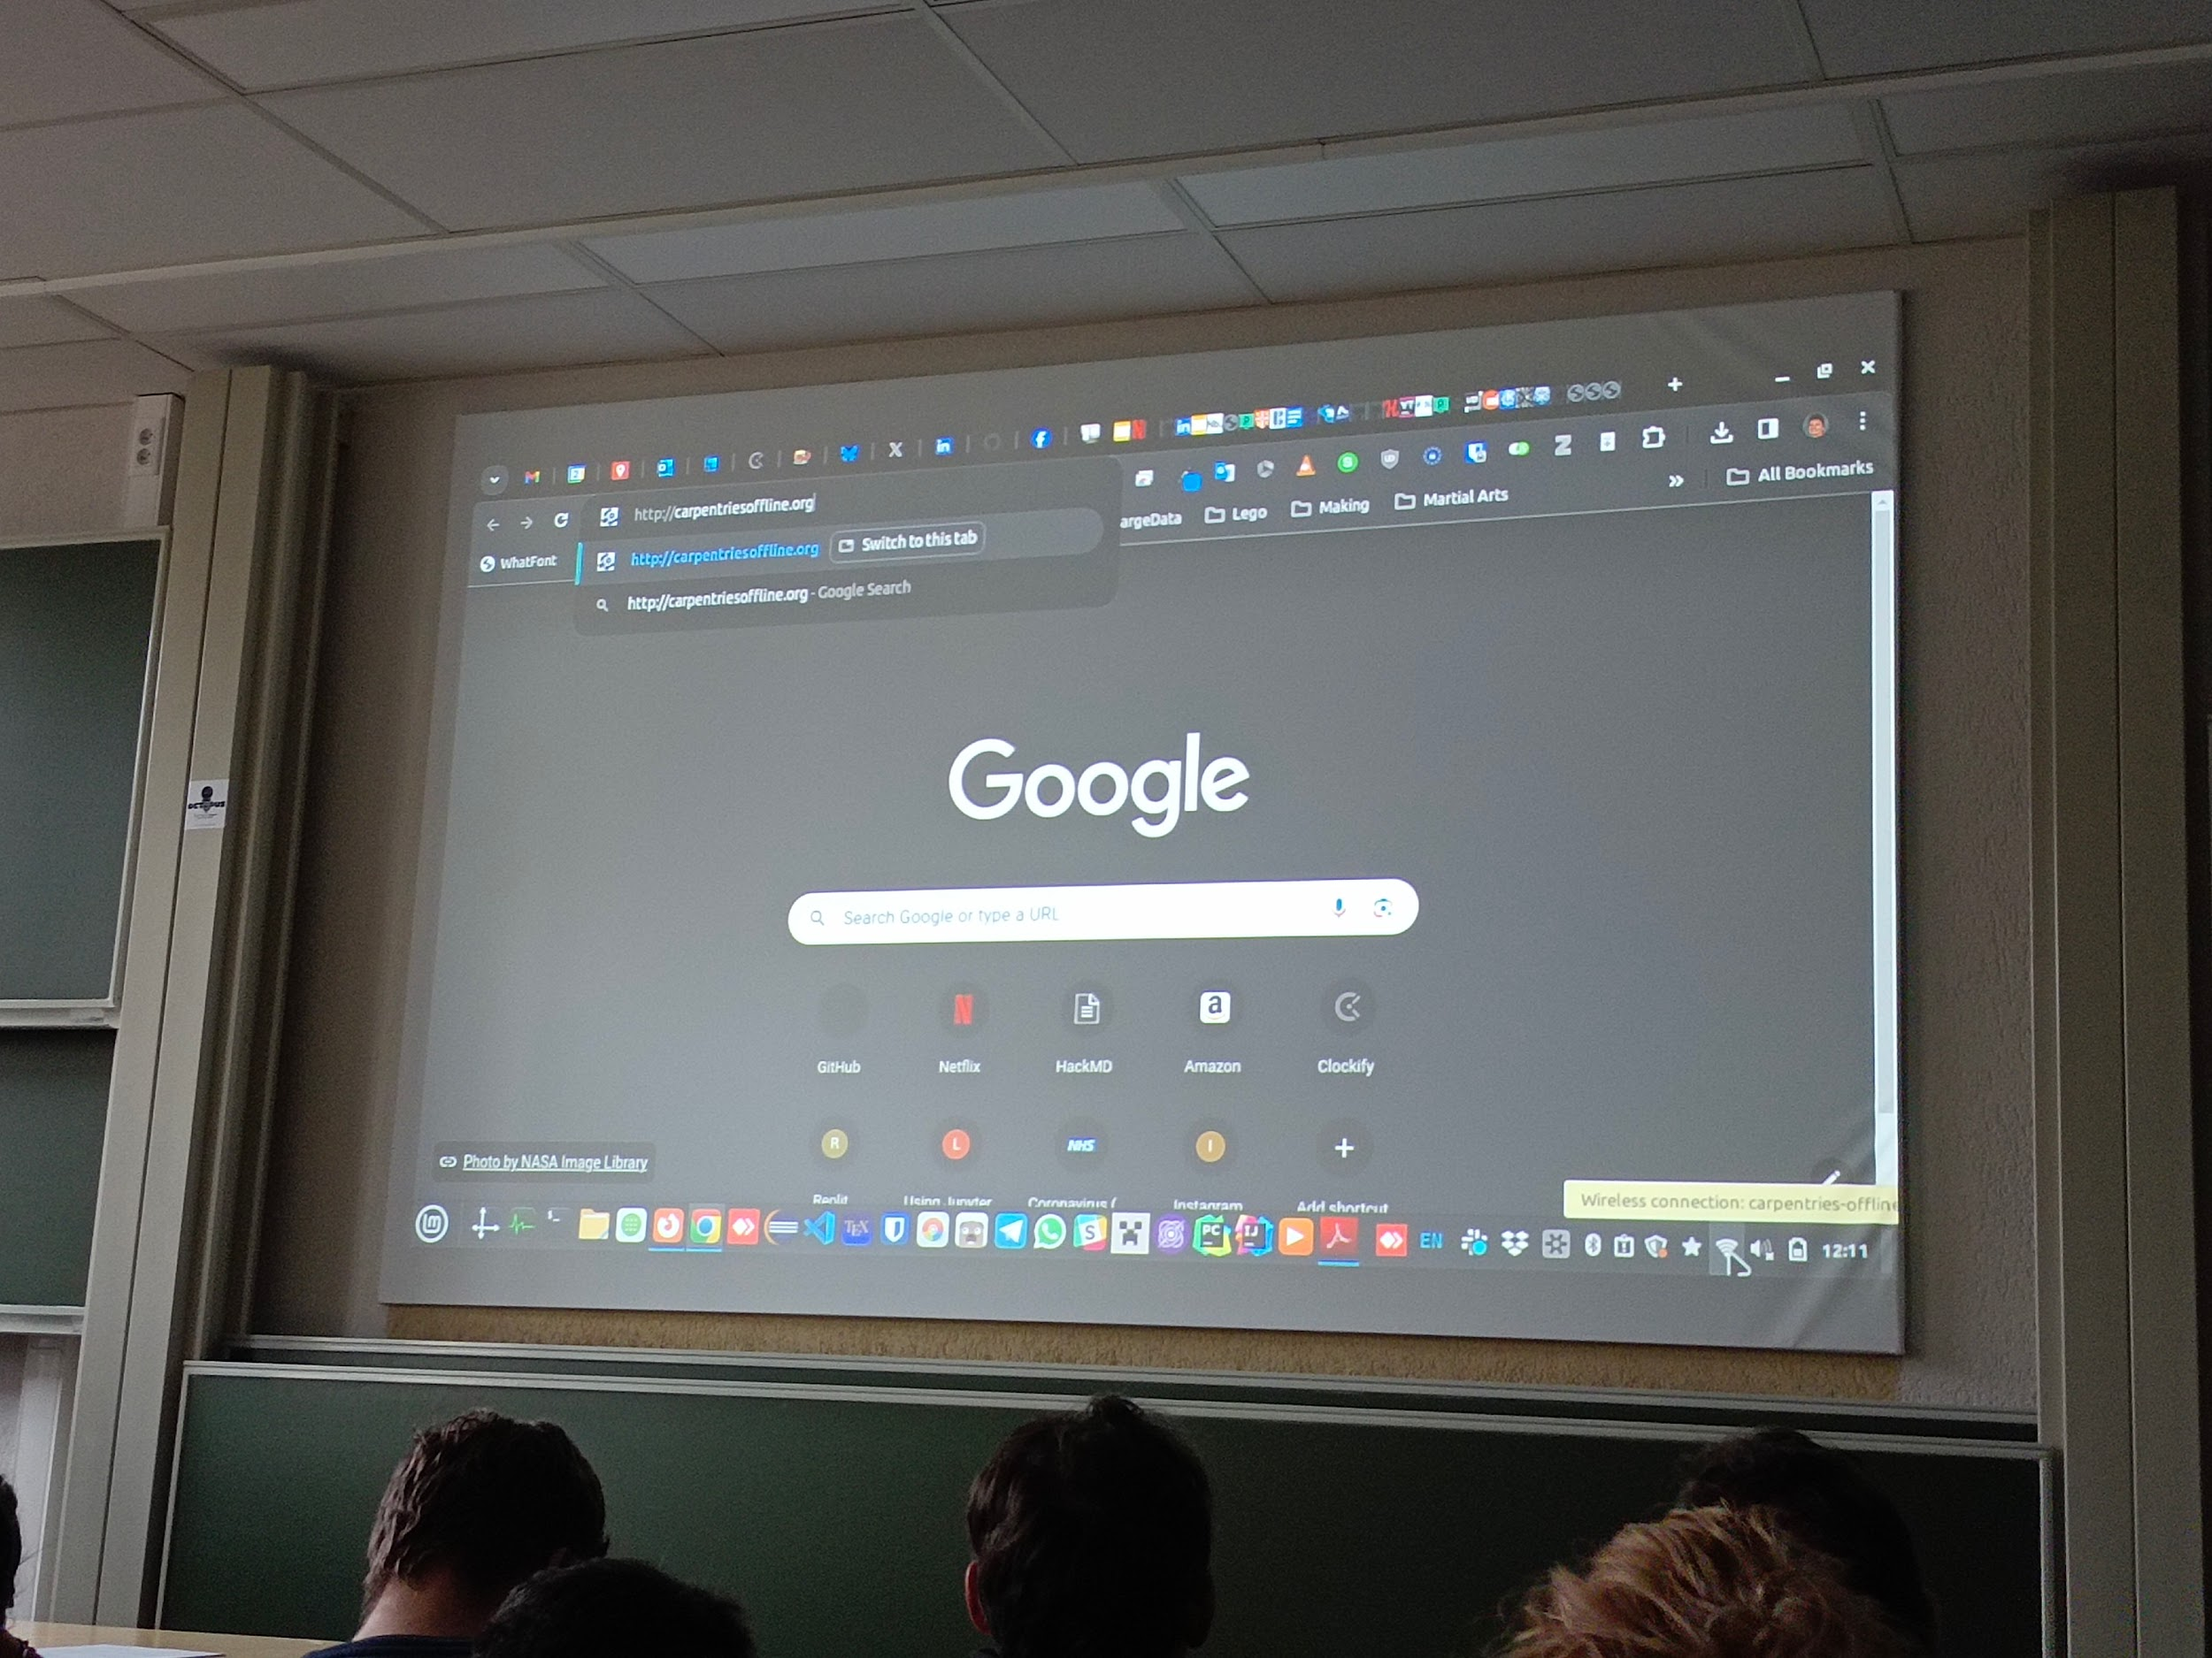

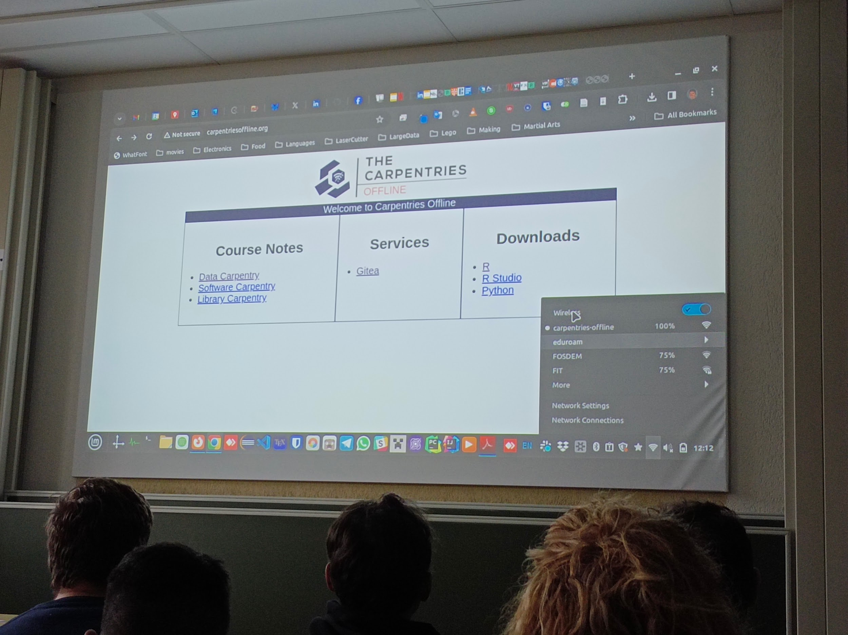

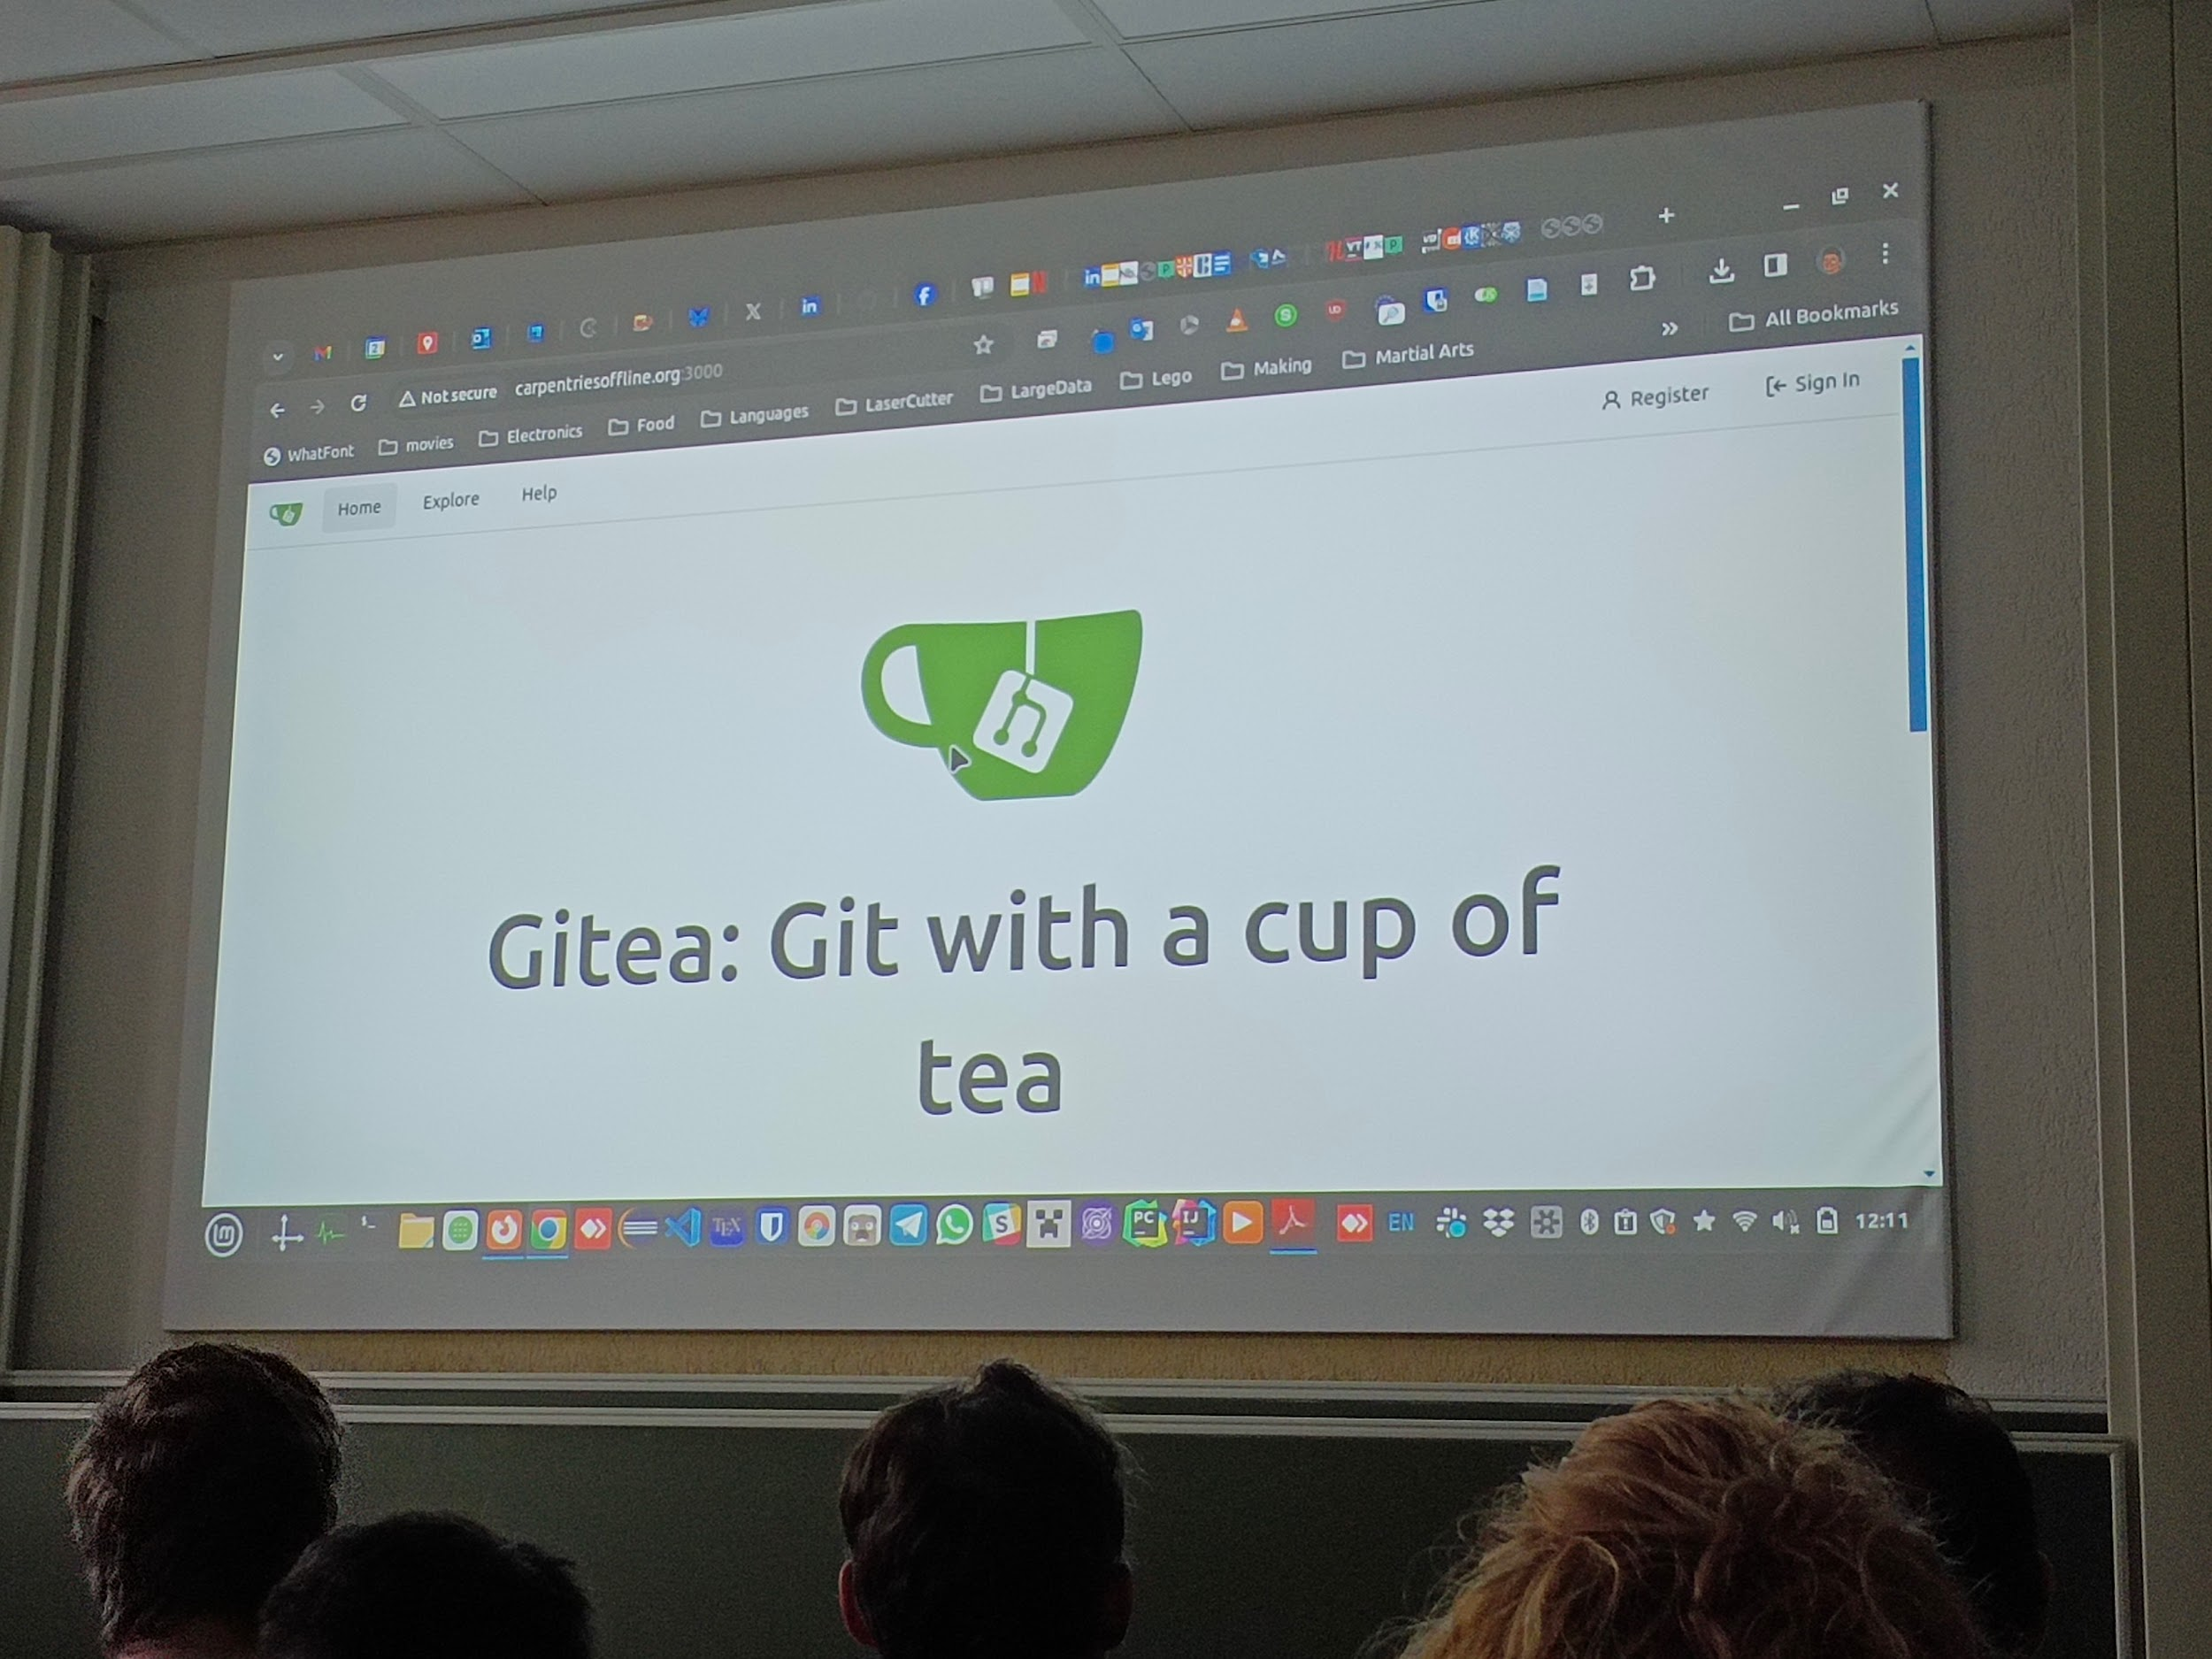

* Building a raspberry pi image
* initially for testing, helpful in case of unexpected as device sudden down
* Bootable flash drive
* MiniHPC

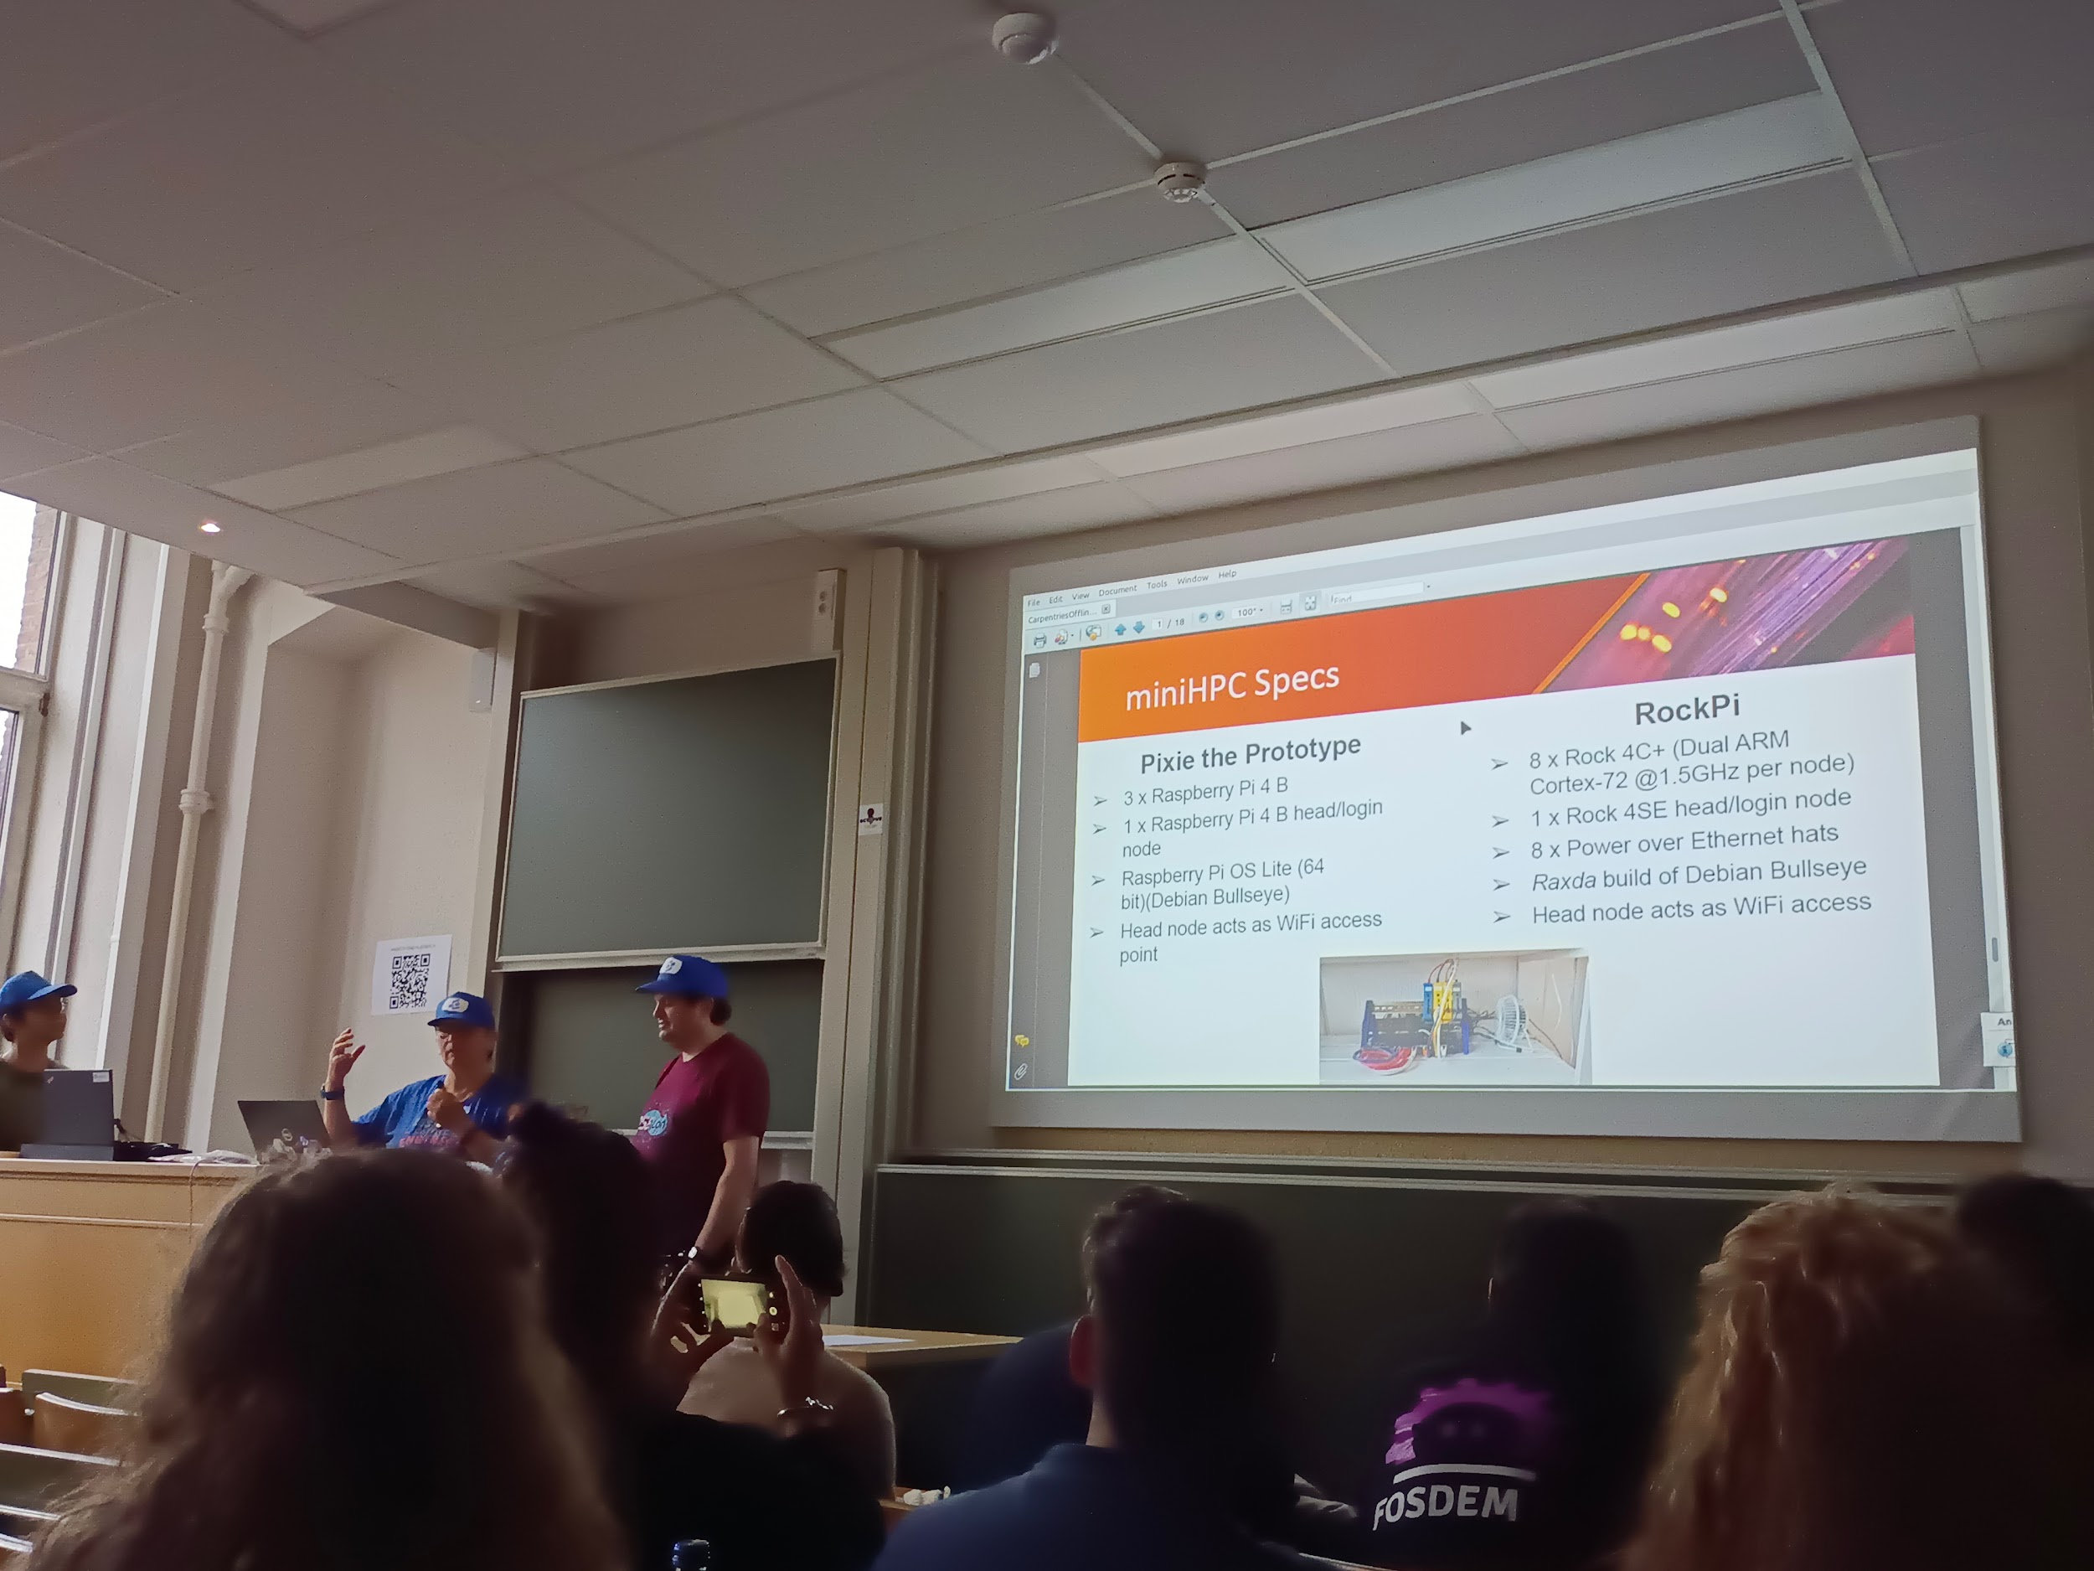

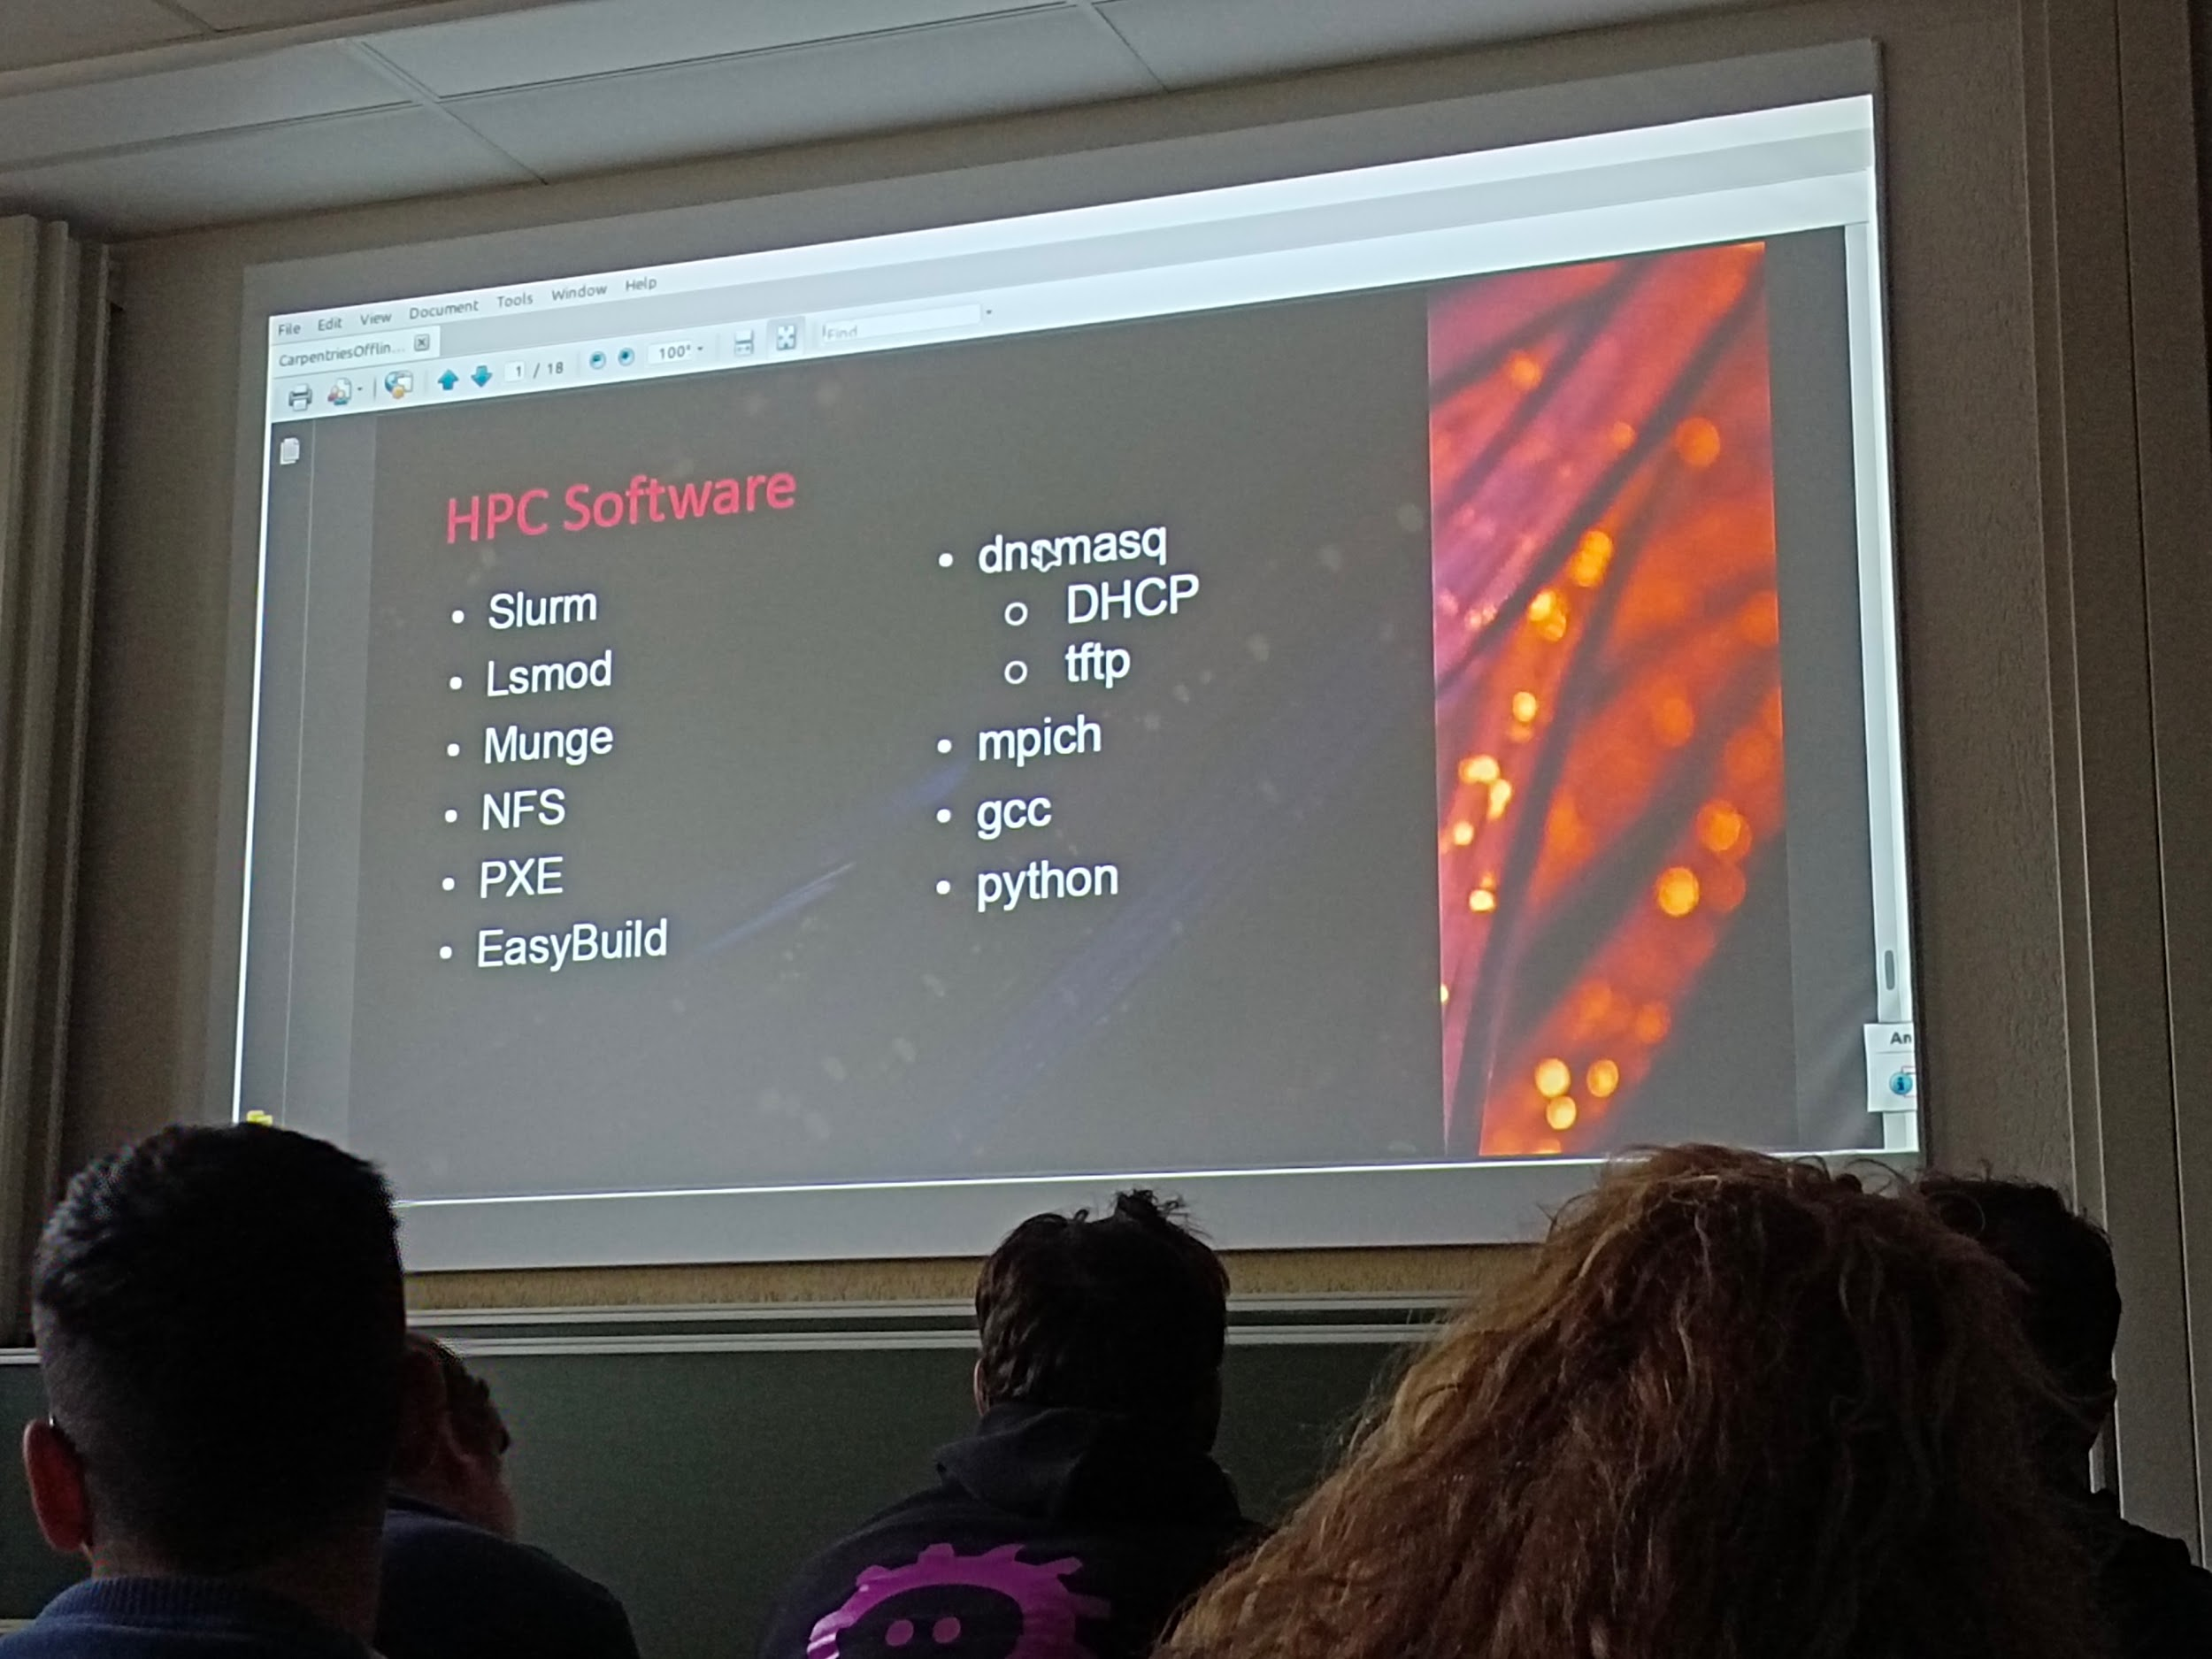

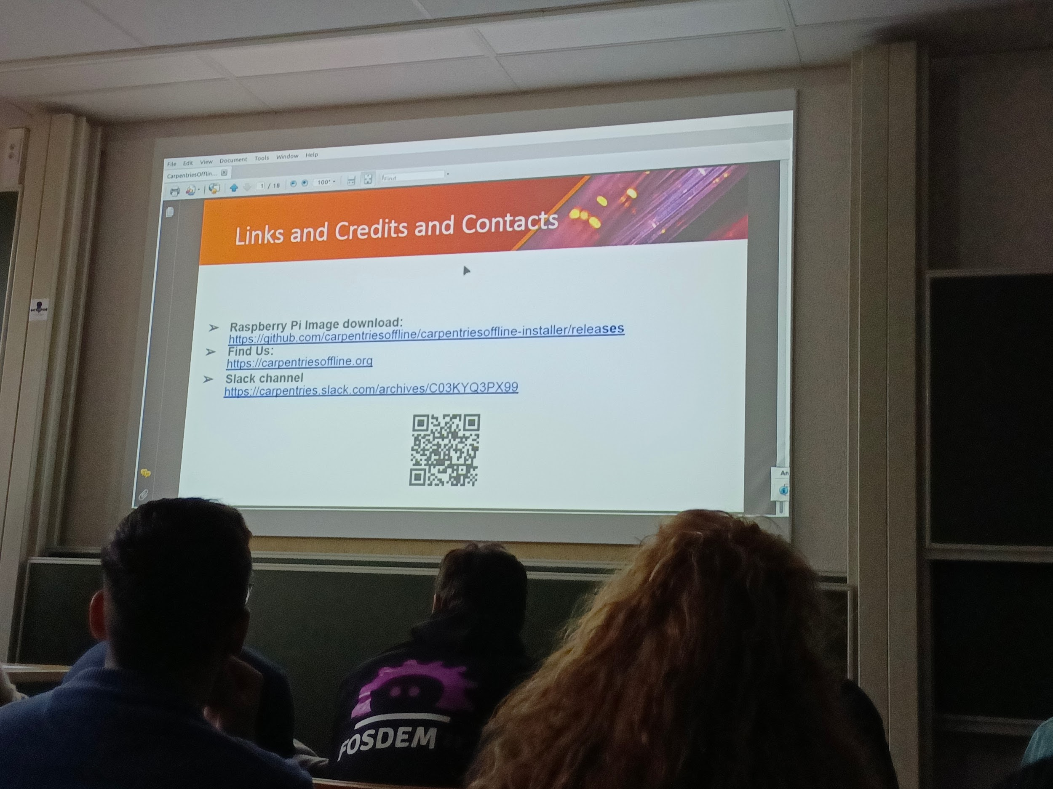

* How can use it outside of the team?
* Still working on it, not really known yet but it will come
* Limit of ppl in the same time during workshop
* 8 ppl connected has been tested, up to 10?30?

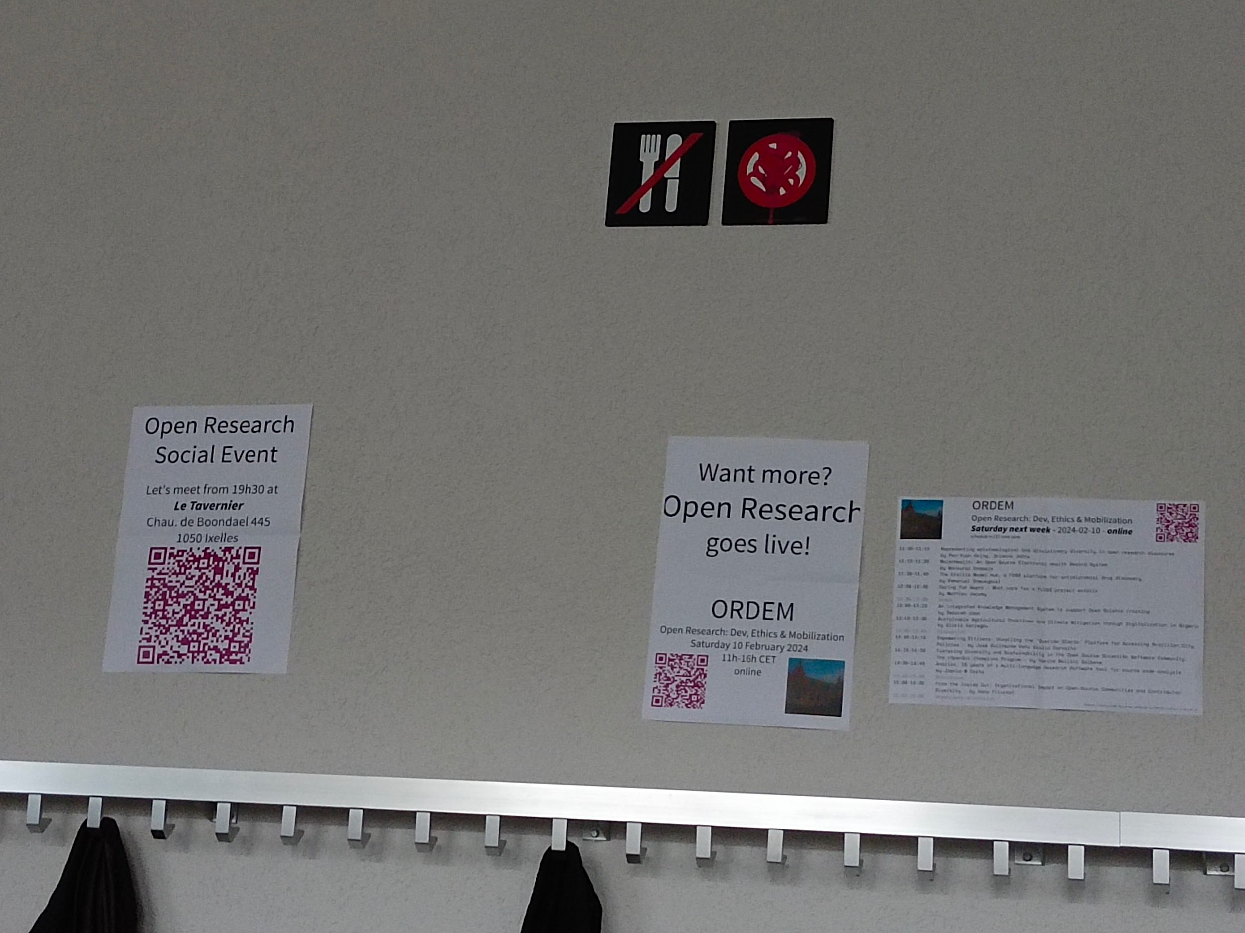

* (Offline and online meeting)

---

## [FOSDEM 2024 - The French Open Science Monitor: steering the science based on open bibliographic databases](https://archive.fosdem.org/2024/schedule/event/fosdem-2024-3185-the-french-open-science-monitor-steering-the-science-based-on-open-bibliographic-databases/)

Ub4132 french open science monitor

* <https://frenchopensciencemonitor.esr.gouv.fr/> (EN) / <https://barometredelascienceouverte.esr.gouv.fr/> (FR)

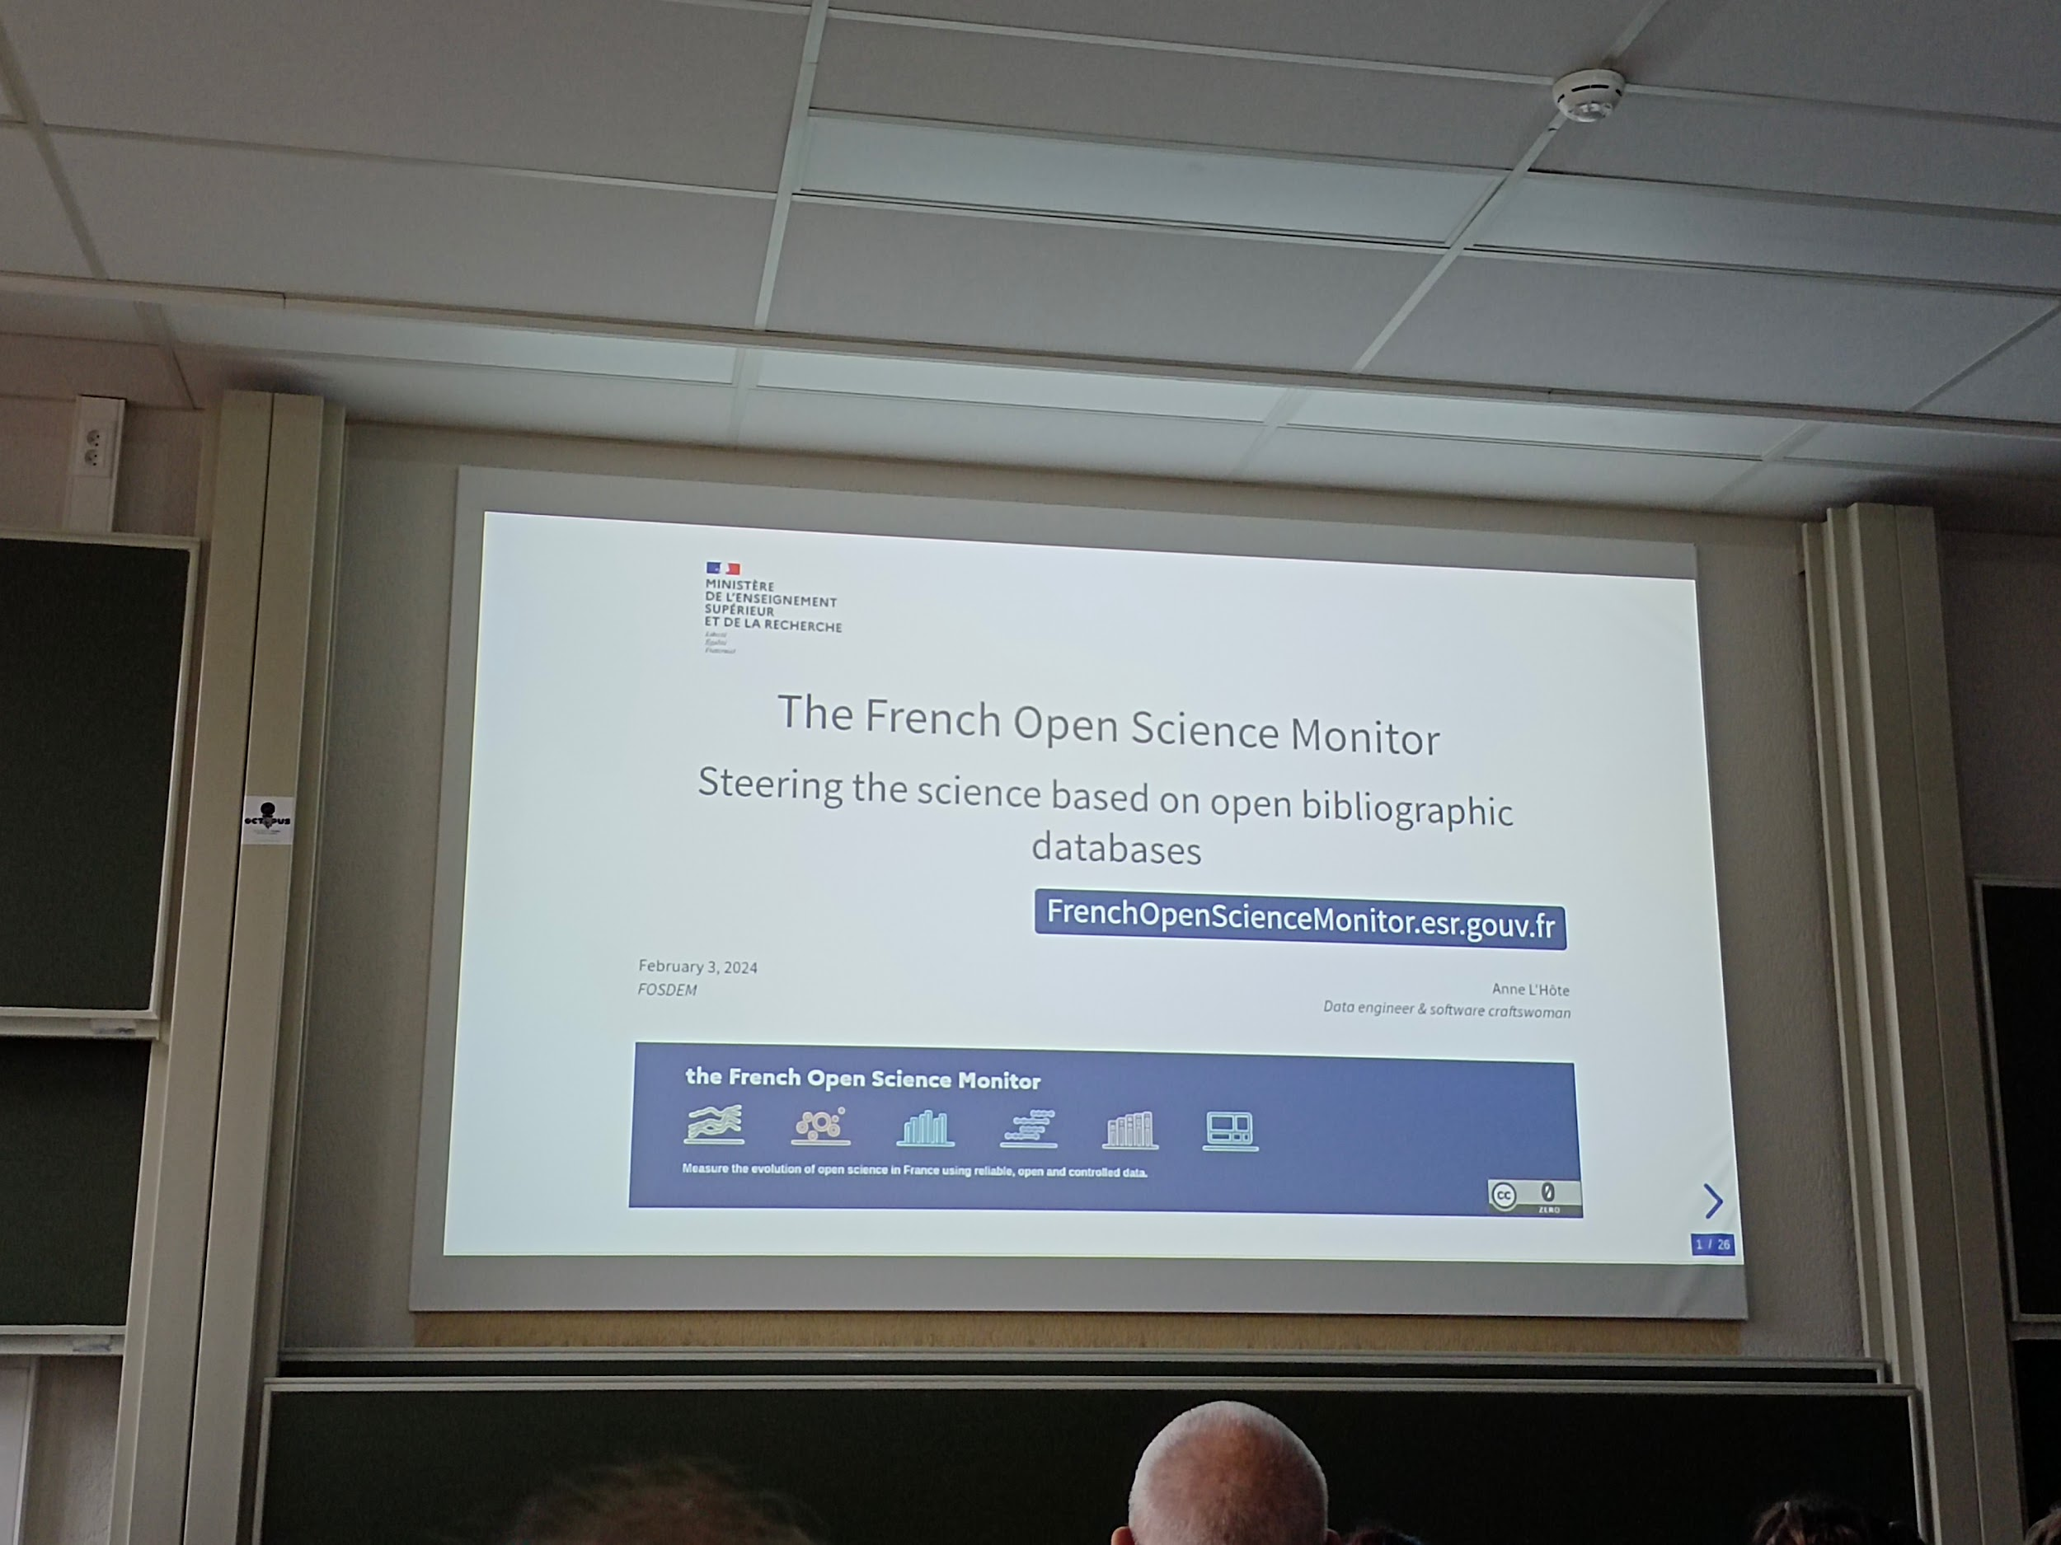

* National plan to open science since 2018
* Survey tool to measure
* Goal: more complete and accurate (currently disparate not as accurate complete as proprietary ones)

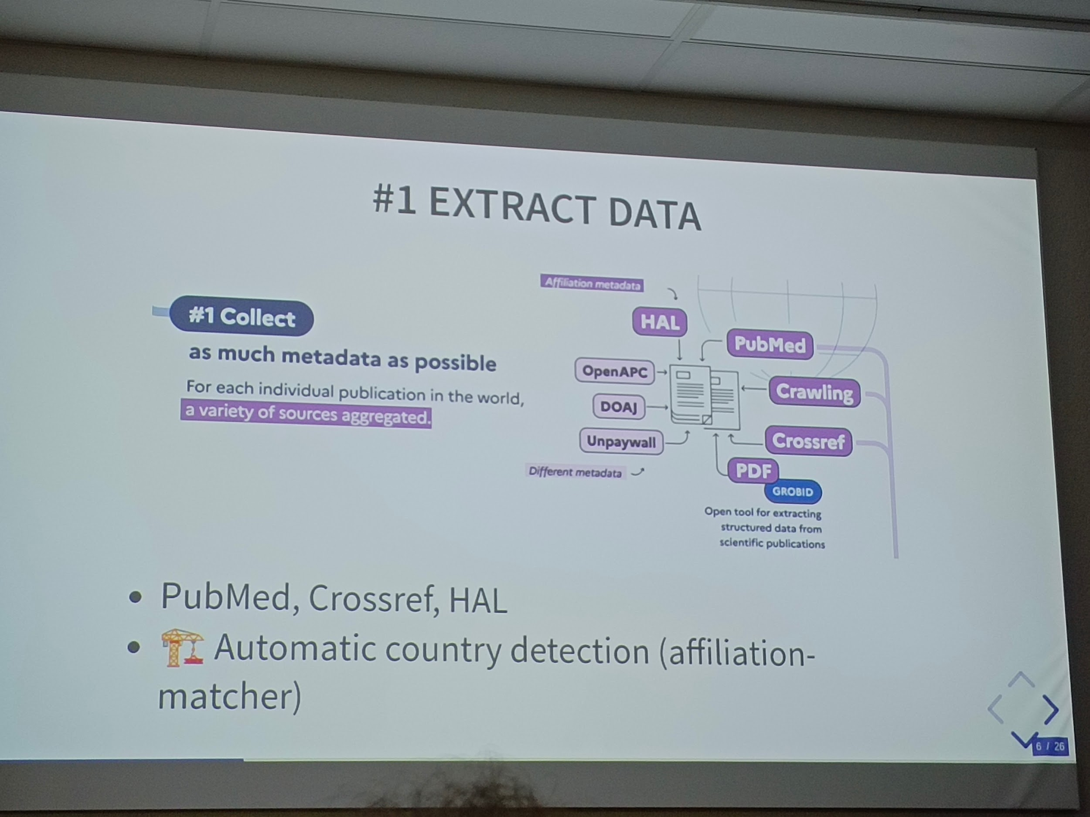

* Affiliation challenge
* Opening status
* Disciplinary classification
* Sharing:

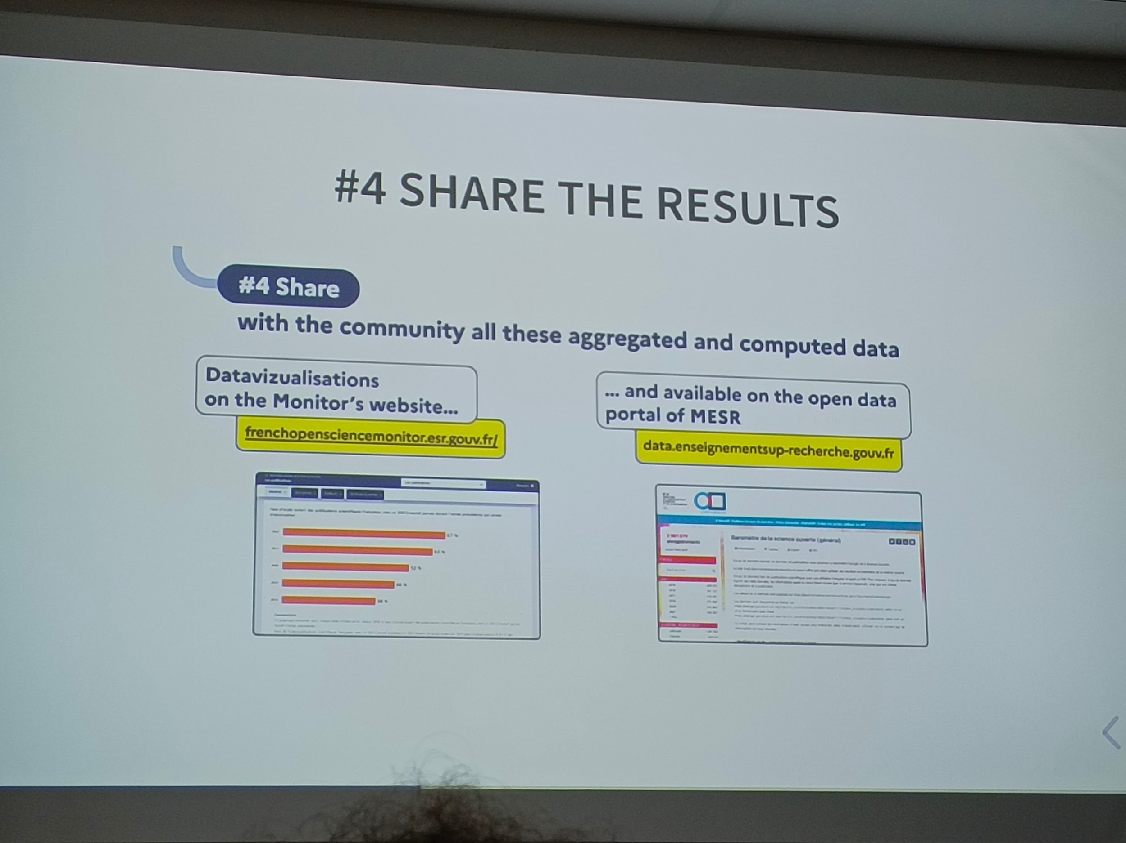

* <http://data.enseignementsup-recherche.gouv.fr/>

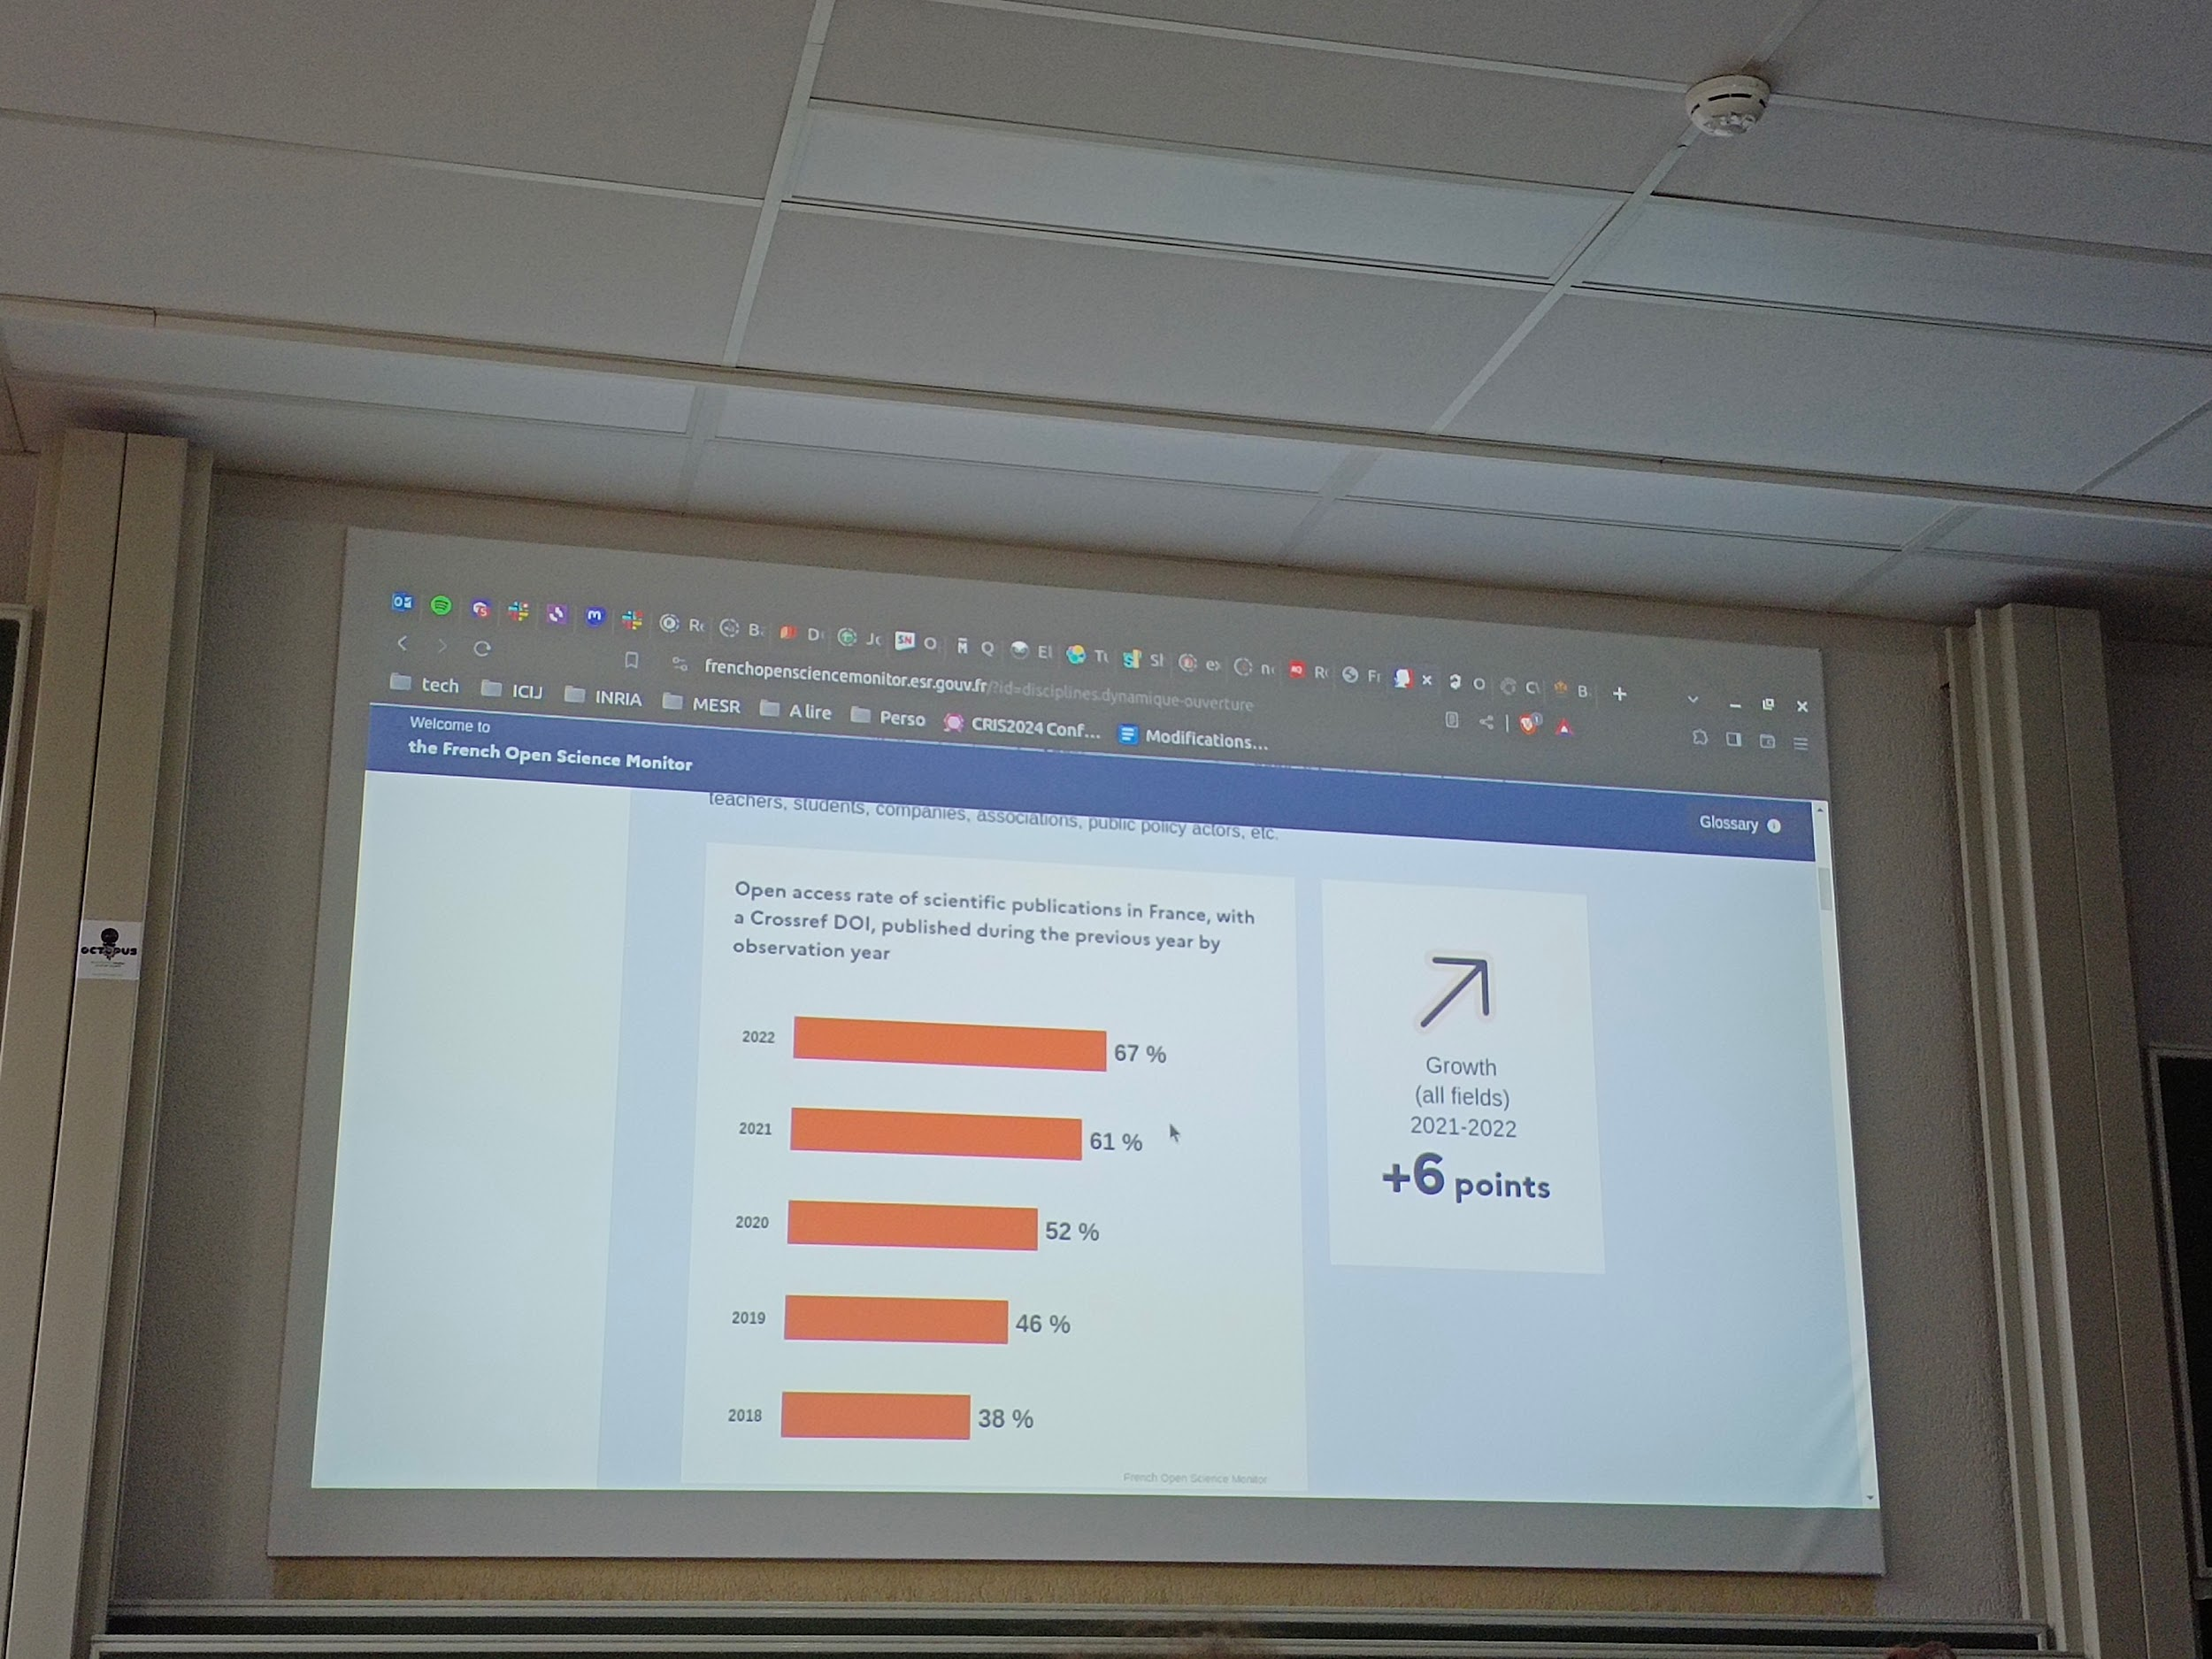

* Collect data
* Download like pdf
* Consolidate (with grobid)
* Tools developed: dataset & softcite
* Indicators

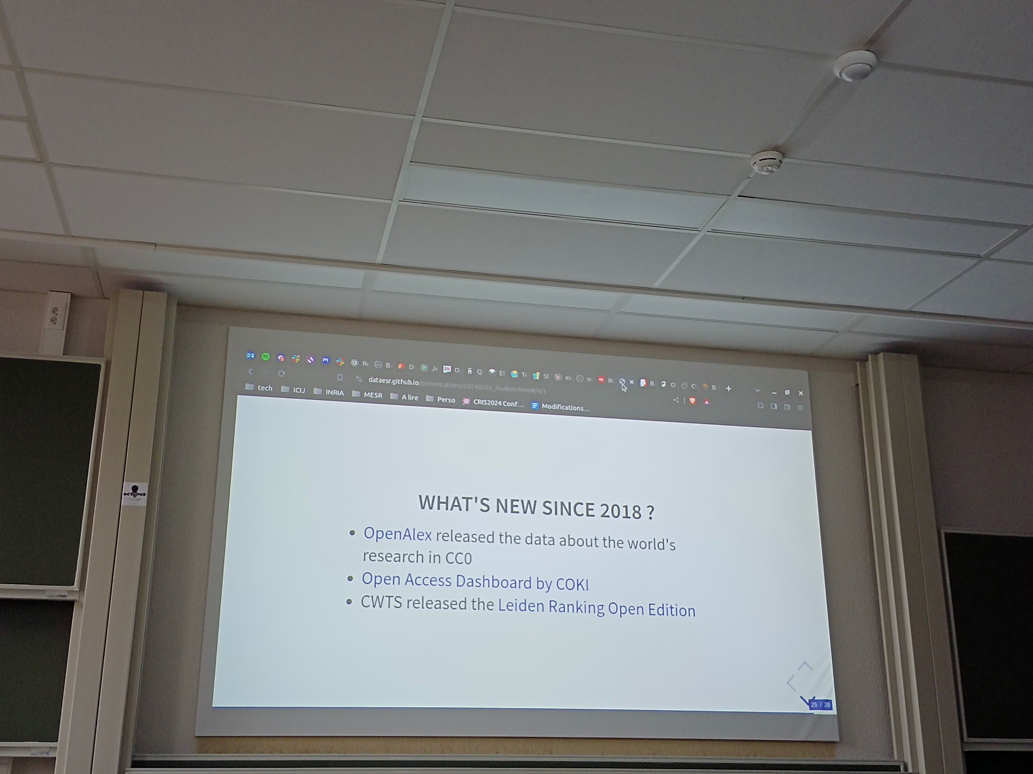

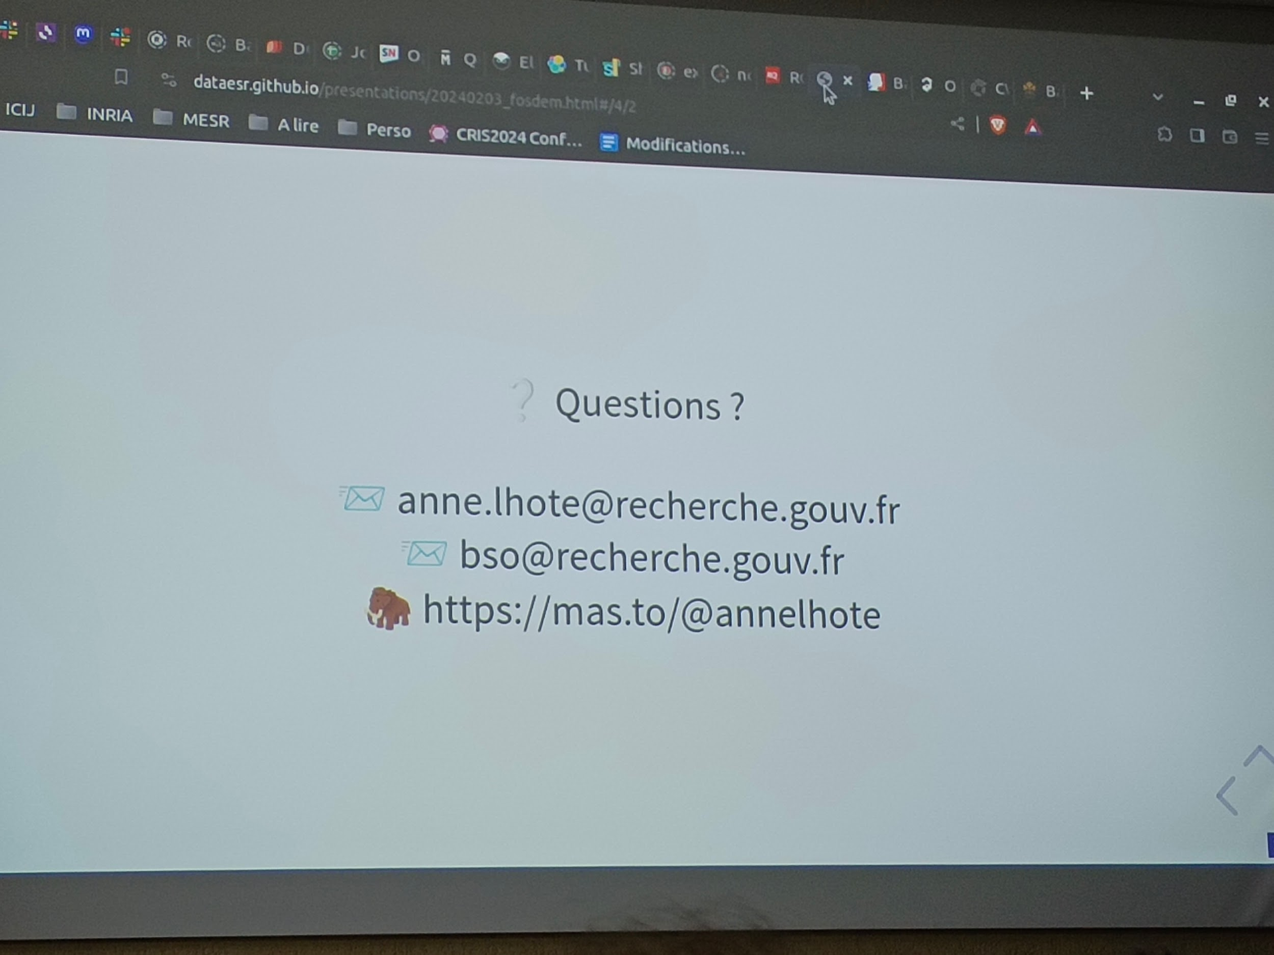

* The delay in publication? Once a year from the previous year, so within 2 years since publication

----

## [FOSDEM 2024 - Infra Finder: Increasing visibility of open technologies for open science](https://archive.fosdem.org/2024/schedule/event/fosdem-2024-3436-infra-finder-increasing-visibility-of-open-technologies-for-open-science/)

Ub4132 infra finder

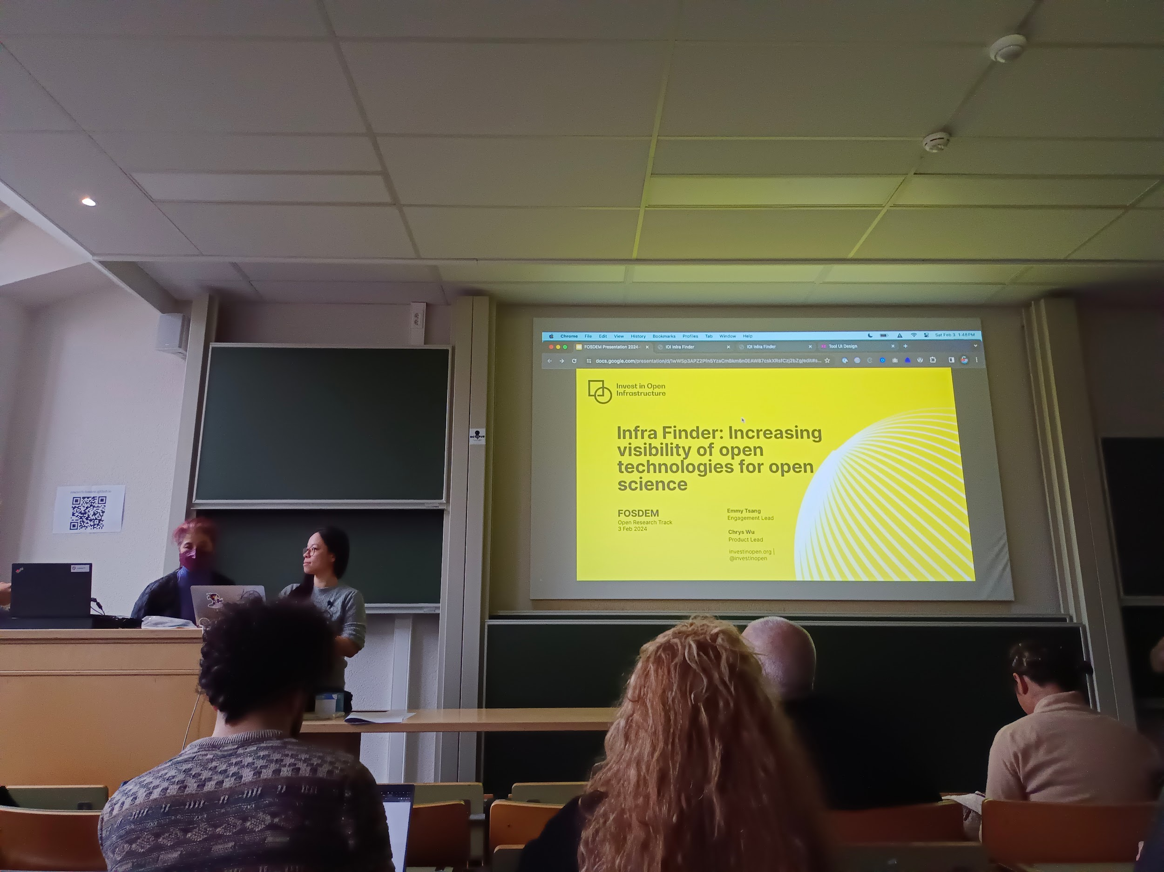

* Goal of the commentators: Increase investment into open
* One of the aspect it's data room,
* The target? Institutional decision makers > to make Impact
* The consideration? Cost, risk, dependence/interoperability, aim of openness/equitable access
* Infra finder
* Navigate infra services and standarts
* Under prototype currently

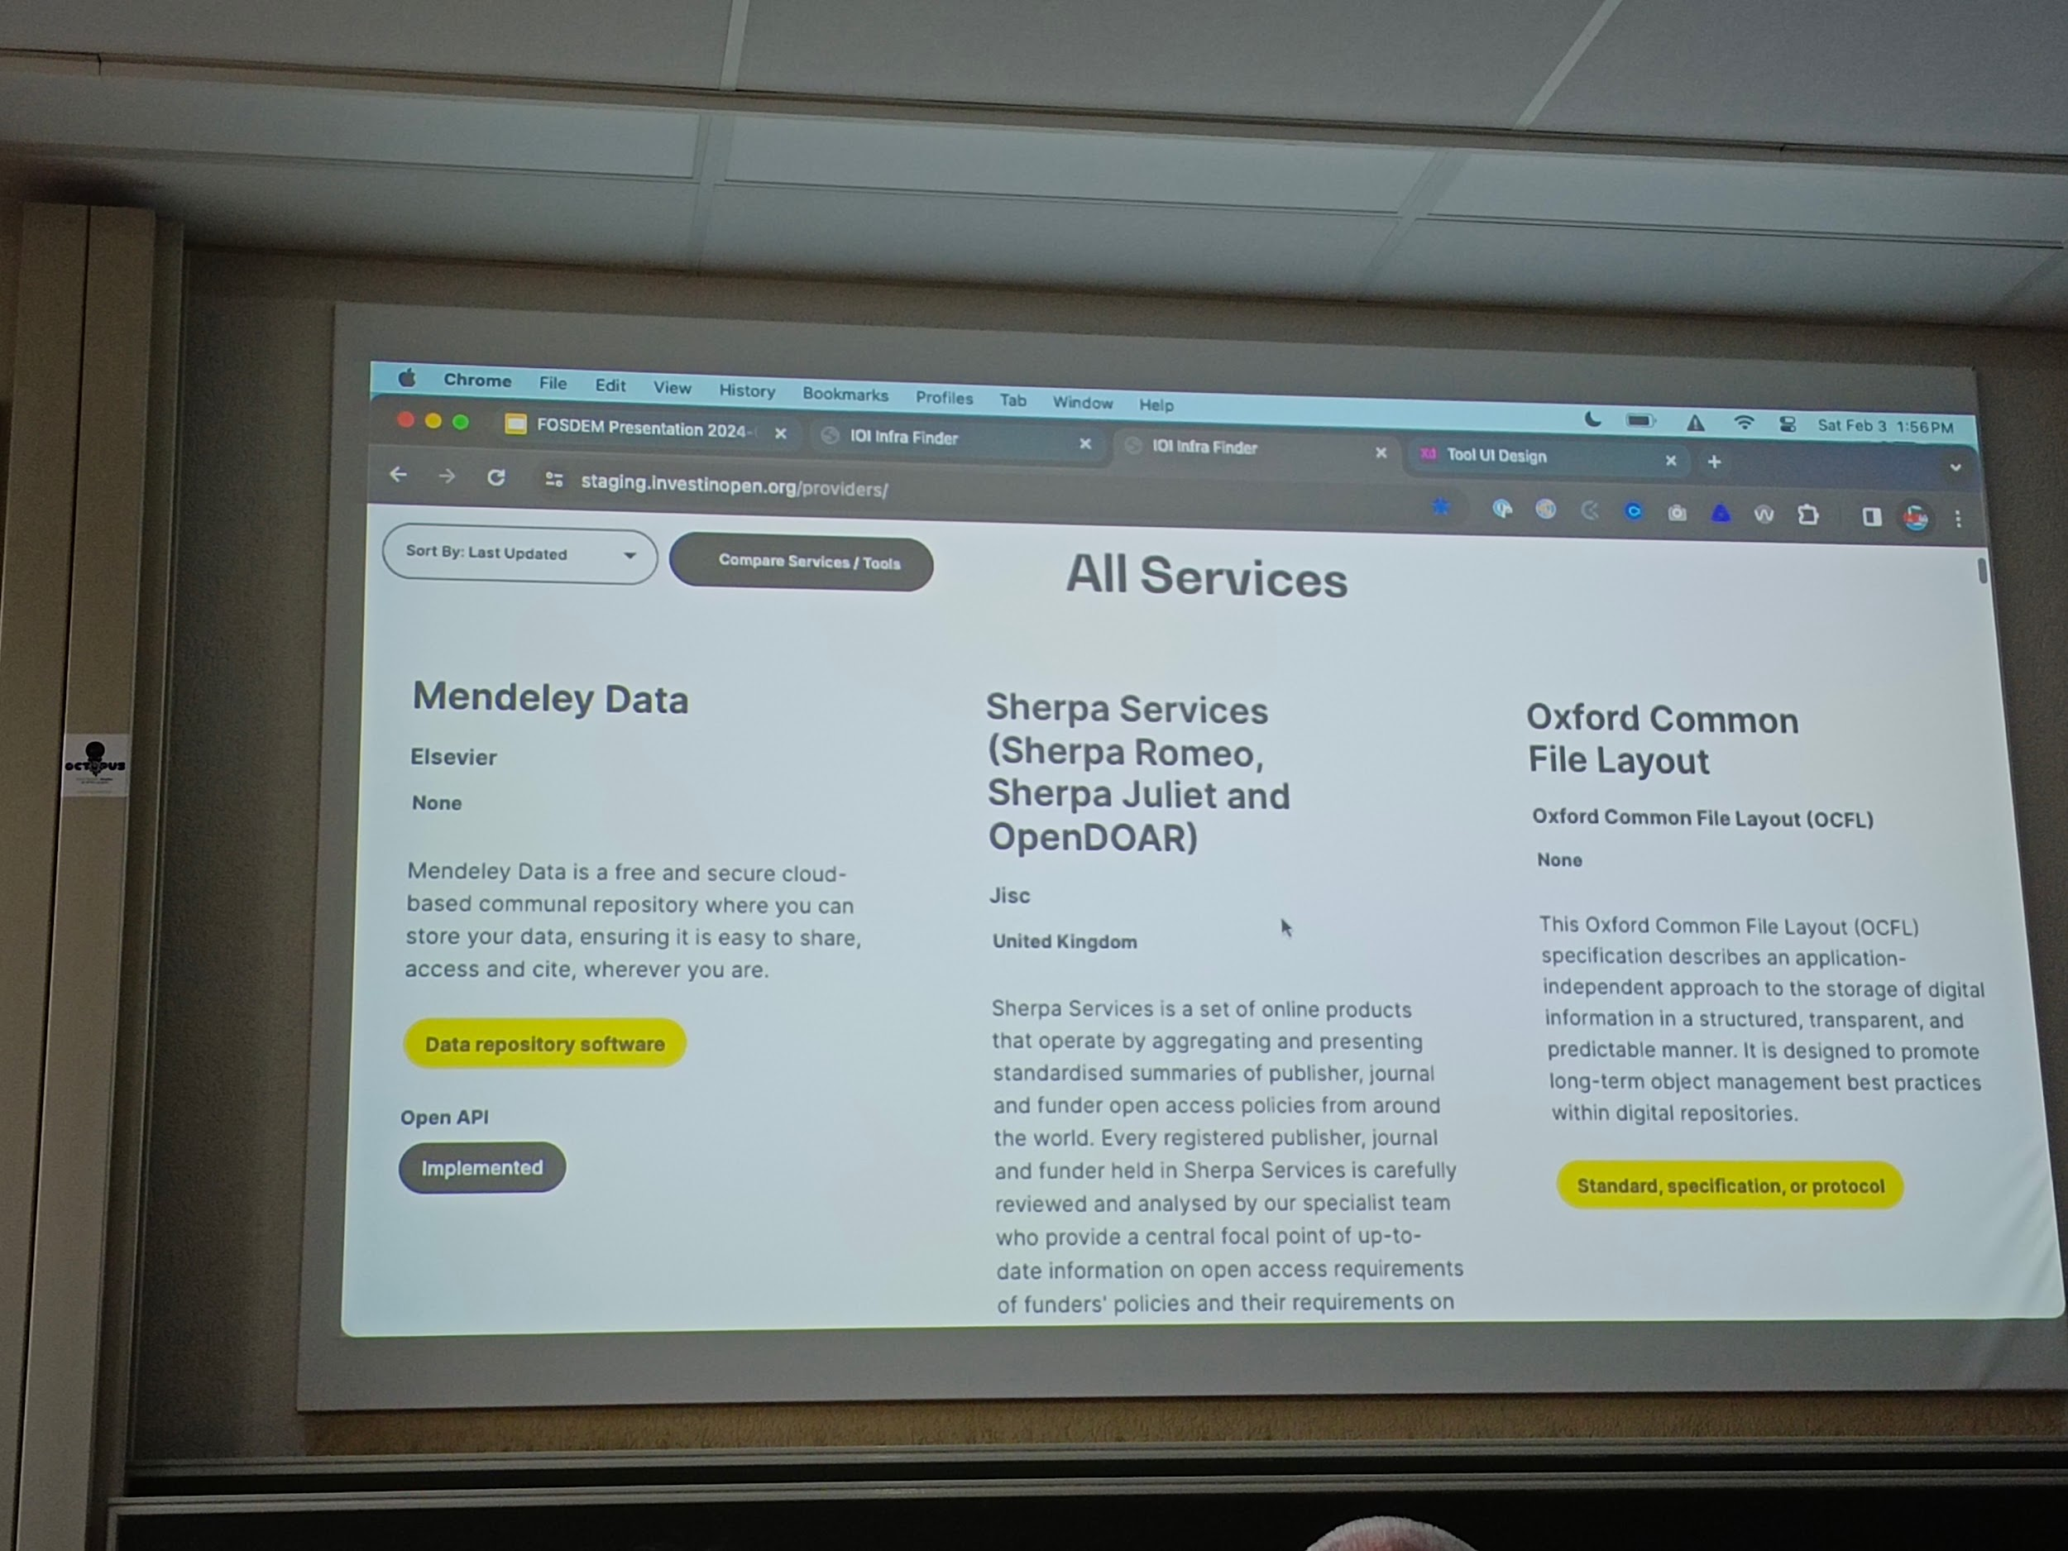

* About interoperability?

----

## [FOSDEM 2024 - Virtual Thread’s Next Steps](https://archive.fosdem.org/2024/schedule/event/fosdem-2024-3255-virtual-thread-s-next-steps/)

Ub5132 virtual thread

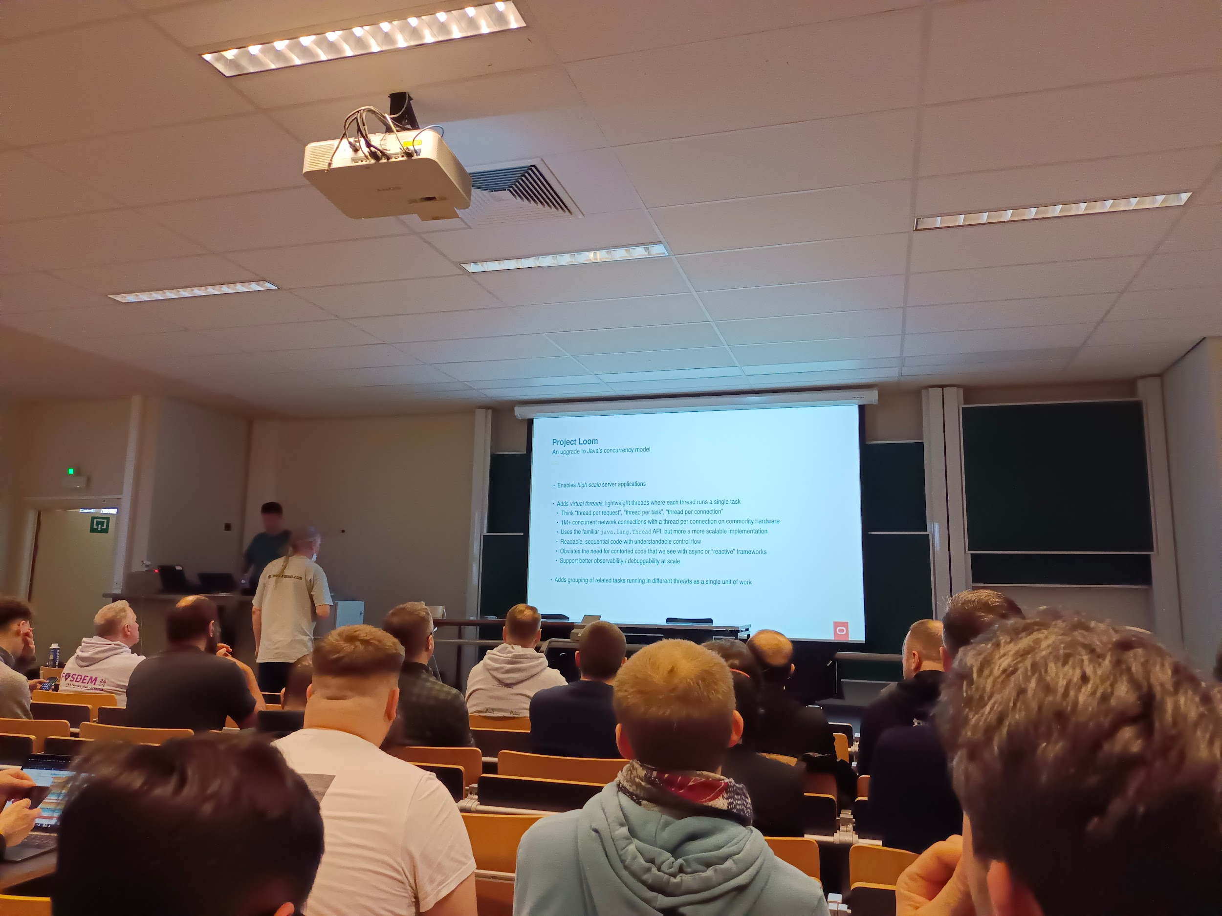

* Permanent feature Since jdk21
* Quality of implementation
* Work in progress
* About virtual thread

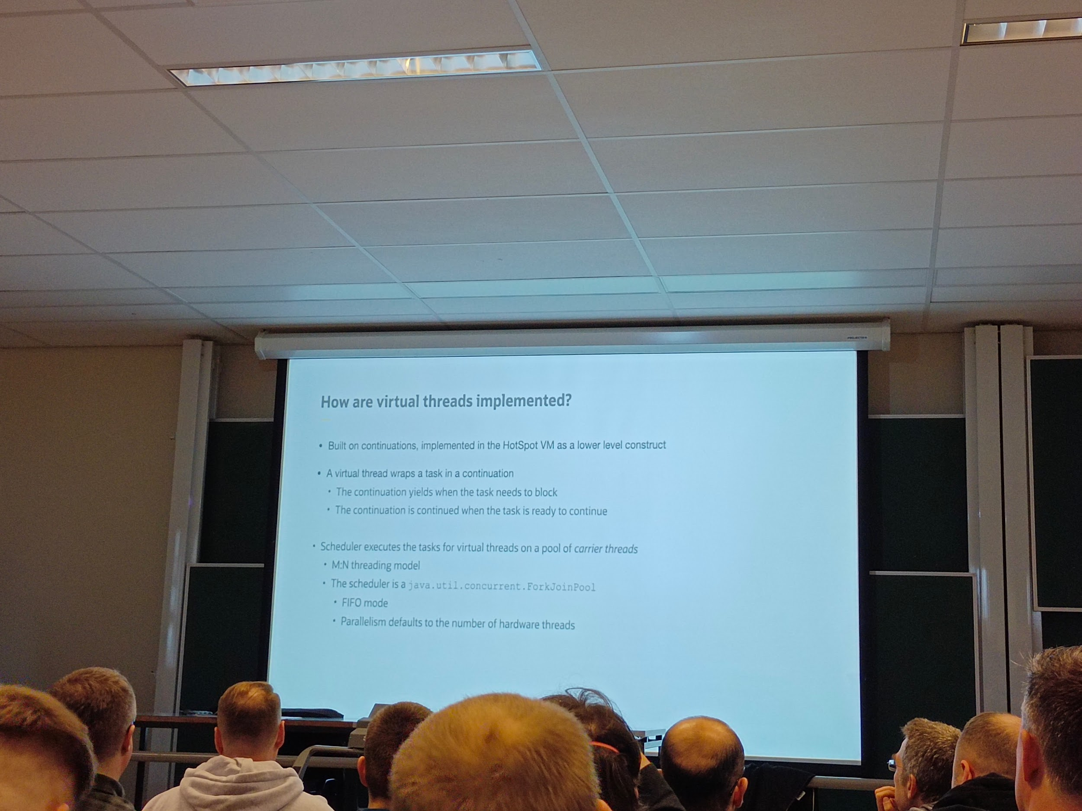

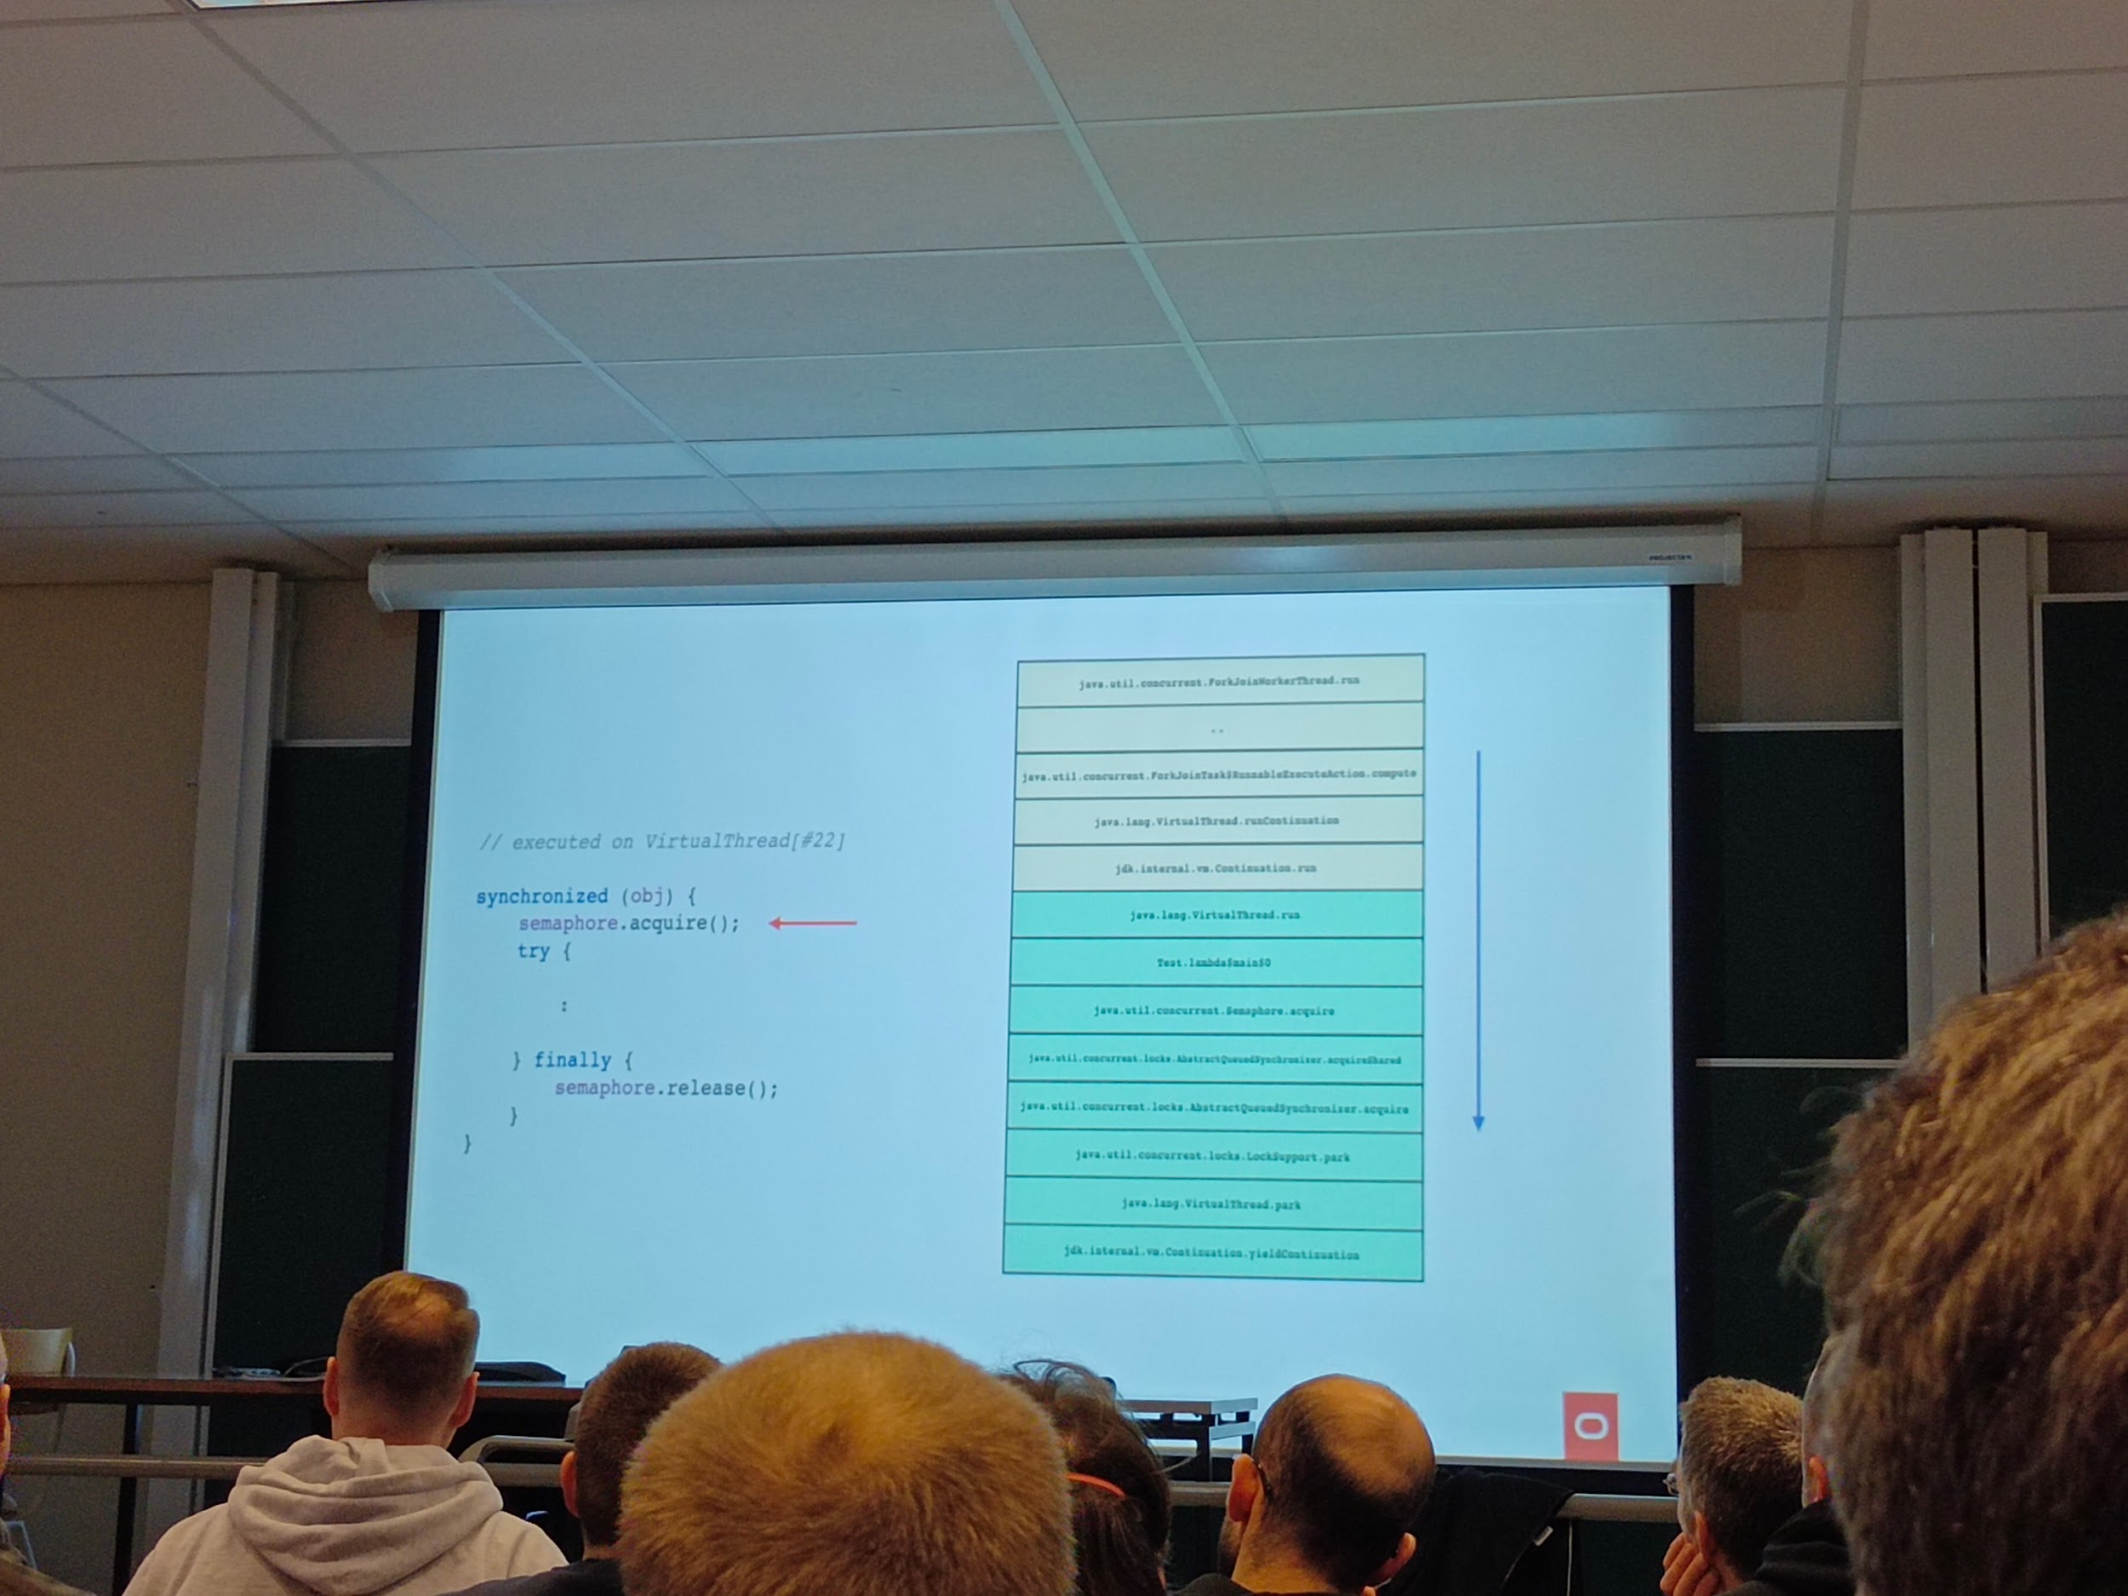

* Pinning issues
* About I/O

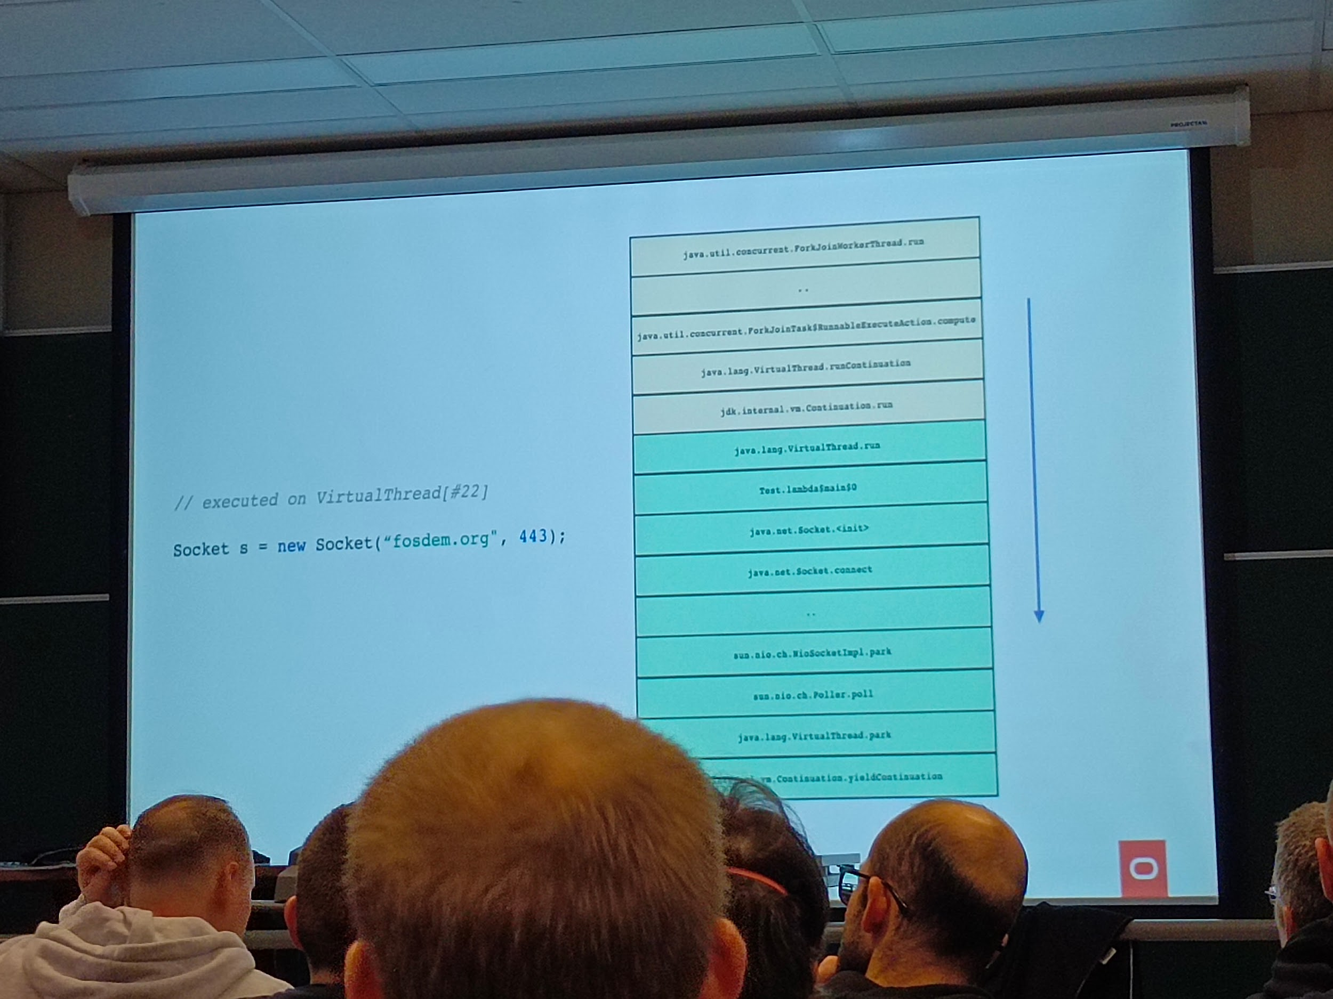

* Some benchmarks

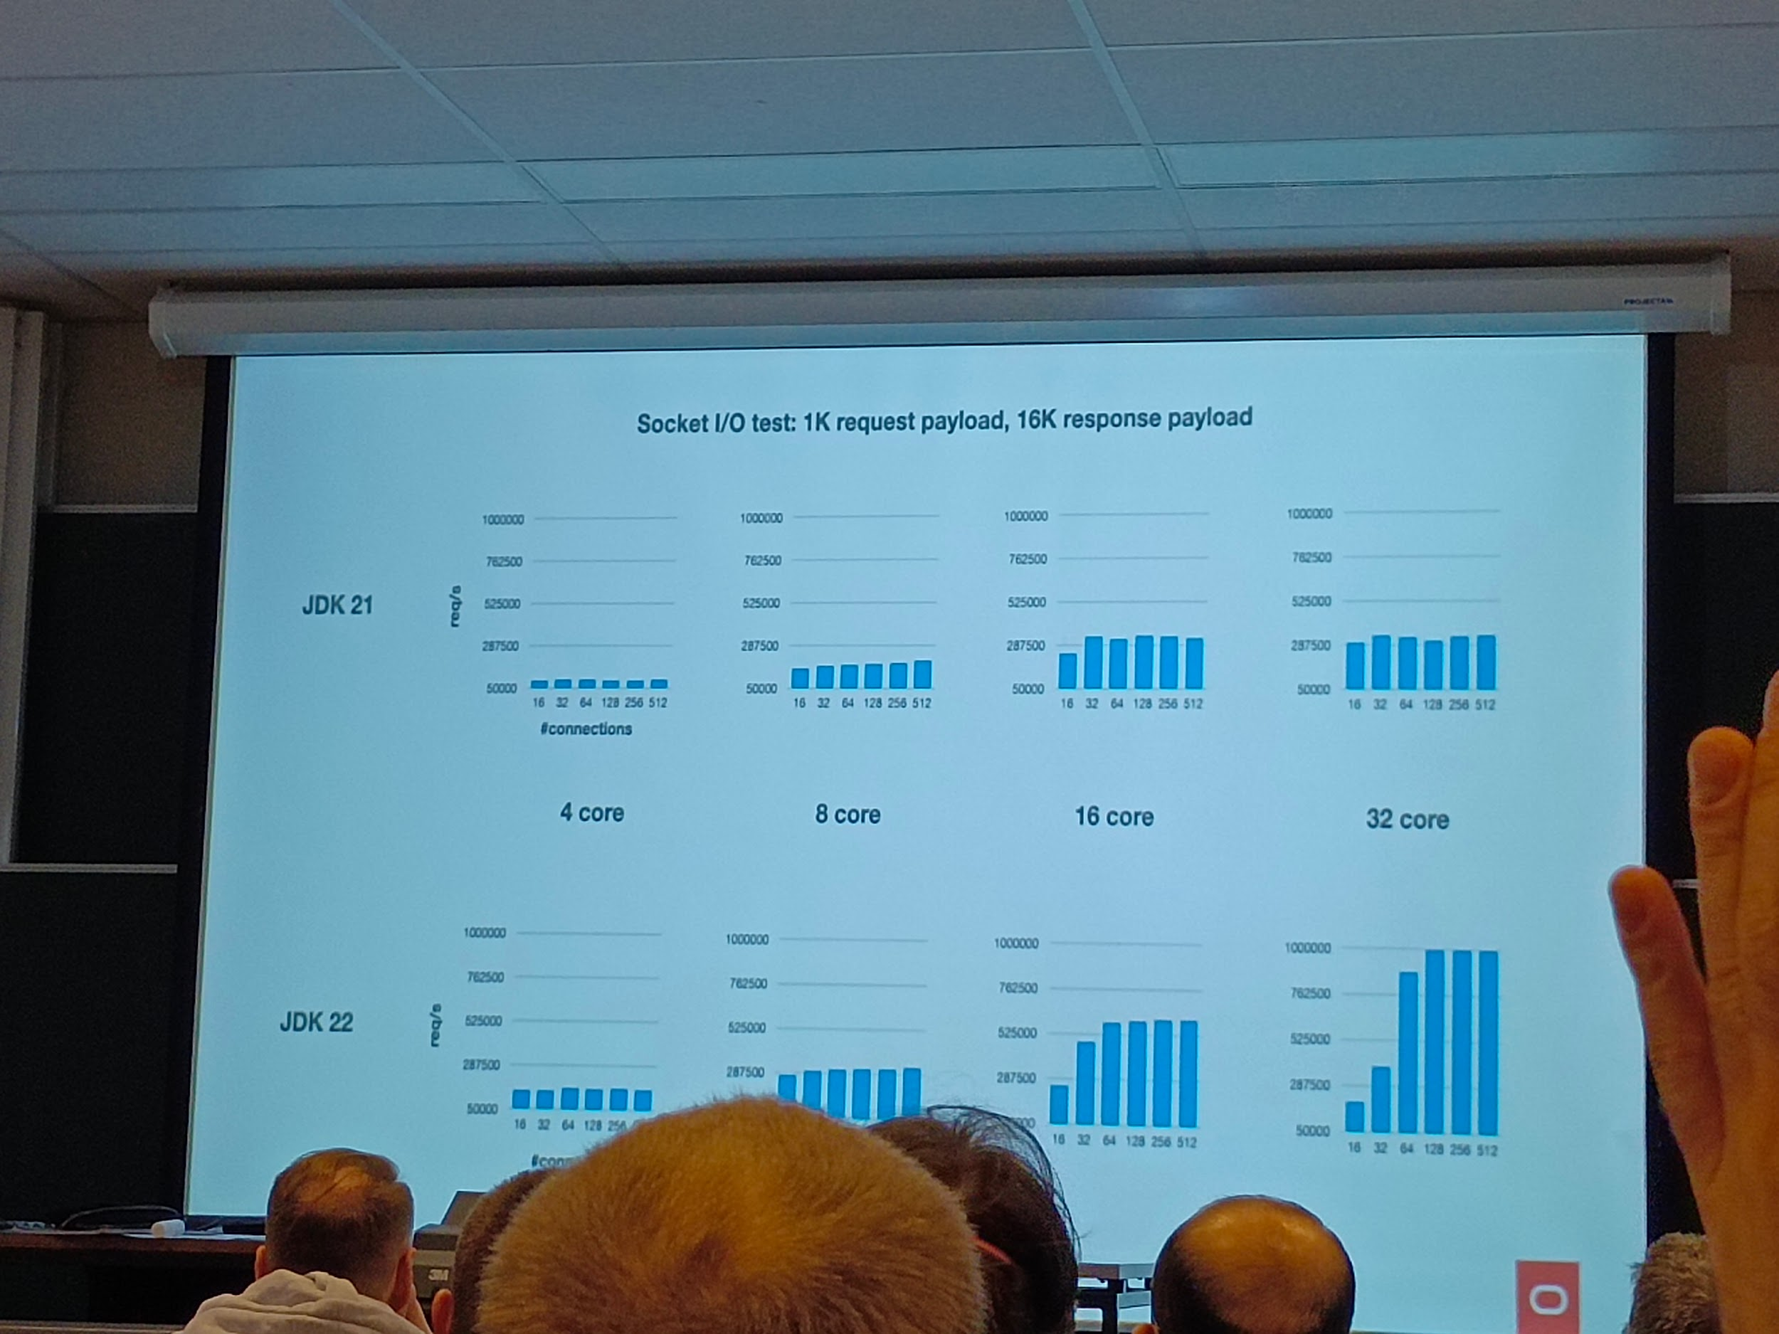

---

## [FOSDEM 2024 - Updating open data standards](https://archive.fosdem.org/2024/schedule/event/fosdem-2024-3109-updating-open-data-standards/)

Ub4132 update open data standards

----

## [FOSDEM 2024 - A microkernel-based orchestrator for distributed Internet services?](https://archive.fosdem.org/2024/schedule/event/fosdem-2024-3011-a-microkernel-based-orchestrator-for-distributed-internet-services-/)

Ud2208 microkernel

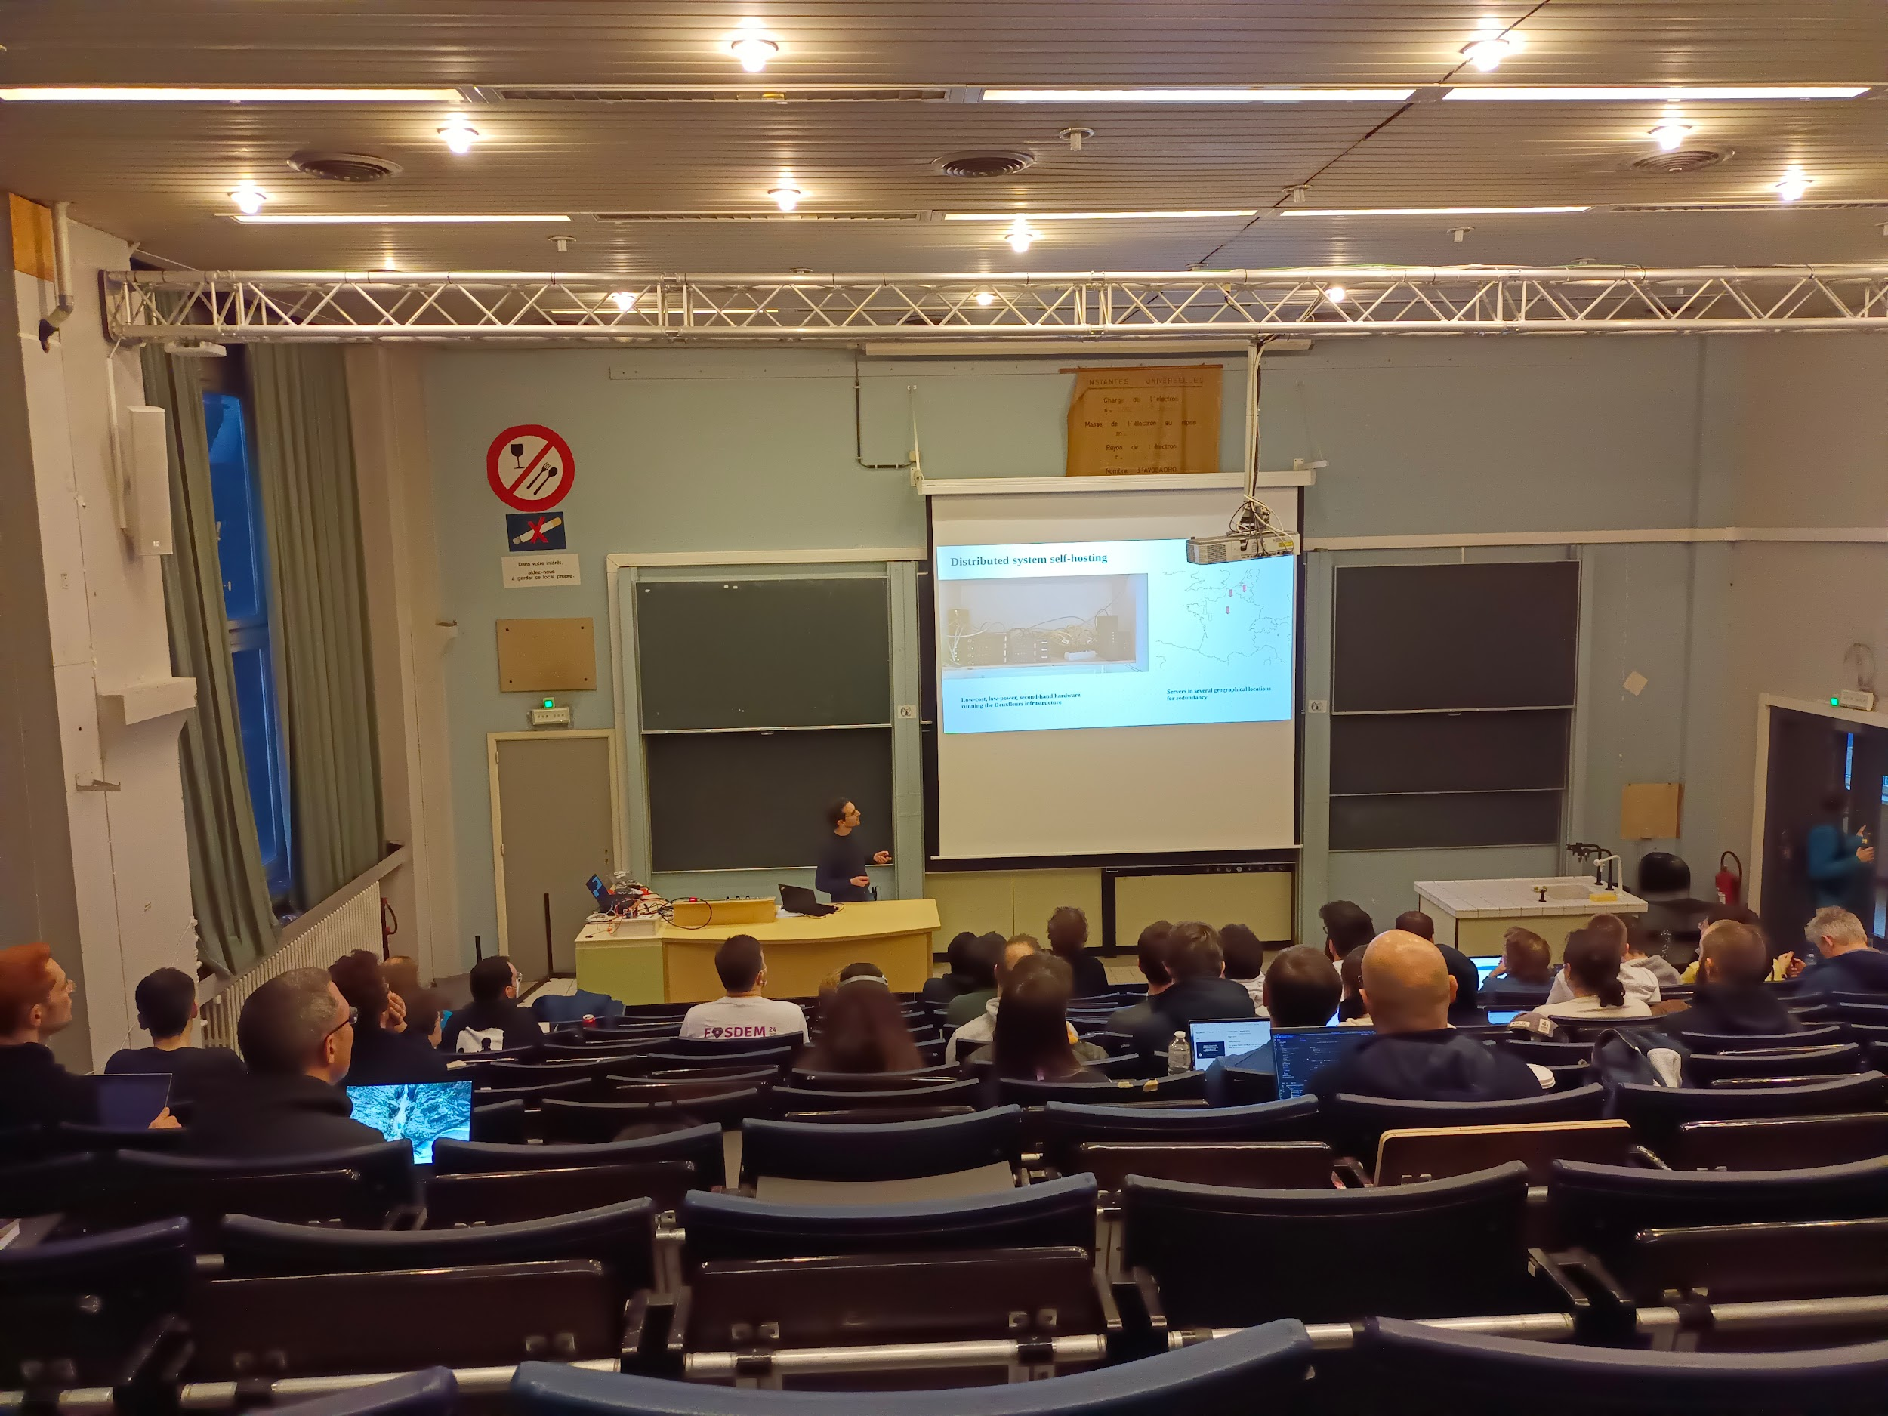

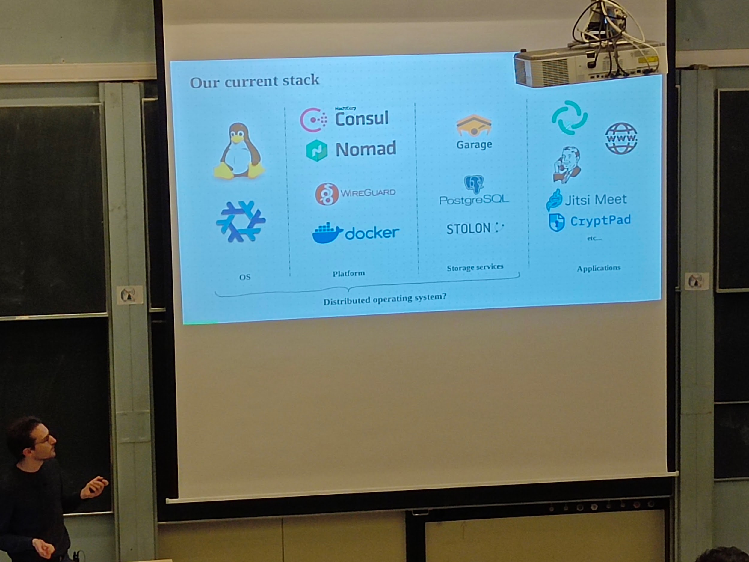

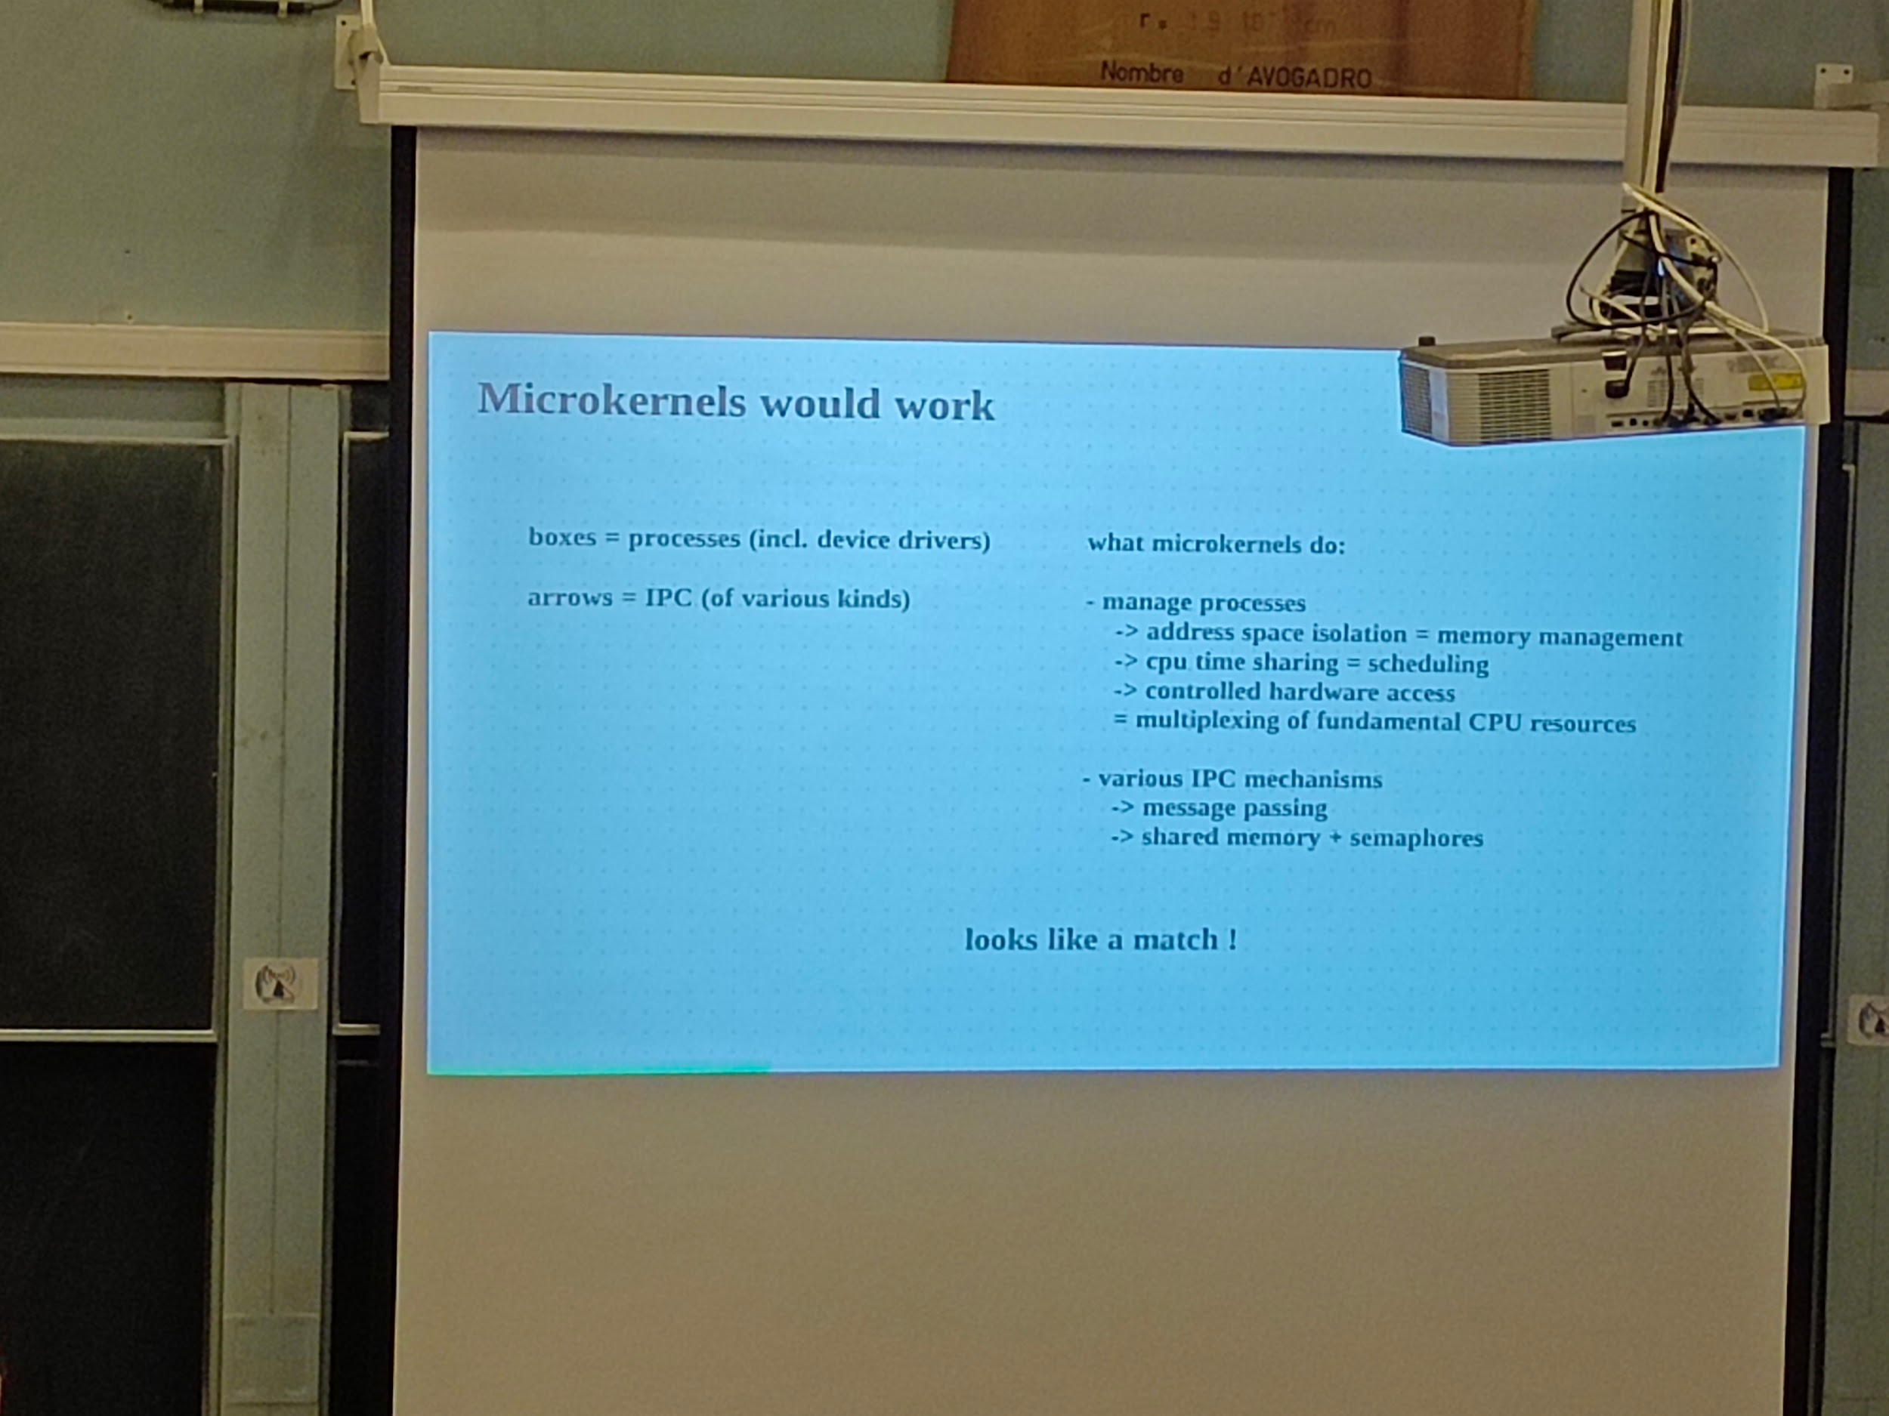

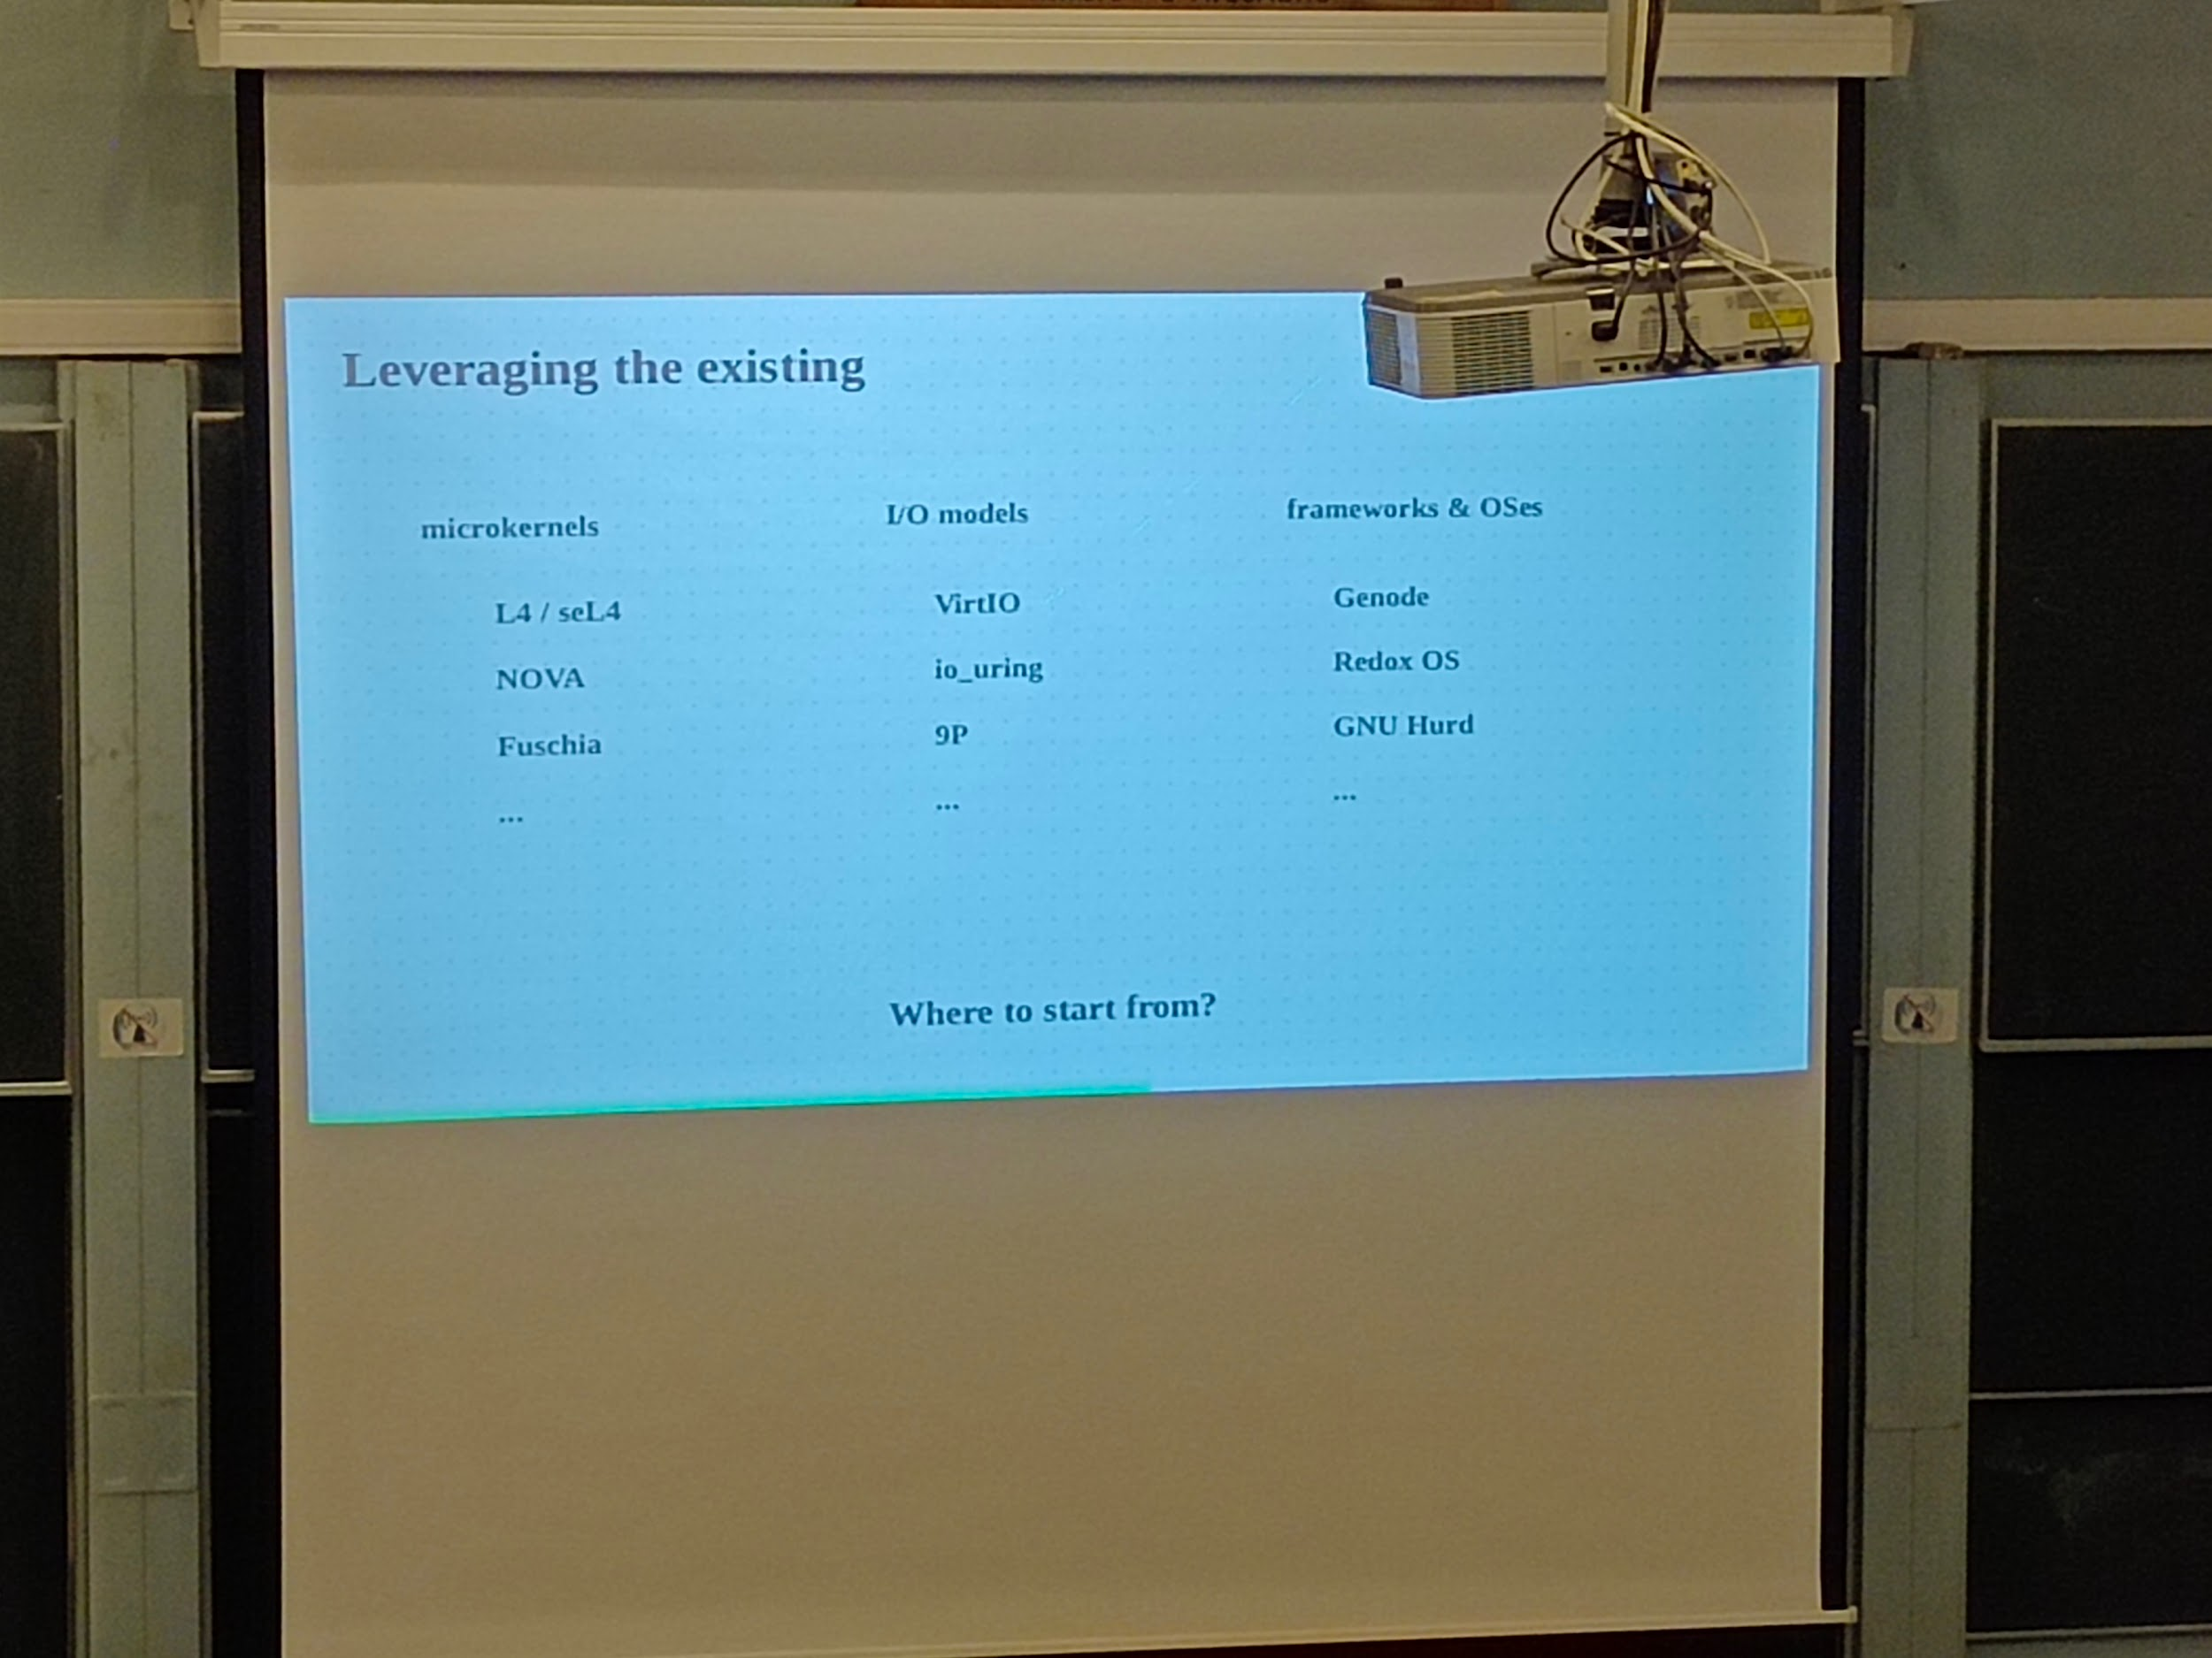

Make it minimalist

--

## [FOSDEM 2024 - A Modular Approach to Effortless and Dependency-Aware Unikernel Building](https://archive.fosdem.org/2024/schedule/event/fosdem-2024-3456-a-modular-approach-to-effortless-and-dependency-aware-unikernel-building/)

Ud2208 modular approach unikernel

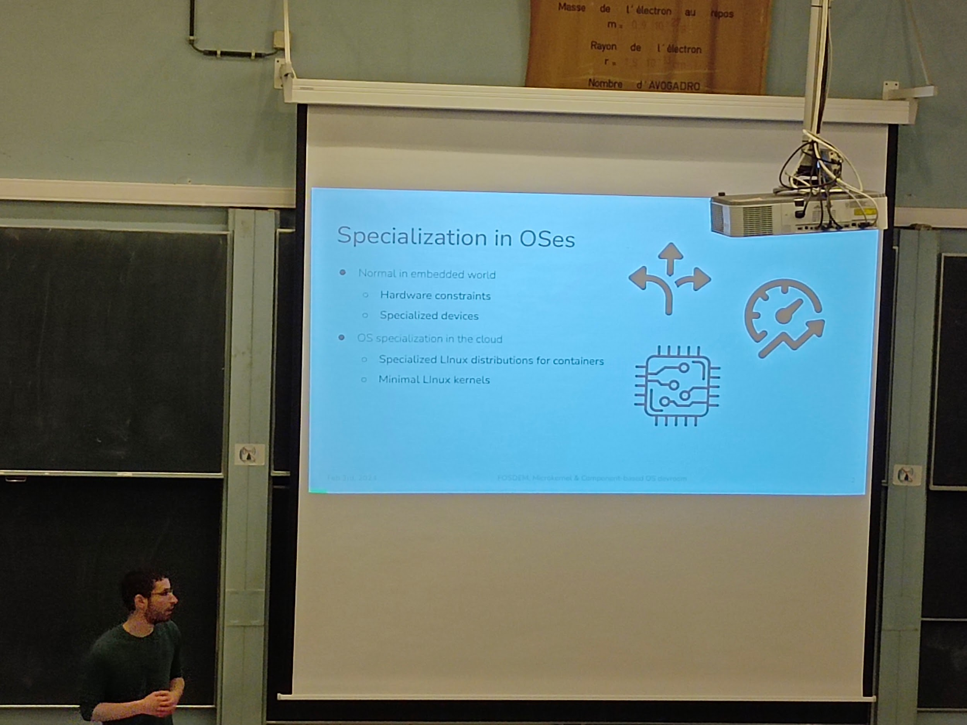

* Library OS:
  + Standalone independent library
* Building:
  + Cross compilation,
* Building tools for unikernel:
  + Kraftkit, Unik
* Bunny : new approach
  + Config, simplify process of building, limit dépendances

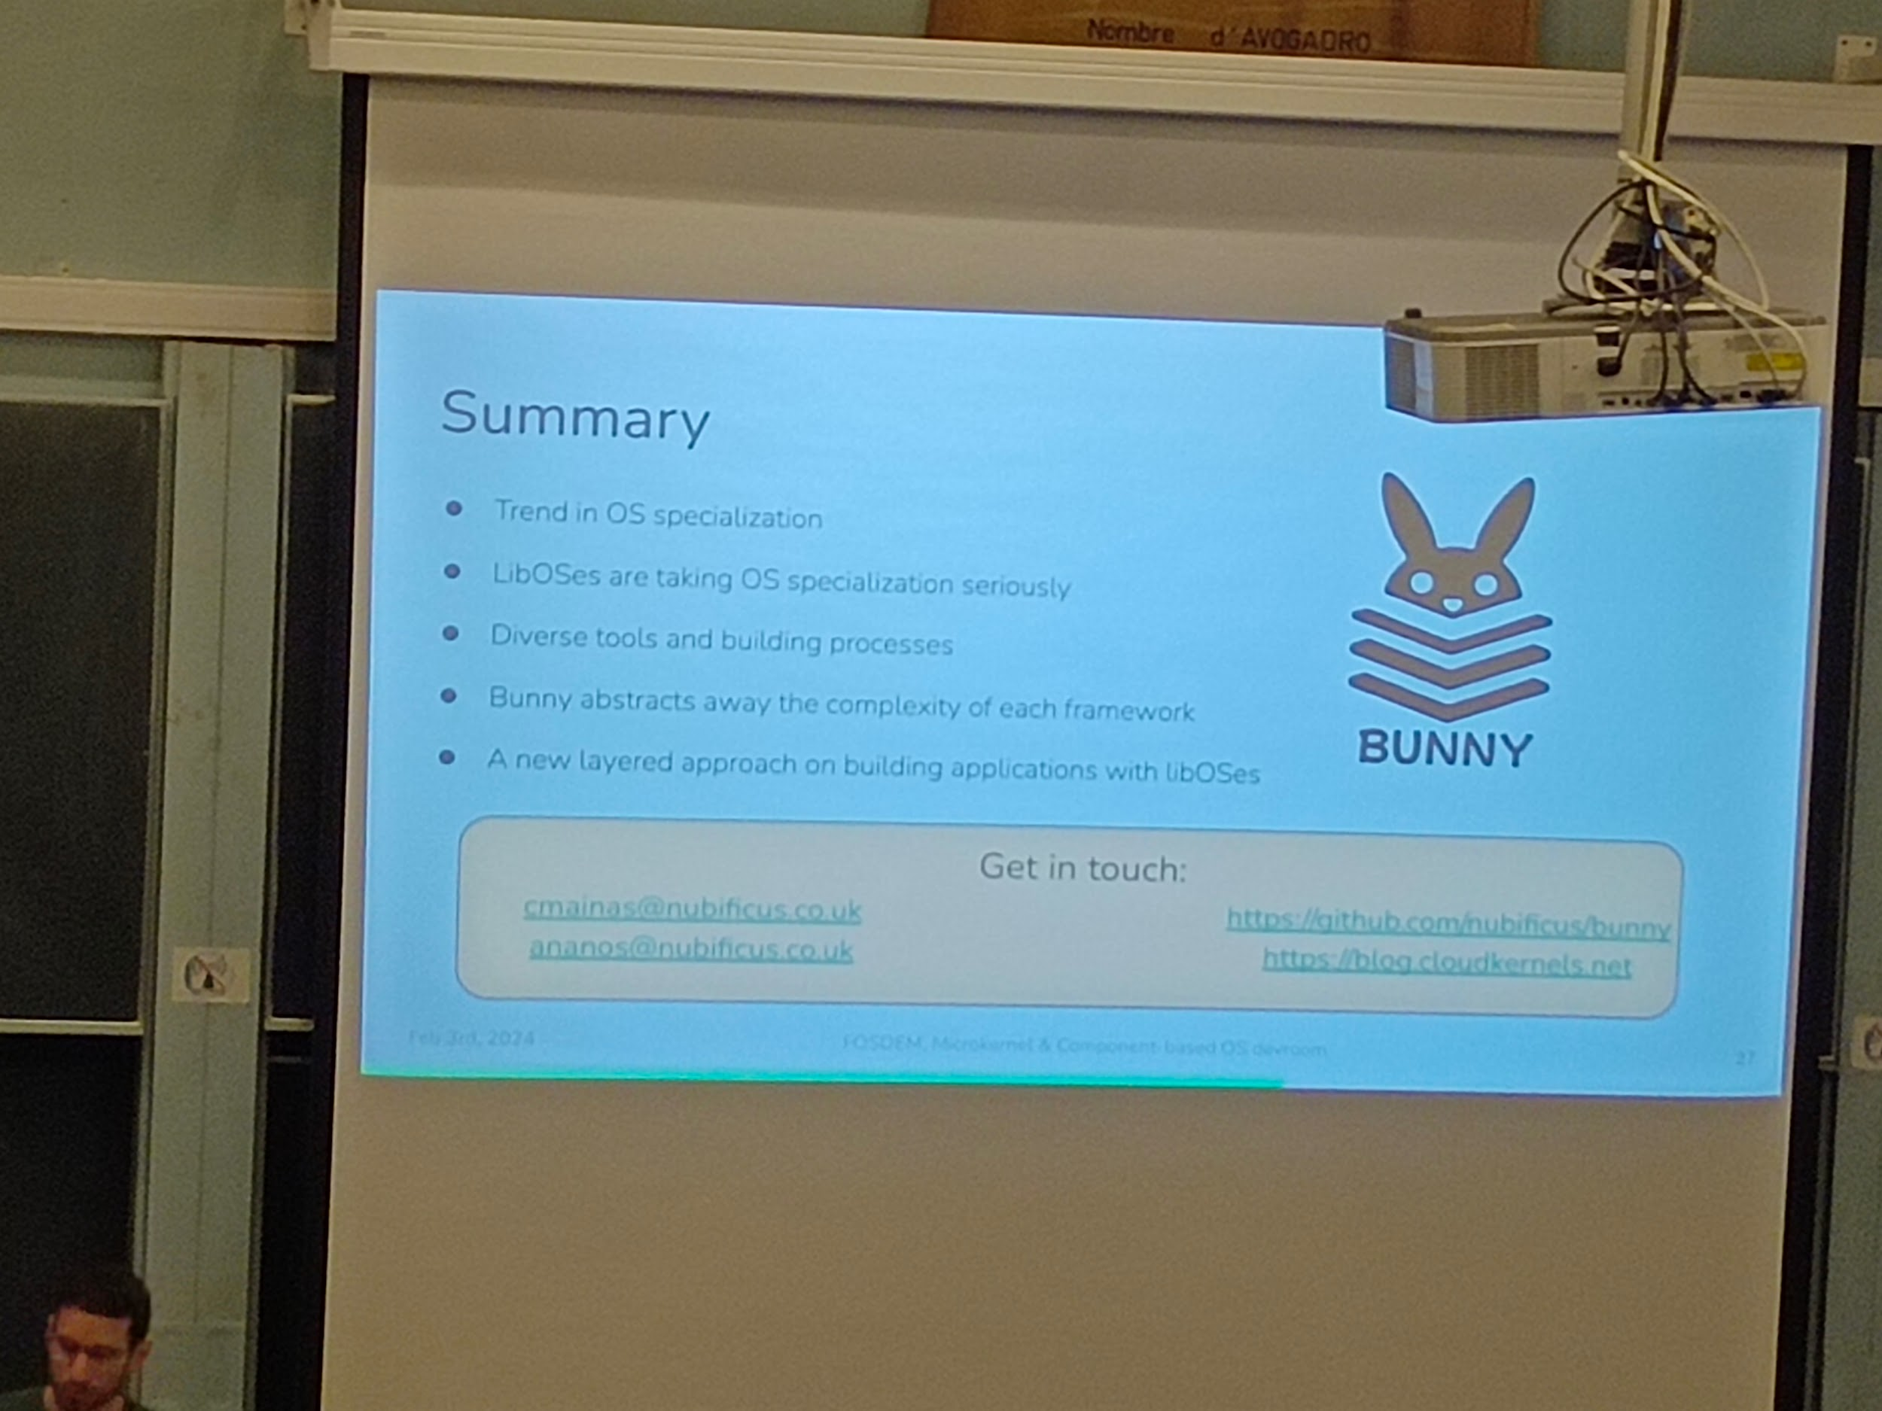

----

## [FOSDEM 2024 - Run Node.js in a unikernel reliably](https://archive.fosdem.org/2024/schedule/event/fosdem-2024-3269-run-node-js-in-a-unikernel-reliably/)

Ud2208 nodejs unikernel

* For web and mobile app
* About challenges
* Vision: optimize ressources allocation and cost, response time, easy to use, auto scaling, secure
* Runtime FaaS arch
* Challenges: cold start, upgrade without redeploy, security and isolation
* How?
  + Snapshots
  + User code Mounted as separate filesystem
  + Firecracker jailer to run sandboxes
  + Limit RSS for each VM
* Benchmark:
  + On a simple code almost a ping , compared to on a shelf solution and to Linux
* In ongoing phase: future: multi and more langage

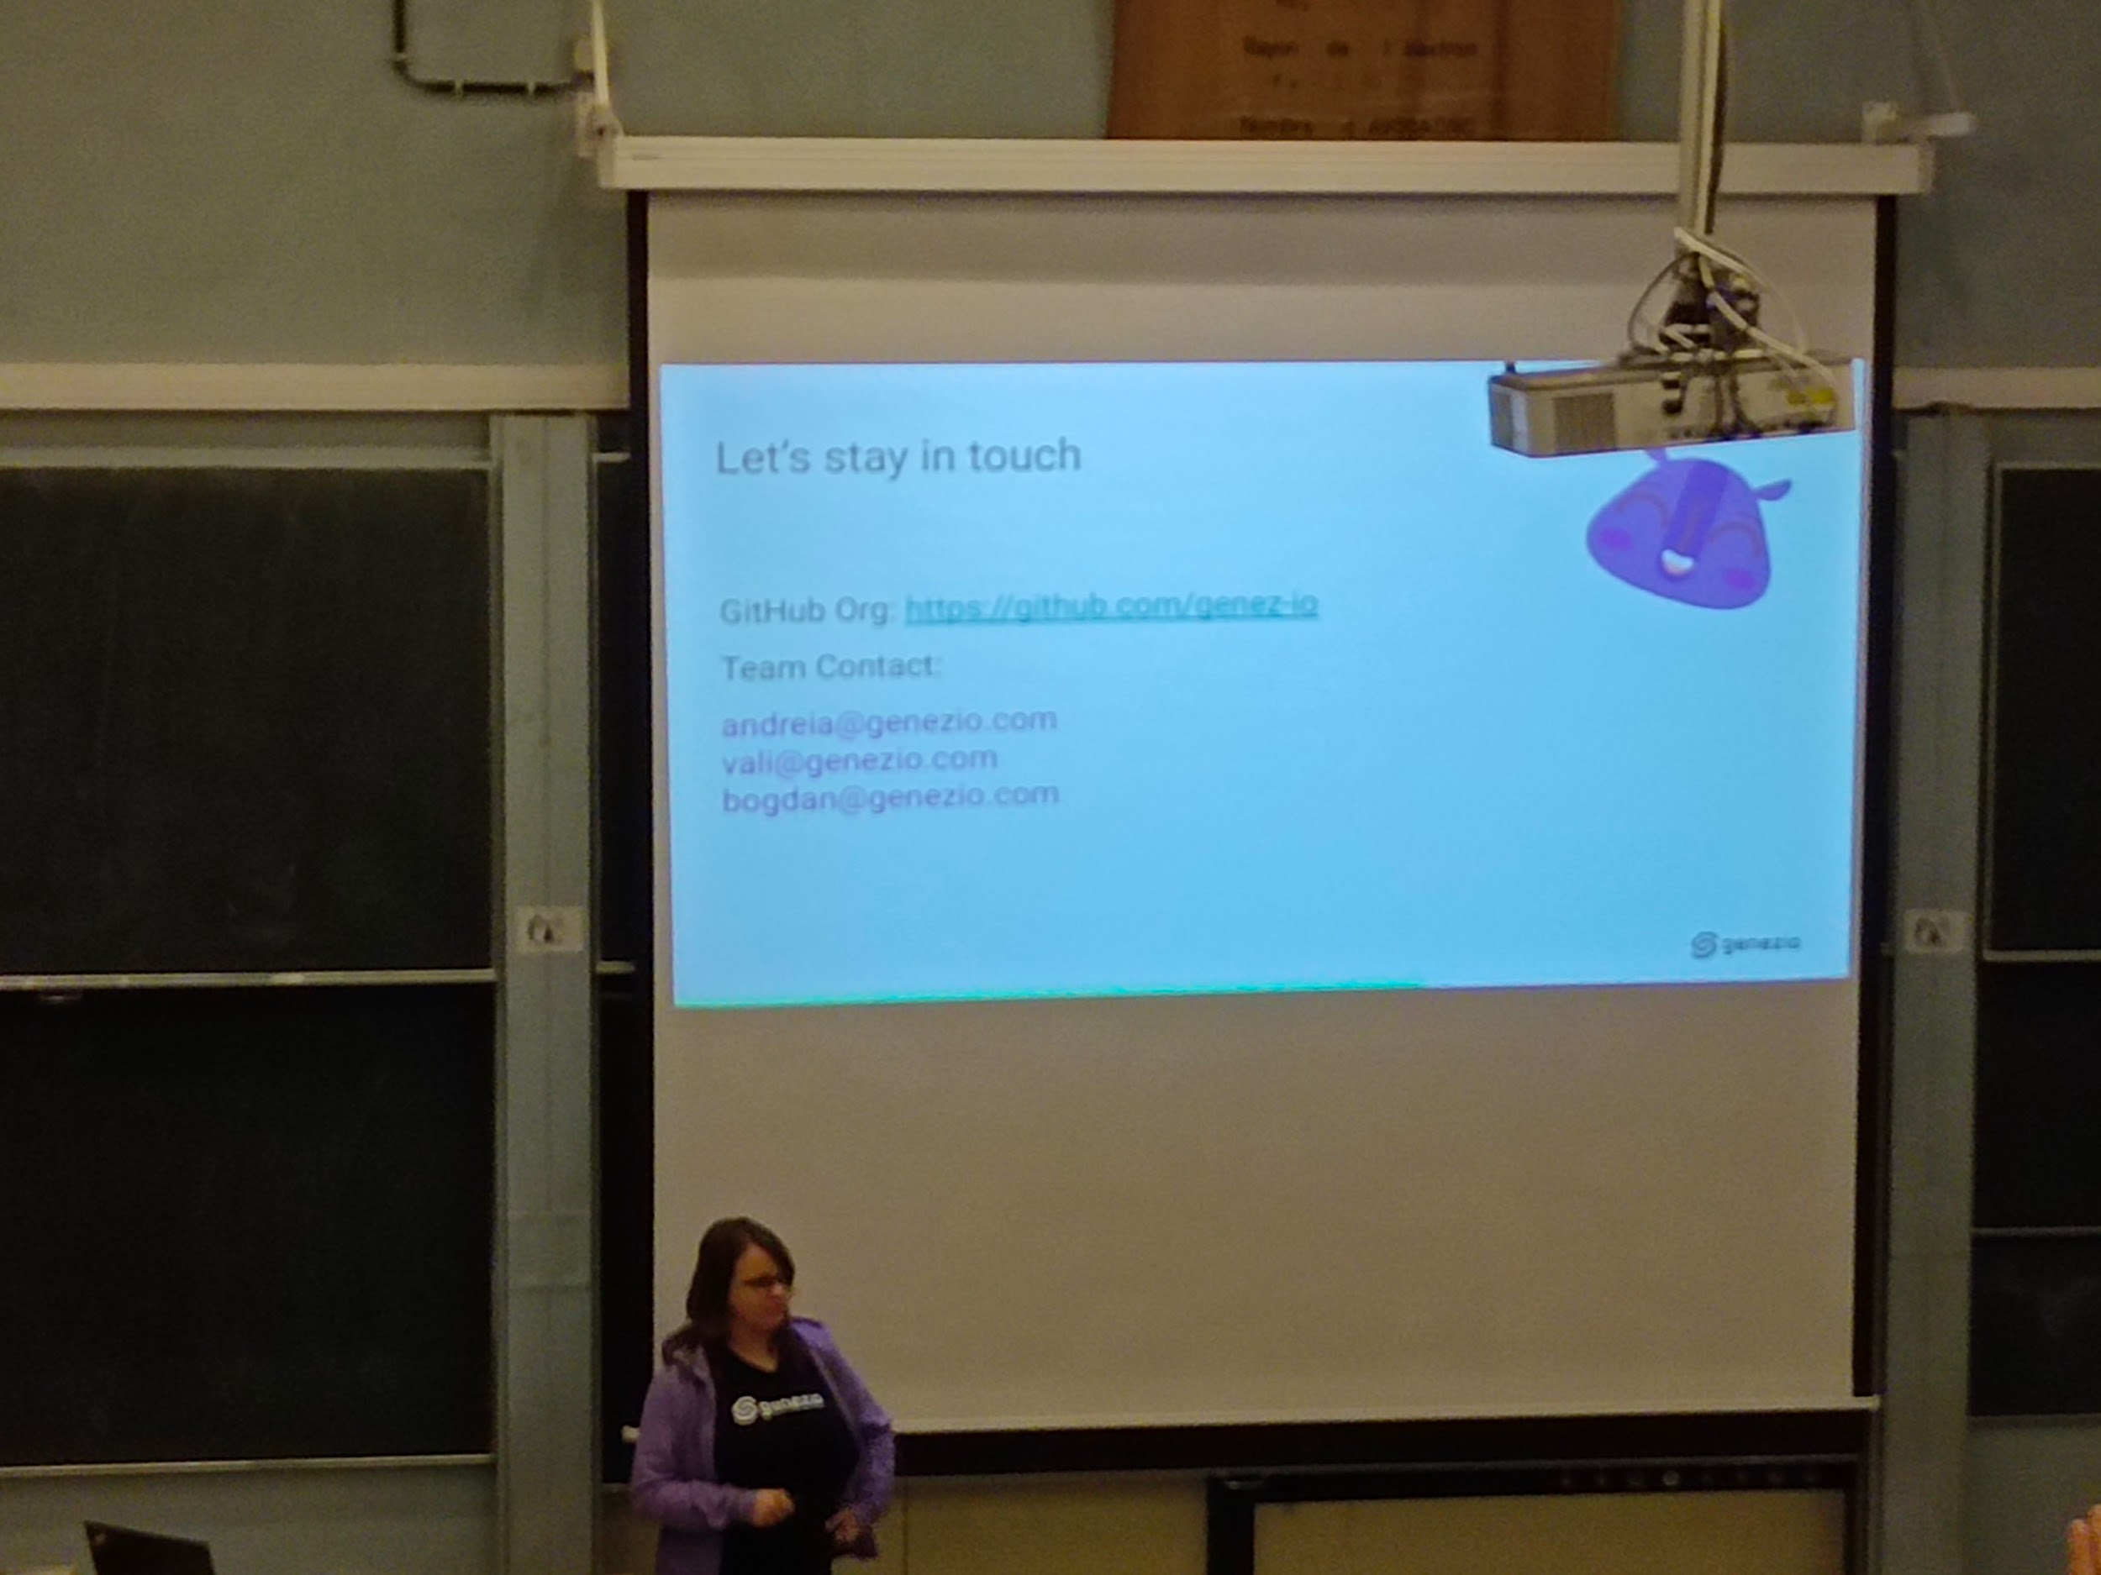

* The idea is to be able to reproduce the optimisation with many other languages (eg java)

----

## [FOSDEM 2024 - Carbon measurement and energy attribution for processes and hardware devices in the Linux kernel](https://archive.fosdem.org/2024/schedule/event/fosdem-2024-1885-carbon-measurement-and-energy-attribution-for-processes-and-hardware-devices-in-the-linux-kernel/)

H2214 16h carbone measurements in linux

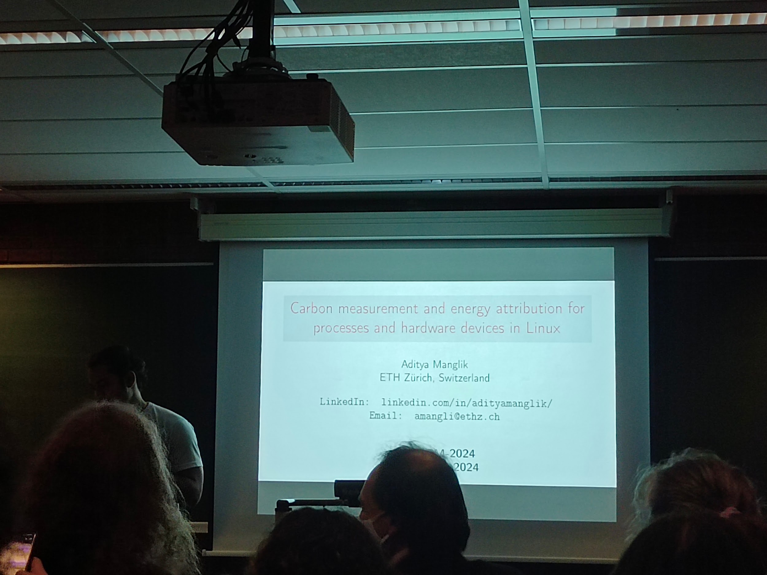

* Energy source
* Actually use them to the minimum (of capacity) because of battery capacity
* Energy consumption= power X latency but how actually calculate, some missing

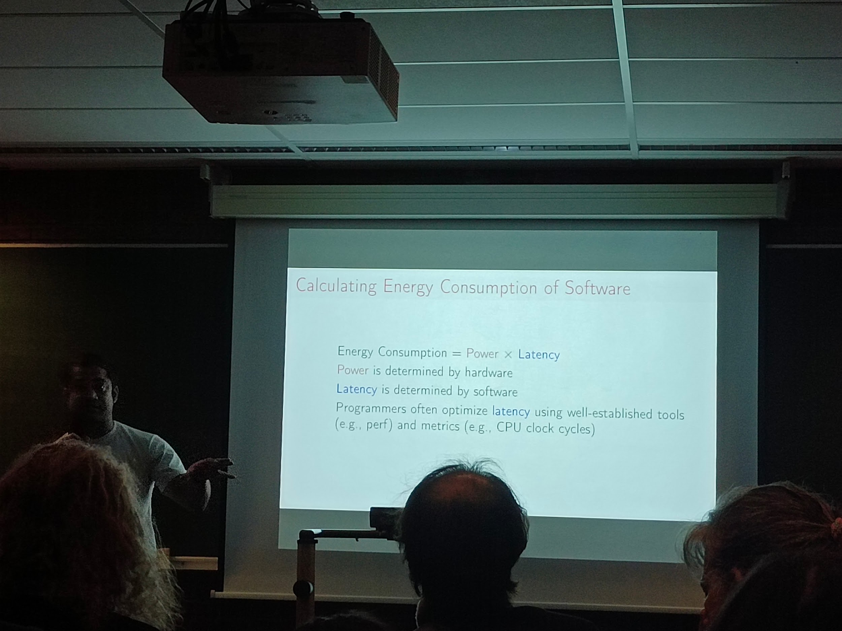

* Calculate your application energy consumption?
* RALP?
* RALP only available on intel
* Known calculation based on CPU alone, what about the rest like screen, memory, network cards?
* On assumption only
* Goal: a framework to measure
* Models and tools
  + Power models, poorly understood
  + Tools to calculate
* > Accurate models, reliable tools
* What have been done till now:
  + Power top, how it helps a programmer to improve?
  + System design,
    - Define specific measurement: by isolating (turn off every else)
    - Kernel process accounting infra,
  + All models are Wrong but some are useful,
* challenges:
  + Accuracy and bias trade off
  + Data collection, by private data? Who would share and who would owned the collected data
* carbon emissions of software:
  + Footprint = energy consumption X energy composition
* Expose API for programmers > actionability
* Remember: we cannot improve what we cannot measure, let's measure correctly / CPU measure is not everything nit the tip of the iceberg

----

## [FOSDEM 2024 - Web-accessibility for open-source privacy & security tools](https://archive.fosdem.org/2024/schedule/event/fosdem-2024-3326-web-accessibility-for-open-source-privacy-security-tools/)

AW1126 17h accessibility lab

Goal: it is Vital

* Usability, actual satisfaction to use
* Inclusion
* Benefits: Competitive advantages, legislation, …
* Security

AXIS

Studies through audit and such

Some eg

* Linux too complex to accessibility
* Screen readers

some solutions

* Eye tracker
* Switch
* Braille converter
* Audio description

WCAG2.2 web content accessibility guidelines

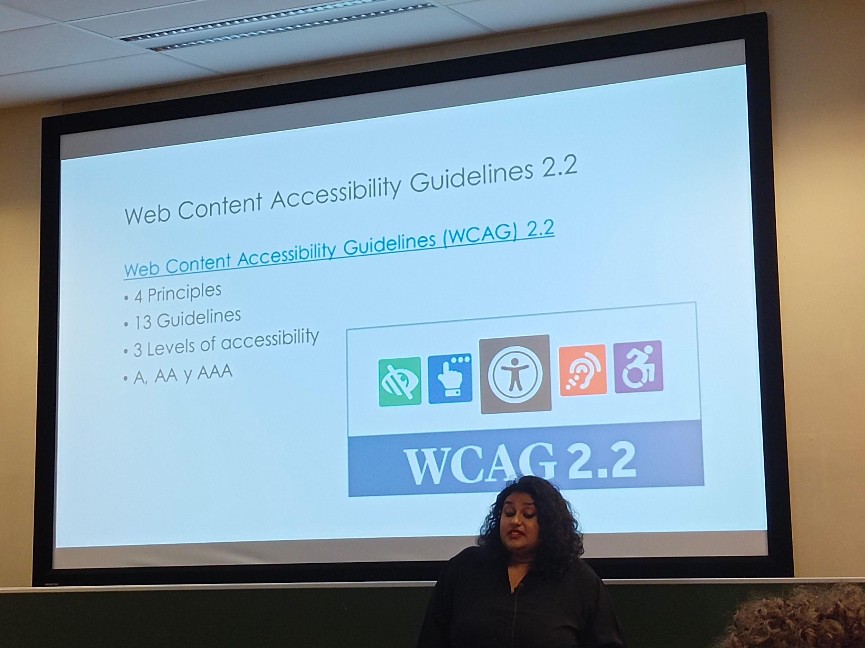

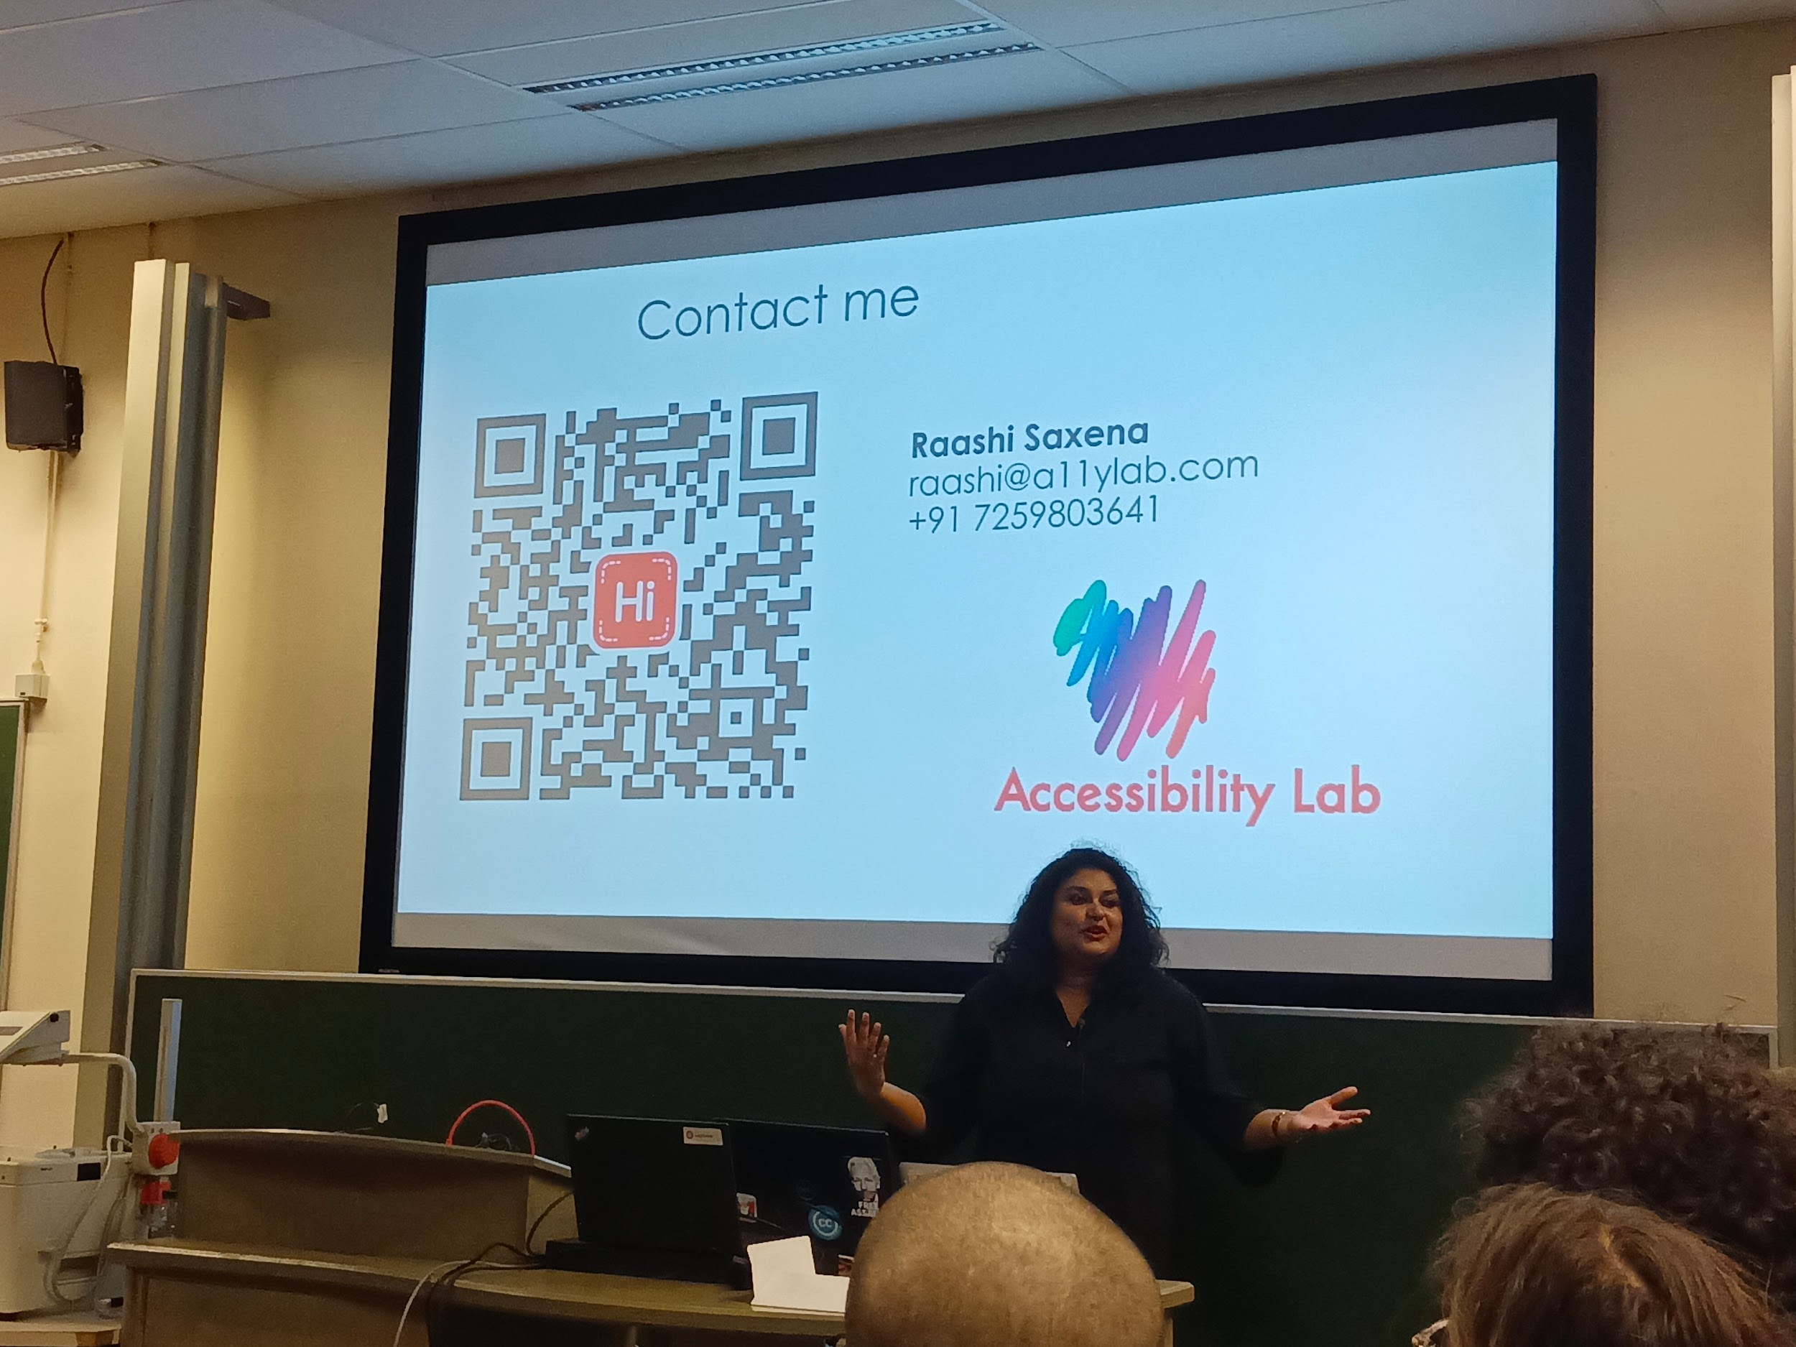

Some ideas:

* Make fosdem more accessible
* Improve conference to actually make also accessible (like slides are for the watchers… not the rest)

-----

## [FOSDEM 2024 - Science without secrets – how Galaxy democratizes data analysis](https://archive.fosdem.org/2024/schedule/event/fosdem-2024-3316-science-without-secrets-how-galaxy-democratizes-data-analysis/)

Ub4132 17h30 galaxy

-----

## [FOSDEM 2024 - Workflow managers in high-energy physics: enhancing analyses with Snakemake](https://archive.fosdem.org/2024/schedule/event/fosdem-2024-3415-workflow-managers-in-high-energy-physics-enhancing-analyses-with-snakemake/)

Ub4132 17h45 high energy physics

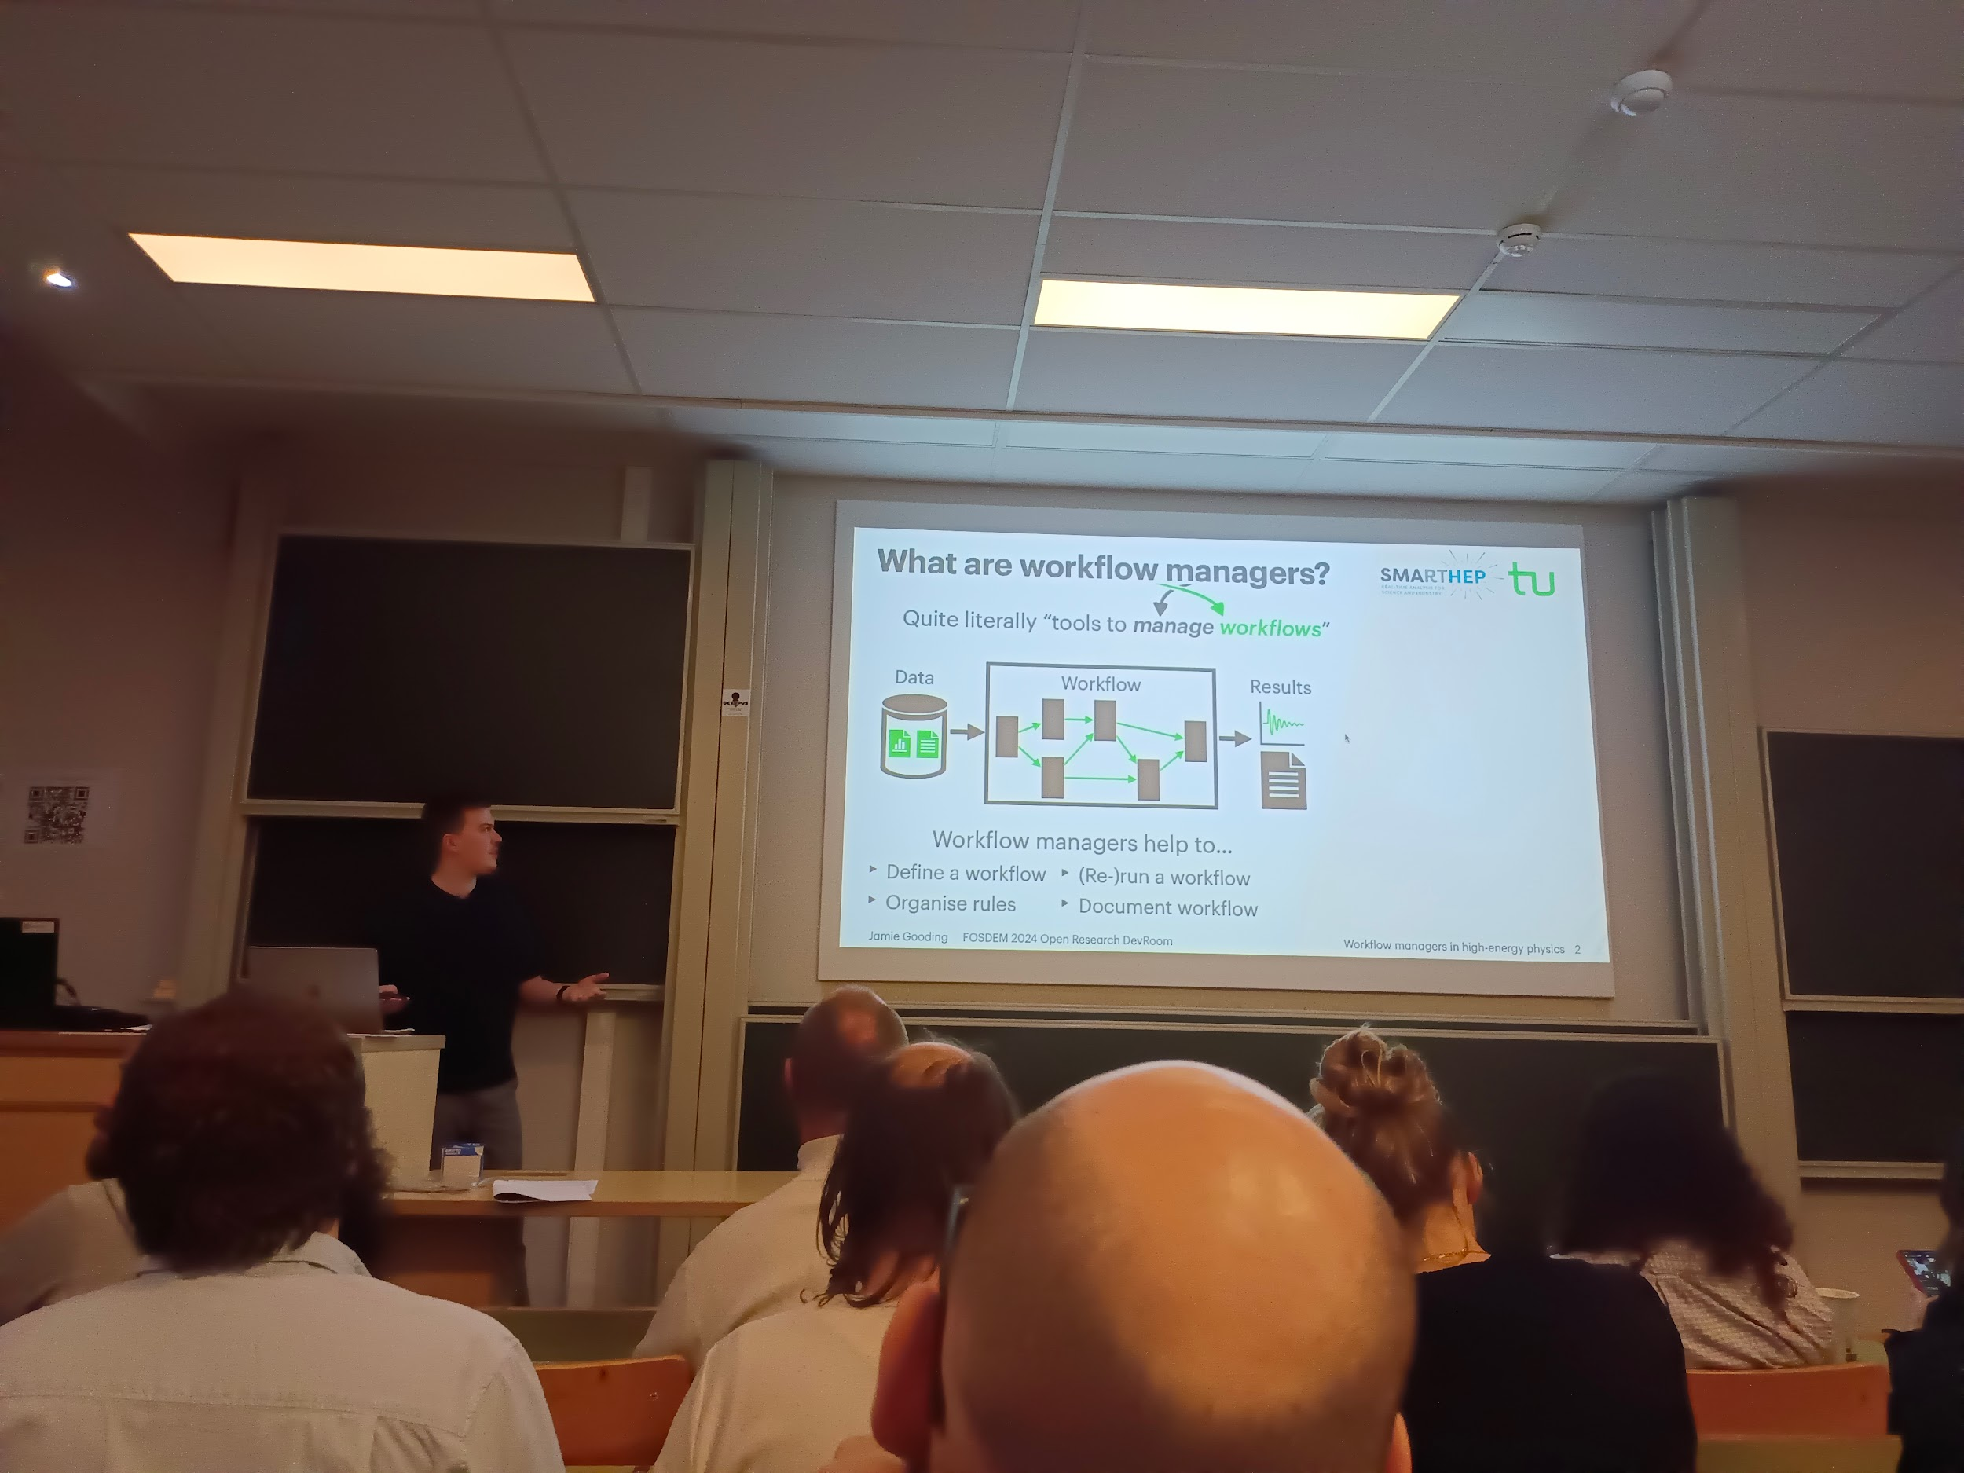

* Snakemake
* From gnu paradigm
* HEP high energy physics
* Physics of the very early Earth

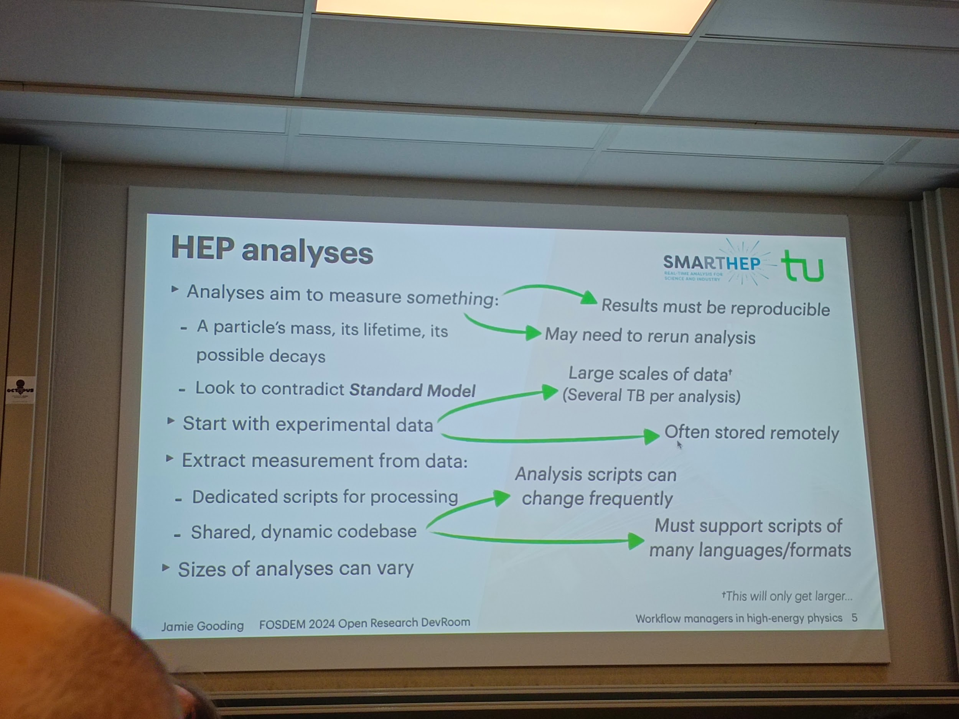

* And scalable

----

## [FOSDEM 2024 - Open Neuroscience: practical suggestions for conducting open neuroscience research](https://archive.fosdem.org/2024/schedule/event/fosdem-2024-2223-open-neuroscience-practical-suggestions-for-conducting-open-neuroscience-research/)

Ub4132 18h00 neuroscience

Why open neurosciences

* Reproducibility
* Synergy
* Transdisciplinary

Not only academia would gain also industry

Struggles to access to complexity, dead brain is quite a poor representation

Data and computing make it alive and more "observable"

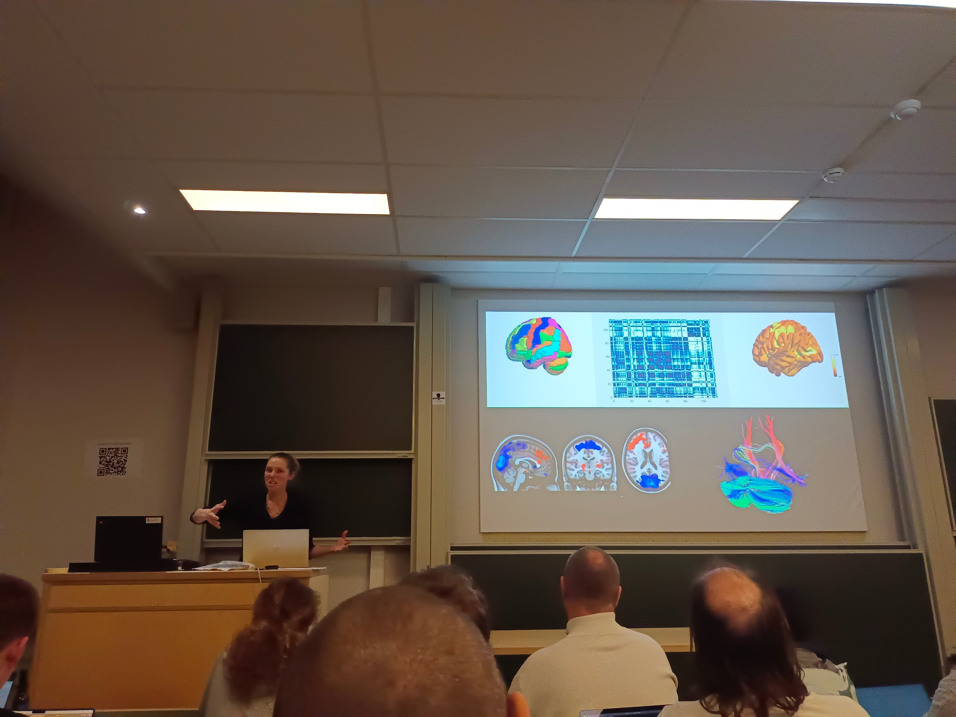

Imagery: reg, MRI, meg

* Each has challenges and downs, like 3d, résolution, timeline, activity

collecting data

* Drawbacks: balance between privacy and open
* Address gender bias
* Break the WEIRD (acronym) cycle
* (Community) Inclusion into data collection, how to?

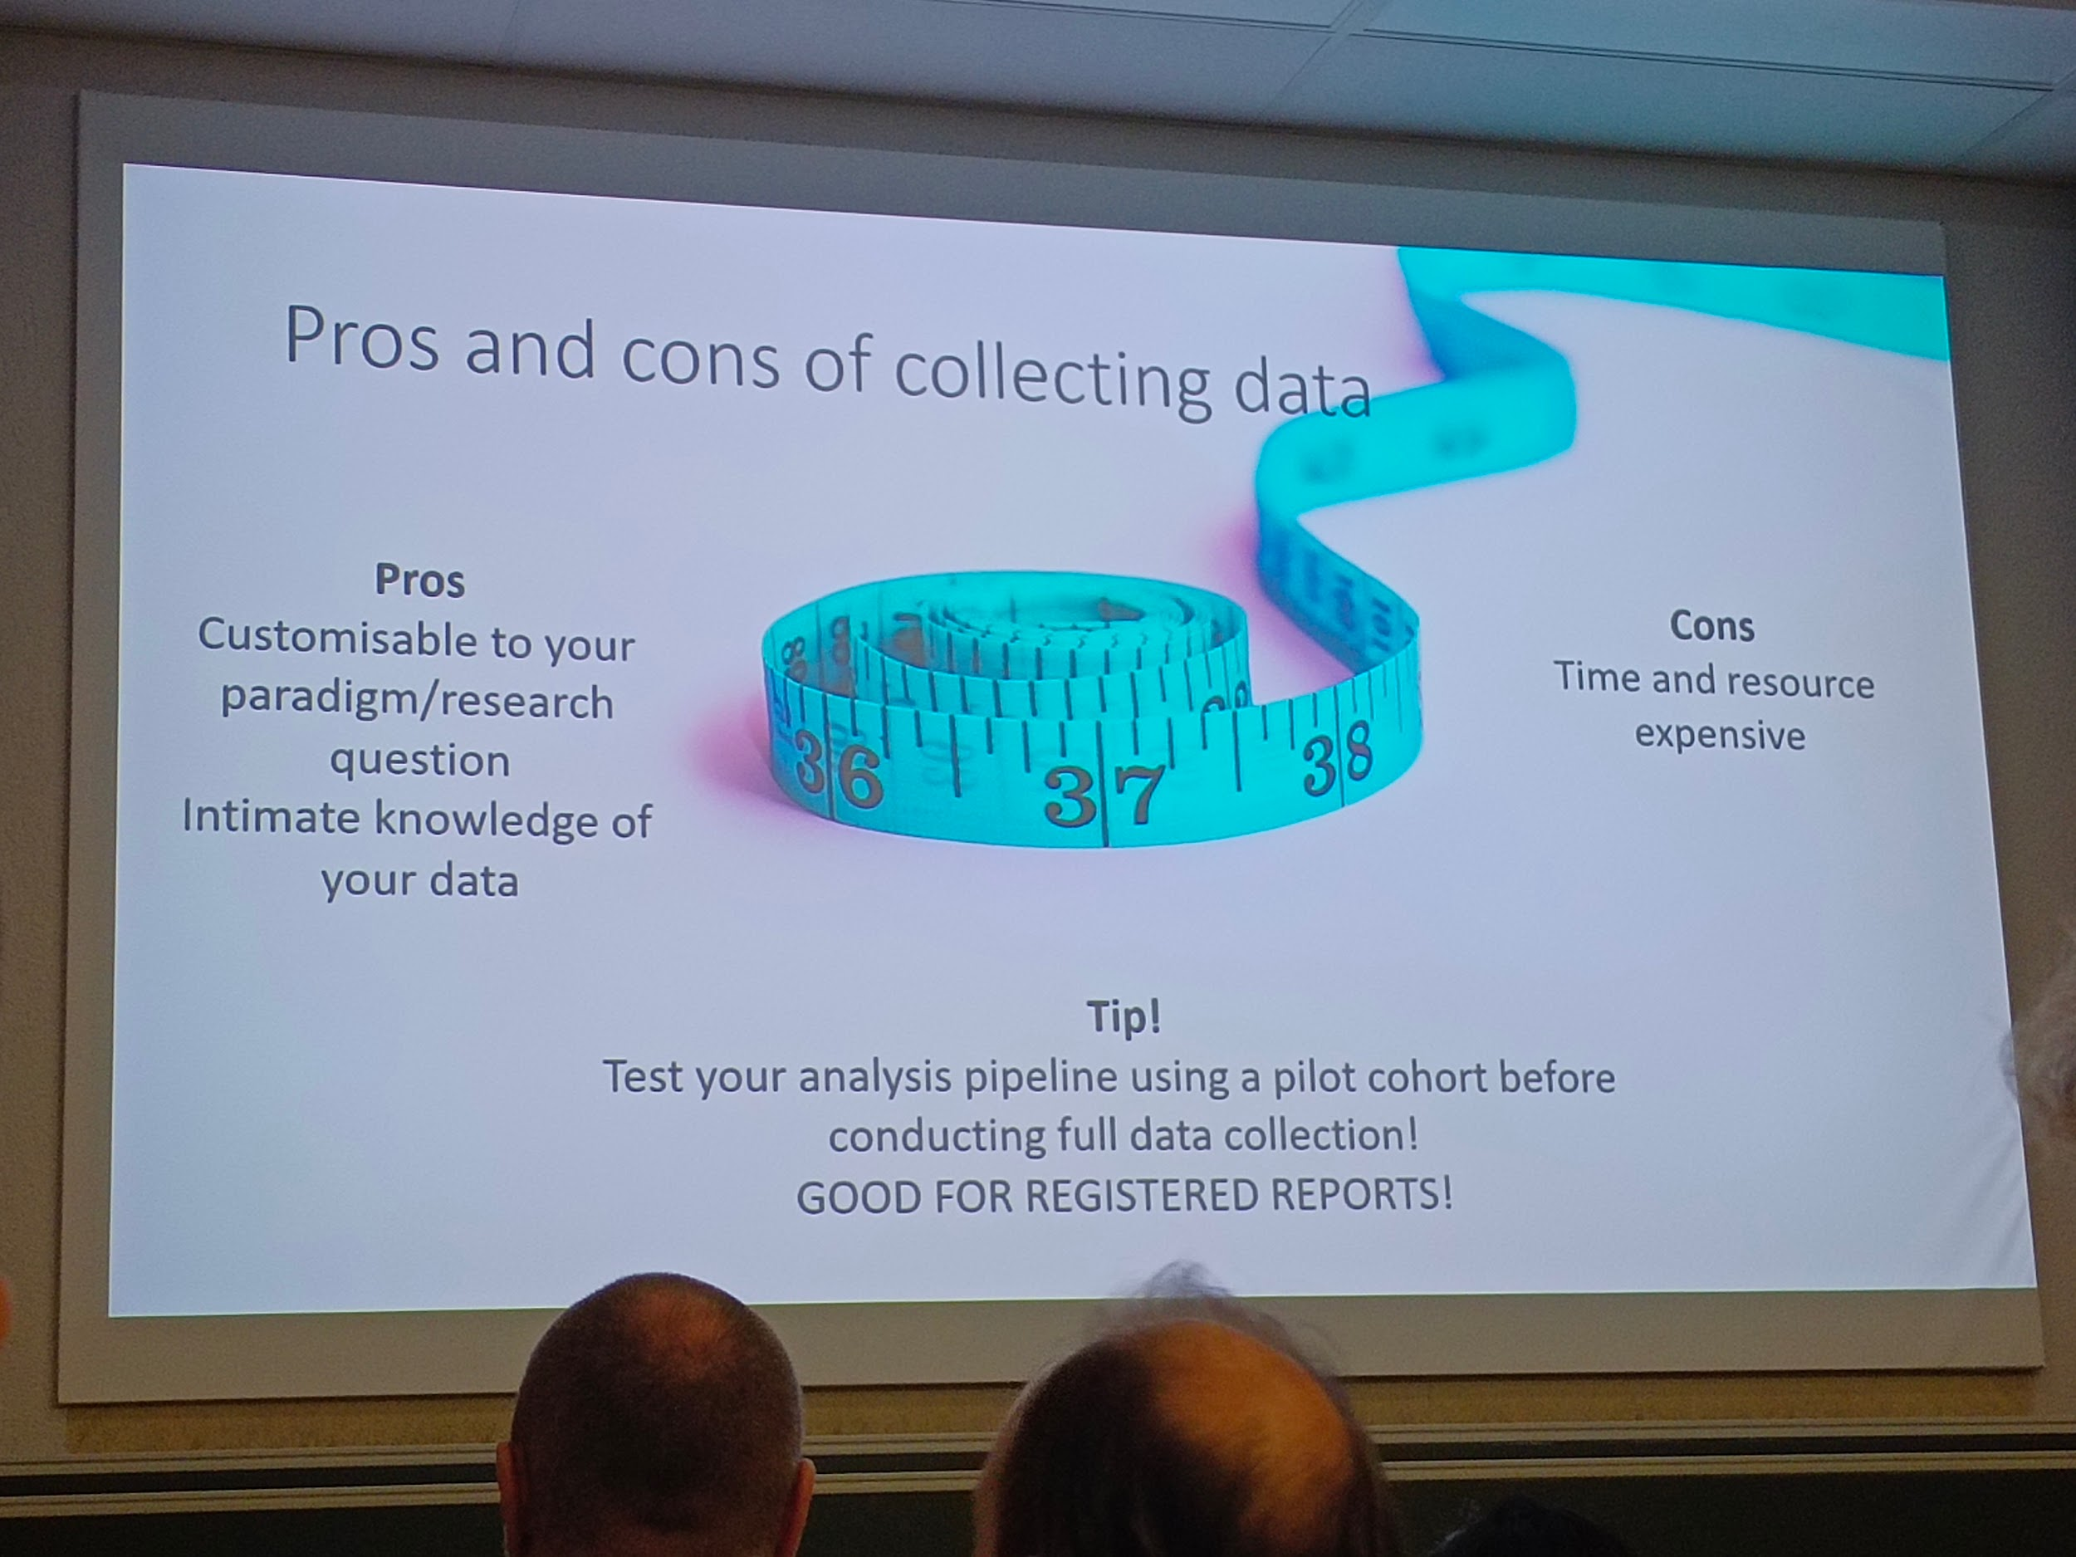

* Data anonymisation

available data

* ready to be used
* But got through the same previous process but earlier
* Human connectome project

fMRIPrep

BIDS

Neurosynth.org

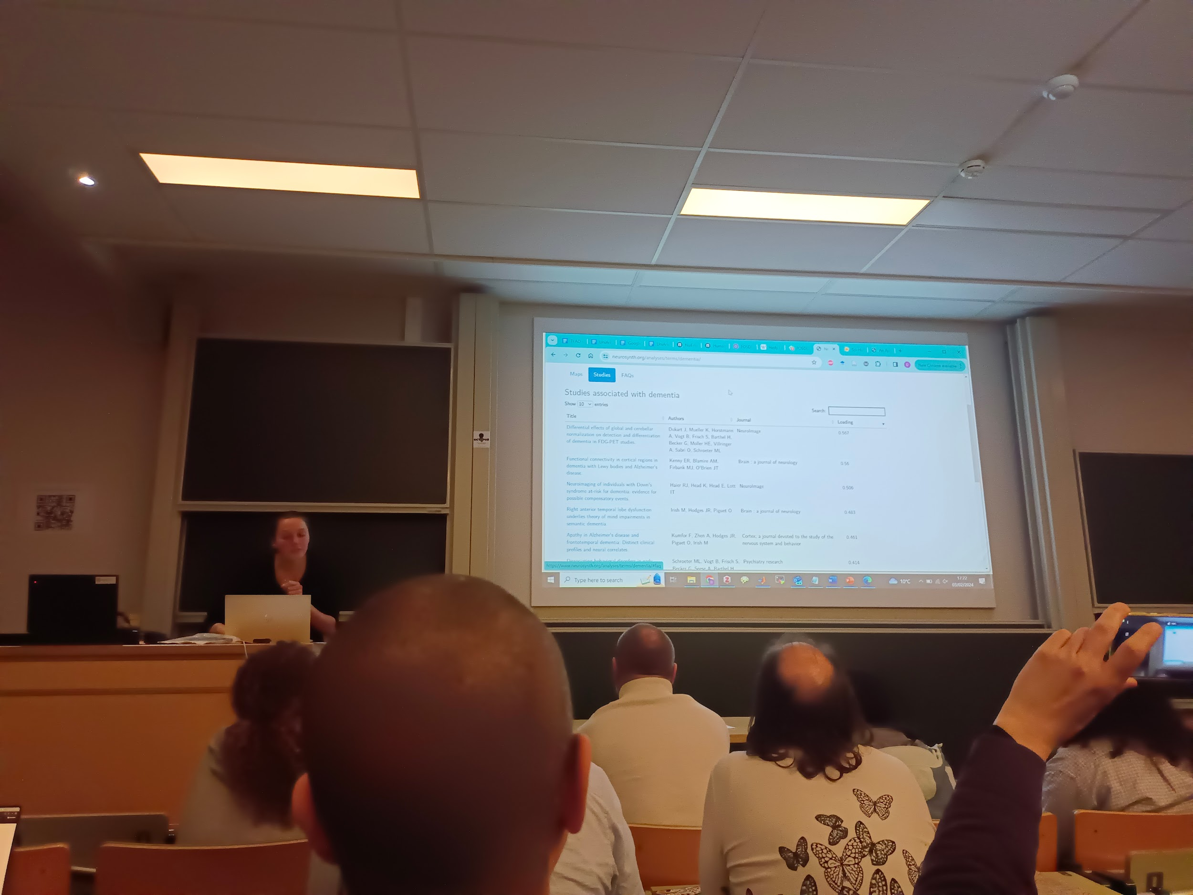

Papers

* Paywall (documentary)

SCI-HUB

NTRIC

…

Questions

State? Not great,

Multi scale? Multi modal imagery

----

## [FOSDEM 2024 - Apache Maven 4.0.0 - Current State](https://archive.fosdem.org/2024/schedule/event/fosdem-2024-2225-apache-maven-4-0-0-current-state/)

Ub5132 18h40 maven 4

* Model version 4.0.0
* What a pom: build config and dependencies management
* Can't change the format, so what about separate things

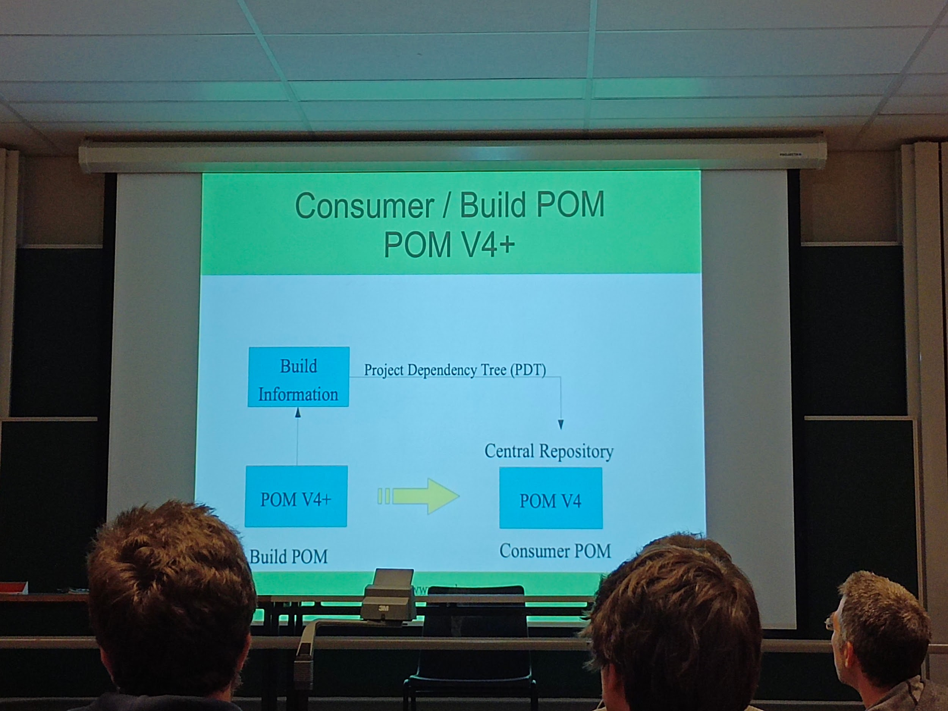

* Separate build and dependancies
* Allow to make the previous pom still working as usual under 4
* Self contained

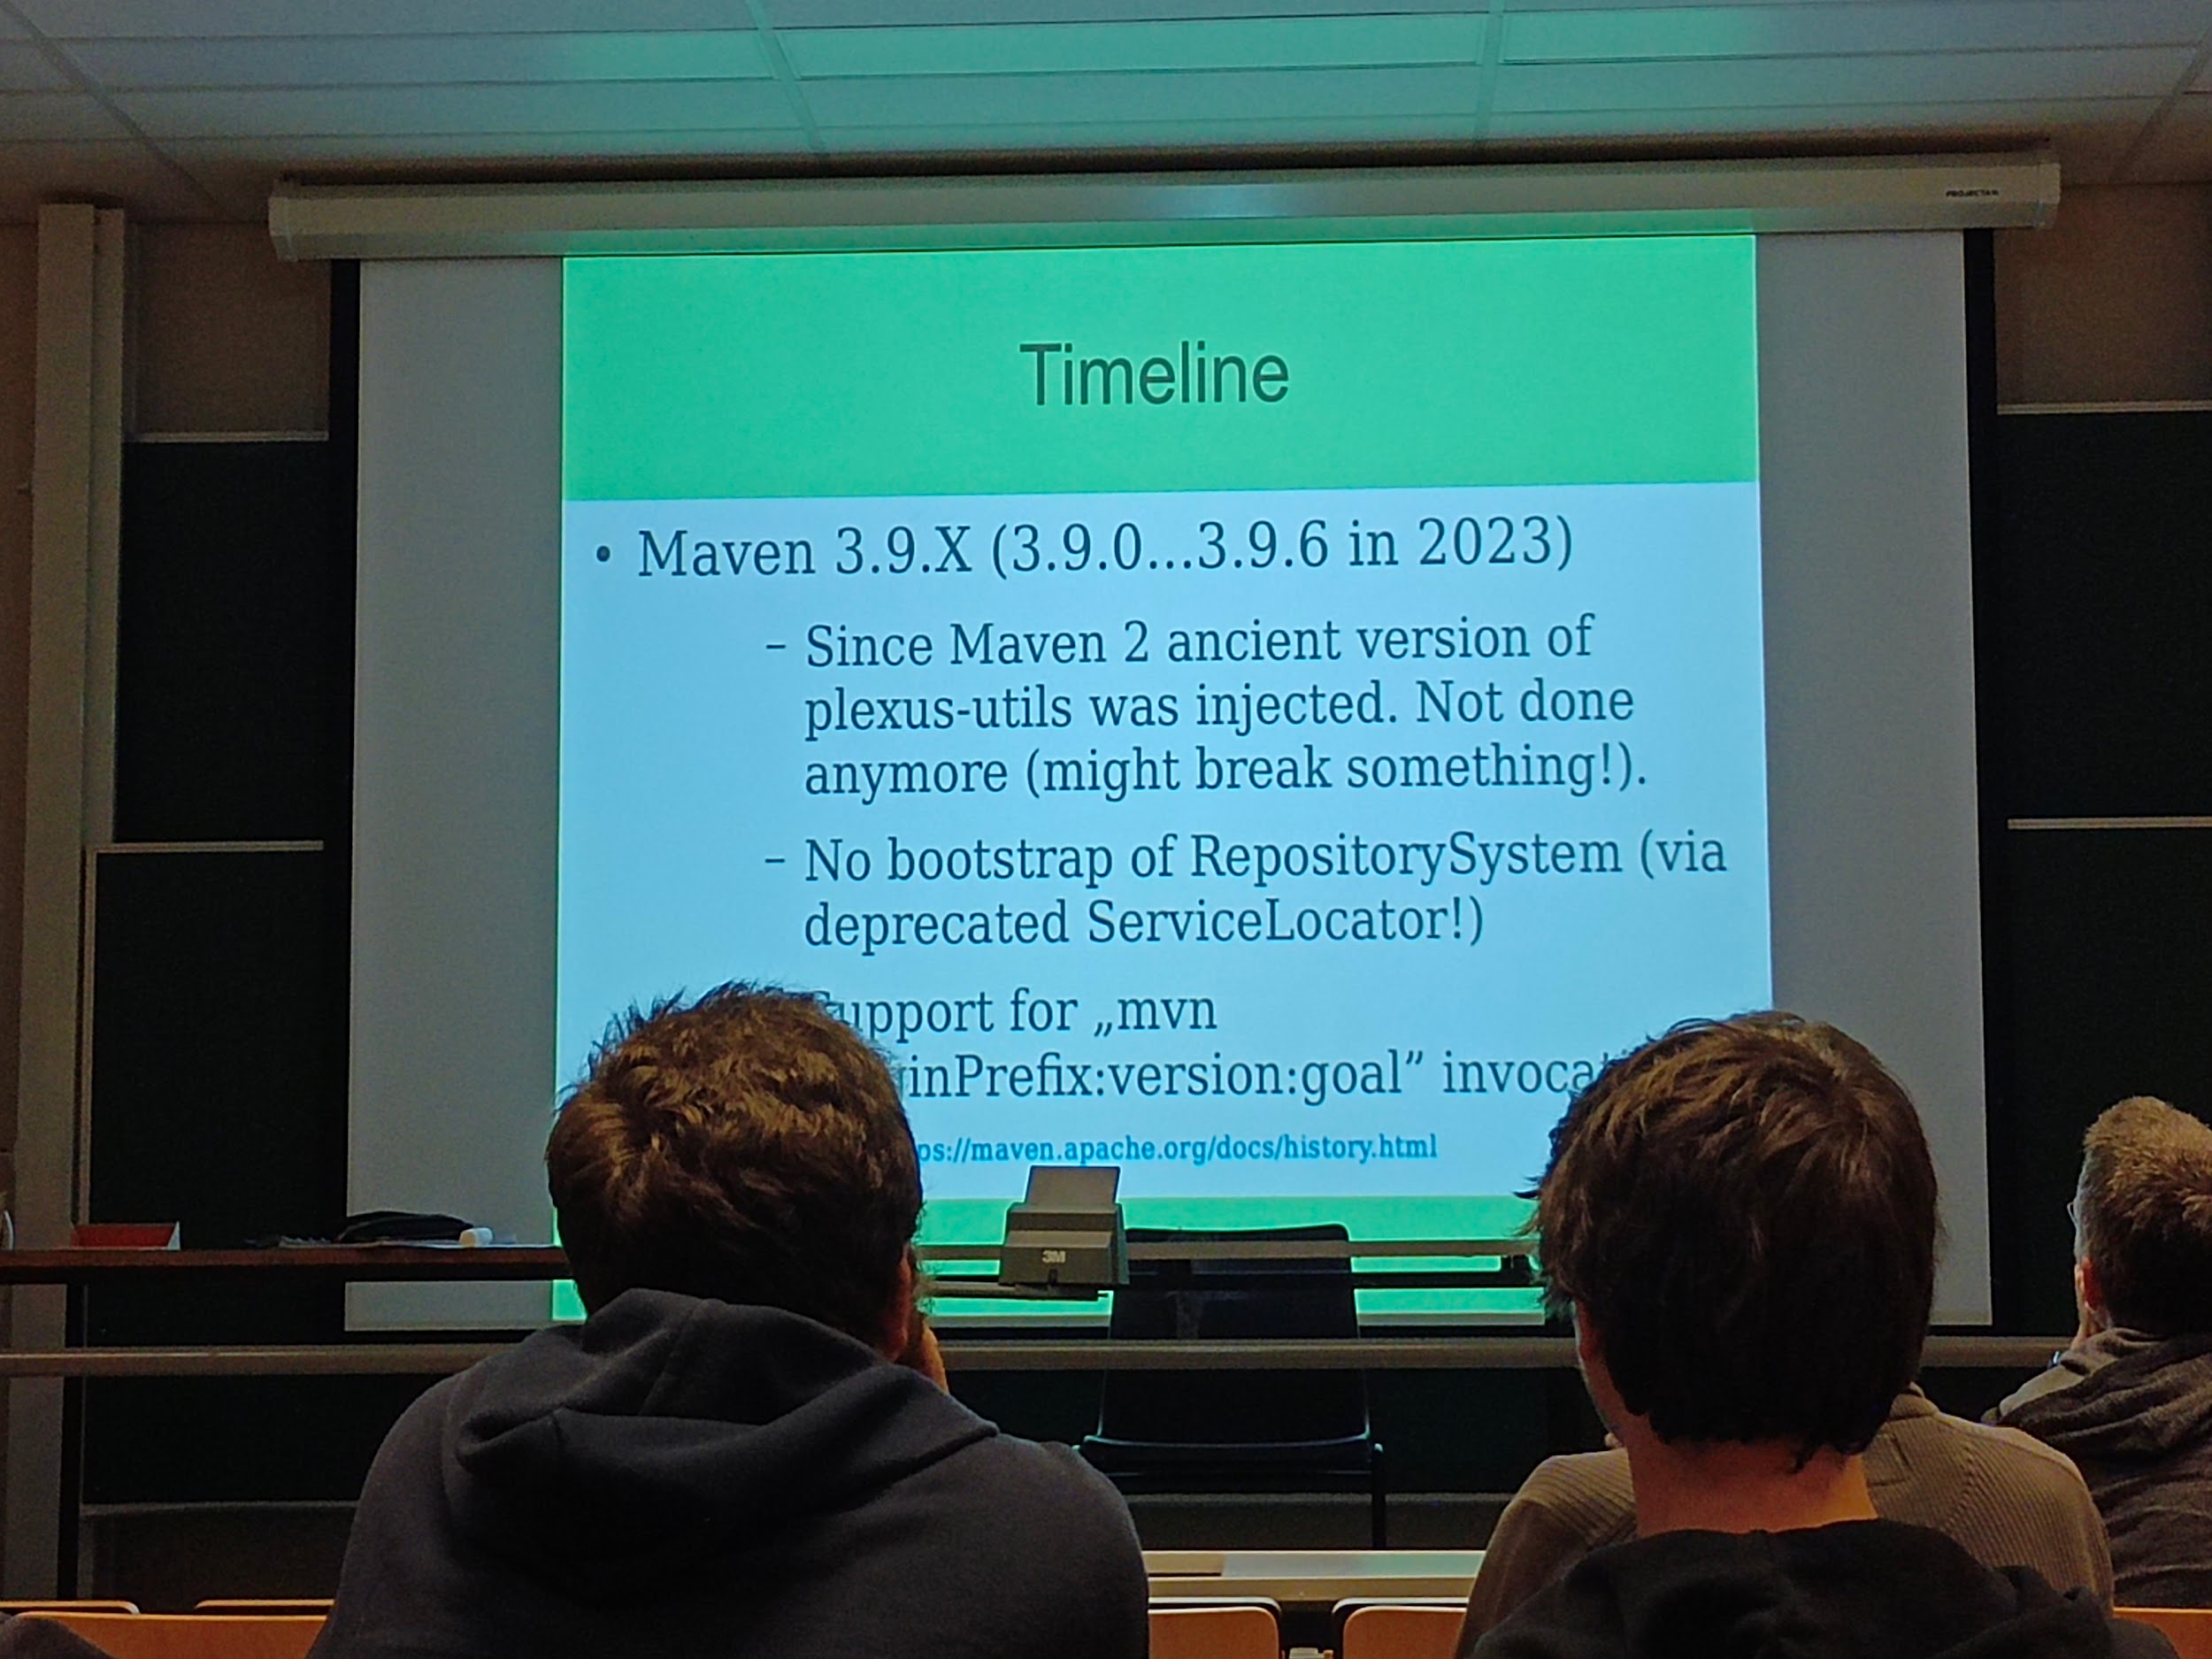

* Void slides timeline
* Currently ongoing

# Sunday

## [FOSDEM 2024 - Open Source in 2024: boundaries, burnout, business](https://archive.fosdem.org/2024/schedule/event/fosdem-2024-2029-open-source-in-2024-boundaries-burnout-business/)

Ua2114 10h20 open source boundaries

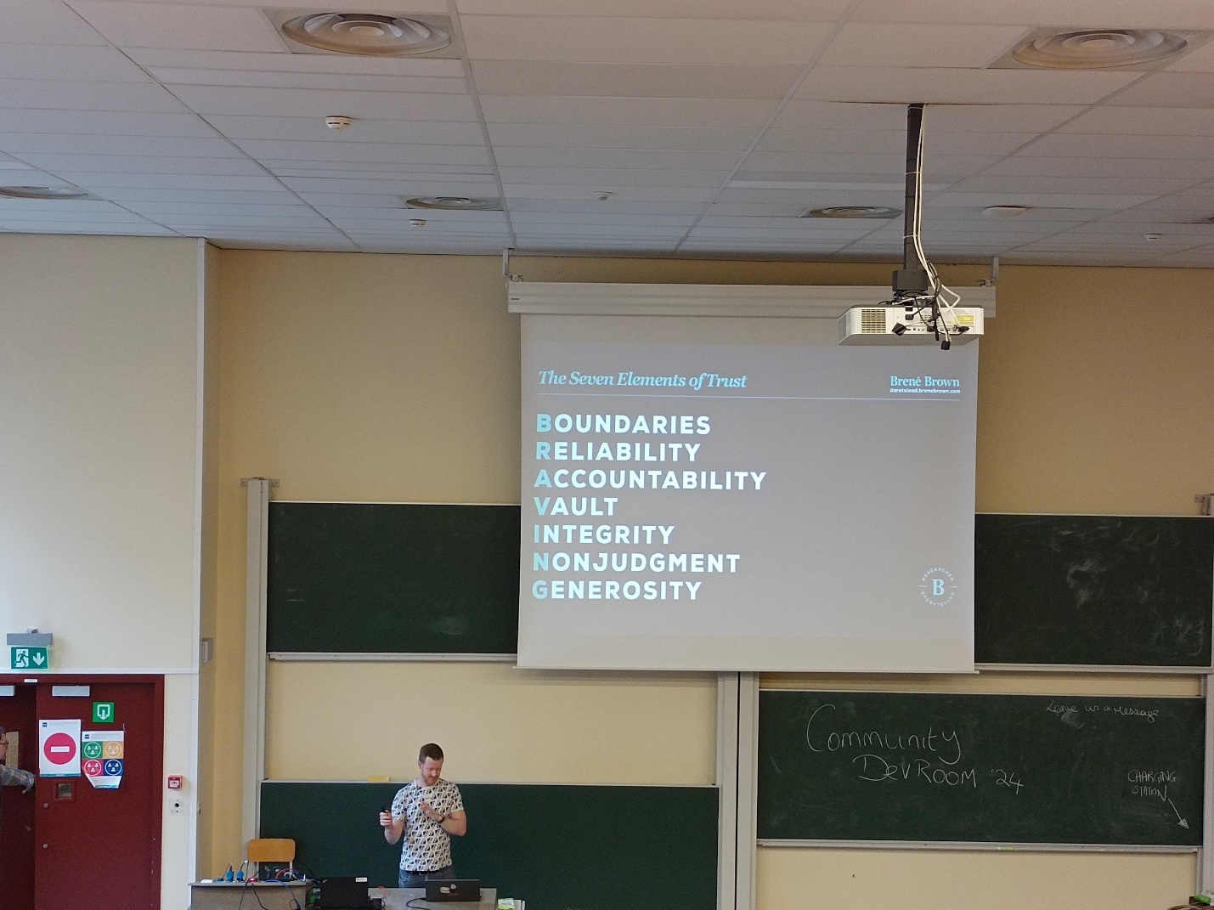

* Boundaries=API
* How you want to treat others and be treated by others
  + Saying no
* Users >>>> contributors >>> maintainers

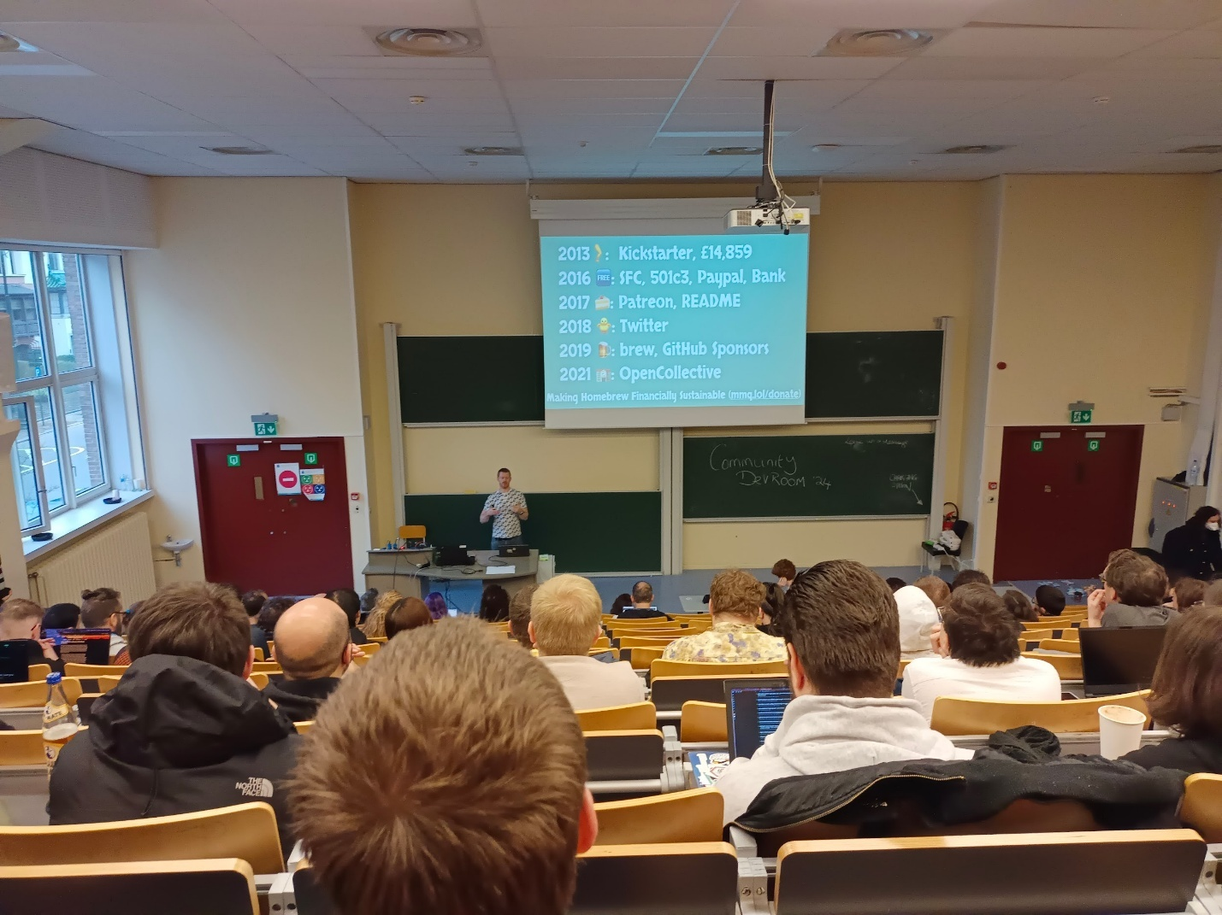

* Financially suitable

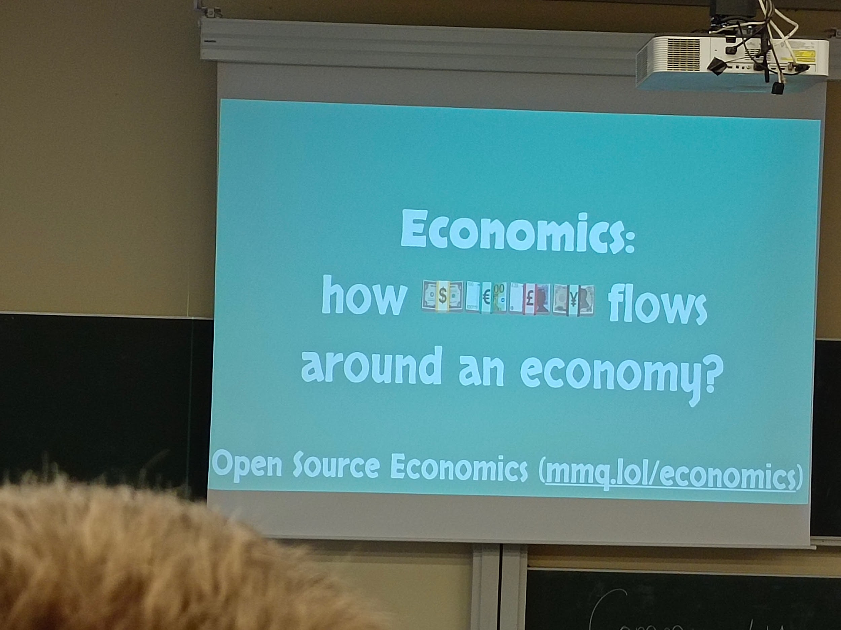

* Limit of maintainers
* Why keep doing open source? Maintain joy / interest
* OSS license

---

## [FOSDEM 2024 - Know Your Ingredients: Security Starts With the SBOM](https://archive.fosdem.org/2024/schedule/event/fosdem-2024-2920-know-your-ingredients-security-starts-with-the-sbom/)

K4401 11h00 SBOM

* JFrog

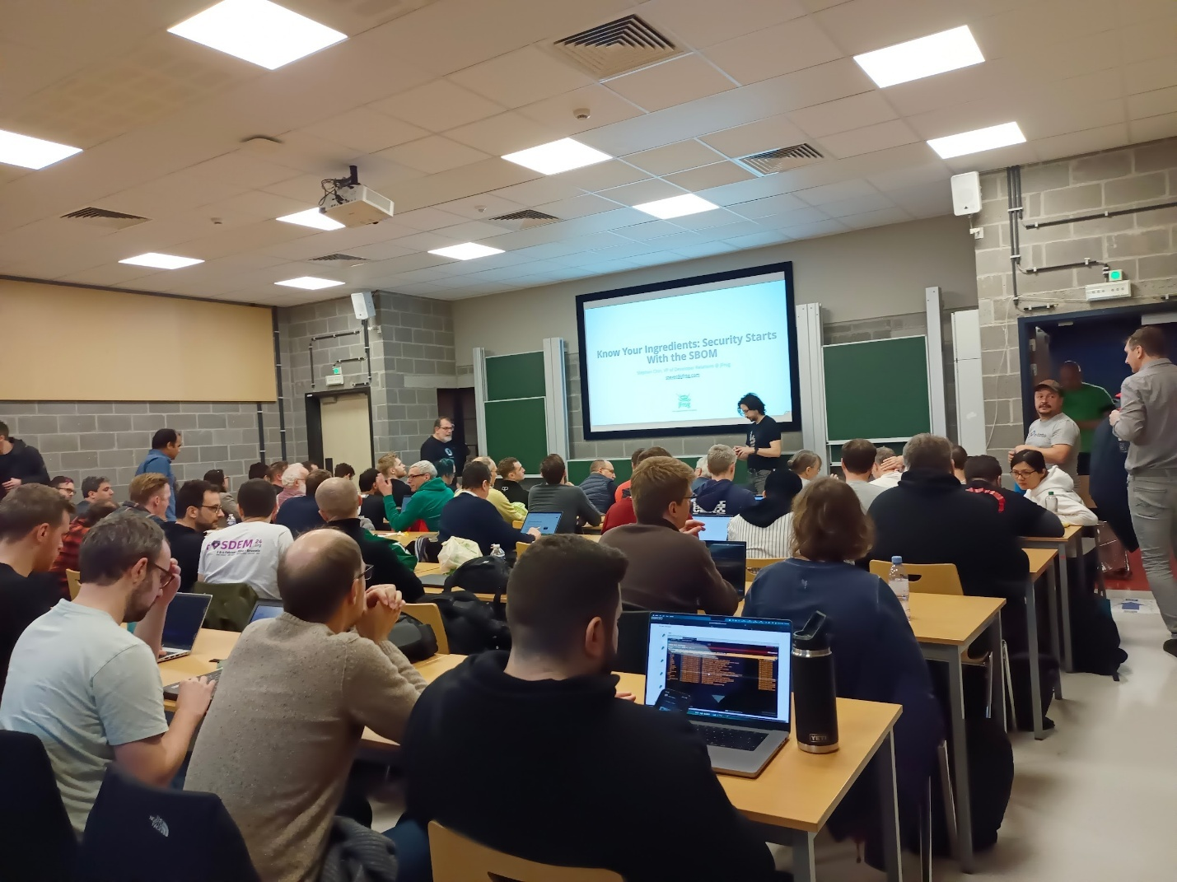

* Safe suppliers/clean supplies are necessary for a good start in the chain
* SLSA security standard

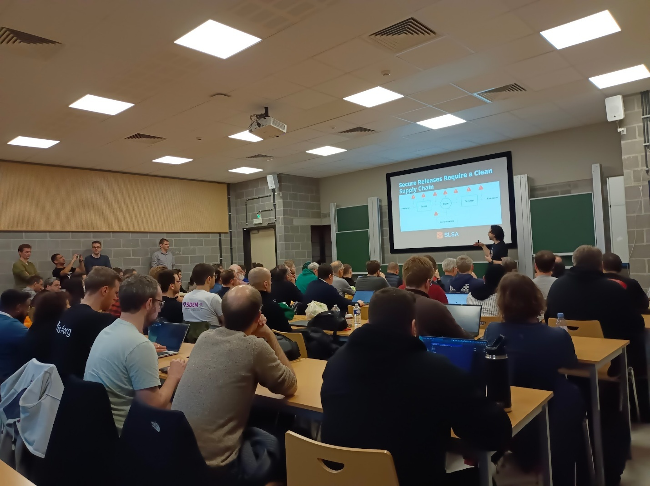

* Trusted by SBOM:
* SPDX, CycloneDX
* Is my product chain is effective and secure
* What about Deliverying/package management?
* "Dependency confusion attack"
  + Package mining
* 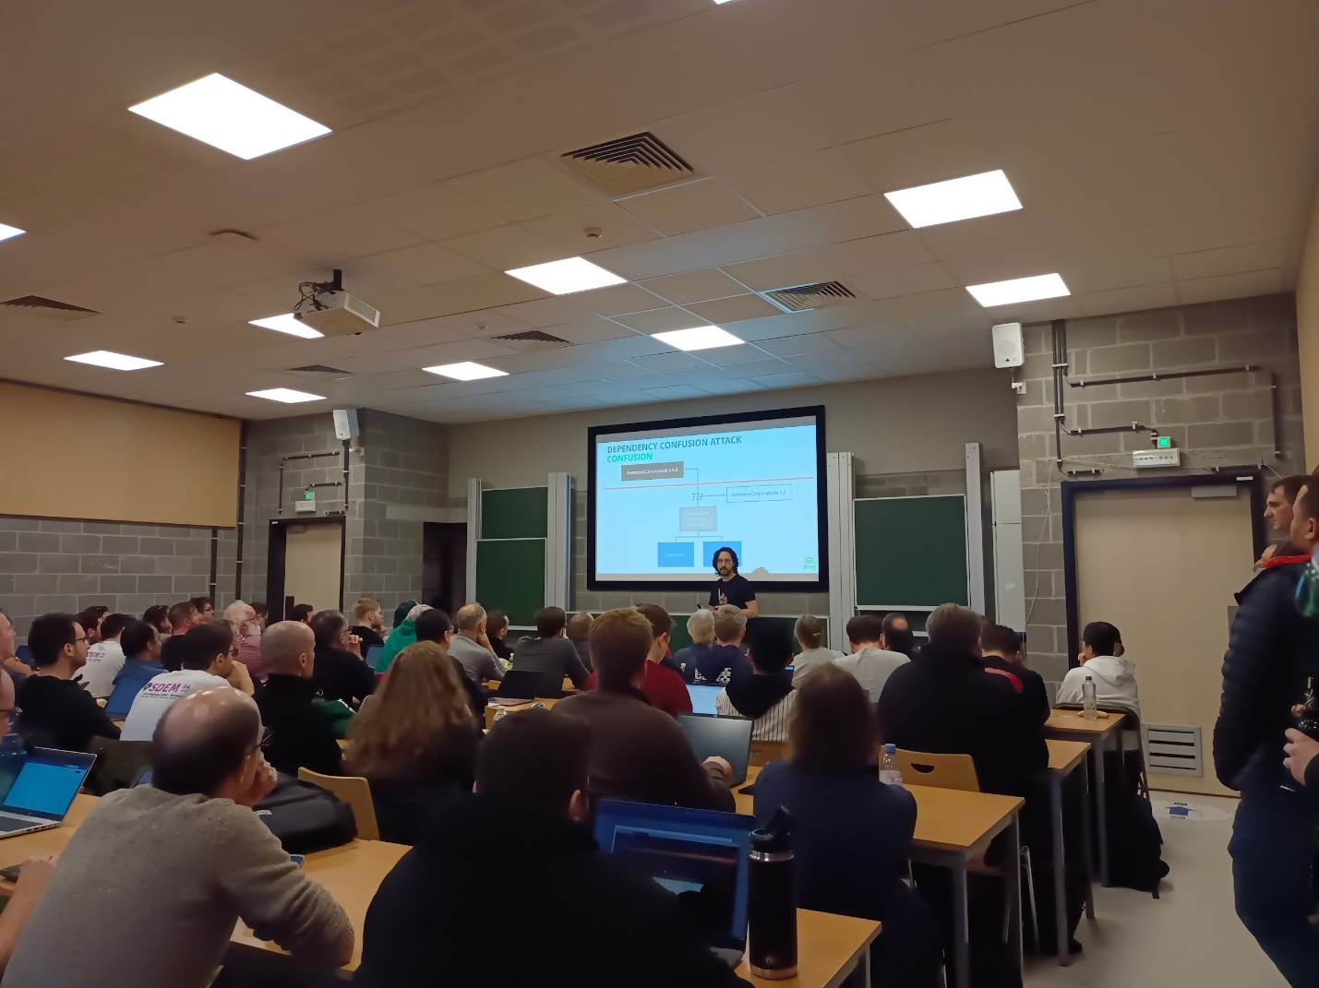
* "Type"/"Typo?"
* Attack based on left out namespace(or ext.), and so collecting the corrupted package instead of the wanted one
* "The left pad accident" (with Kik)
* Rotted code contaminated the rest (like a rotten fruit)
* GUAC tool: look on your dependencies
* Exposed secrets in central repos
  + Check your code for exposed secrets
  + ?
  + Accès moderation on secrets
  + Careful on token while fixing
  + No unnecessary public info
* OpenSSF Scorecard: tool to help you to know the level of the security in your code
* What about ML models?
  + Vulnerable with easy malicious code injection
  + Not safe currently
  + Risk of exposure of your own code vulnerability due to use of ML

----

## [FOSDEM 2024 - Breaking Barriers: Content Management Systems and Accessibility](https://archive.fosdem.org/2024/schedule/event/fosdem-2024-2638-breaking-barriers-content-management-systems-and-accessibility/)

K4601 11h45 accessibility

Accessibility challenges due to nature, permanent or temporary situation, mental/motor/technical/economical/geographic

Think about it from the start

Inclusion cost? Actually do not include means exclusion of potential target, money is not the issue

"A11Y"

Performance cost? Actually thinking about inclusion make it build more performance minded

Security? Actually more challenging for inclusion, a trade off?

* Authentication challenge
  + What is actually effective? Captcha? No, pad? Not really… other solutions exist

content management

* Front: for users obv
* Back too in teh code itself: for maintainers, devs, etc. !
  + More thoughts while coding but Less while maintaining/fixing !

"mittwald."

Coding guidelines

Semantic content structure

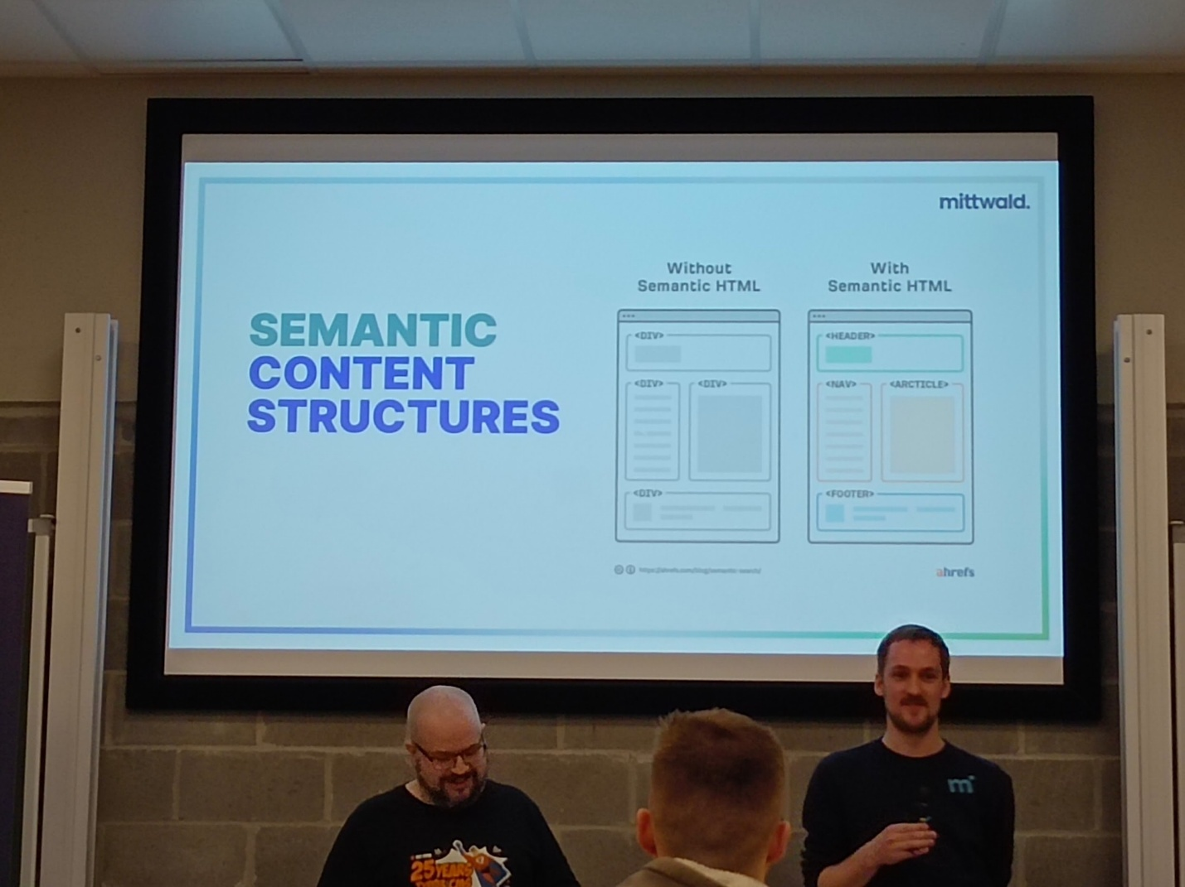

Users expectations

* Situation where a training is necessary to acces to our API
* Adhere to Convention (like menu convention) make it easier for users and coders
* Do not clutter !
* Give choices (aesthetic like dark mode, organisation cluttered or not, readability like font size)
* Autoplay are intrusive annoying and consuming let's not use it
* 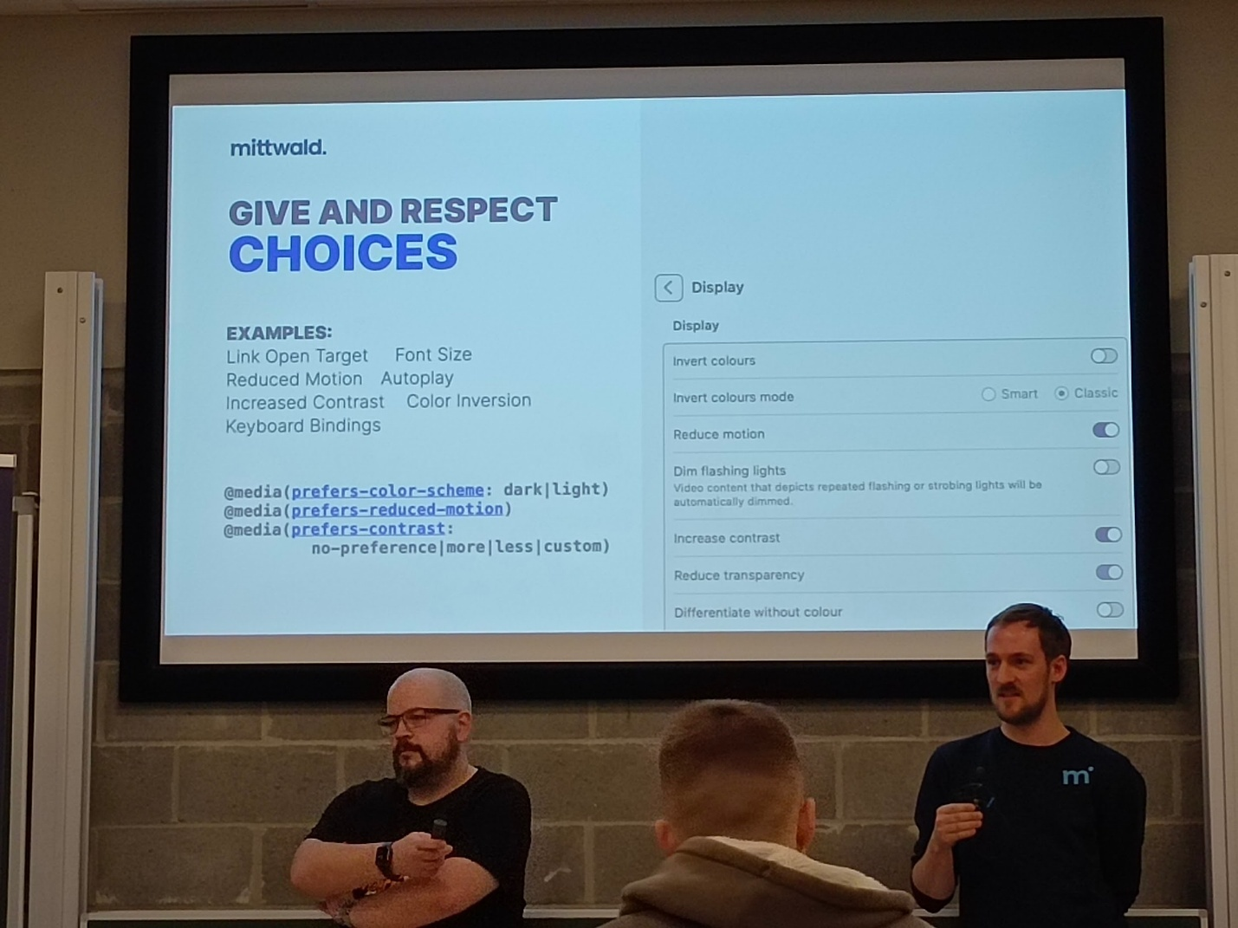
* Mindful of movement/animation and colours

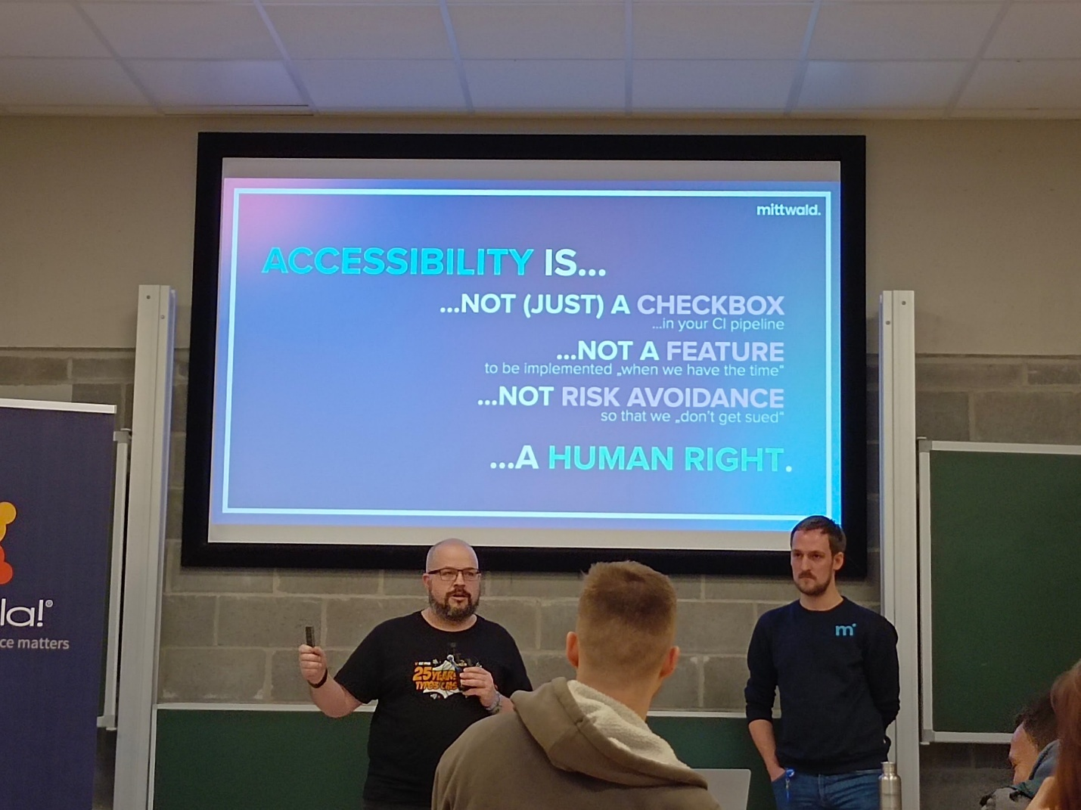

Make advantage of being multiple/many

Automatic change like auto dark mode, is it bad? Just let's the choice to the user. Make it clear the user can choose

----

## [FOSDEM 2024 - SBOMs that you can trust - the good, the bad, and the ugly](https://archive.fosdem.org/2024/schedule/event/fosdem-2024-2889-sboms-that-you-can-trust-the-good-the-bad-and-the-ugly/)

K4401 13h00 SBOM

* Chainloop-dev (GitHub)

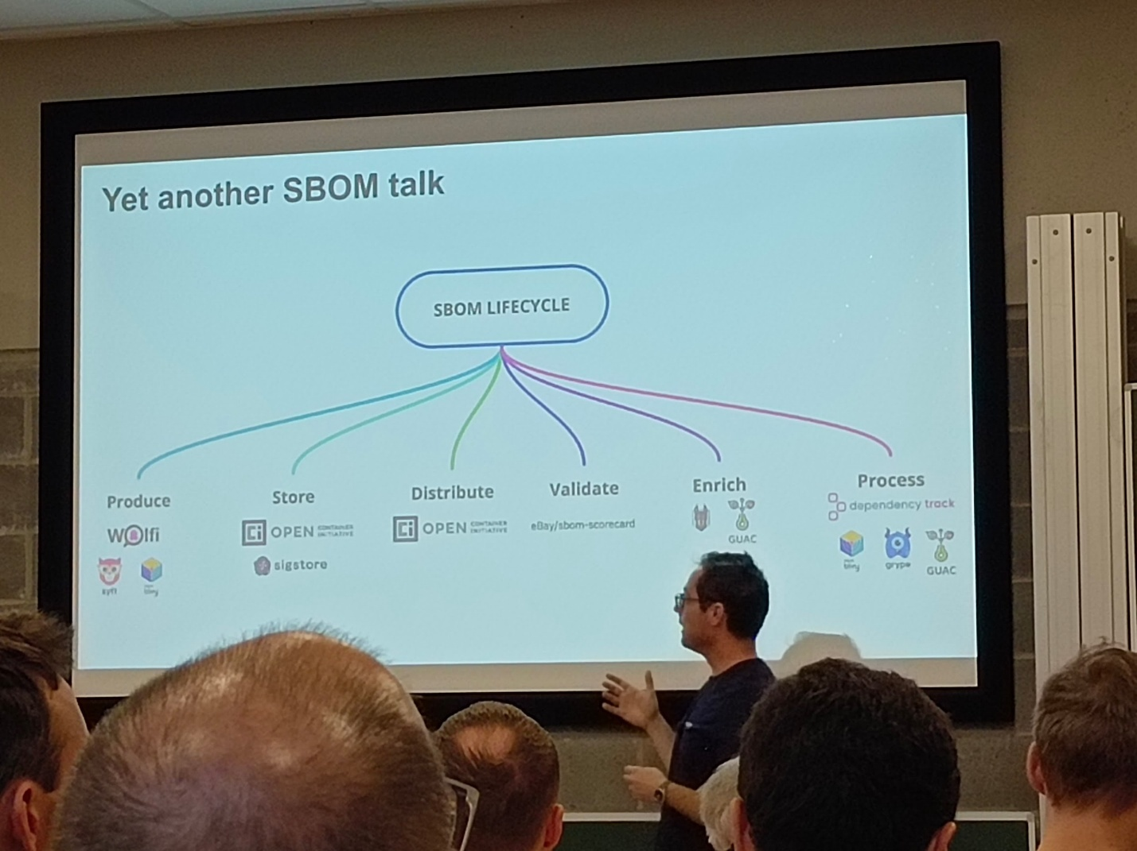

* Trust?

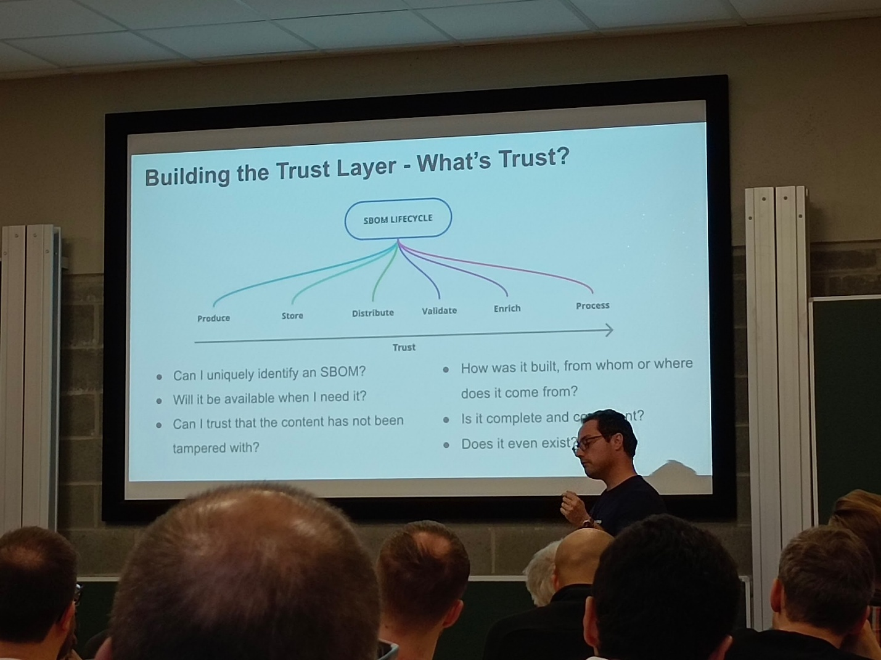

* Identify? Avaibility? Has been tampered? What how from where? Complete and consistent? Actually exists?
* SSC
* Attestation:
* Sigstore, in-toto, sbomit, slsa
* CAS content addressable storage:
* Open container initiative
* Implementation:
  + Chainloop

---

## [FOSDEM 2024 - Desktop Linux, as easy as a smartphone! Just in a Snap!](https://archive.fosdem.org/2024/schedule/event/fosdem-2024-1860-desktop-linux-as-easy-as-a-smartphone-just-in-a-snap-/)

Ua2118 13h30 snap

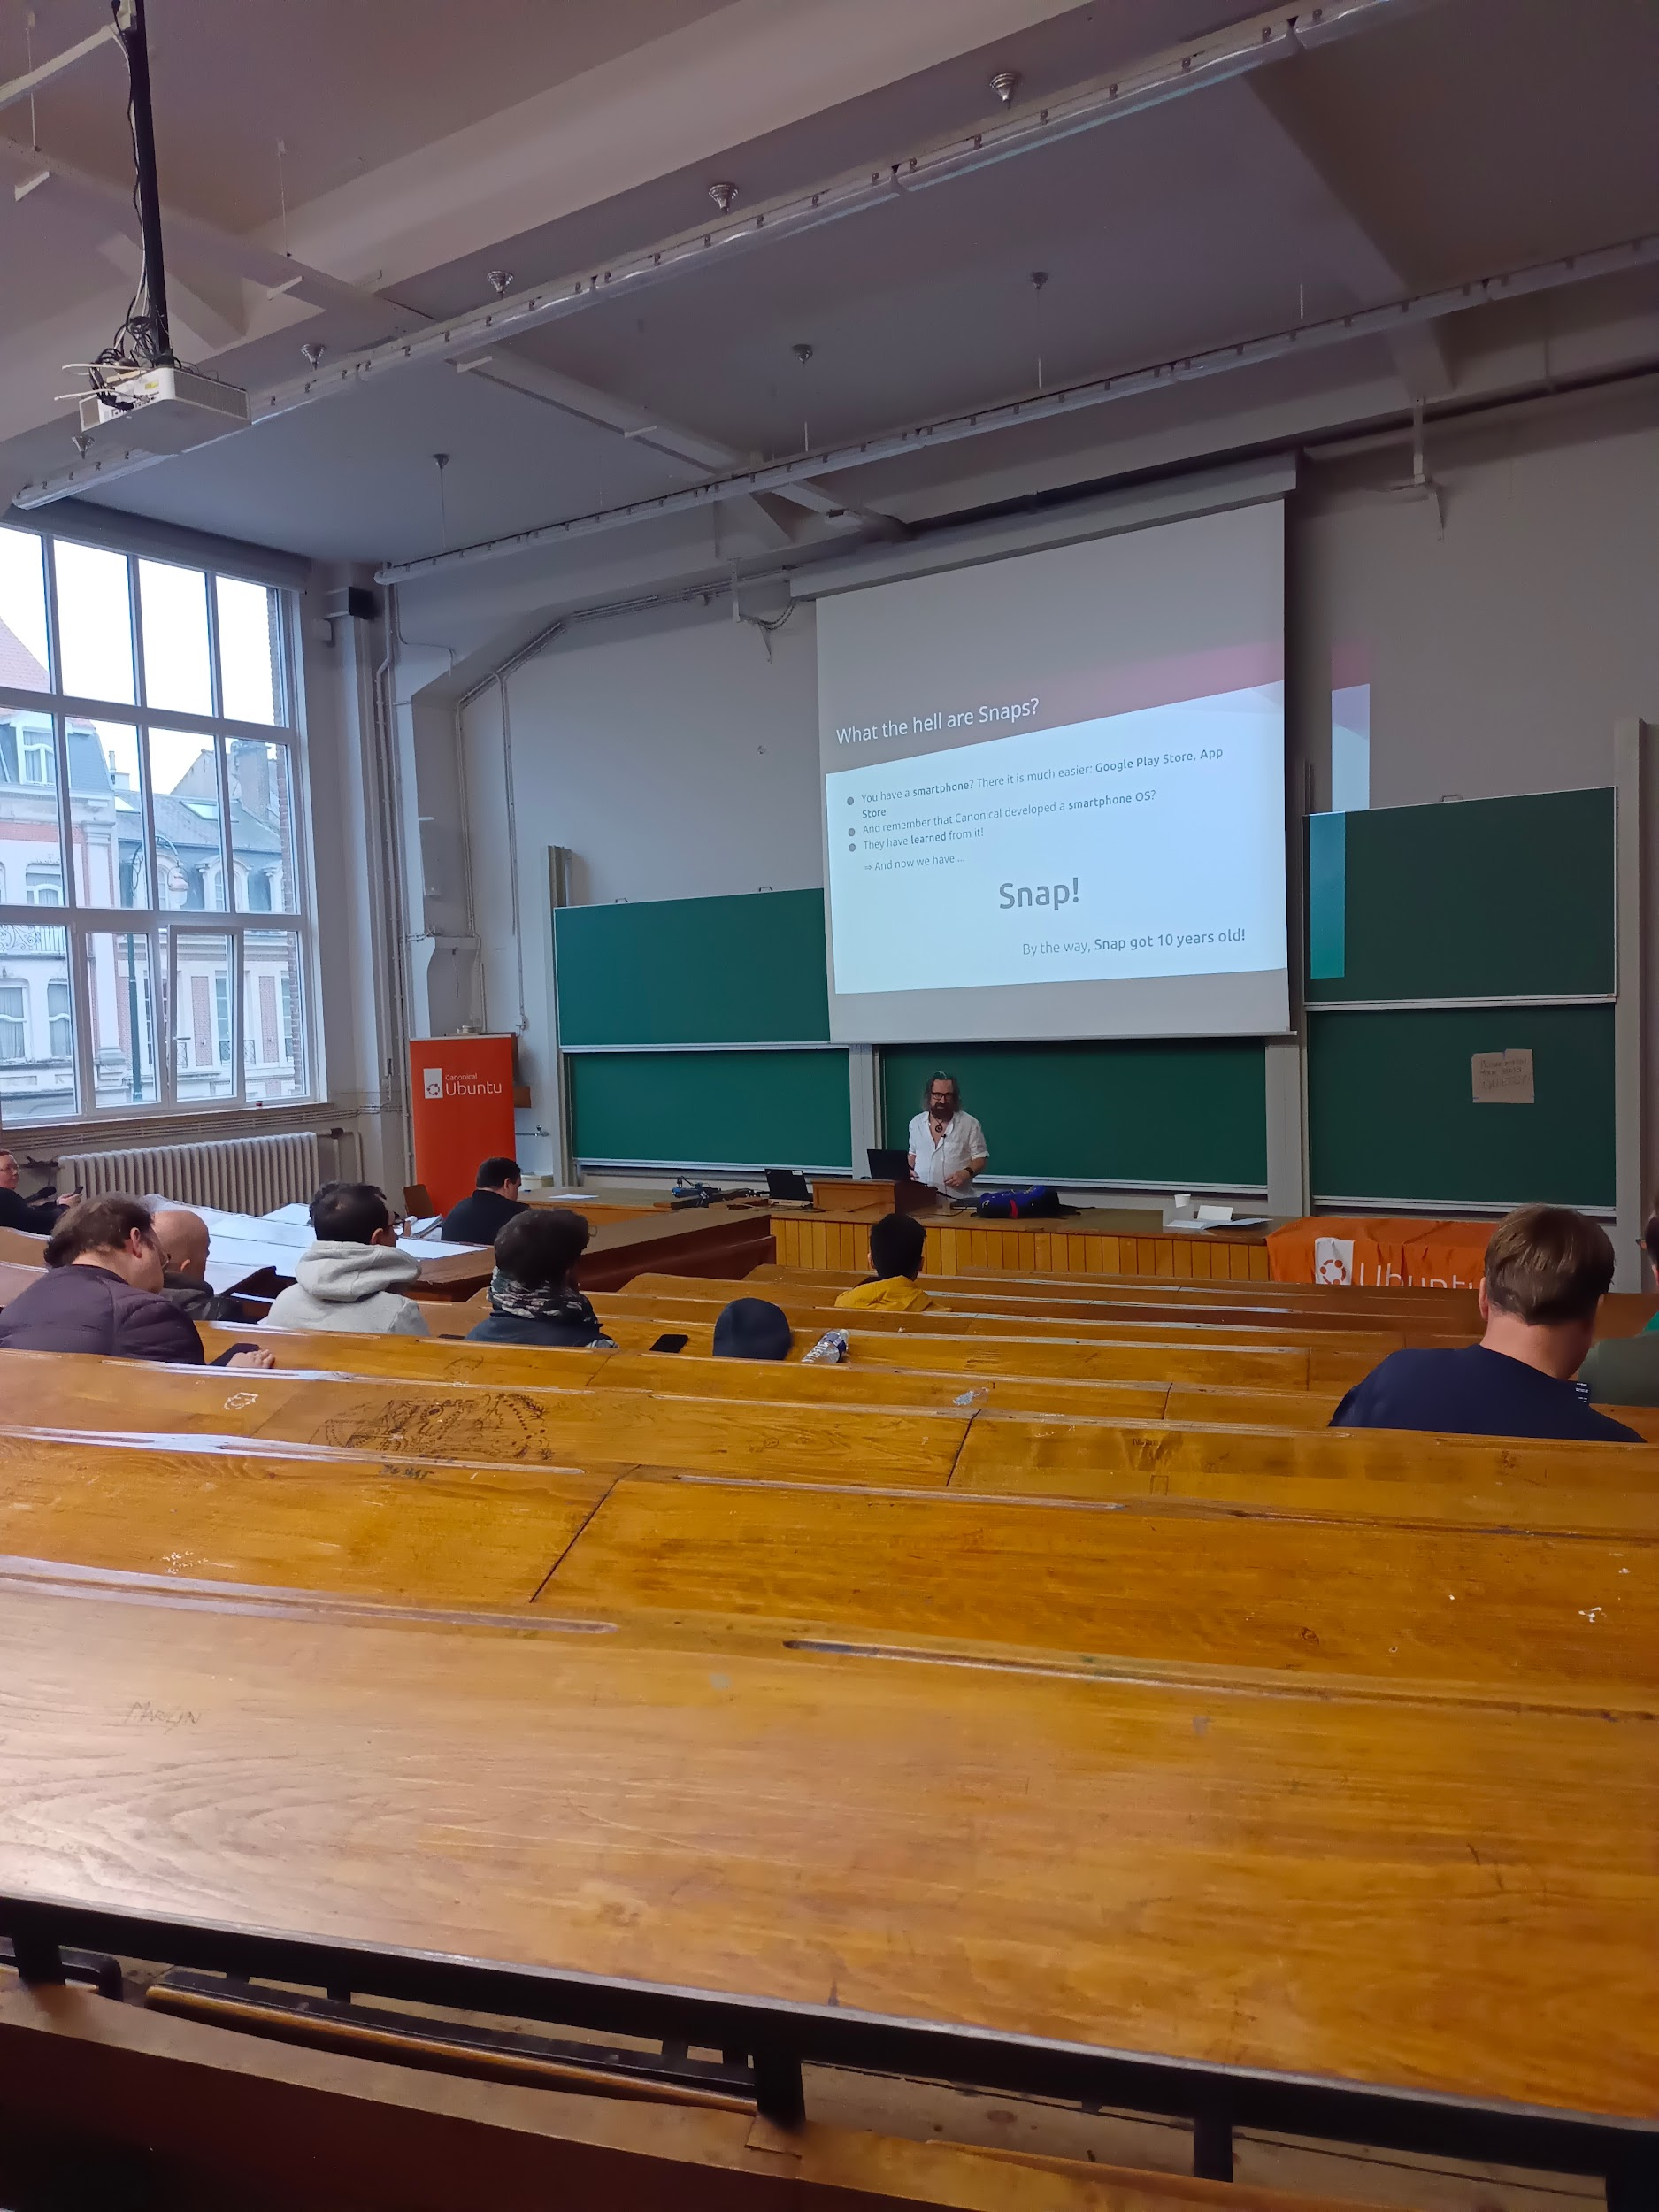

Sandboxed packaging

Os distribution indépendant

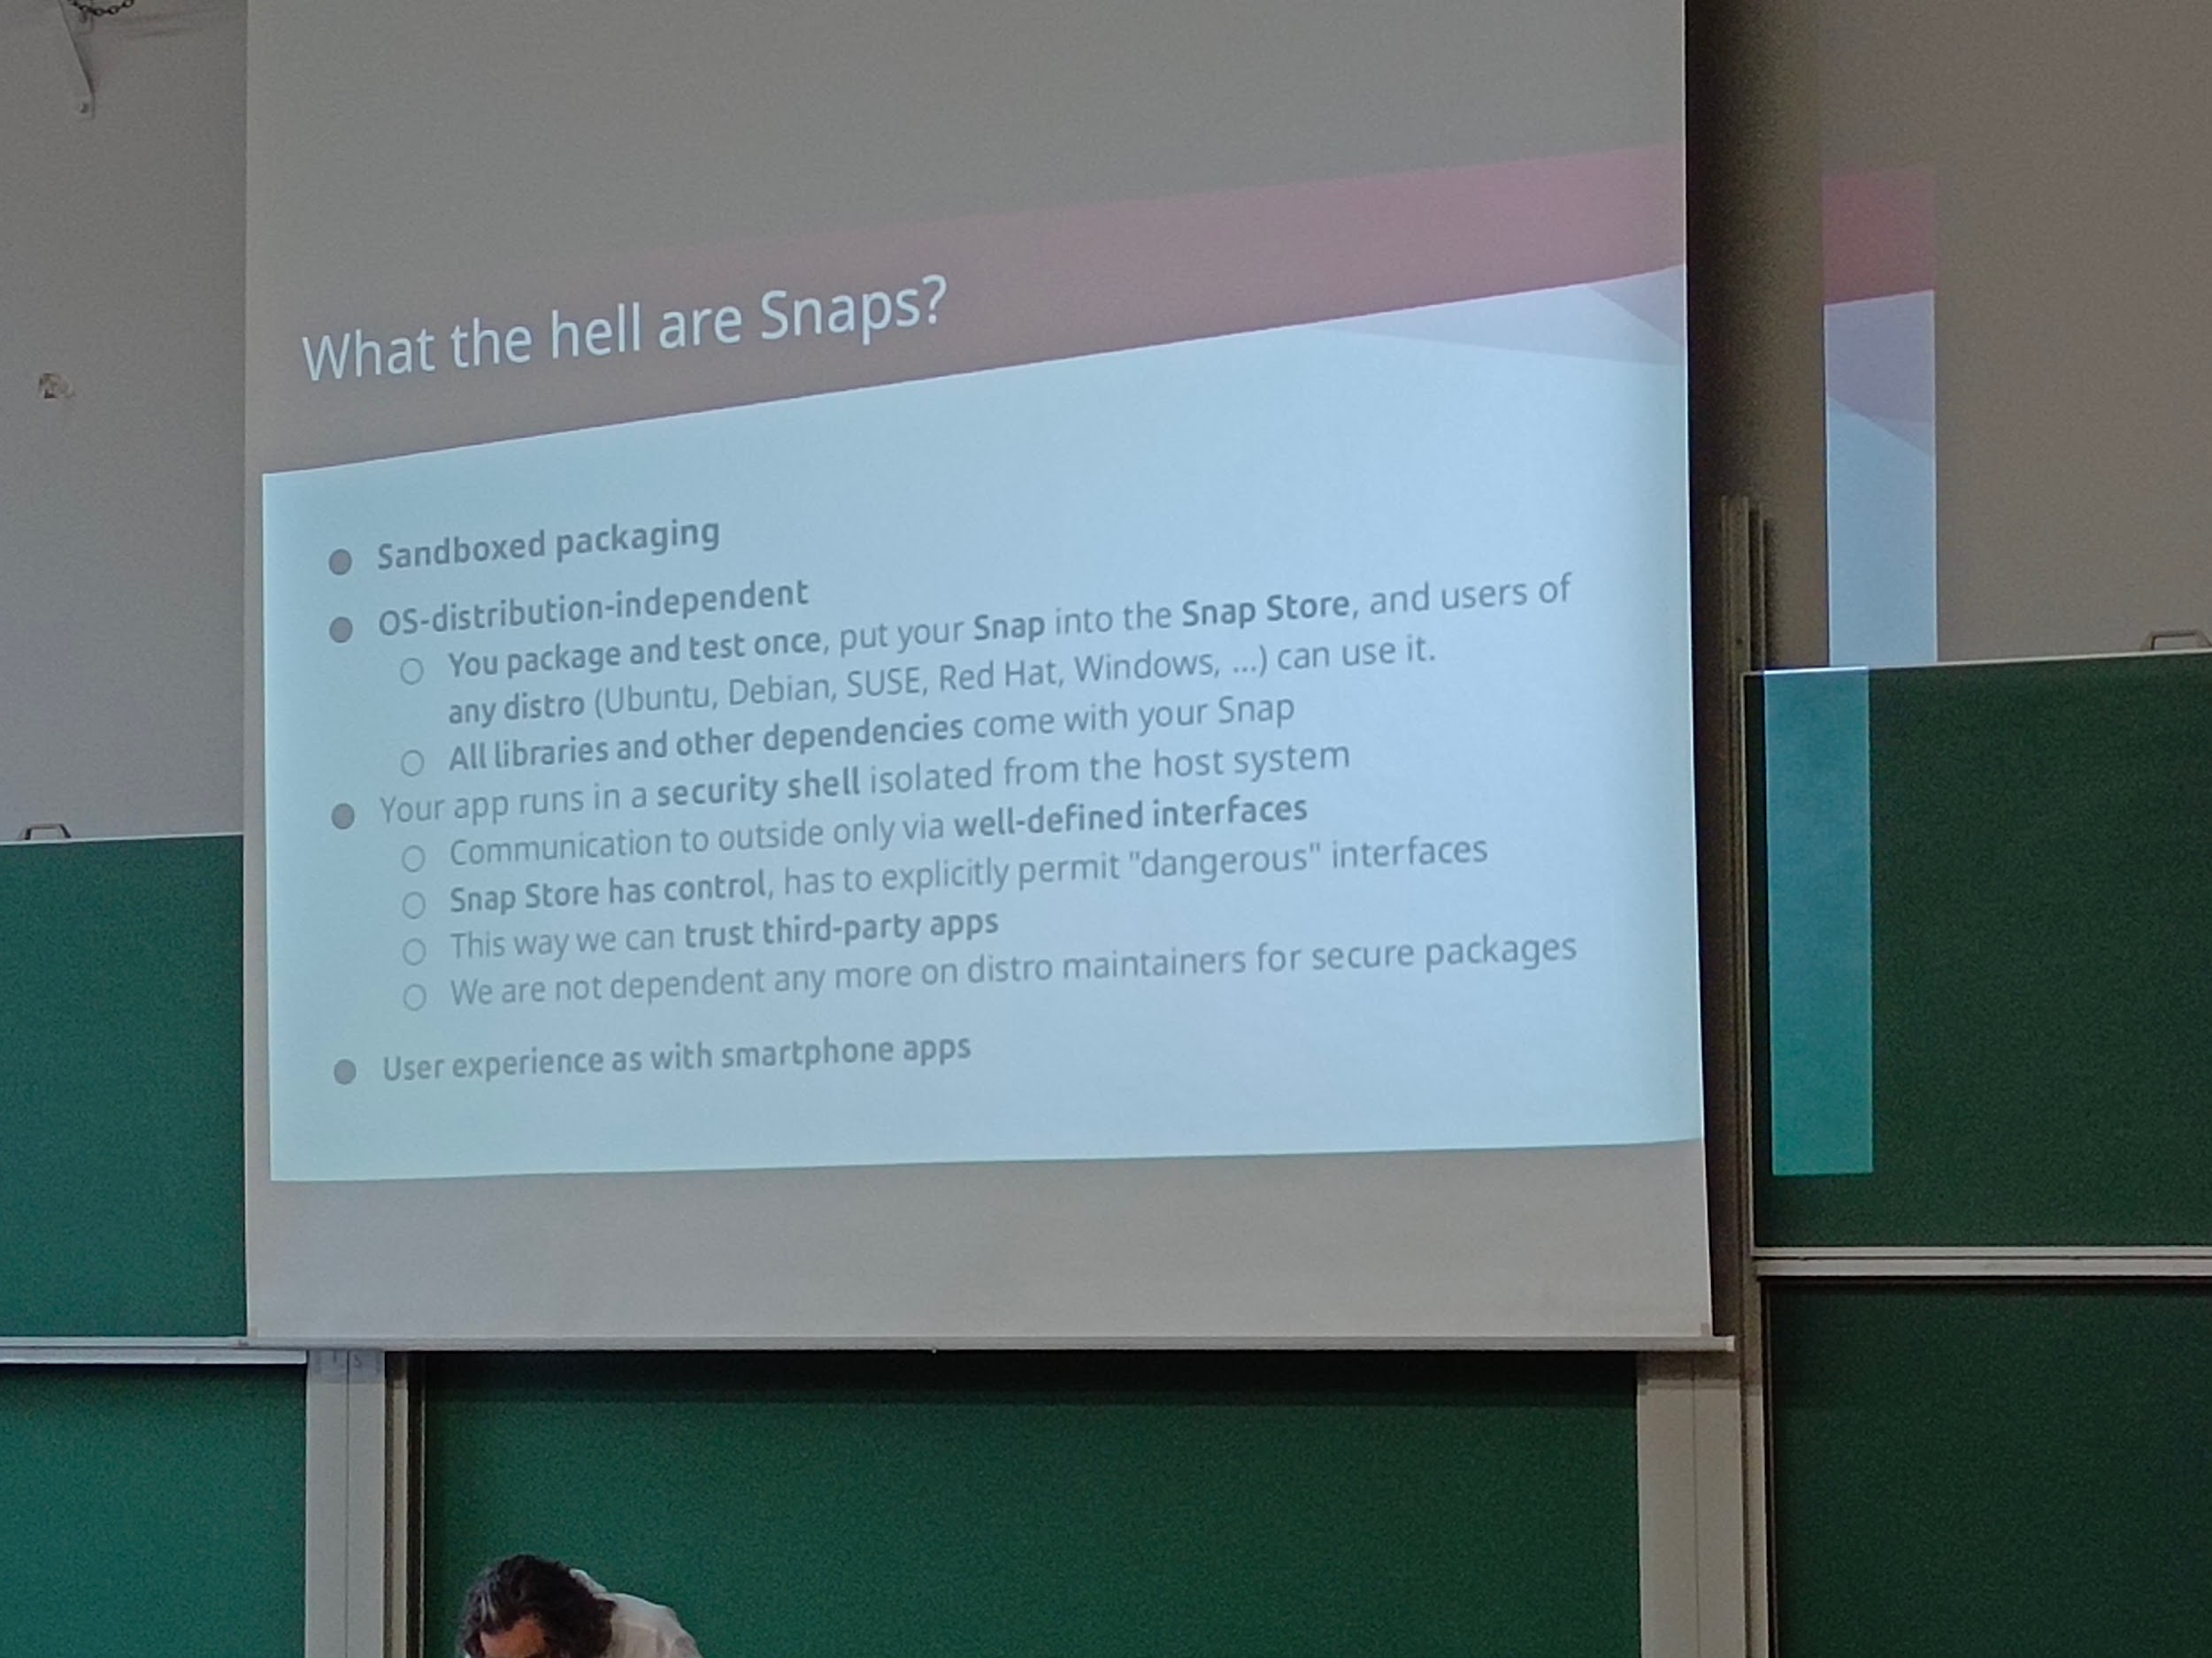

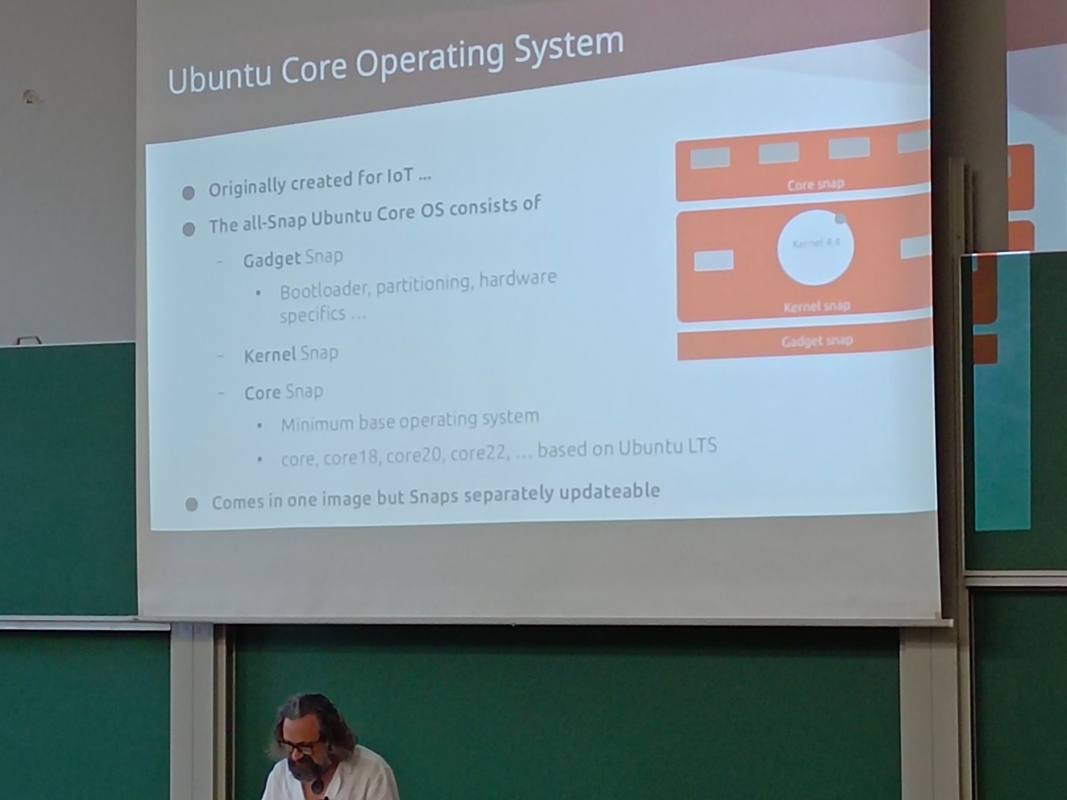

Each snap is independent and isolated J

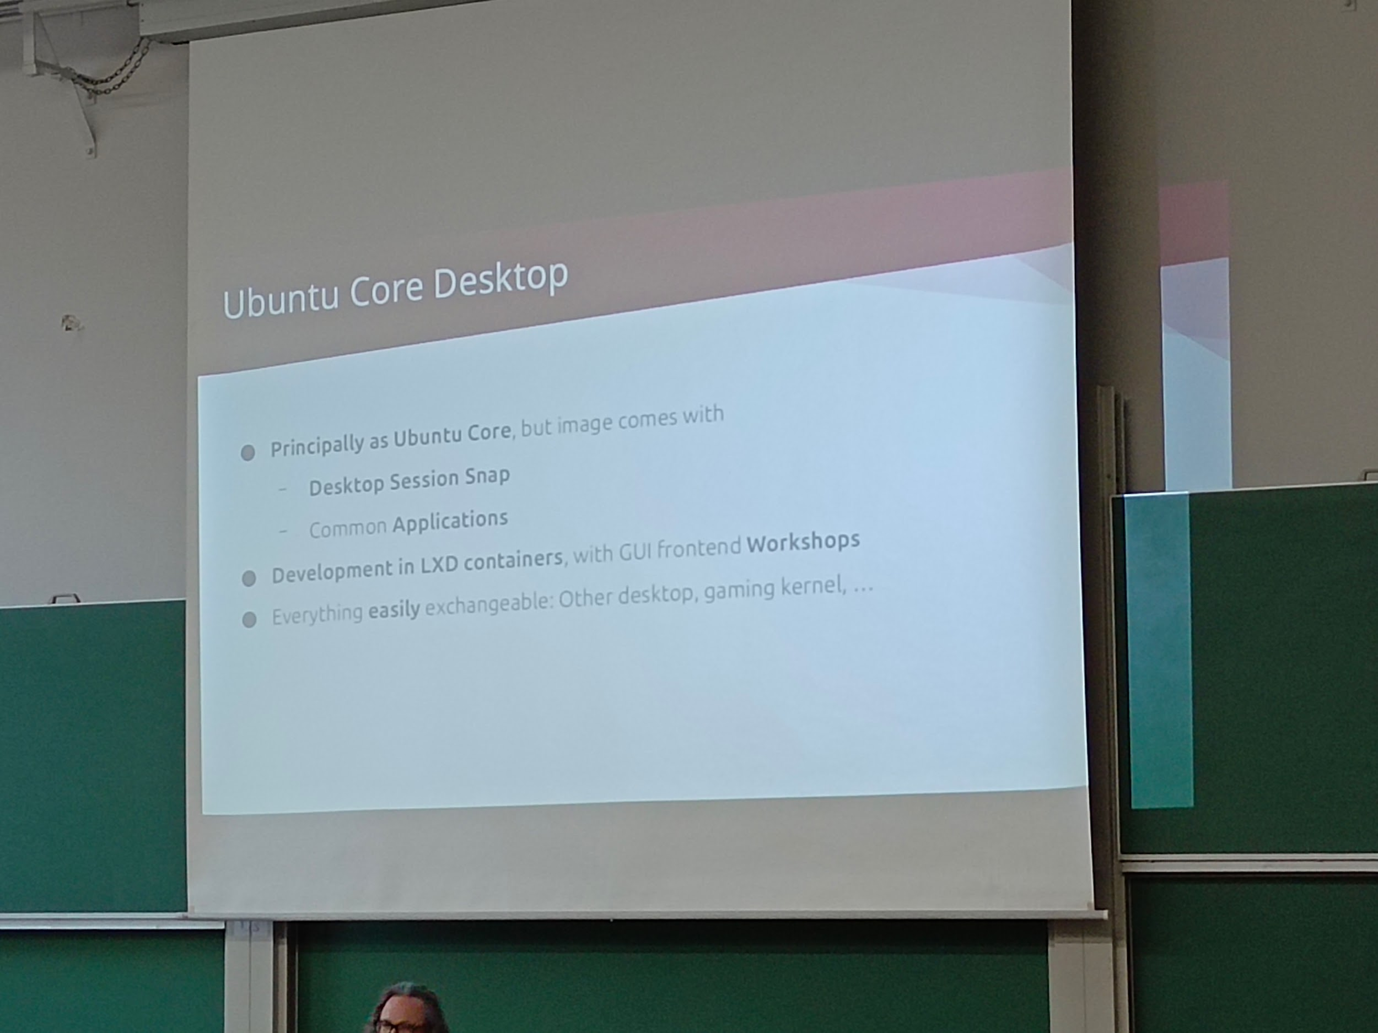

Still ongoing

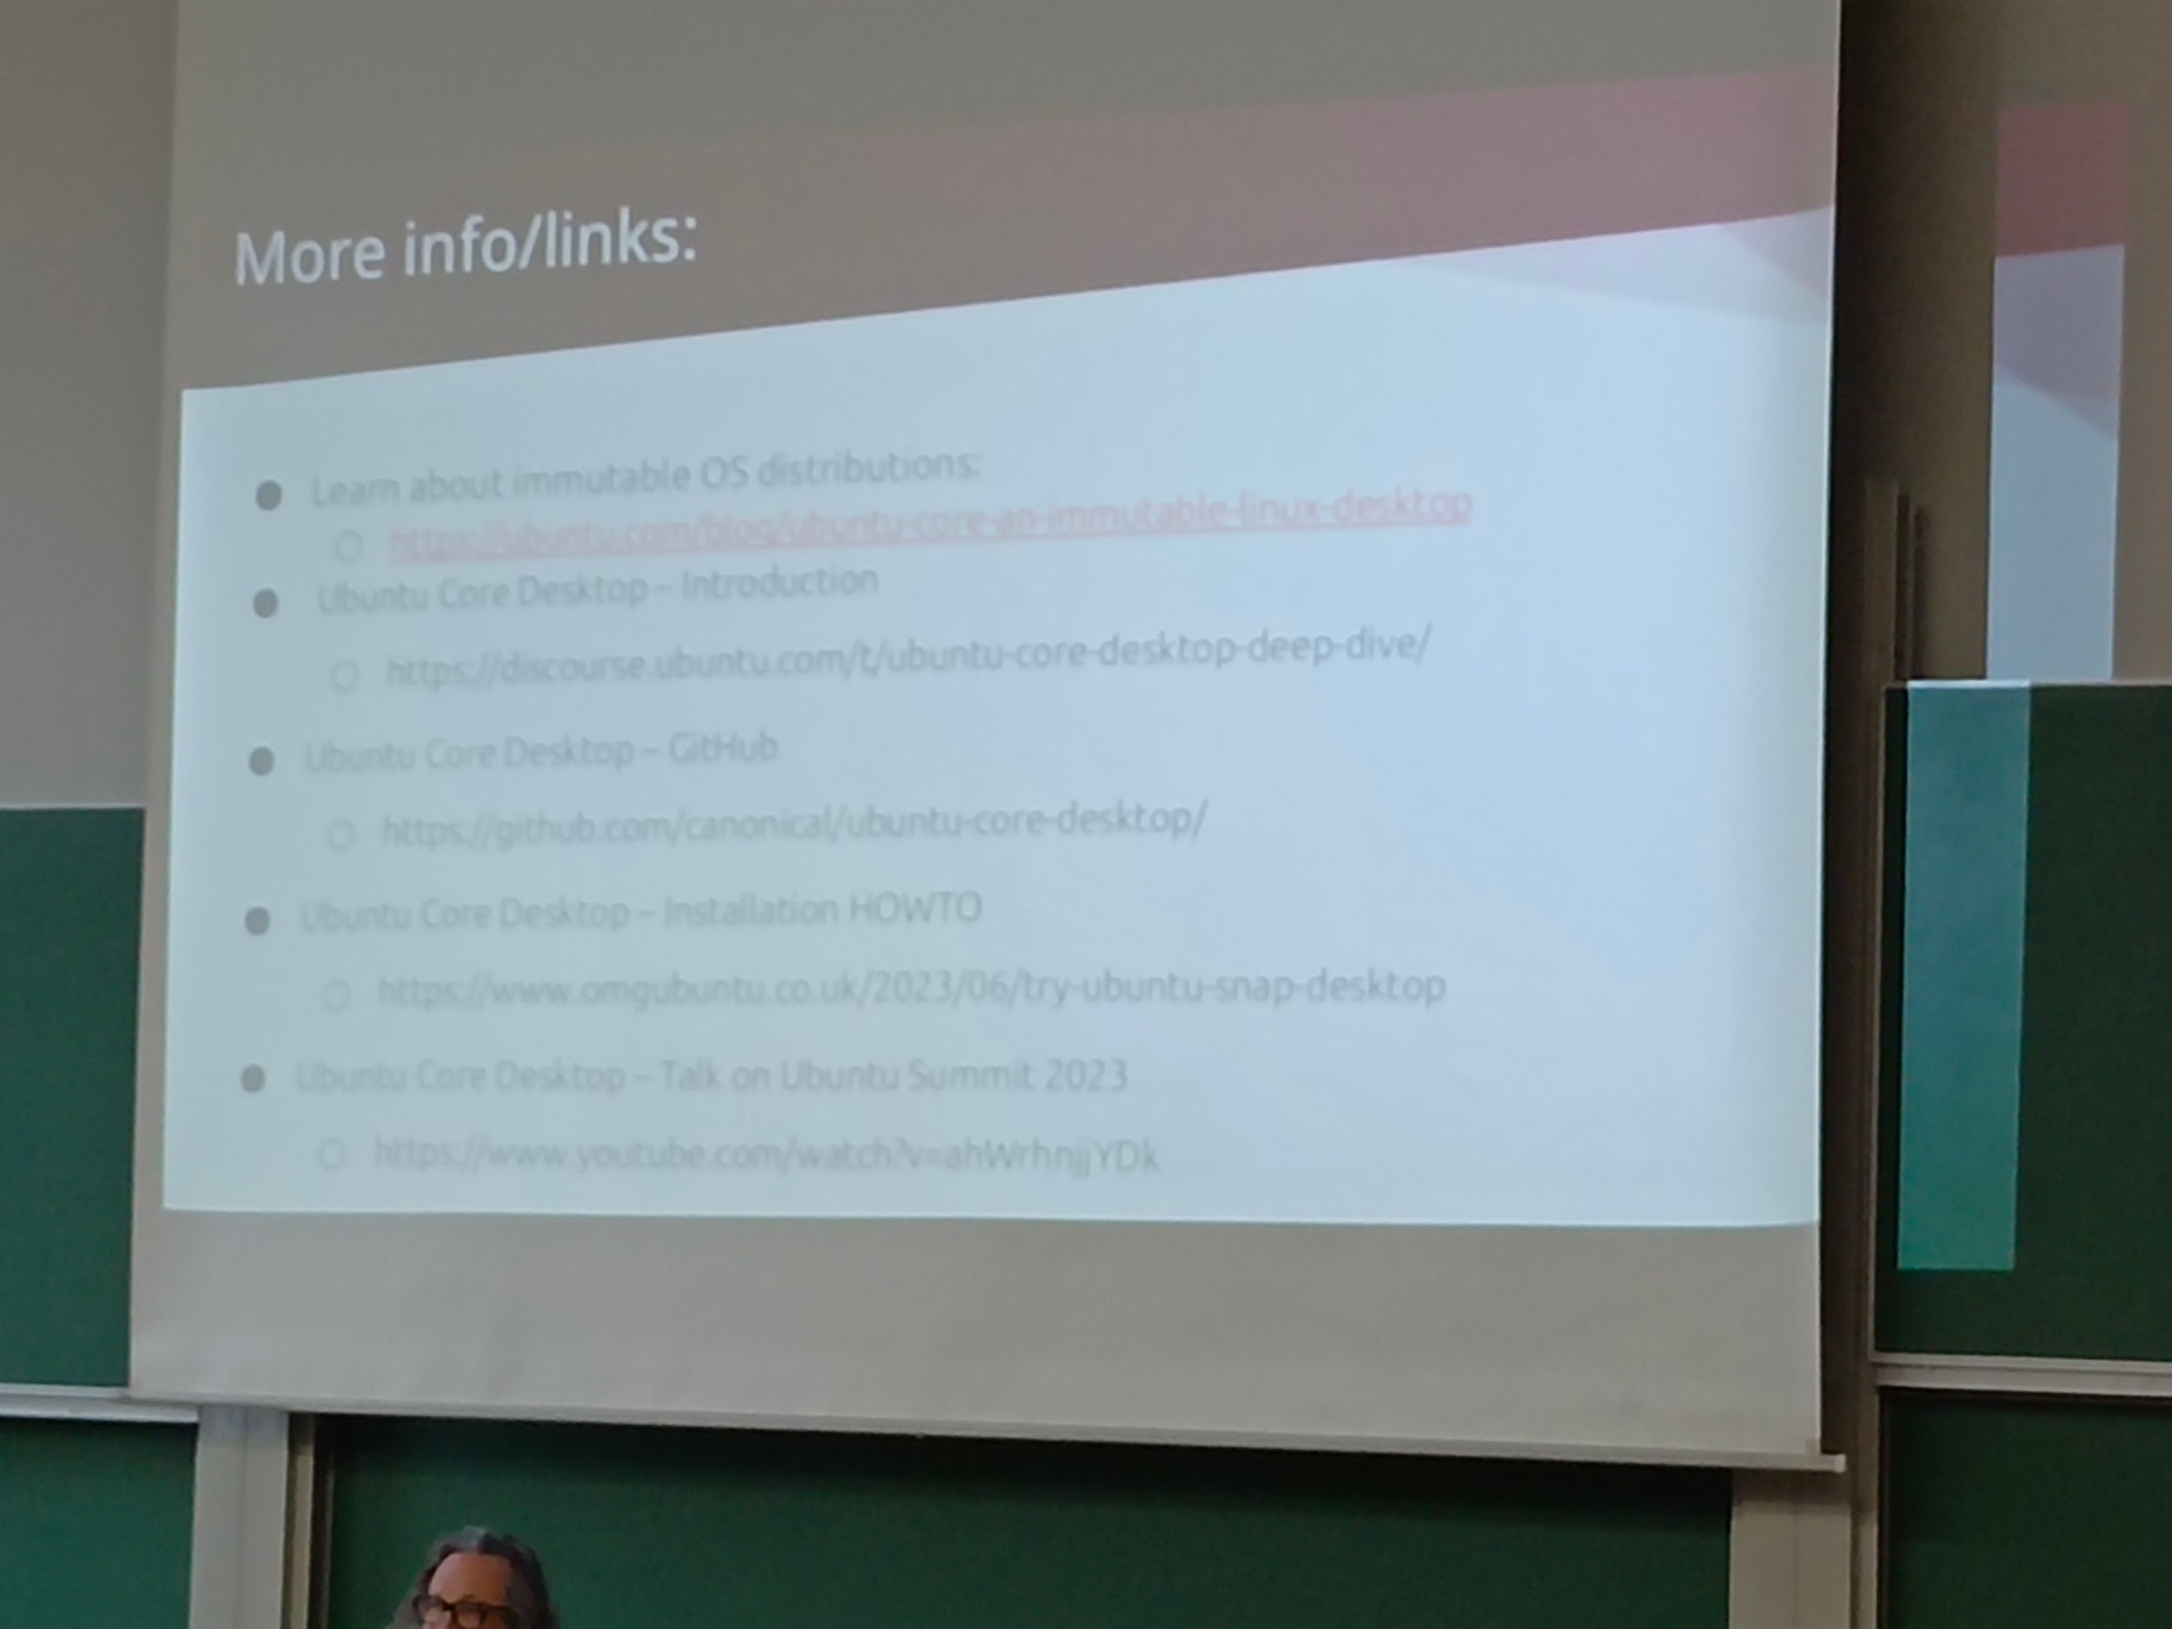

---

## [FOSDEM 2024 - Web Accessibility and ATAG](https://archive.fosdem.org/2024/schedule/event/fosdem-2024-3757-web-accessibility-and-atag/)

Aw1121 14h00 bof atag

WCAG 2.2

ATAG tools & guidelines for accessibility (users and coders?)

* Document ! For back and users, both

CMS

Security vs accessibility

By design

Tools itself being accessible ? It would involve and widespread more

Take advantage to ppl being from everywhere and every situation as collaborators (user, tester, coder, etc.)

Issues with guidelines like taking care of some situations but not their opposites (like some colorblindness in one side and the total opposite like blue and white Or black and blue)

Good enough?

Involve ppl with particular situations for audit or testing group (done by the ppl of the Saturday talk in Mexico and India)

* Make ppl volontaire by themselves as particular situations testers instead of looking for them locally: like an open platform

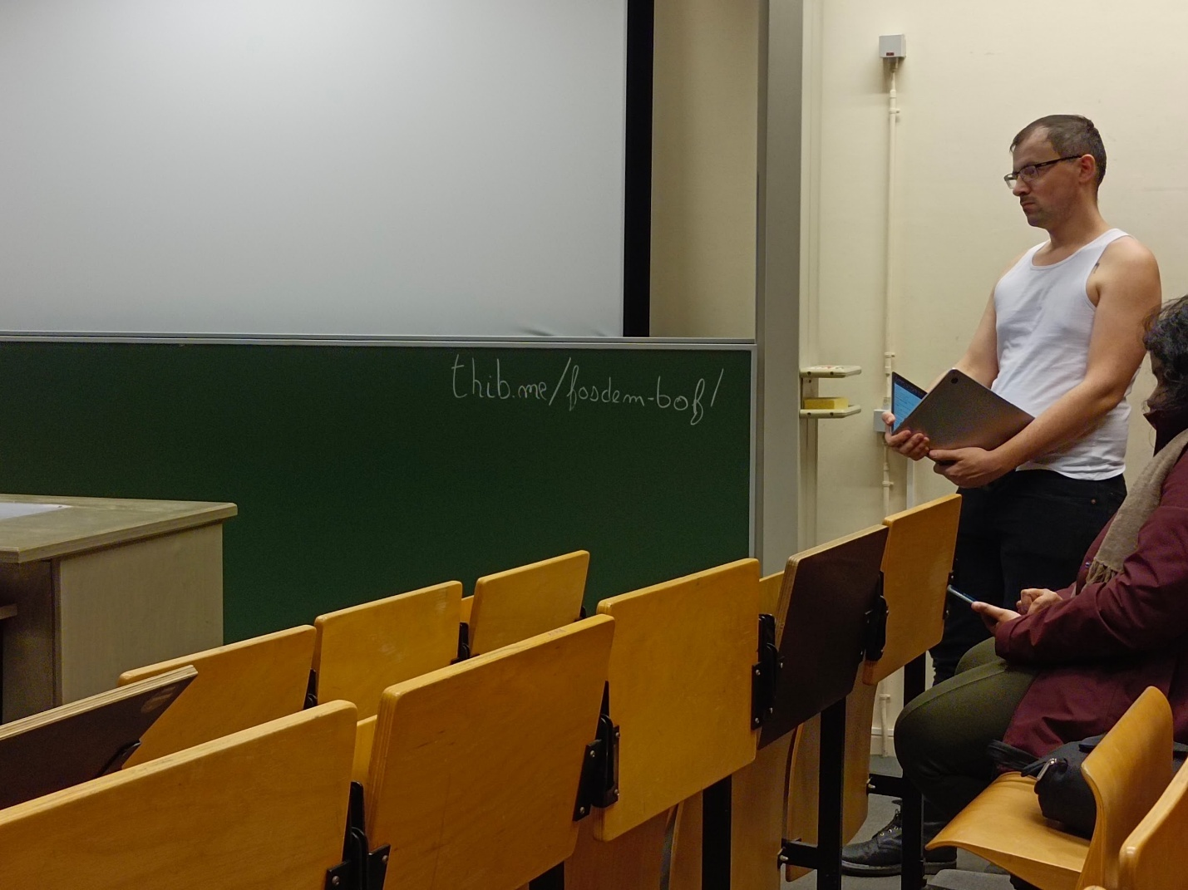

---

## [FOSDEM 2024 - Open Source for Sustainable and Long lasting Phones](https://archive.fosdem.org/2024/schedule/event/fosdem-2024-3362-open-source-for-sustainable-and-long-lasting-phones/)

Janson 15h00 open source for sustainable phones fairphone

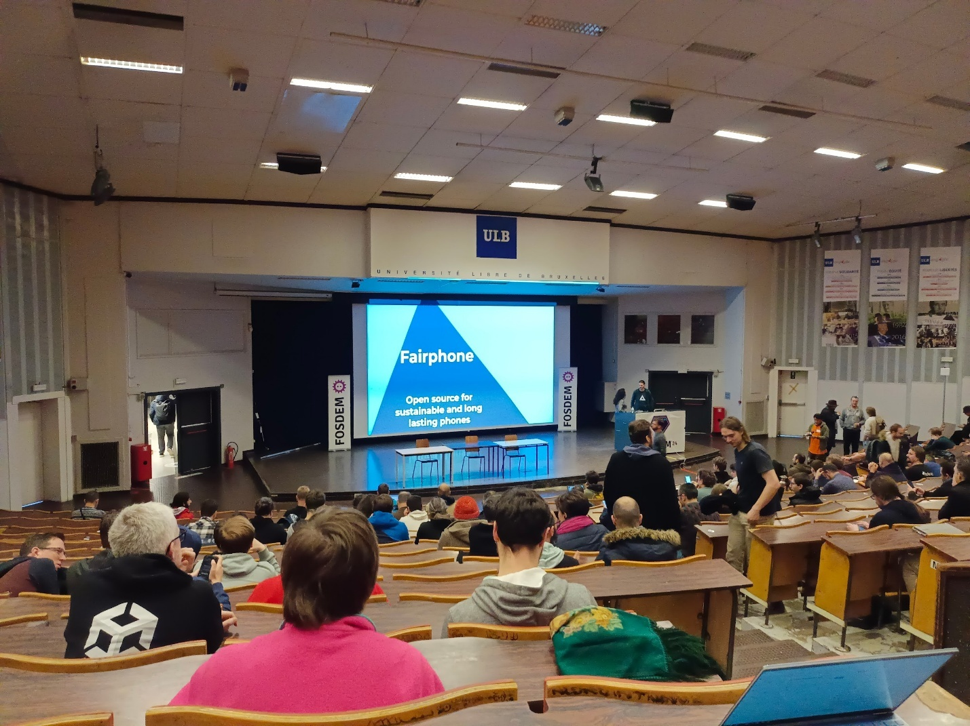

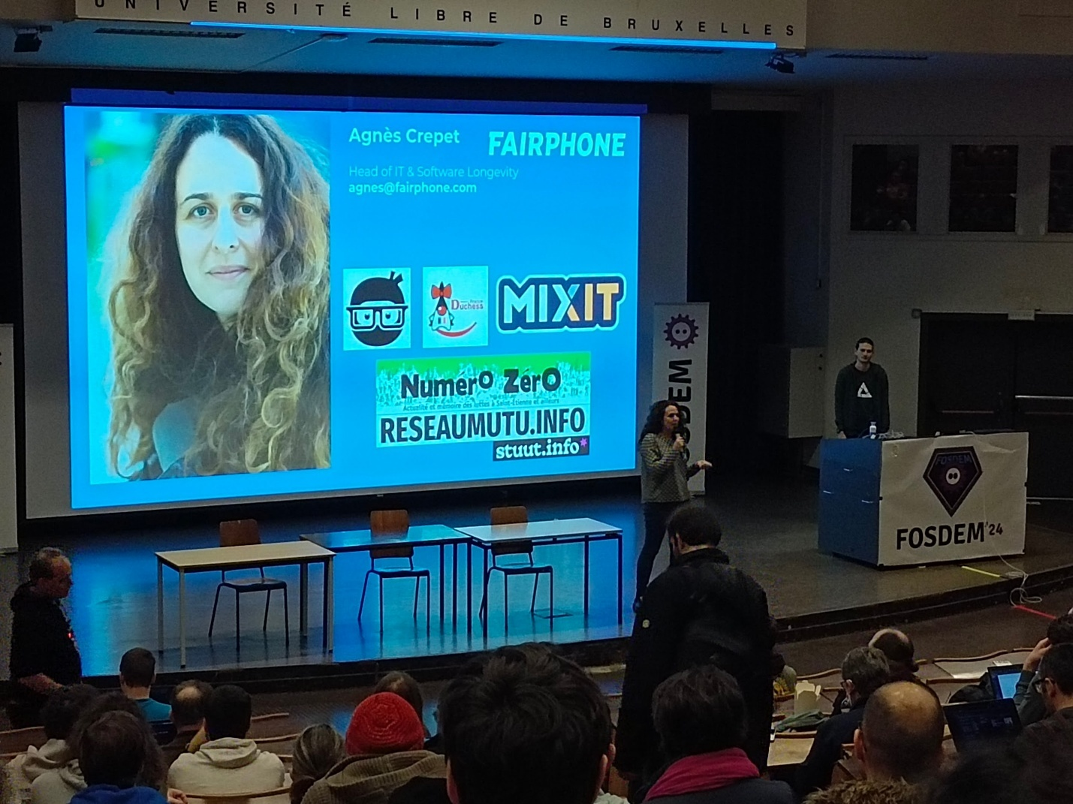

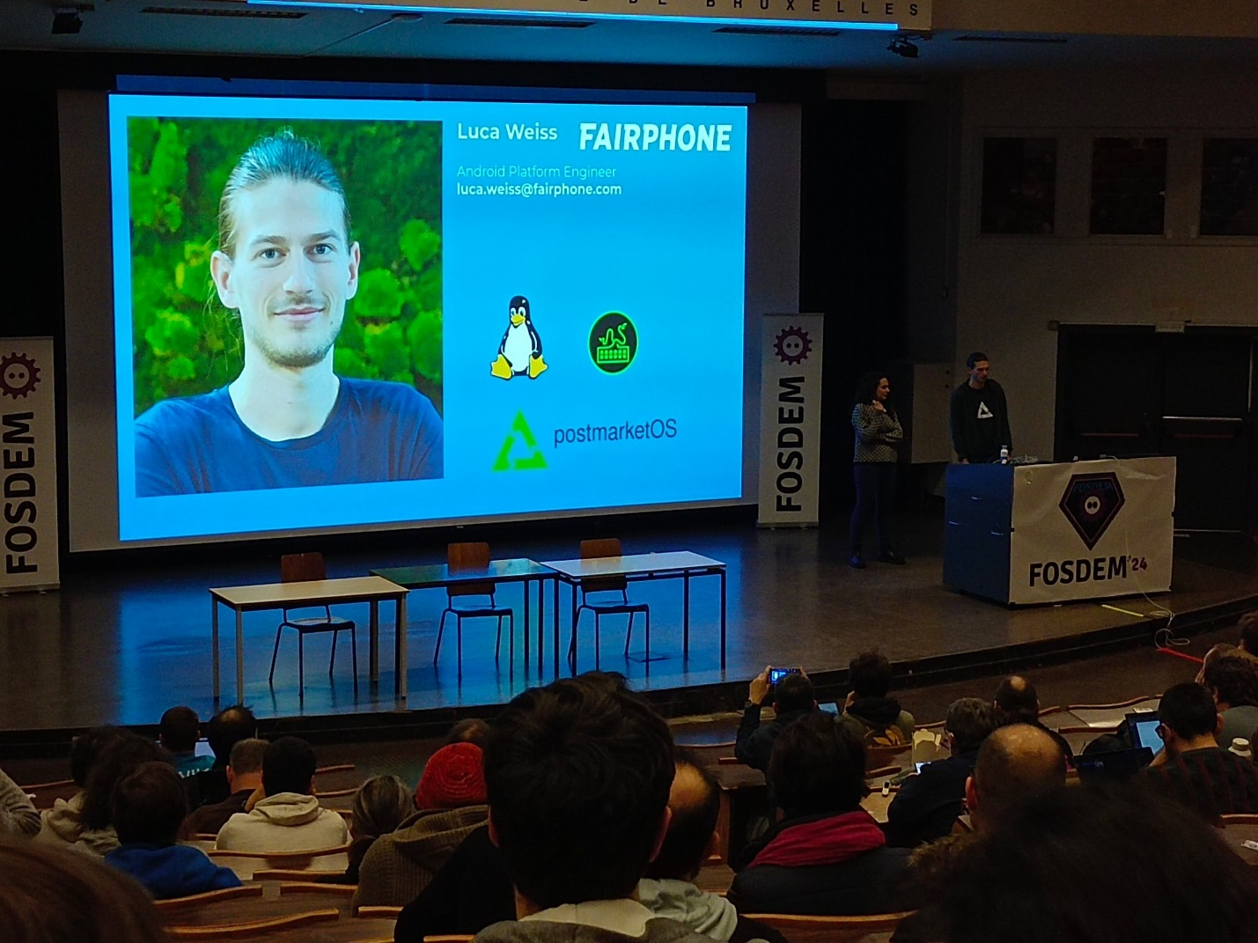

Fairphone

Started in technology challenging environment/geography

Waag organisation

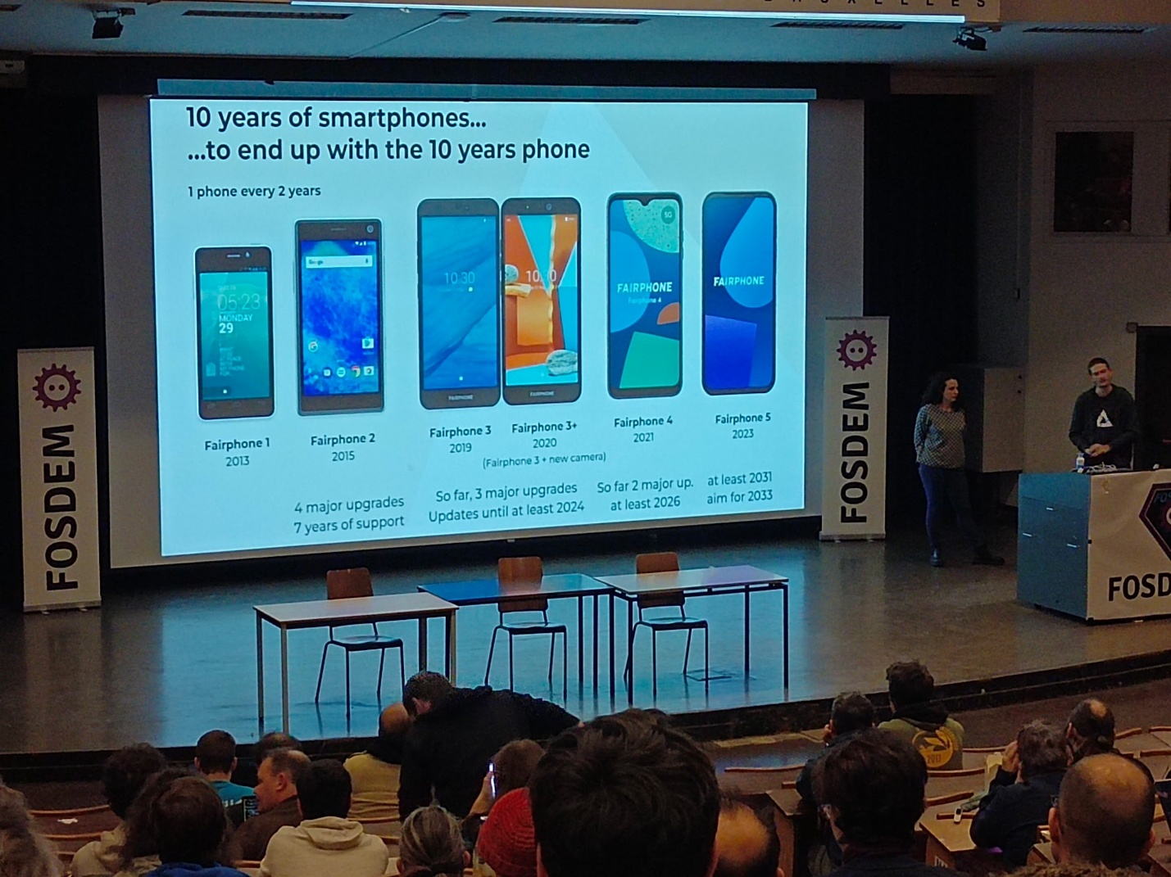

Obsolescence comes from the hardware (battery, glass, etc.)

And from software (OS, patches, etc.)

Difficult to access to the broken parts

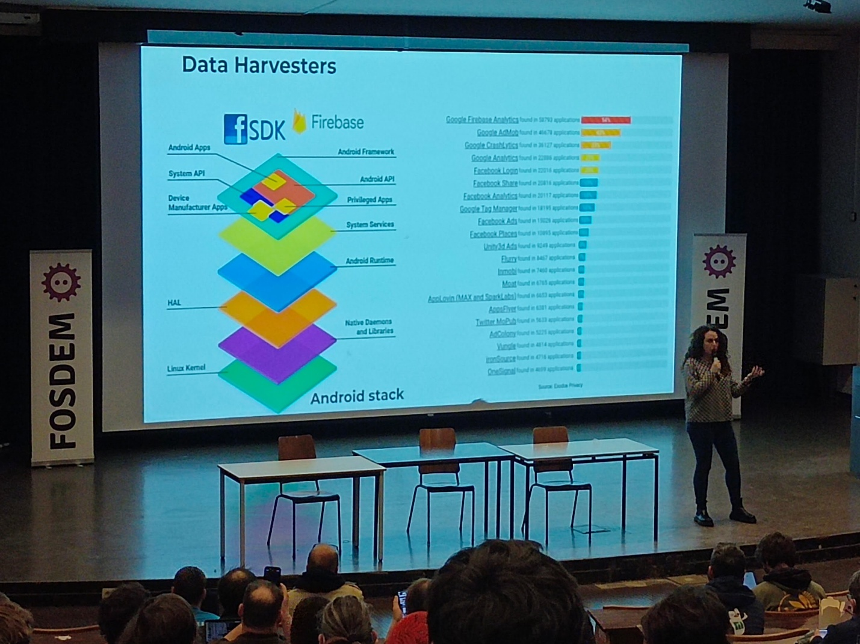

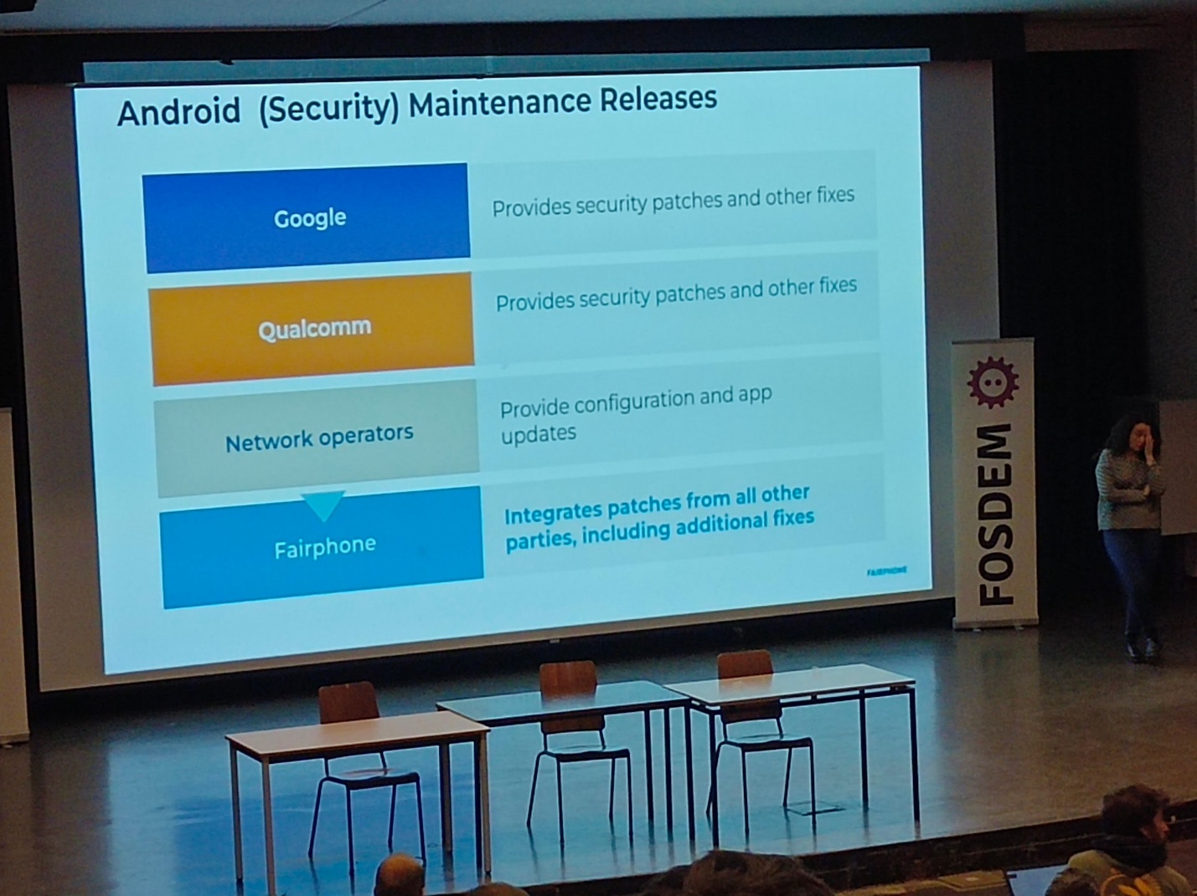

Code.fairphone.com

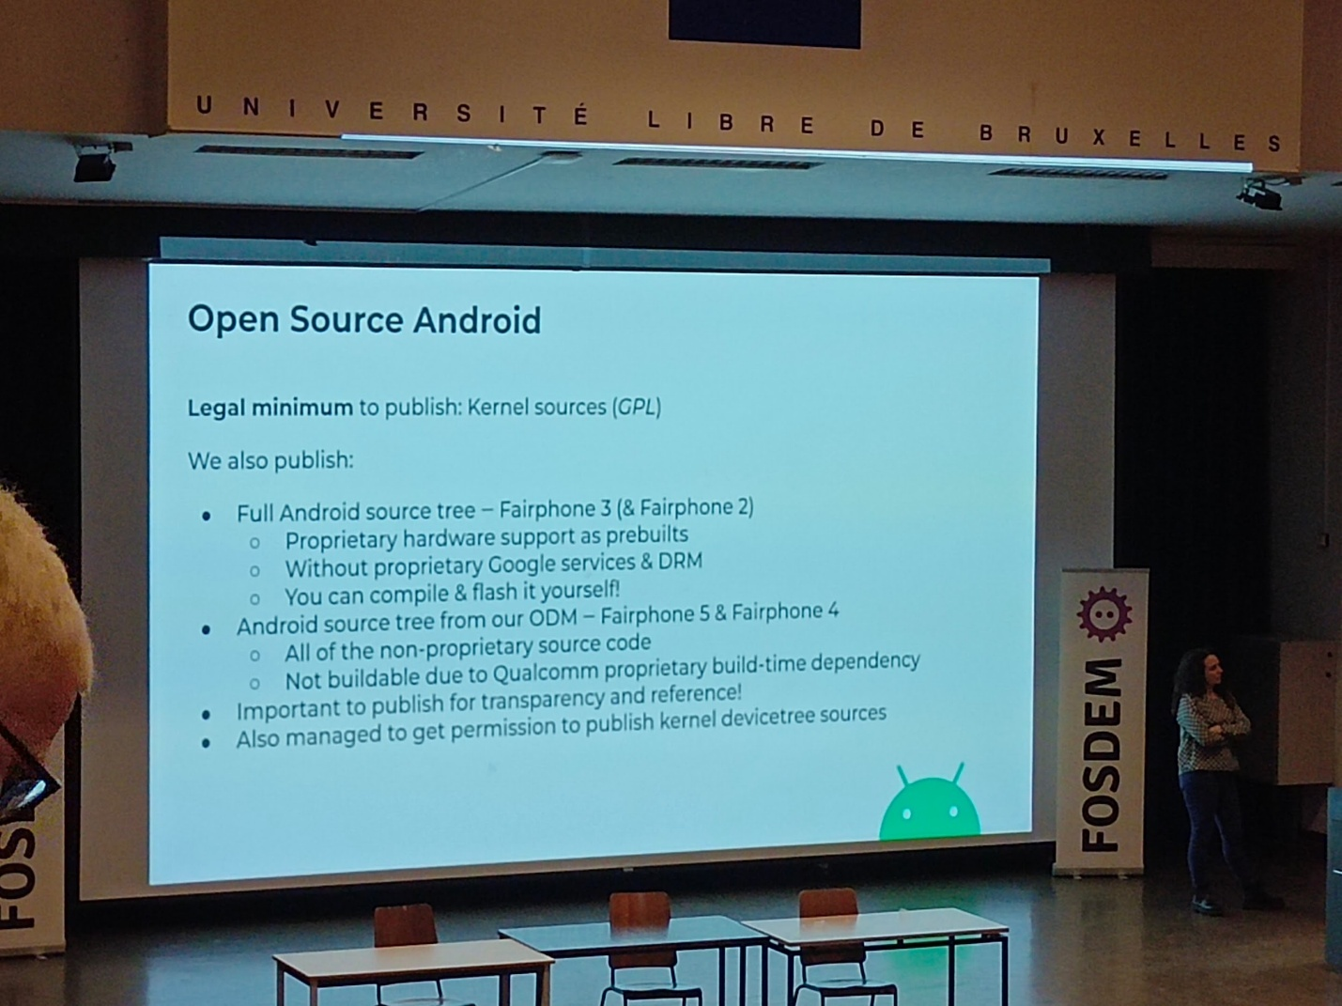

Take a look at FOSS on mobile devices

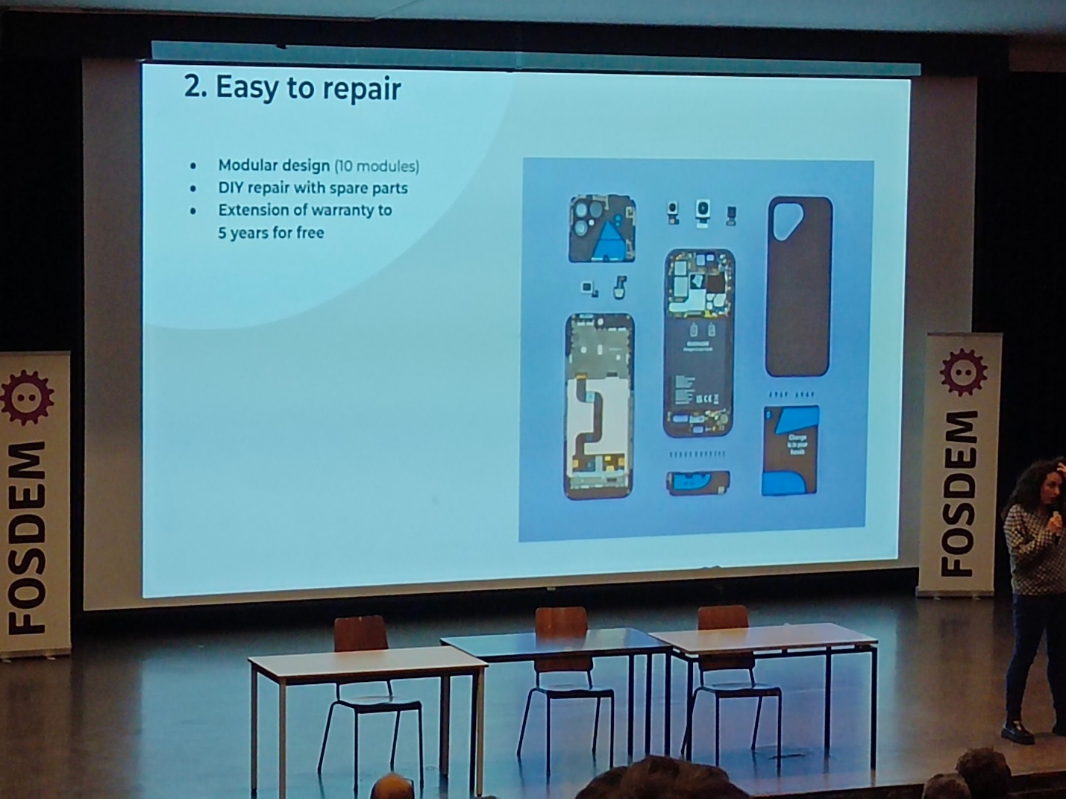

Schematics provided

Security is not a reason to not share the schematic

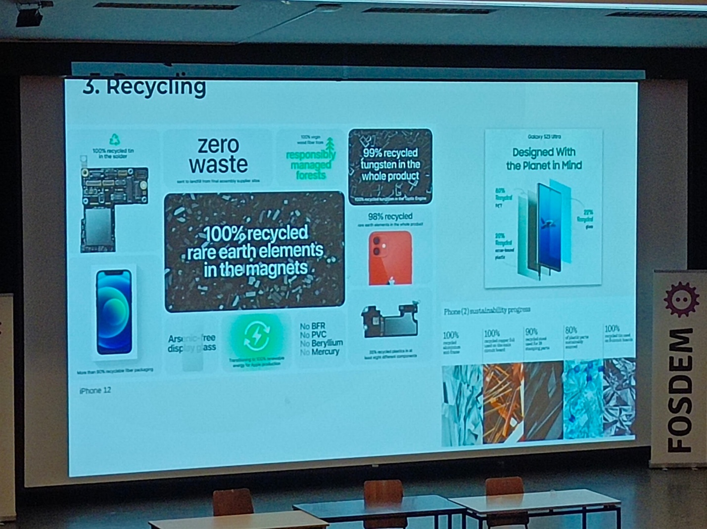

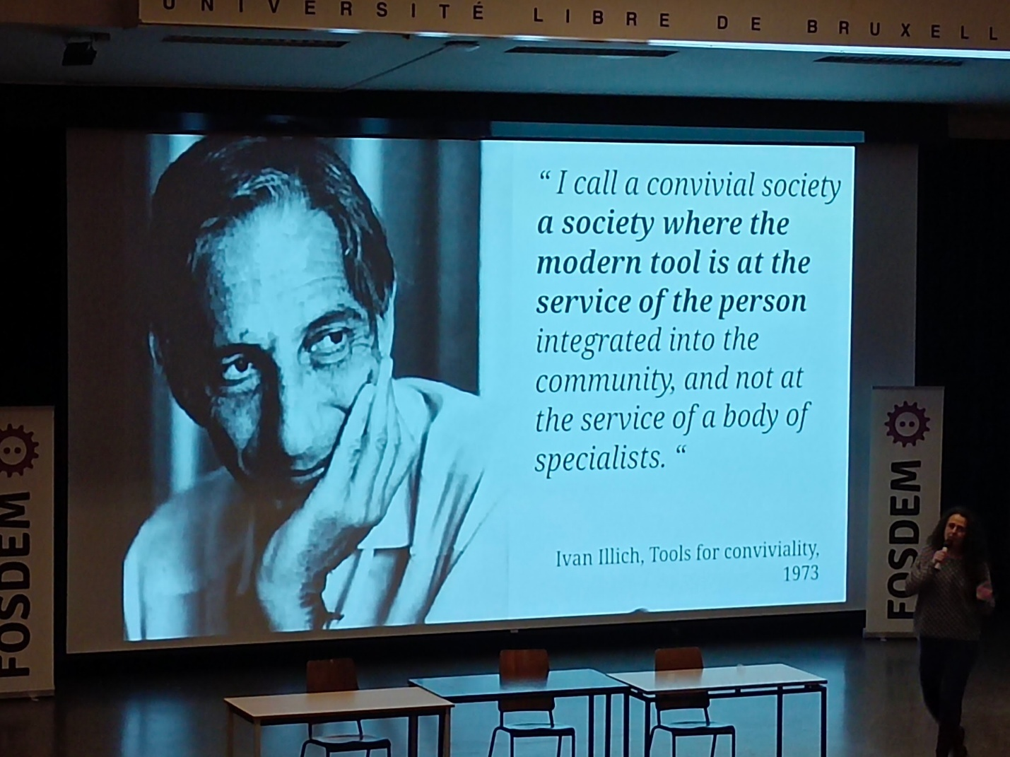

Technodiscernment opensource itself is not responsible

Socialjustice contribution to empower ppl

---

## [FOSDEM 2024 - A journey documenting the Sanco 8003 computer](https://archive.fosdem.org/2024/schedule/event/fosdem-2024-2008-a-journey-documenting-the-sanco-8003-computer/)

Ub5230 16h10 Sanco 8003

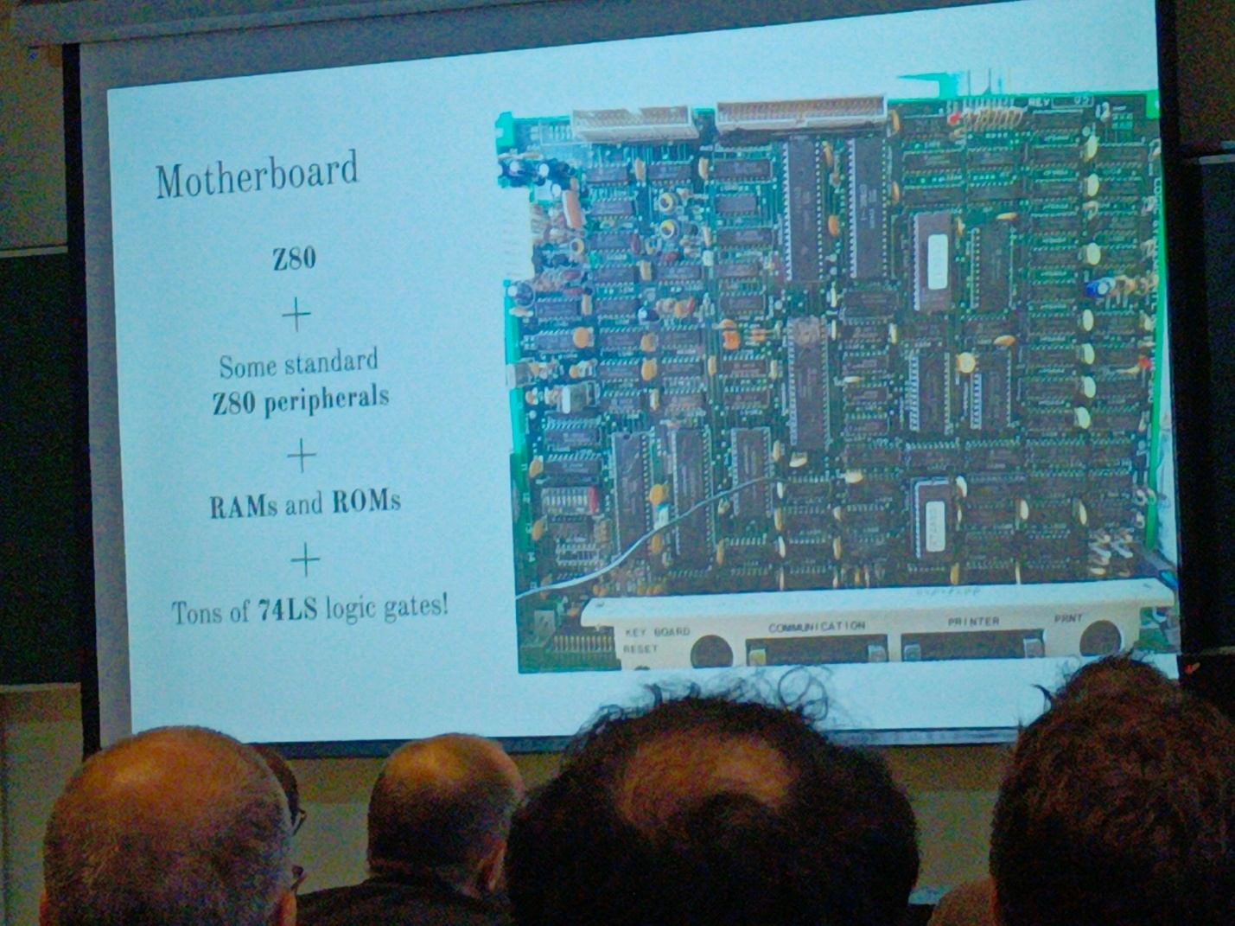

Decortocage dun ordi

Need testers (go on GitHub: glgprograms/ceda-cemu)

----

## [FOSDEM 2024 - Controlling a 6 degree Robot Arm using a 48K ZX Spectrum](https://archive.fosdem.org/2024/schedule/event/fosdem-2024-2898-controlling-a-6-degree-robot-arm-using-a-48k-zx-spectrum/)

Ub5230 16h30 6° robot arm 48k ZX spectrum

Loadzx.com

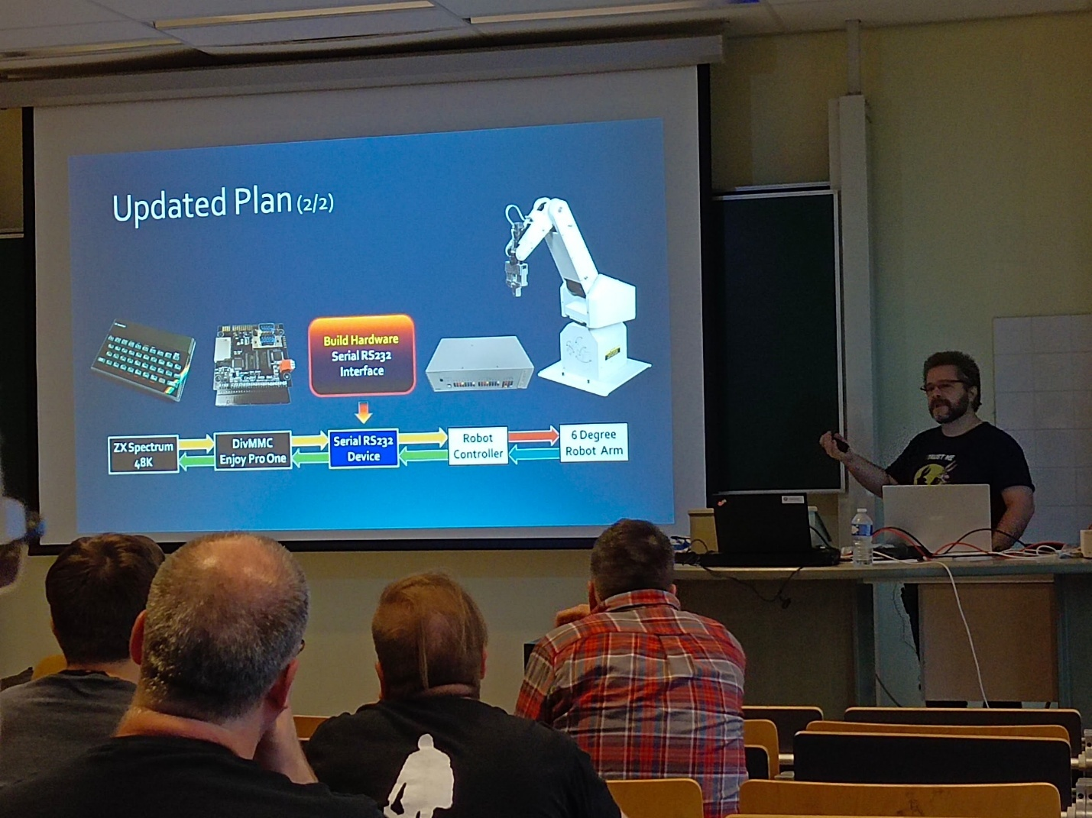

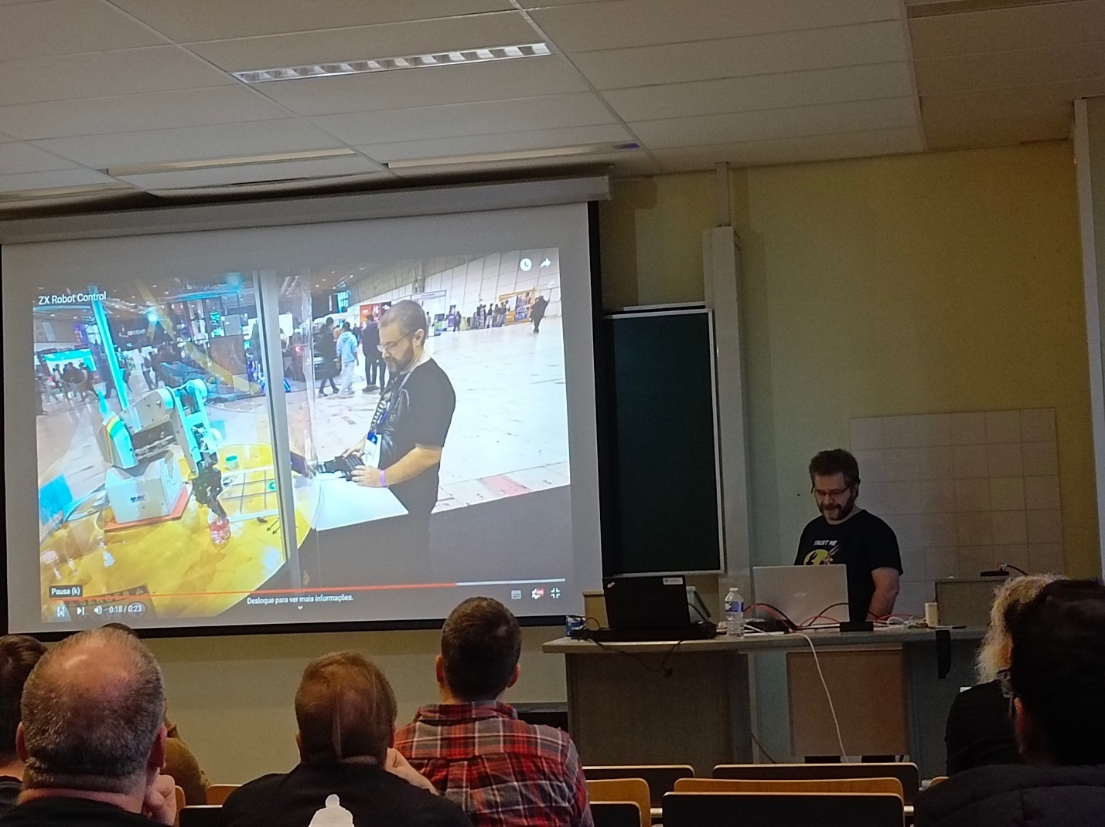

----

## [FOSDEM 2024 - FOSDEM 2024 Highlights](https://archive.fosdem.org/2024/schedule/event/fosdem-2024-3723-fosdem-2024-highlights/)

Janson highlights

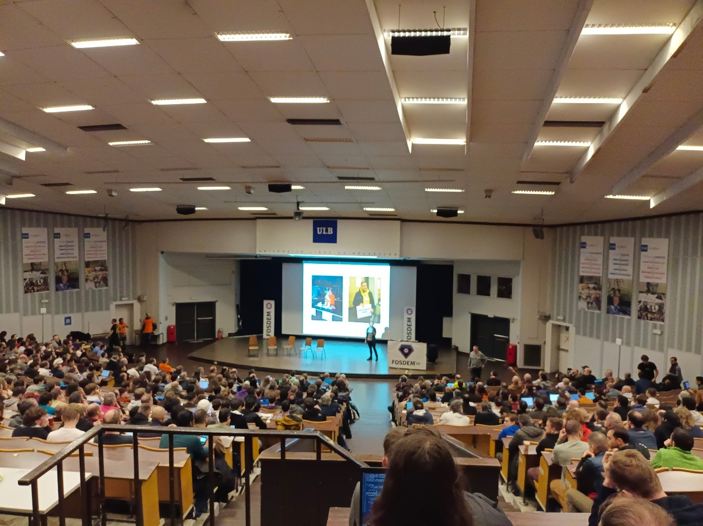

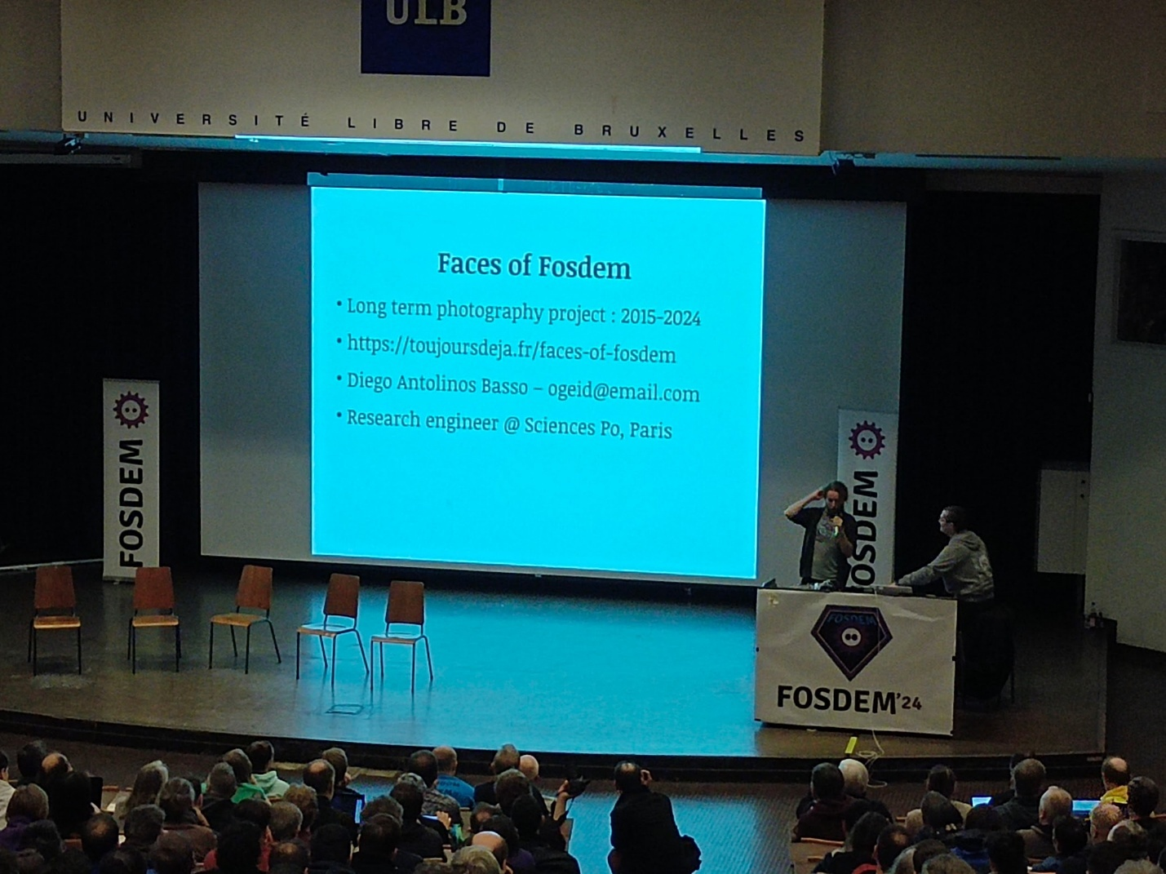

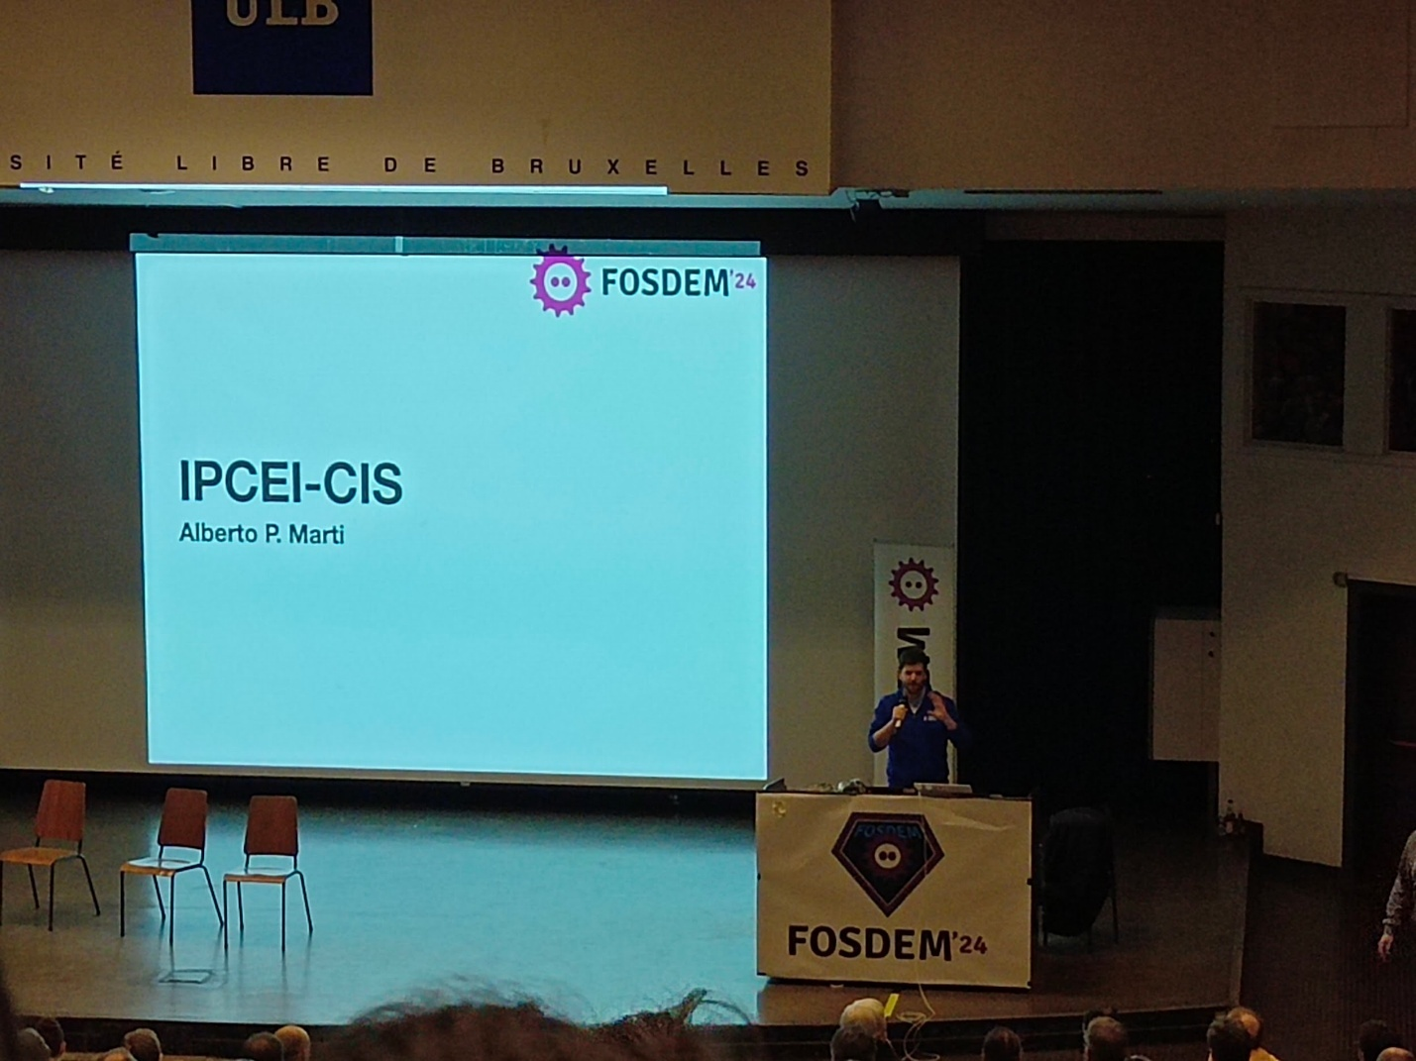

Build open source European cloud project

Energy devroom

Energy, open software, open hardware …

Community on energy to join (previous talk on Janson room)

Embedded

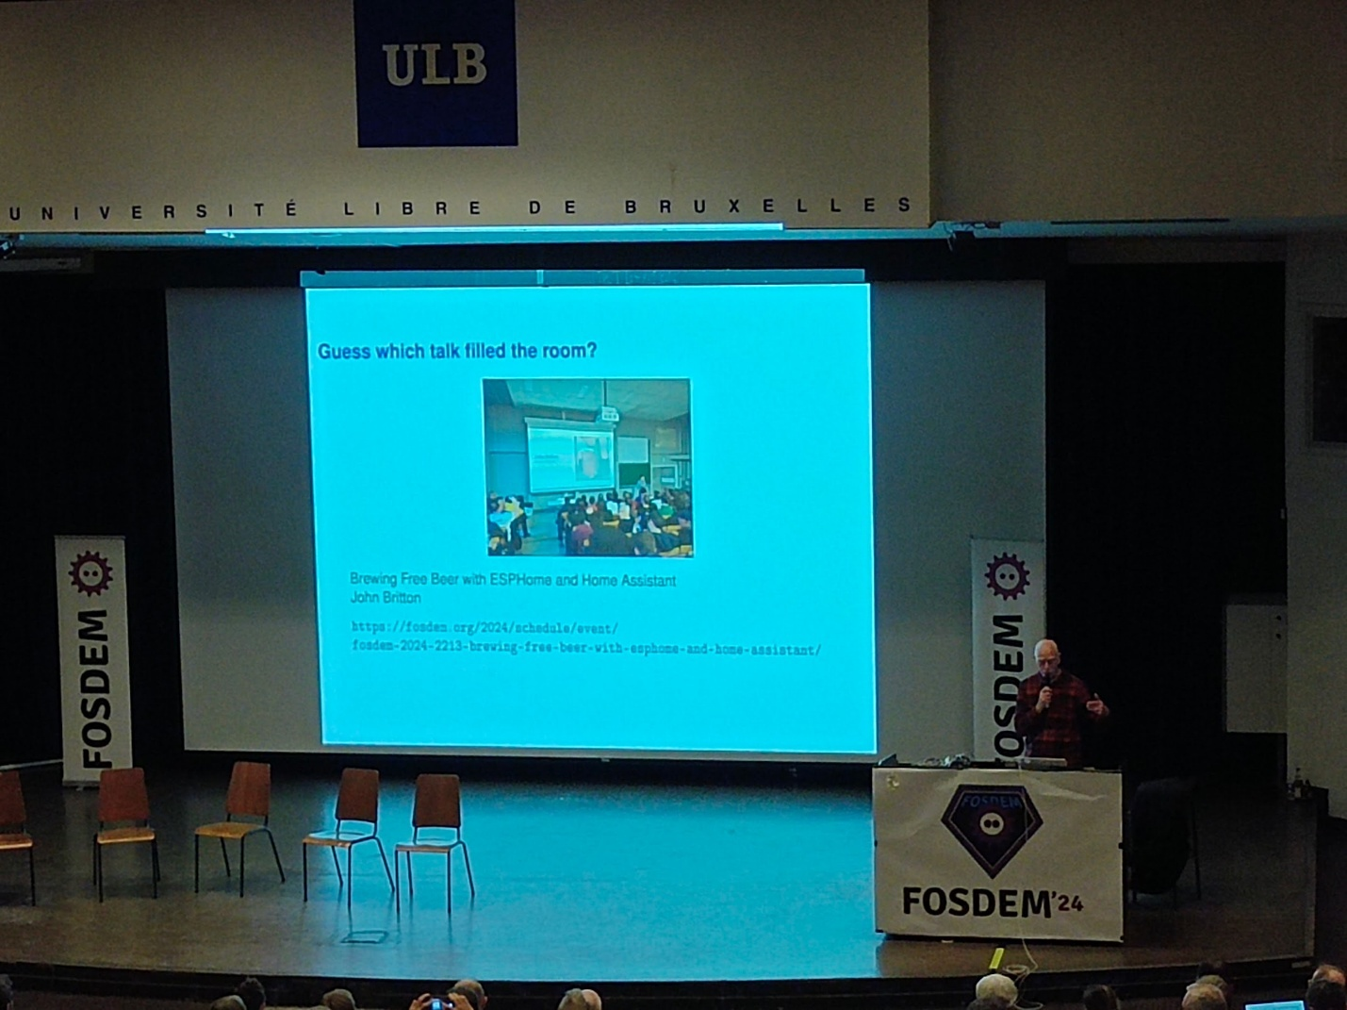

Monitoring and observability

GCC

Fosdem junior

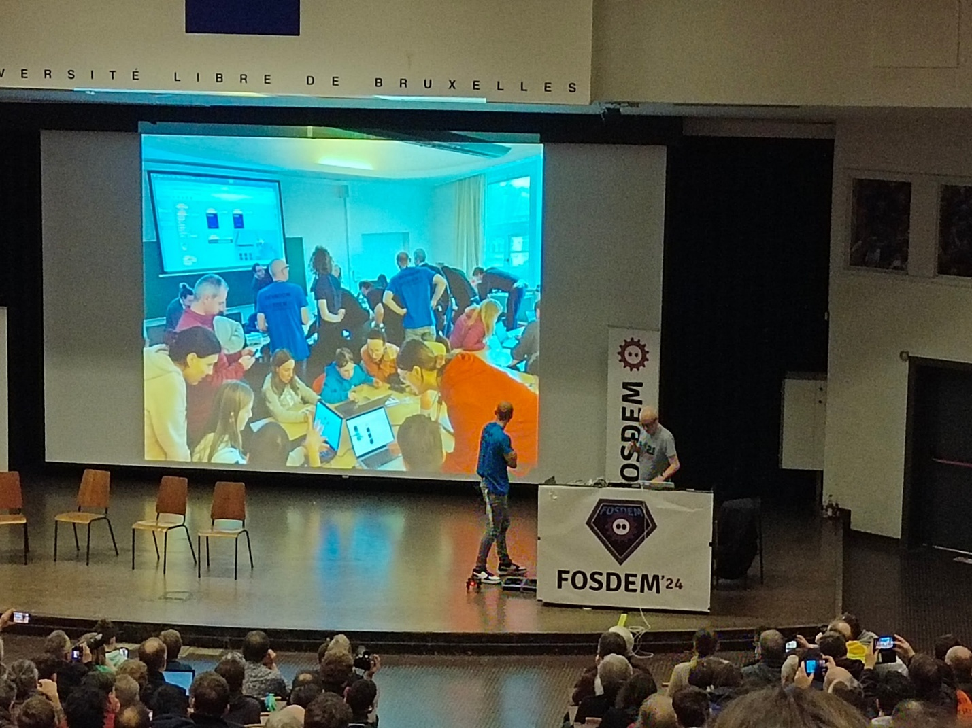

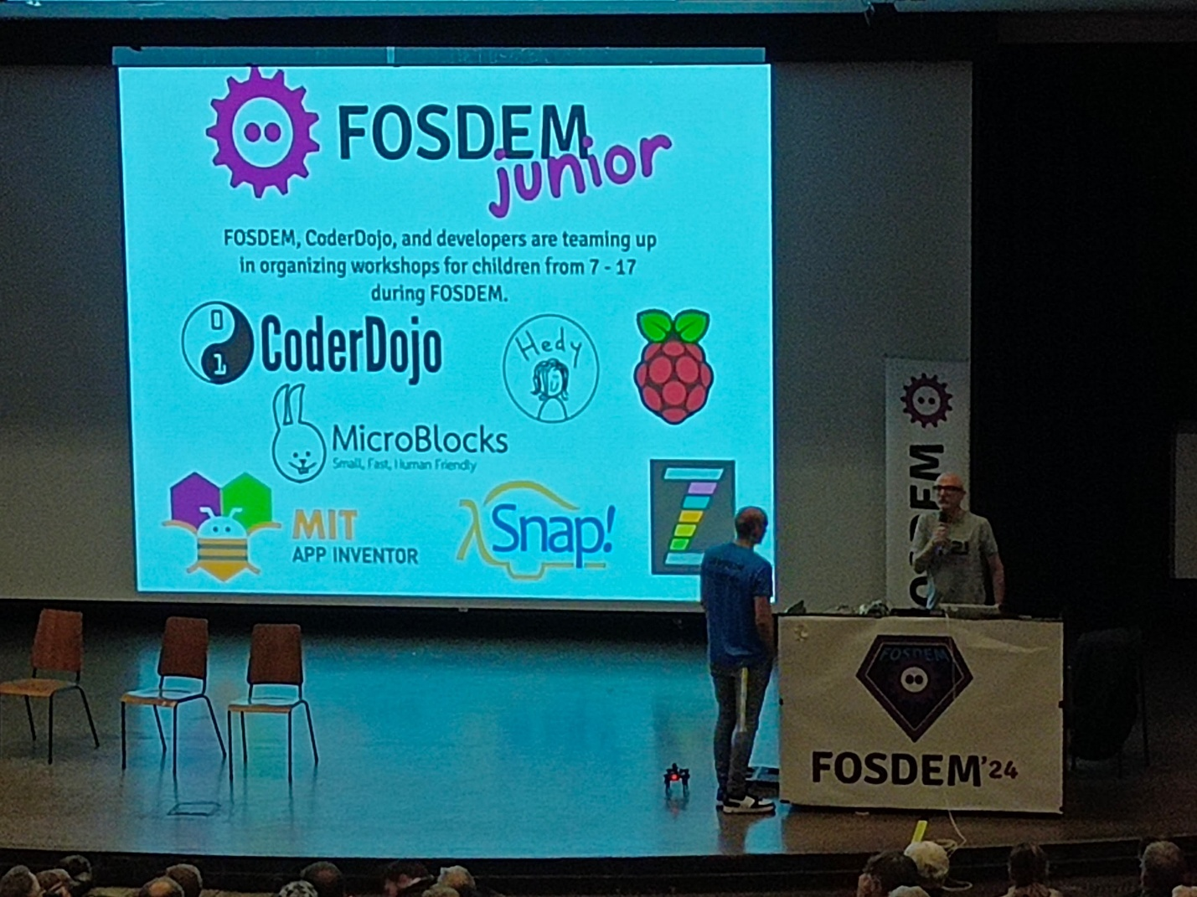

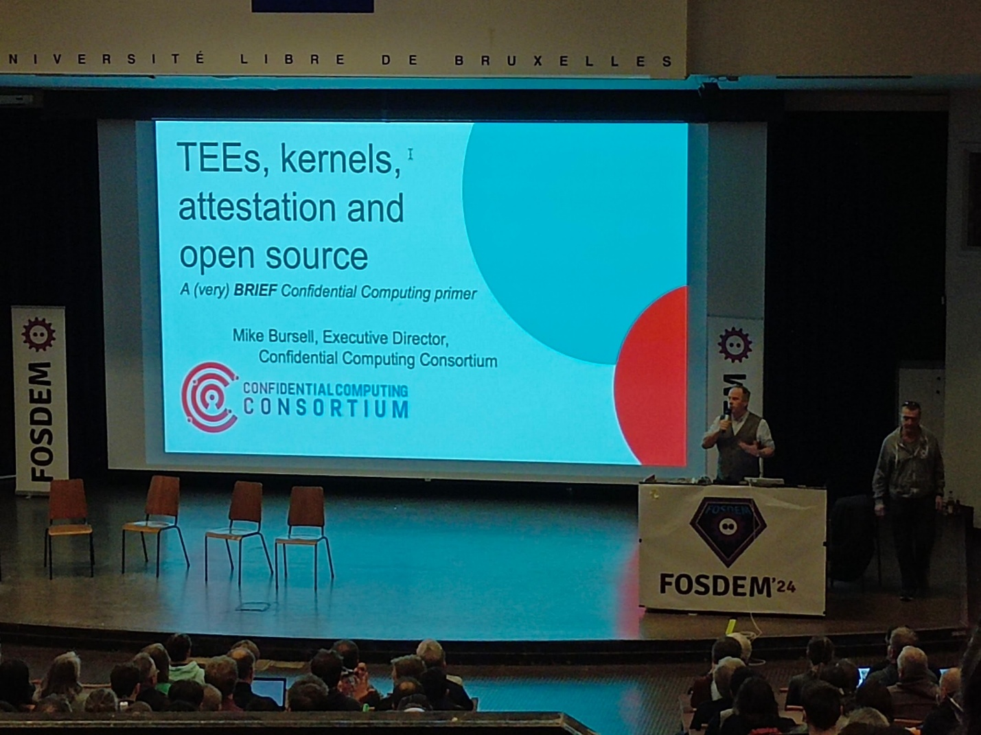

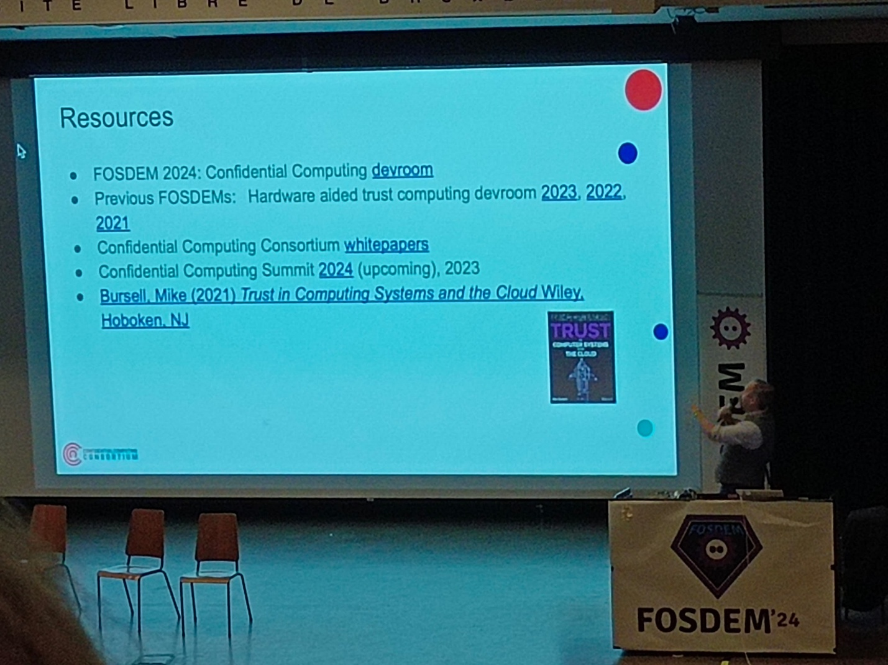

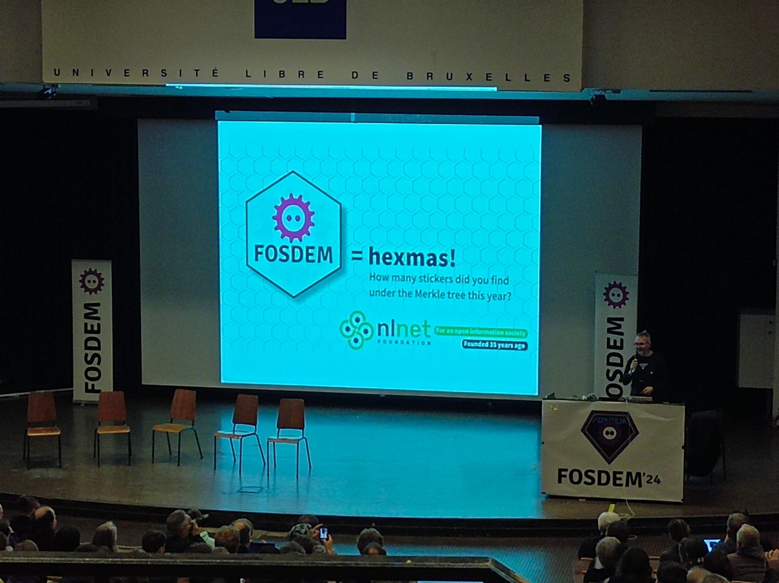

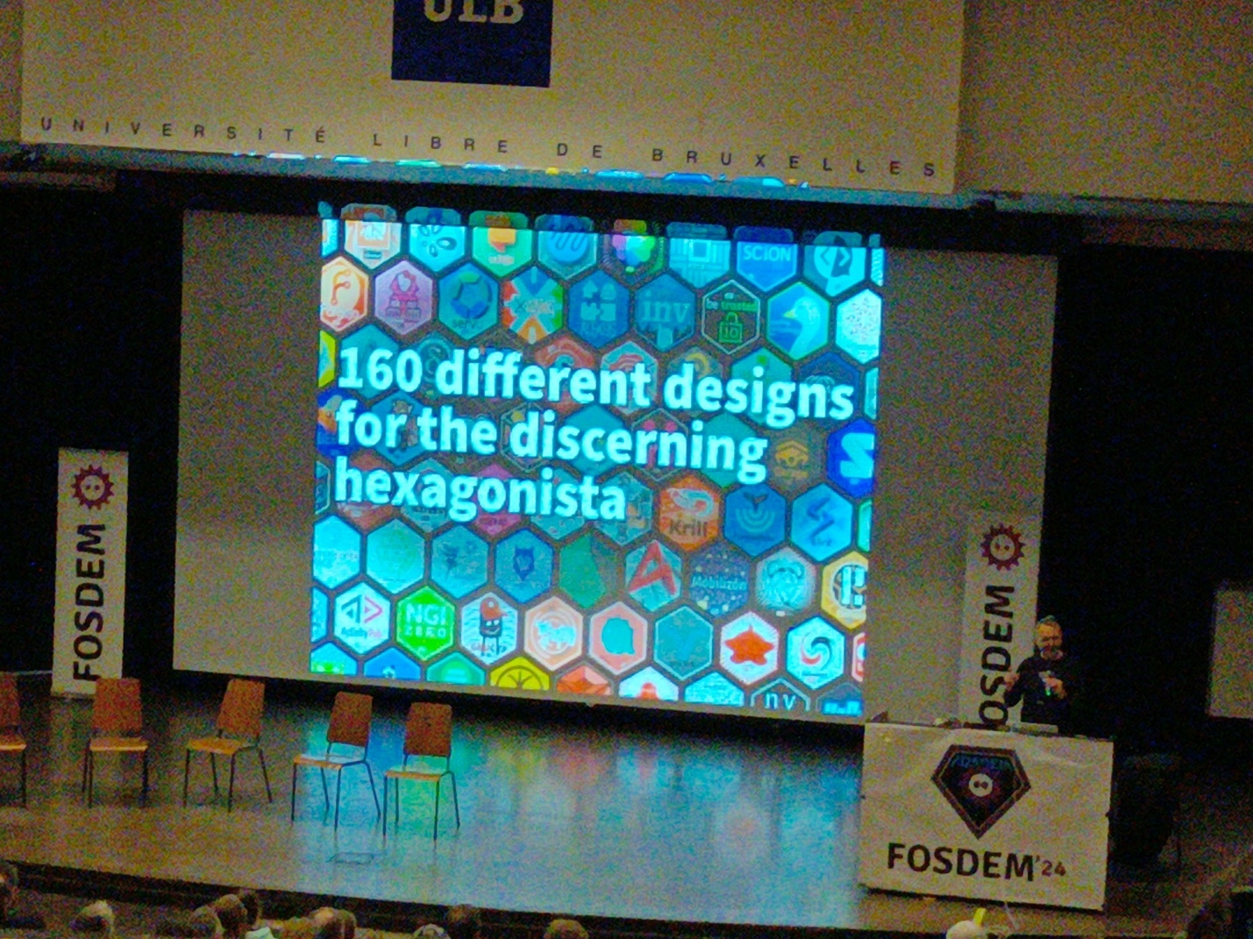

Hexa sticker standard (l43.9mm h50.8mm)

European legislation impact